Pacific Australia Labour Mobility scheme quarterly update

Data current up to 30 June 2026

Published: 4 September 2026
Data about workers and employers participating in the Pacific Australia Labour Mobility (PALM) scheme is published monthly on the PALM website www.palmscheme.gov.au/palm-scheme-data. This quarterly report presents longer-term trends and analysis for key metrics.
PALM scheme worker counts are a measure of the number of workers from participating PALM scheme countries holding a valid visa who are currently onshore in Australia. Worker participation will vary from month to month reflecting a range of factors, including:
- the cyclical nature of the program and worker visa conditions (9 months for the short-term stream and up to 4 years for the long-term stream)
- changing workforce demand e.g. stemming from growing cycles for different crops in different regions, and
- workers returning home for holidays or other personal commitments.

PALM scheme employer counts record the number of employers holding a current PALM scheme deed.

PALM scheme worker trends – June quarter 2026
Over the 12 months to June 2026:
- The worker count increased by 5% or 1,590 workers. Short-term worker counts increased by 7% over the year while long-term worker counts increased by 3% over the year.
- Worker counts by industry:
  - Agriculture increased by 6% (1,115 workers) since June 2025.
  - Meat processing increased by 5% (575 workers) over the last 12 months.
  - The remaining PALM industries, which account for about 9% of the total PALM workforce, recorded mixed movements over the year: Health care and social assistance declined by 11% (145 workers); Accommodation declined by 1.2%; and other industries increased by 7%.
- By country, between June 2025 and June 2026, worker counts:
  - increased for: Papua New Guinea, Samoa, Timor-Leste, Tonga and Vanuatu
  - decreased for: Fiji, Kiribati, Naoero, Solomon Islands and Tuvalu

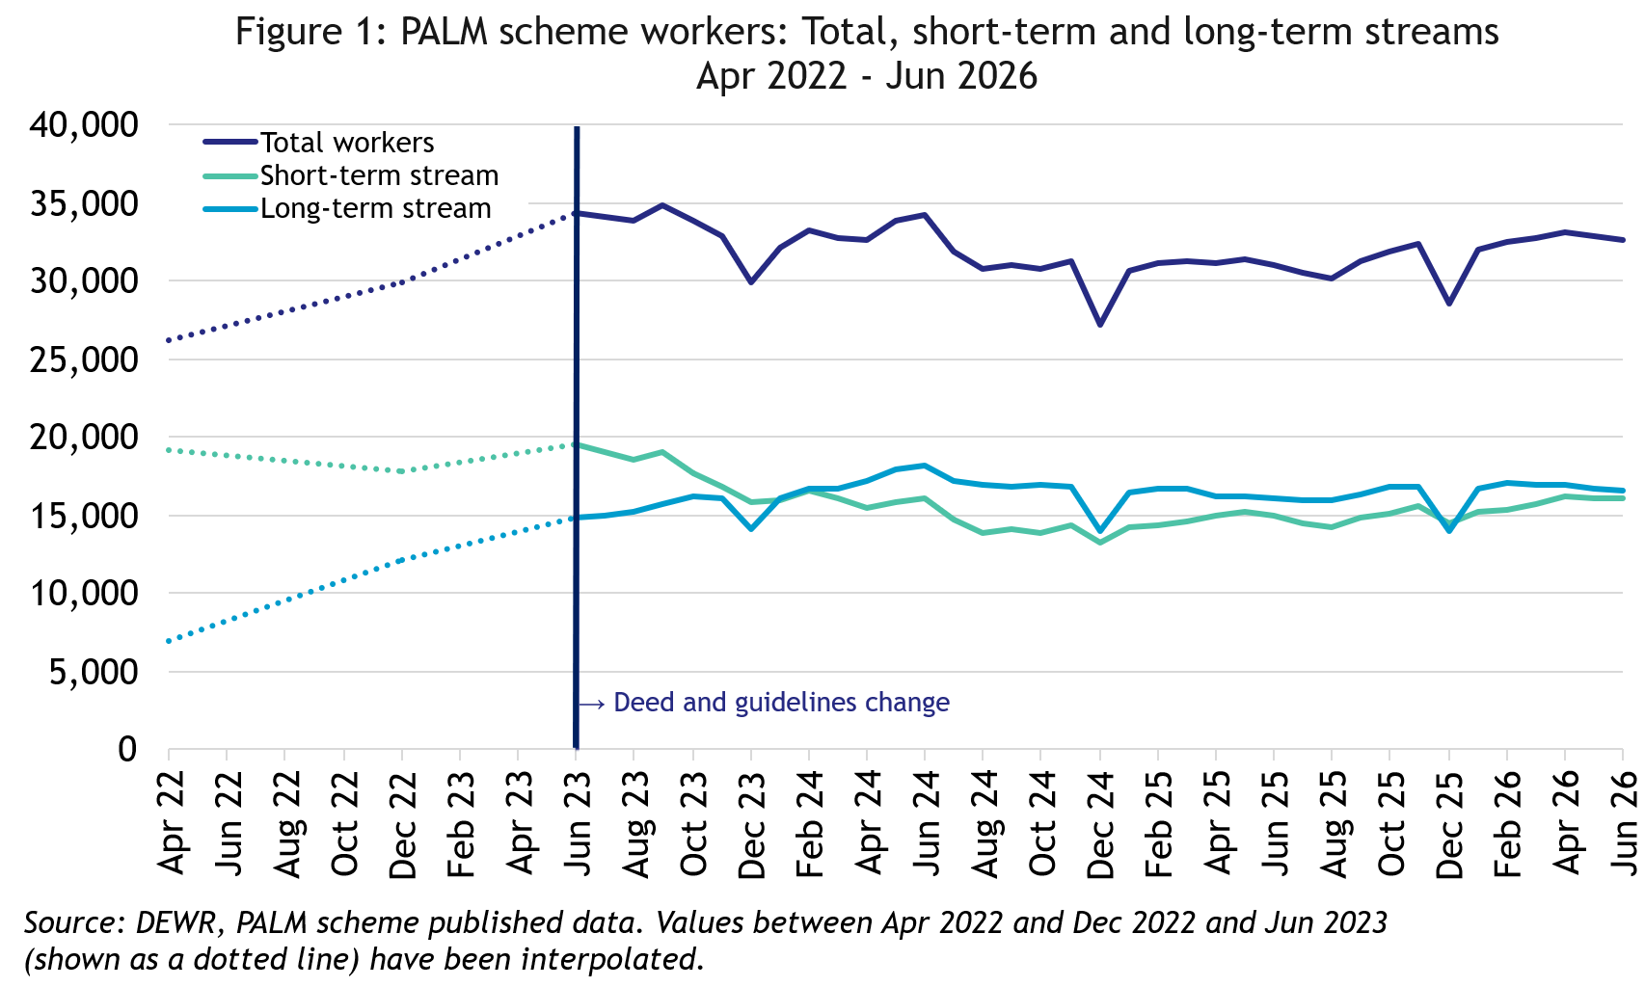

In June 2026, there were:
- 32,645 workers
- 16,050 in the short-term stream
- 16,595 in the long-term stream
In the 12 months to June 2026, the total number of workers was up by 5% or 1,590 workers.
- The long-term stream was up by 3%
- The short-term stream was up by 7%.

PALM scheme employer trends
The number of PALM scheme employers has continued to grow since the new PALM scheme deed, and guidelines were introduced in June 2023.
- 189 new employers have joined the scheme since June 2023, bringing the total number of employers to 556 in June 2026.

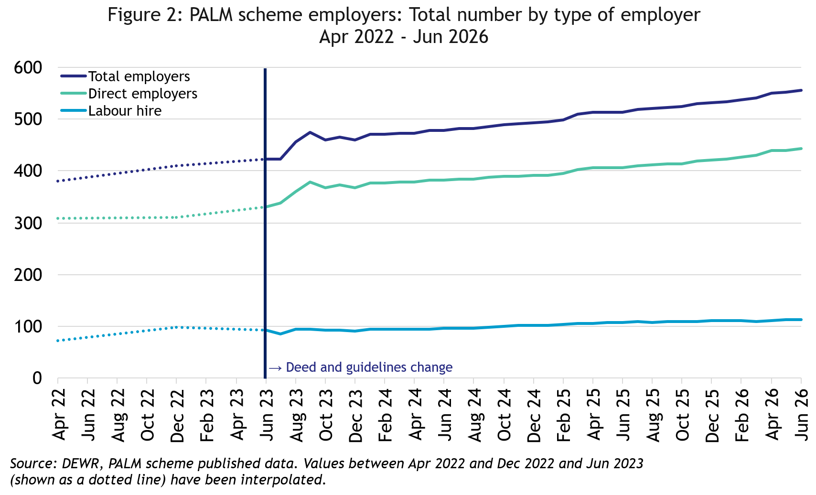
In June 2026, there were:
- 559 employers.
- 446 were direct employers
- 113 were labour hire employers.

Data and chart notes:
All published PALM scheme worker data including any totals and subtotals are rounded to the nearest 5. For more information see the Glossary.
Worker counts are only available for April 2022, December 2022 and from June 2023 onwards. In the charts in this report, the unknown values between April 2022 and December 2022, and December 2022 and June 2023 have been inferred and are represented by the dotted lines. This produces artificially smooth lines that are not representative of the usual fluctuations expected in the monthly data.

Appendix A: Detailed PALM scheme worker trends

PALM scheme worker trends by industry
Since June 2023, the PALM scheme has diversified, with employers from a broad range of industries entering the scheme, offering Pacific Island and Timor-Leste workers more choice.
- Agriculture remains the leading PALM sector representing 56% of the total PALM workforce. There has been a small shift from short-term to long-term agriculture placements, with long-term placements increasing from 14% at June 2023 to 18% in June 2026.
- Meat processing has increased its share of the PALM workforce, from 30% in June 2023 to 35% in June 2026.
- The number of workers in Health and social assistance, all long-term, increased from 715 workers (representing 2% of the PALM workforce) in June 2023, to 1,145 workers (4% of the workforce) by June 2026.

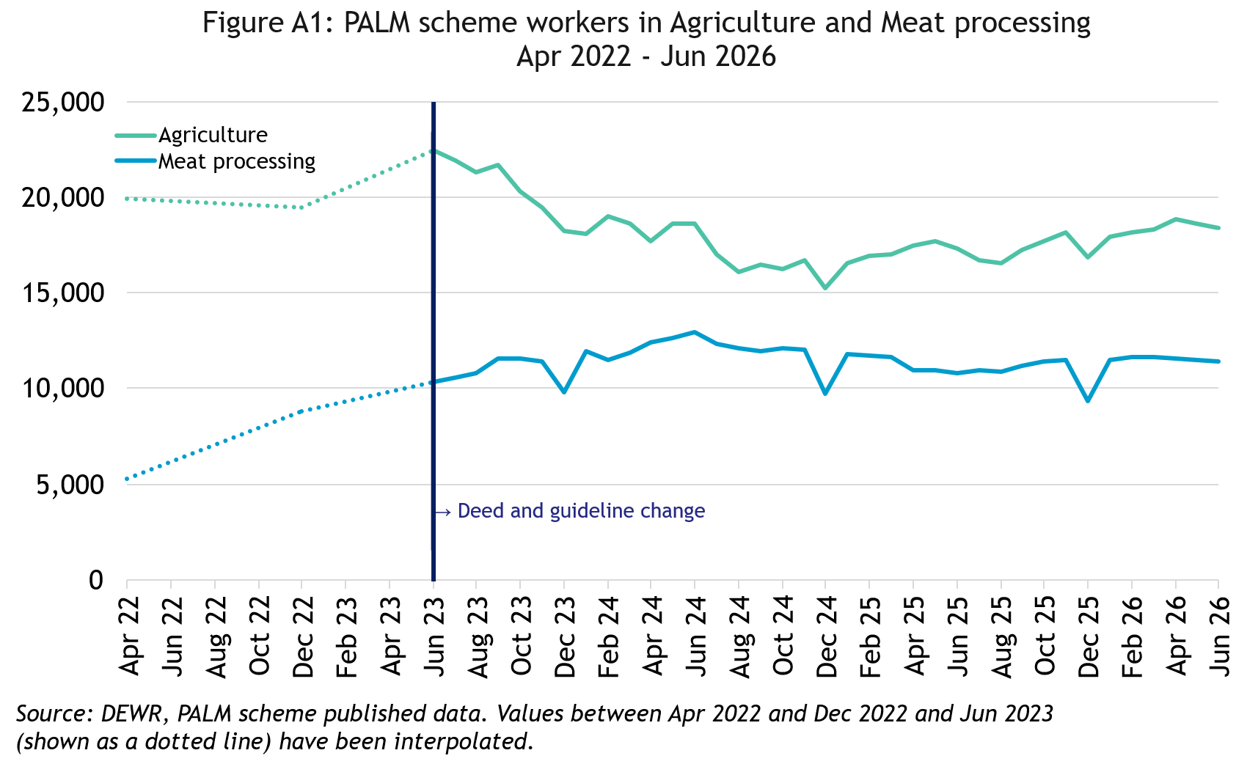
In June 2026, there were:
- 18,410 workers in Agriculture
- down by 7% since April 2022
- up by 6% in the 12 months to June 2026
- 82% were short-term
- 18% were long-term

- 11,400 workers in Meat processing
- more than doubled since April 2022
- up by 5% in the 12 months to June 2026
- 4% were short-term
- 96% were long-term

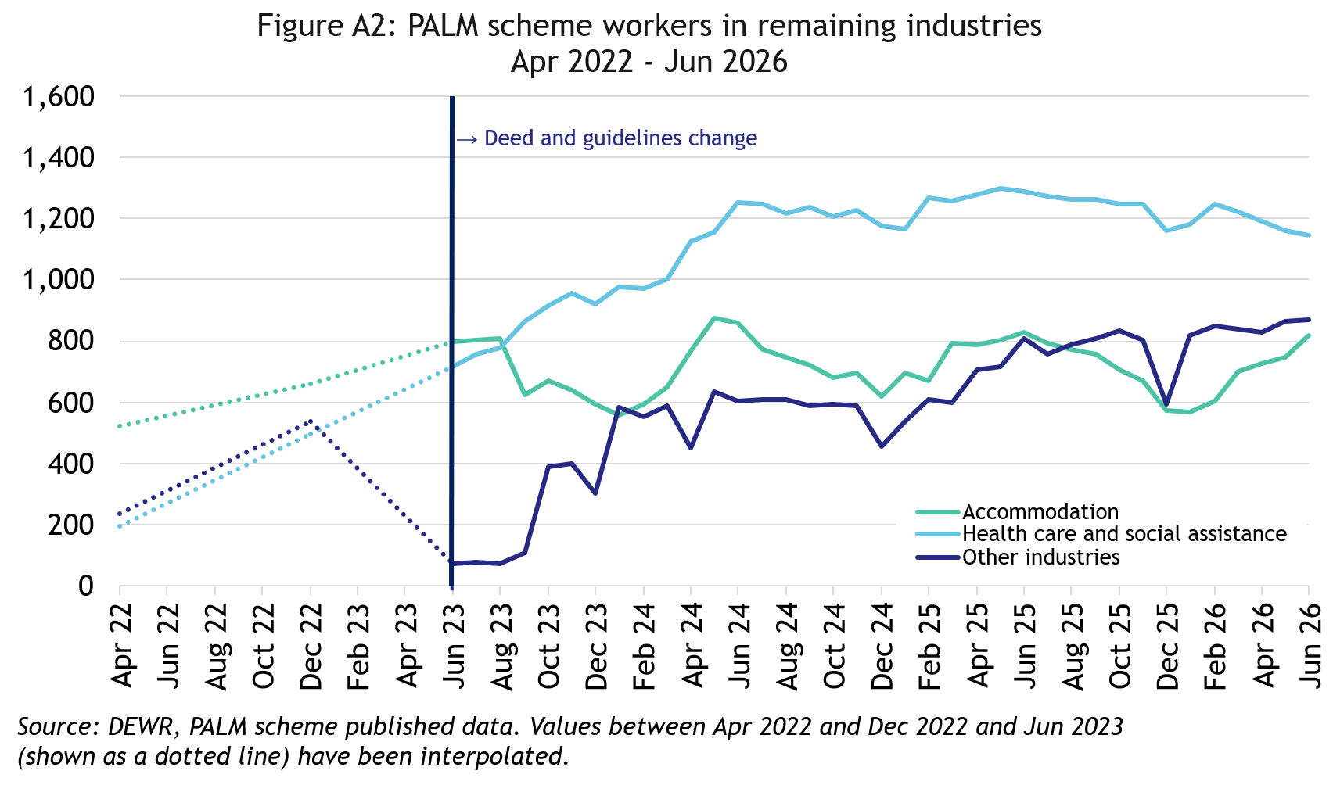

In June 2026, there were:
- 1,145 workers in Health care and Social Assistance
- up 950 workers since April 2022
- down by 11% in the 12 months to June 2026
- all were long-term

- 870 workers in other industries
- more than tripled since April 2022
- up by 7% in the 12 months to June 2026
- 21% were short-term
- 79% were long-term
- 820 workers in Accommodation
- up by 58% since April 2022
- down by 1% in the 12 months to June 2026
- 29% were short-term
- 71% were long-term

PALM scheme worker trends by country of origin

Fiji

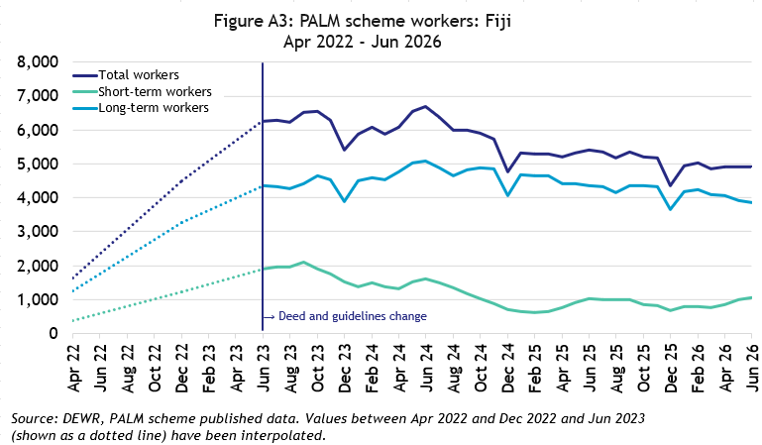
In June 2026, there were 4,910 workers from Fiji:
- tripled since April 2022
- down by 9% in the 12 months to June 2026
- 79% of Fijian PALM scheme workers were in the long-term stream

Kiribati

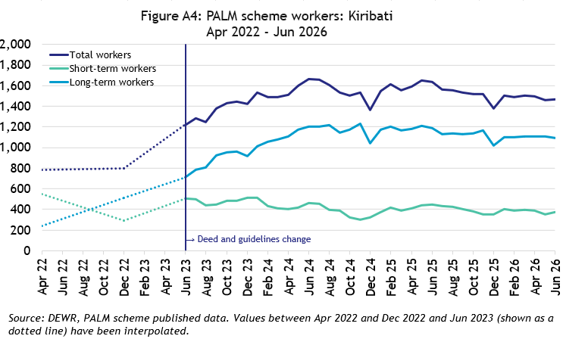
In June 2026, there were 1,470 workers from Kiribati:
- up by 87% since April 2022
- down by 10% over the 12 months to June 2026
- 74% of Kiribati PALM scheme workers were in the long-term stream

Naoero
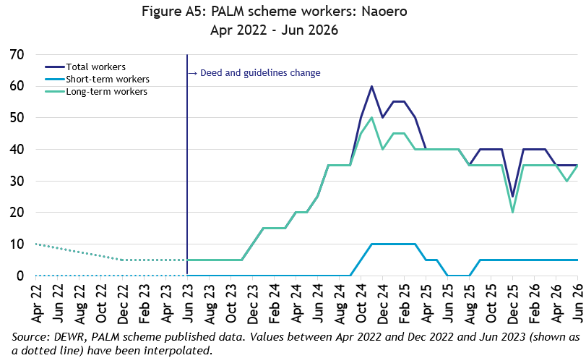
In June 2026, there were 35 workers from Naoero:
- up 25 workers since April 2022
- down by 5 workers in the 12 months to June 2026
- Most of the dei-Naoero PALM scheme workers were in the long-term stream

Papua New Guinea

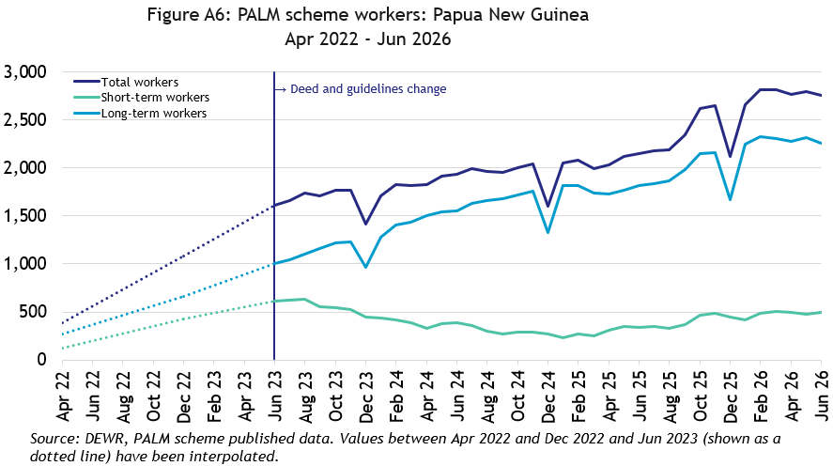
In June 2026, there were 2,755 workers from Papua New Guinea:
- up significantly (2,370 workers) since April 2022
- up by 28% in the 12 months to June 2026
- 82% of Papua New Guinean PALM scheme workers were in the long-term stream

Samoa
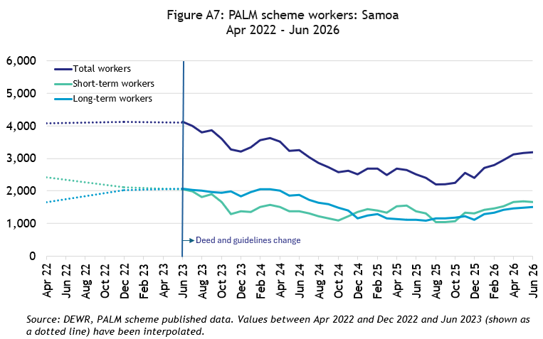
In June 2026, there were 3,180 workers from Samoa:
- down by 22% since April 2022
- up by 27% in the 12 months to June 2026
- 53% of Samoan PALM scheme workers were in the short-term stream

Solomon Islands

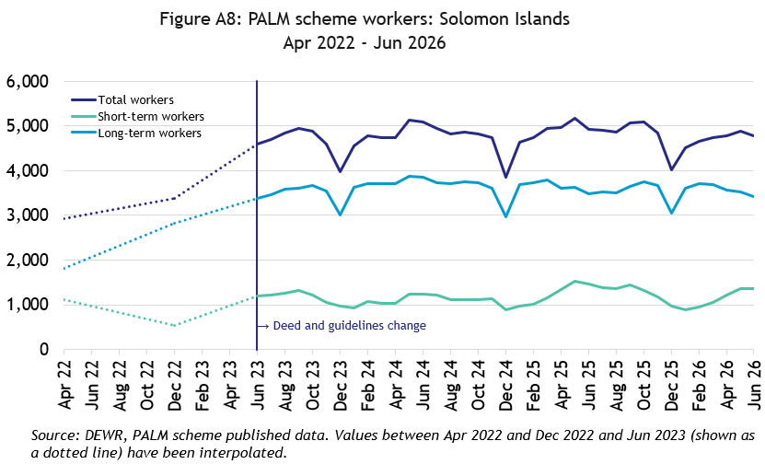
In June 2026, there were 4,785 workers from the Solomon Islands:
- up by 64% since April 2022
- down by 3% in the 12 months to June 2026
- 72% of Solomon Islander PALM scheme workers were in the long-term stream

Timor-Leste

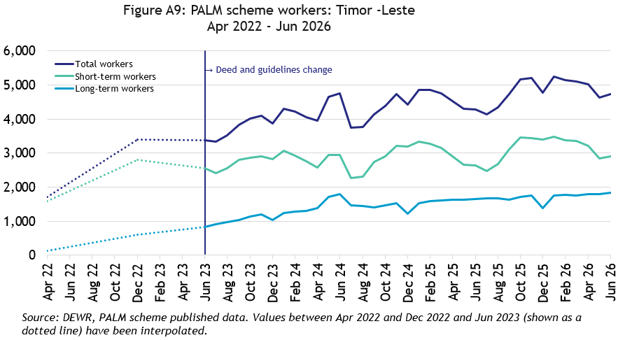
In June 2026, there were 4,745 workers from Timor-Leste:
- more than double since April 2022
- up by 11% in the 12 months to June 2026
- 61% of Timorese PALM scheme workers were in the short-term stream

Tonga

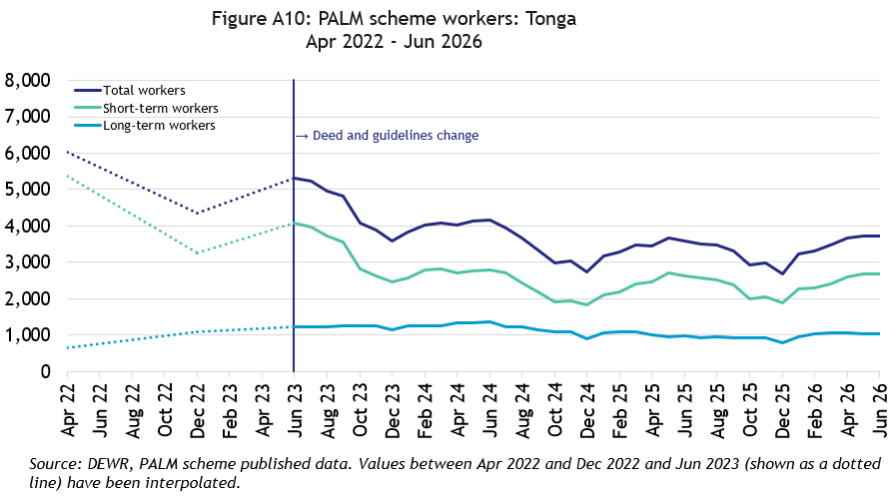
In June 2026, there were 3,715 workers from Tonga:
- down by 38% since April 2022
- up by 3% in the 12 months to June 2026
- 72% of Tongan PALM scheme workers were in the short-term stream

Tuvalu

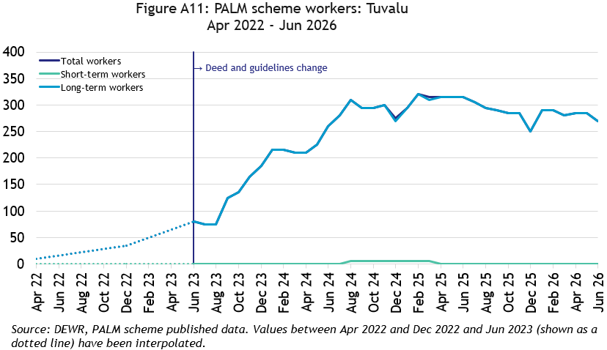
In June 2026, there were 270 workers from Tuvalu:
- a significant increase (260 workers) since April 2022, noting the historically very low number of workers
- down by 14% in the 12 months to June 2026
- All Tuvaluan PALM scheme workers were in the long-term stream

Vanuatu

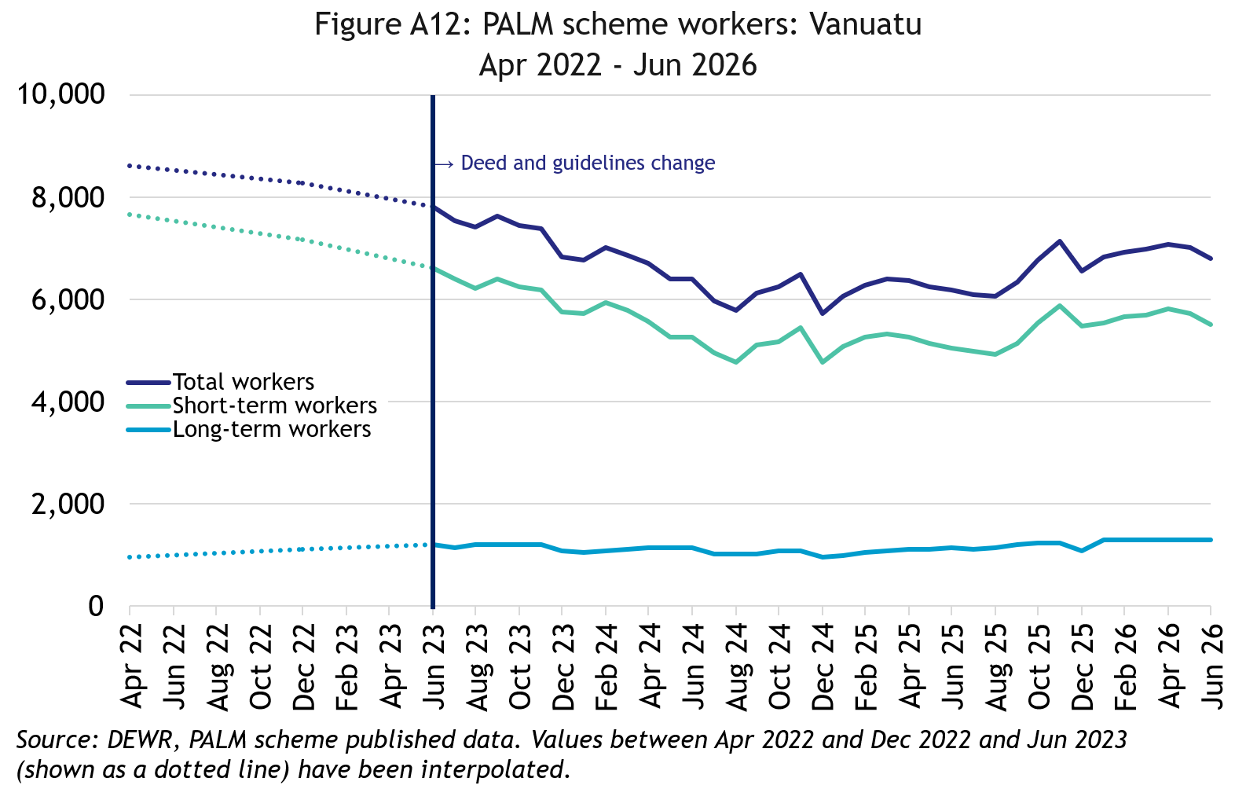
In June 2026, there were 6,780 workers from Vanuatu:
- down by 21% since April 2022
- up by 10% in the 12 months to June 2026
- 81% of ni-Vanuatu PALM scheme workers were in the short-term stream

PALM scheme worker trends by state/territory

New South Wales

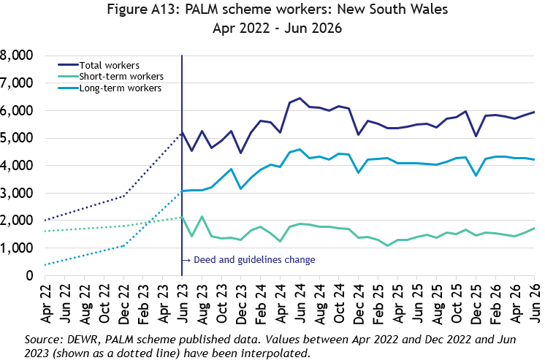
In June 2026, there were 5,950 workers in New South Wales:
- nearly tripled since April 2022
- up by 9% in the 12 months to June 2026
- 71% of New South Wales PALM scheme workers were in the long-term stream

Victoria

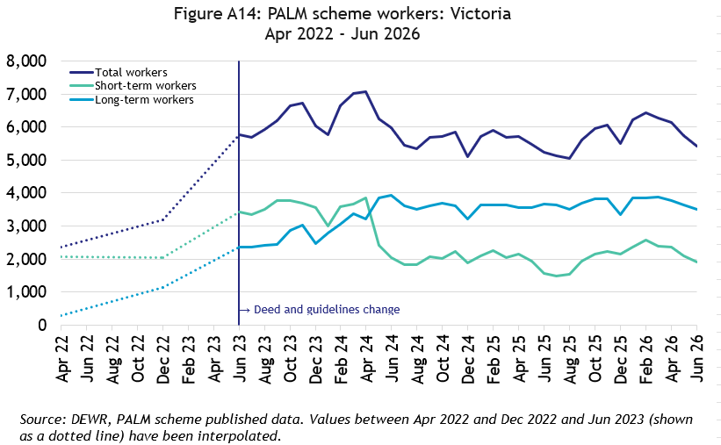
In June 2026, there were 5,410 workers in Victoria:
- more than double since April 2022
- up by 3% in the 12 months to June 2026
- 65% of Victorian PALM scheme workers were in the long-term stream

Queensland

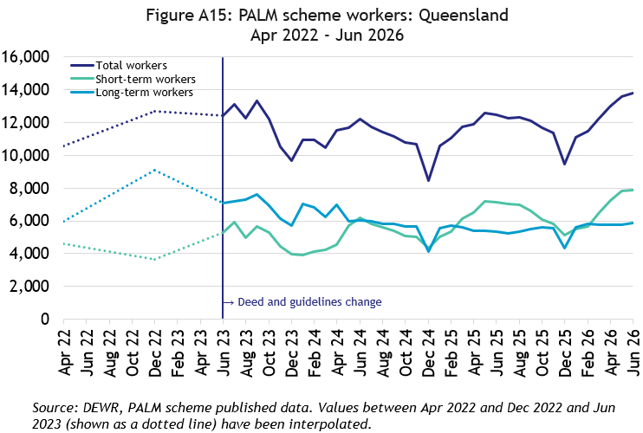
In June 2026, there were 13,785 workers in Queensland:
- up by 30% since April 2022
- up by 10% in the 12 months to June 2026
- 57% of Queensland PALM scheme workers were in the short-term

South Australia

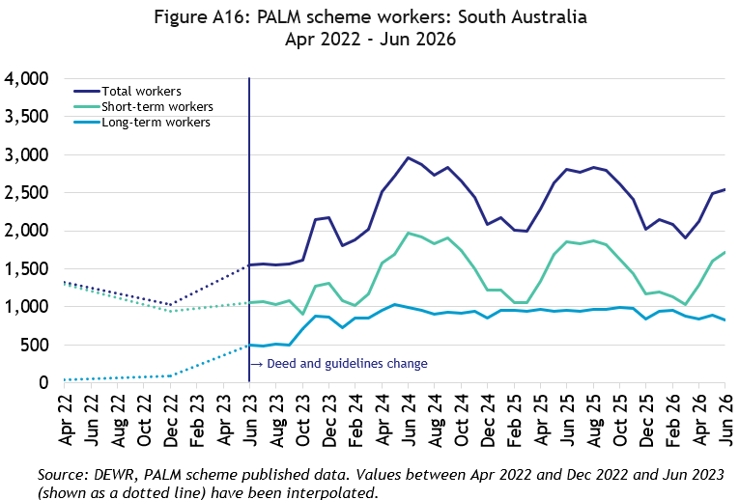
In June 2026, there were 2,540 workers in South Australia:
- nearly double since April 2022
- down by 9% in the 12 months to June 2026
- 68% of South Australian PALM scheme workers were in the short-term stream

Western Australia

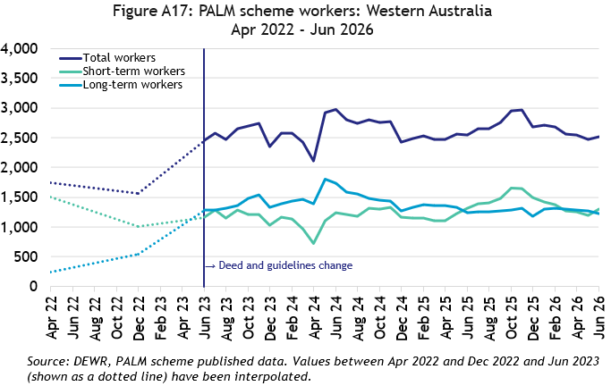
In June 2026, there were 2,515 workers in Western Australia:
- up by 44% since April 2022
- down by 1% in the 12 months to June 2026
- 51% of Western Australian PALM scheme workers were in the short-term stream

Tasmania

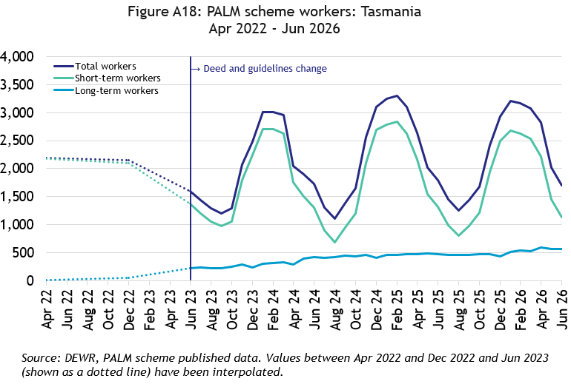
In June 2026, there were 1,700 workers in Tasmania:
- down by 22% since April 2022
- down by 6% in the 12 months to June 2026
- 67% of Tasmanian PALM scheme workers were in the short-term stream

Northern Territory

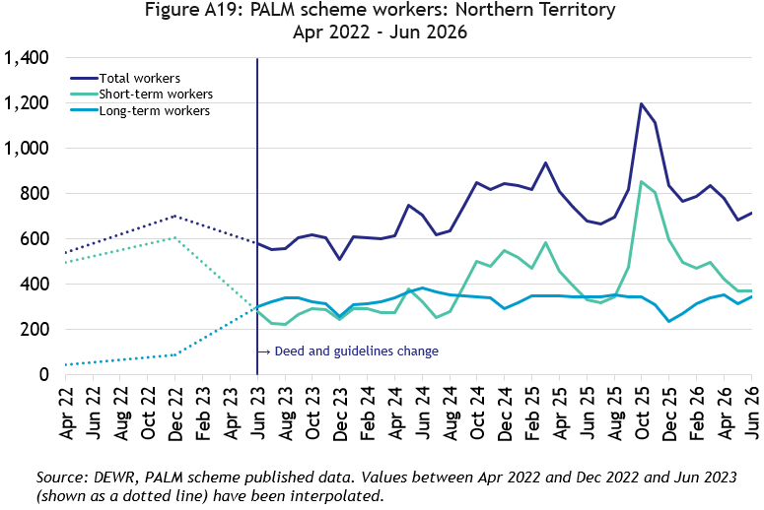
In June 2026, there were 715 workers in the Northern Territory:
- up by 32% since April 2022
- up by 5% in the 12 months to June 2026
- 52% of Northern Territory PALM scheme workers were in the short-term stream

Australian Capital Territory

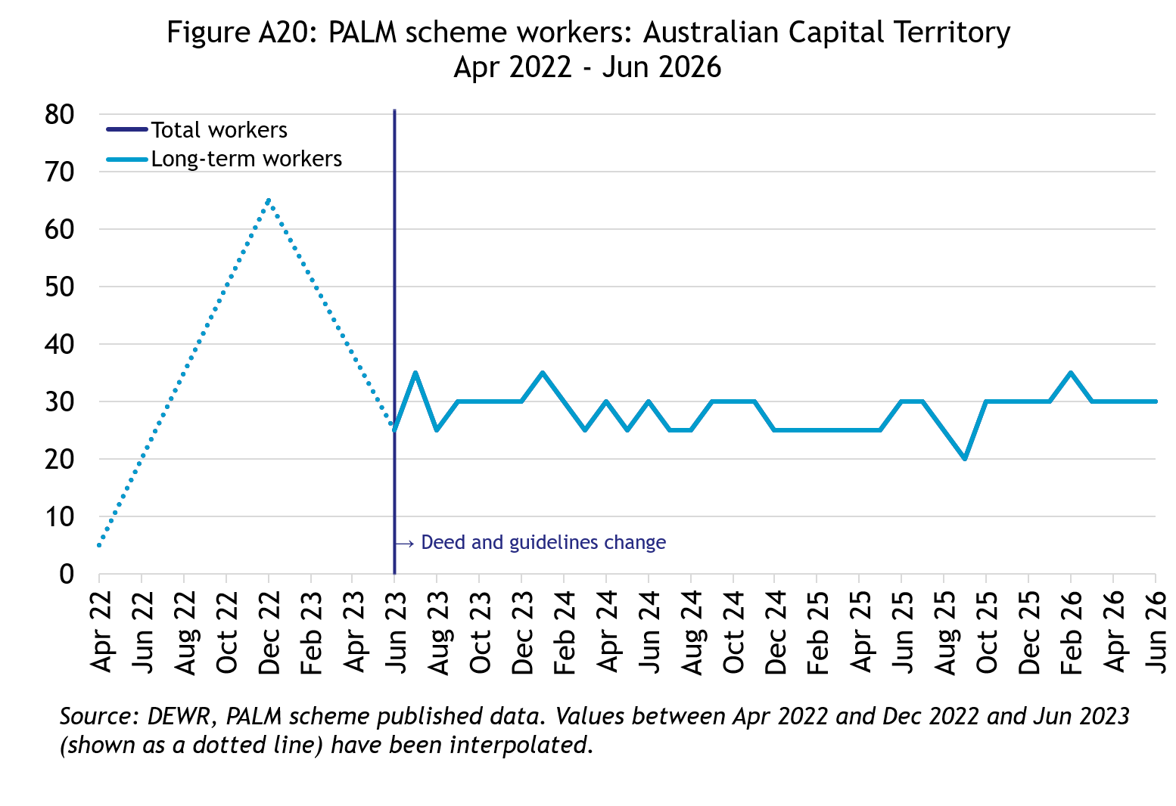
In June 2026, there were 30 workers in the Australian Capital Territory:
- broadly steady since mid-2023
- all PALM scheme workers in the Australian Capital Territory were in the long-term stream

Explanatory notes

Introduction
The PALM scheme allows Australian businesses to hire workers from 9 Pacific Island countries and Timor-Leste when there are not enough local workers available. Businesses who meet the eligibility criteria can access workers in the short-term stream (up to 9 months) and/or in the long-term stream (between one and 4 years).
PALM scheme employers in the agriculture sector and select agriculture-related food product manufacturing sectors can be based anywhere in Australia. All other sectors must be based in a regional or rural location.
For more information, refer to the PALM scheme website: www.palmscheme.gov.au.

Data sources
PALM scheme worker data is a combination of data from the Department of Employment and Workplace Relations (DEWR) IT systems and visa data sourced from the Department of Home Affairs. DEWR administrative data is stored in a live system and reliant on information entered by labour sending units located in each of the partner countries and PALM scheme employers.

Data confidentiality
To protect individuals' privacy, all cells including totals have been rounded to the nearest 5; values from 1 to 7 are rounded to 5. Zero cells are actual zeros. This may result in some totals not adding up. Caution should be taken when recalculating totals from rounded data as this may compound the effects of rounding.

Glossary
PALM scheme worker:
Citizen of a PALM scheme participating country who is issued an approved offer of employment in accordance with the PALM scheme deed and who is granted a PALM stream - temporary work (international relations) visa (subclass 403); or who held a pandemic event (subclass 408) visa
(up to December 2024).

PALM scheme worker data is derived by combining data from DEWR's IT systems and visa data sourced from the Department of Home Affairs. DEWR data is matched against visa data for comprehensive validation and used to construct valid and accurate counts for PALM scheme workers who are identified in visa data as onshore. Offshore visa holders are excluded from the counts.
Sex of PALM scheme worker:
The sex of PALM scheme workers is categorised into: Female, Male, and ‘not stated or inadequately described’. Note that ‘not stated or inadequately described’ includes cases where sex is not missing or not captured in the data; where sex could not be accurately matched between data sources; or those who choose not to disclose their sex. Due to data collection limitations, it is not possible to distinguish between these subgroups.
PALM scheme worker data disaggregated by sex has been derived by matching PALM scheme worker data from internal DEWR systems and visa data from Home Affairs. PALM scheme data reports sex based on the data available at the time of data processing.
Reporting of PALM scheme worker data by sex aligns with ABS and DEWR standards for the reporting of sex and gender data.
PALM scheme employer:
An entity contracted by DEWR under the PALM scheme deed. Employers can be direct employers (arranges the placement of PALM scheme workers it employs with its own business) or labour hire organisations arranging the placement of PALM scheme workers it employs with host organisations using a labour hire arrangement.
New PALM scheme employer:
PALM scheme employer who joined after 1 July 2023 who had no history in earlier PALM schemes.

Country of origin:
PALM scheme participating country that a PALM scheme worker is from. PALM scheme participating countries are Fiji, Kiribati, Naoero, Papua New Guinea, Samoa, Solomon Islands, Timor-Leste, Tonga, Tuvalu and Vanuatu.

‘Unknown’ country of origin is where country of origin cannot be determined for a PALM scheme worker due to incomplete data.

Stream:
Length of placement of employed PALM scheme workers. This is either 'short-term' or 'long-term':
- Short-term: a placement with short-term PALM scheme workers who hold the relevant visa and are employed in a contract of work for up to 9 months.
- Long-term: a placement with long-term PALM scheme workers who hold the relevant visa and are employed in a contract of work for up to 4 years (non-seasonal).
Industry:
Where possible, industries are classified to the Australian Bureau of Statistics Australian and New Zealand Standard Industrial Classification (ANZSIC). An individual business entity is assigned to an industry based on its predominant activity.

Due to gaps in data sources, a best-fit approach has been used to identify industry. ‘Role descriptions’ (which are job or occupation descriptions) may be used to help identify an accurate industry fit. PALM scheme data is reported to 5 key industry groups: Agriculture, Meat Processing, Accommodation, Health Care and Social Assistance, and other industries.

- Agriculture:
Reflects workers in ANZSIC Division A: Agriculture, Forestry and Fishing.
- Meat Processing:
Includes Meat and Meat Product Manufacturing (a subset of the ANZSIC Division C: Manufacturing)
- Accommodation:
ANZSIC Division H: Accommodation and Food Services.
- Health care and social assistance:
ANZSIC Division Q: Health Care and Social Assistance. Includes aged, disability and other health care services, including residential care.
- Other Industries:
Includes all remaining industries, that are not otherwise classified to the industries above (Agriculture, Meat processing, Accommodation, and Health care and social assistance).

Note that a small number of workers in Manufacturing in non-meat processing (such as Grain and cereal manufacturing, or Textile or clothing manufacturing) are included in Other industries. Any workers in Retail are included in Other industries. Due to missing or incomplete data, a small number of workers that cannot be accurately assigned to an industry are also included in Other industries.

Citation
Any publications or reports using the data reported by DEWR must cite DEWR as the source. Where this data has been used for further analysis and interpretation, DEWR requests the inclusion of the following statement in the published report:
“The views expressed in this report are those of the authors and do not necessarily represent those of DEWR."

Contact
For any inquiries, please contact:
- for general PALM scheme enquiries: (PALM@dewr.gov.au)
- for PALM scheme data enquiries: (pacificlabourdata@dewr.gov.au).

