Temporary process for transport cost changes

8 May 2026
The Department of Employment and Workplace Relations (department) has developed a process for managing temporary changes to transport costs under PALM scheme transport plans due to possible fuel supply disruptions.
This is a temporary, operational measure developed to help employers understand their responsibilities and does not change PALM scheme employer obligations or worker protections.
As part of this temporary process, PALM scheme employers are not required to submit a formal change request to seek approval for temporary transport cost changes. Instead, an enquiry can be lodged through the PALM scheme Approved Employer Portal (AE Portal).
This supports timely decision making in response to possible fuel supply disruptions and provides a practical short-term pathway for both employers and the department to manage approvals.
When creating and submitting an enquiry, please note that:
- Workers must continue to receive a net financial benefit.
- Any change to transport cost deductions must be agreed with workers.
- This guidance applies only to transport cost changes resulting from the fuel supply disruption. All other requirements relating to approved transport plans remain unchanged.
- The process applies to both transport cost increases and decreases. Employers must pass on any cost decreases to workers as soon as they occur, in the same way increases are managed. All changes must be submitted to the department for approval.

How to create and submit an enquiry
Instructions | Screenshot
- Log into the PALM scheme AE Portal using your login details. | 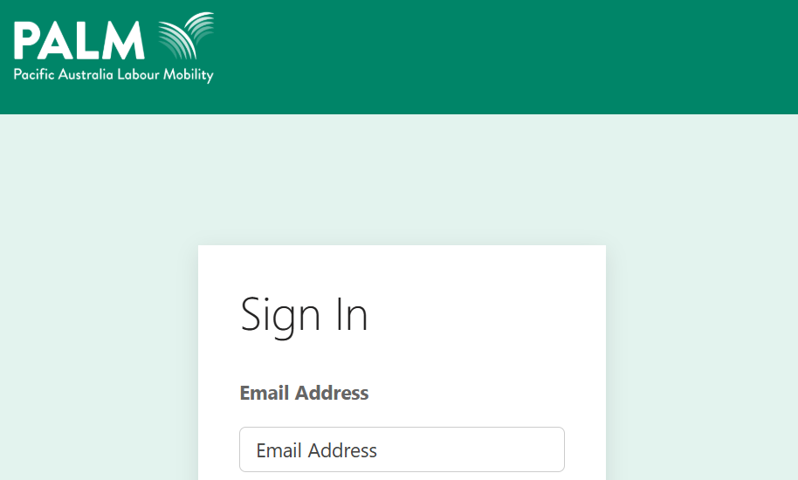
- Click on ‘Support Service’ drop-down button.  - When available, click on ‘Create Enquiry’ | 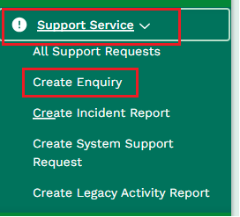
- Populate ‘Subject’ box and enter the required information where it says: ‘Change to transport costs on RPXXXX due to fuel situation’ | 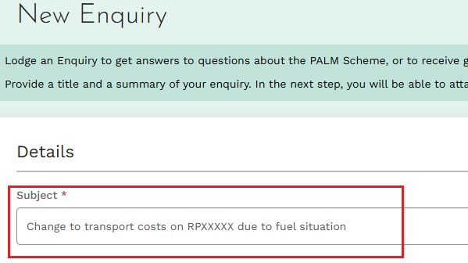
- Click on the ‘Select a recruitment plan’ the affected.  - The AE Portal allows only one recruitment plan (RP) to be selected. | 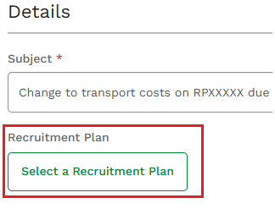
- Please note: If multiple RPs are affected, reference all relevant RPs in the subject line or enquiry details. This applies only where the transport cost change is the same for all affected RPs. Where transport costs differ, separate enquiries must be submitted.
- In the summary section, provide details and justification of the cost increase.
Please include:
Previous and new cost breakdown
- Clearly show the original amount and the revised amount, including the value of the increase passed on to workers.
Justification for the change
- Provide a clear justification for any change in fuel or transport costs, including:
  - why the change was necessary?
  - how the revised amount was calculated?
Worker agreement statement
- Include a statement confirming that genuine agreement will be obtained from all affected workers before implementing the change in transport deductions.
- This should include confirmation that workers have signed, or will sign, a revised agreement, and that the reason for the change has been clearly explained to them.
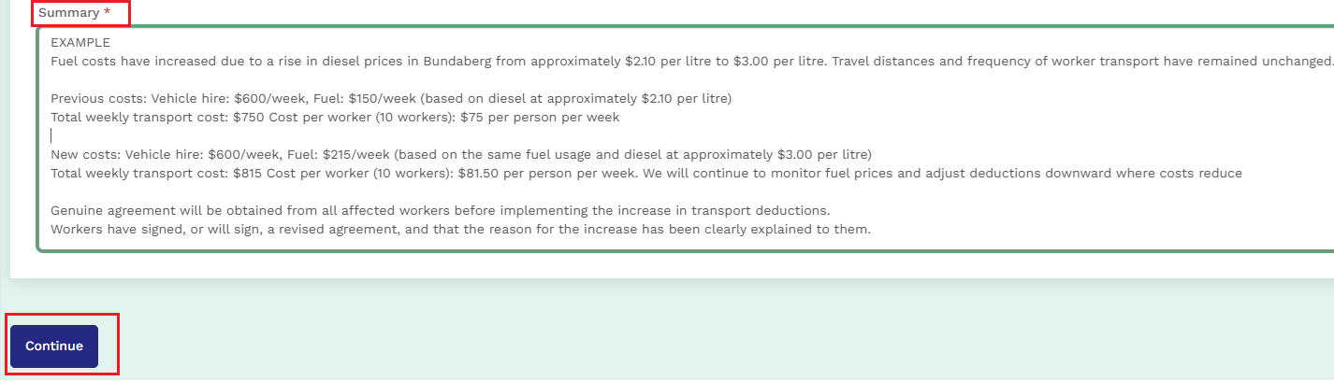
- Optional: Attach relevant supporting documentation (such as fuel invoices demonstrating costs). |  | 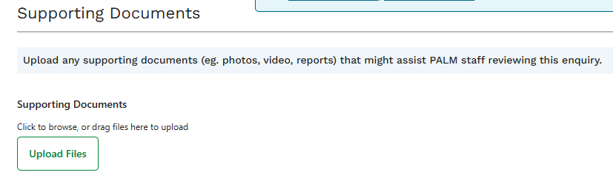
- Add details of relevant Host/Work site |  | 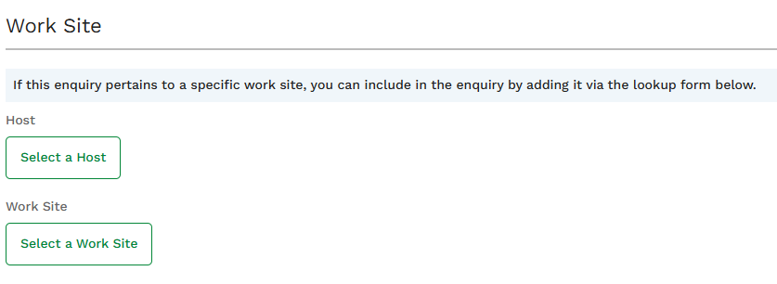
- Once completed, please click the ‘Submit Enquiry’ button. |  | 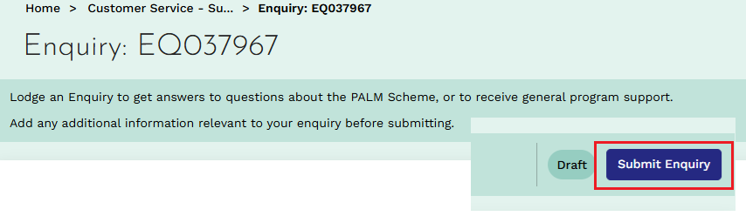
You have now submitted your enquiry.

If you have any questions, please reach out to your relationship manager, or call the PALM scheme support service via phone on 1800 51 51 31 or via email (palm@dewr.gov.au)

