Pacific Australia Labour Mobility scheme quarterly update

Data current up to 31 March 2026

Published: 22 May 2026
Data about workers and employers participating in the Pacific Australia Labour Mobility (PALM) scheme is published monthly on the PALM website www.palmscheme.gov.au/palm-scheme-data. This quarterly report presents longer-term trends and analysis for key metrics.
PALM scheme worker counts are a measure of the number of workers from participating PALM scheme countries holding a valid visa who are currently onshore in Australia. Worker participation will vary from month to month reflecting a range of factors, including:
- the cyclical nature of the program and worker visa conditions (9 months for the short-term stream and up to 4 years for the long-term stream)
- changing workforce demand e.g. stemming from growing cycles for different crops in different regions, and
- workers returning home for holidays or other personal commitments.

PALM scheme employer counts record the number of employers holding a current PALM scheme deed.

PALM scheme worker trends – March quarter 2026
Over the 12 months to March 2026:
- The worker count has remained stable. Short-term worker counts increased by 7% over the year while long-term worker counts increased by 2% over the year.
- Worker counts by industry:
  - Agriculture increased by 8% (1,285 workers) since March 2025.
  - Meat processing increased slightly but was largely stable over the last 12 months.
  - Other PALM industries, (which account for about 8% of the total PALM workforce), recorded mixed movements over the year: Accommodation declined by 11%; Health care and social assistance declined by 3%; and Other industries increased by 40%.
- By country, between March 2025 and March 2026, worker counts:
  - increased for: Papua New Guinea, Samoa, Timor-Leste and Vanuatu
  - decreased for: Fiji, Kiribati, Nauru, Solomon Islands and Tuvalu
  - remained stable for Tonga.

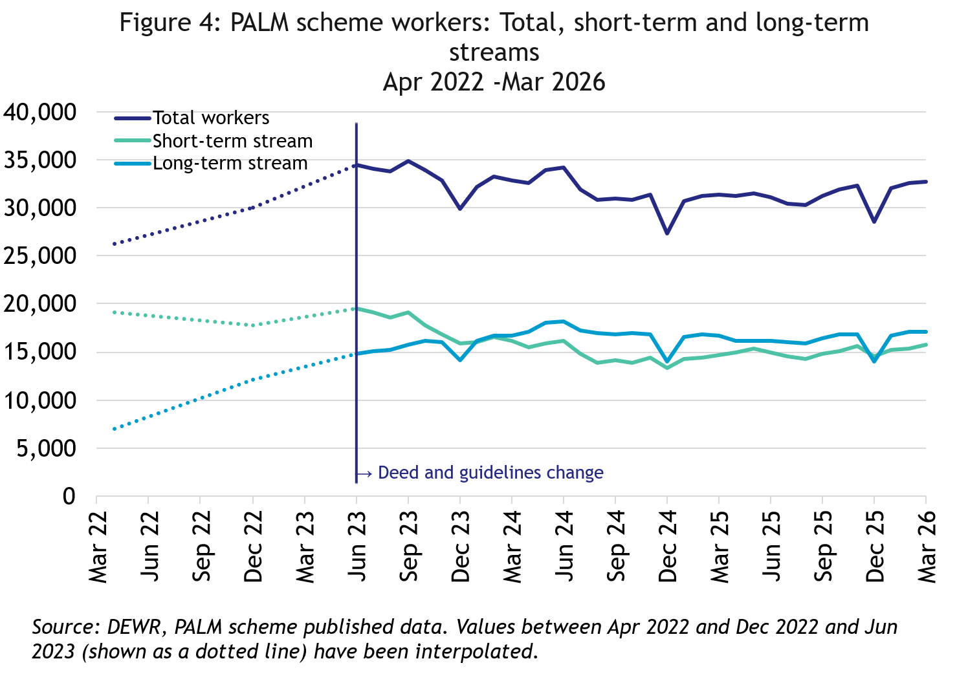
In March 2026, there were:
- 32,725 workers
- 15,705 in the short-term stream
- 17,020 in the long-term stream
In the 12 months to March 2026, the total number of workers was up by 5% or 1,415 workers.
- The long-term stream was up by 2%
- The short-term stream was up by 7%.

PALM scheme employer trends
The number of PALM scheme employers has continued to grow since the new PALM scheme deed and guidelines were introduced in June 2023.
- 168 new employers have joined the scheme since June 2023, bringing the total number of employers to 541 in March 2026.

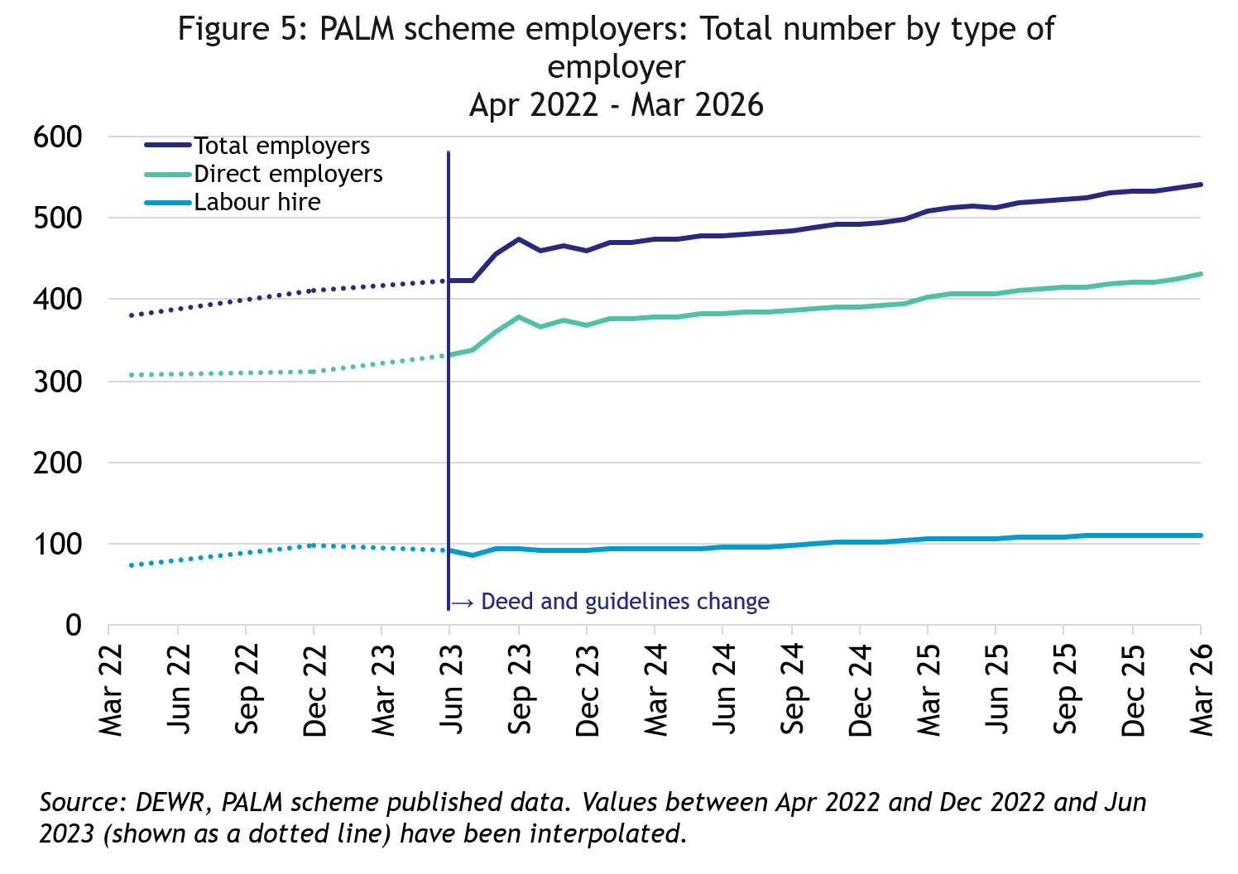
In March 2026, there were:
- 541 employers.
- 431 were direct employers
- 110 were labour hire employers.

Data and chart notes:
All published PALM scheme worker data including any totals and subtotals are rounded to the nearest 5. For more information see the Glossary.
Worker counts are only available for April 2022, December 2022 and from June 2023 onwards. In the charts in this report, the unknown values between April 2022 and December 2022, and December 2022 and June 2023 have been inferred and are represented by the dotted lines. This produces artificially smooth lines that are not representative of the usual fluctuations expected in the monthly data.

Appendix A: Detailed PALM scheme worker trends

PALM scheme worker trends by industry
The PALM scheme has become increasingly diversified, with employers from a broad range of industries entering the scheme, offering Pacific Island and Timor-Leste workers more choice.

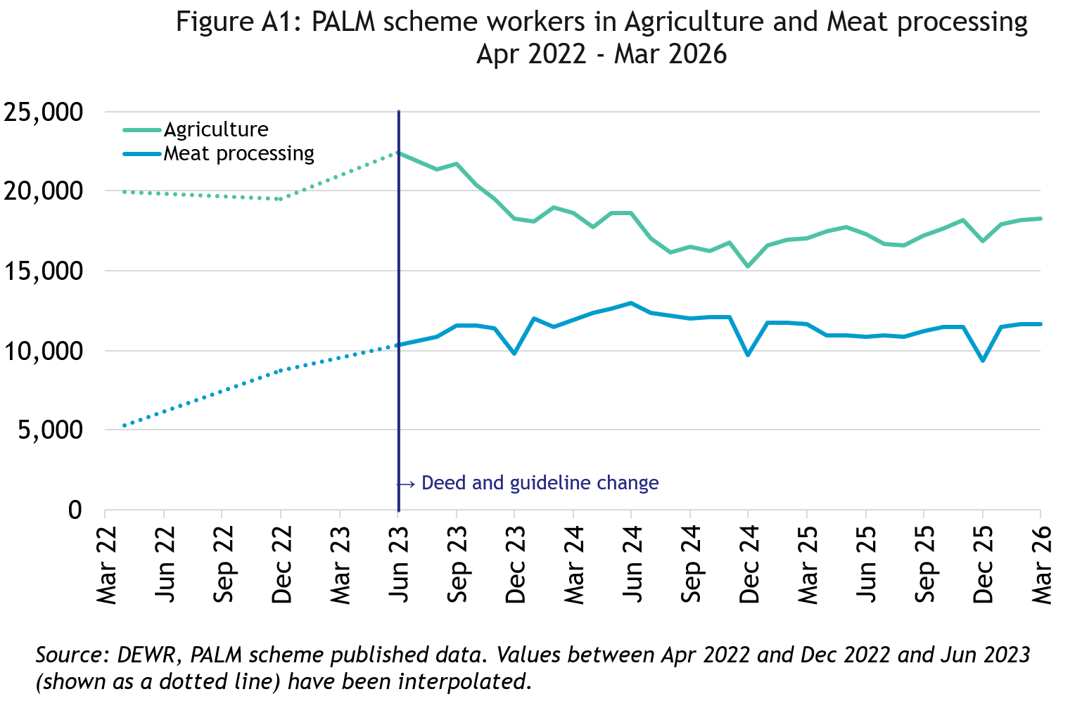
In March 2026, there were:
- 18,295 workers in Agriculture
- down by 8% since April 2022
- up by 8% in the 12 months to March 2026
- 82% were short-term
- 18% were long-term

- 11,675 workers in Meat processing
- More than doubled since April 2022
- remained stable in the 12 months to March 2026
- 3% were short-term
- 97% were long-term

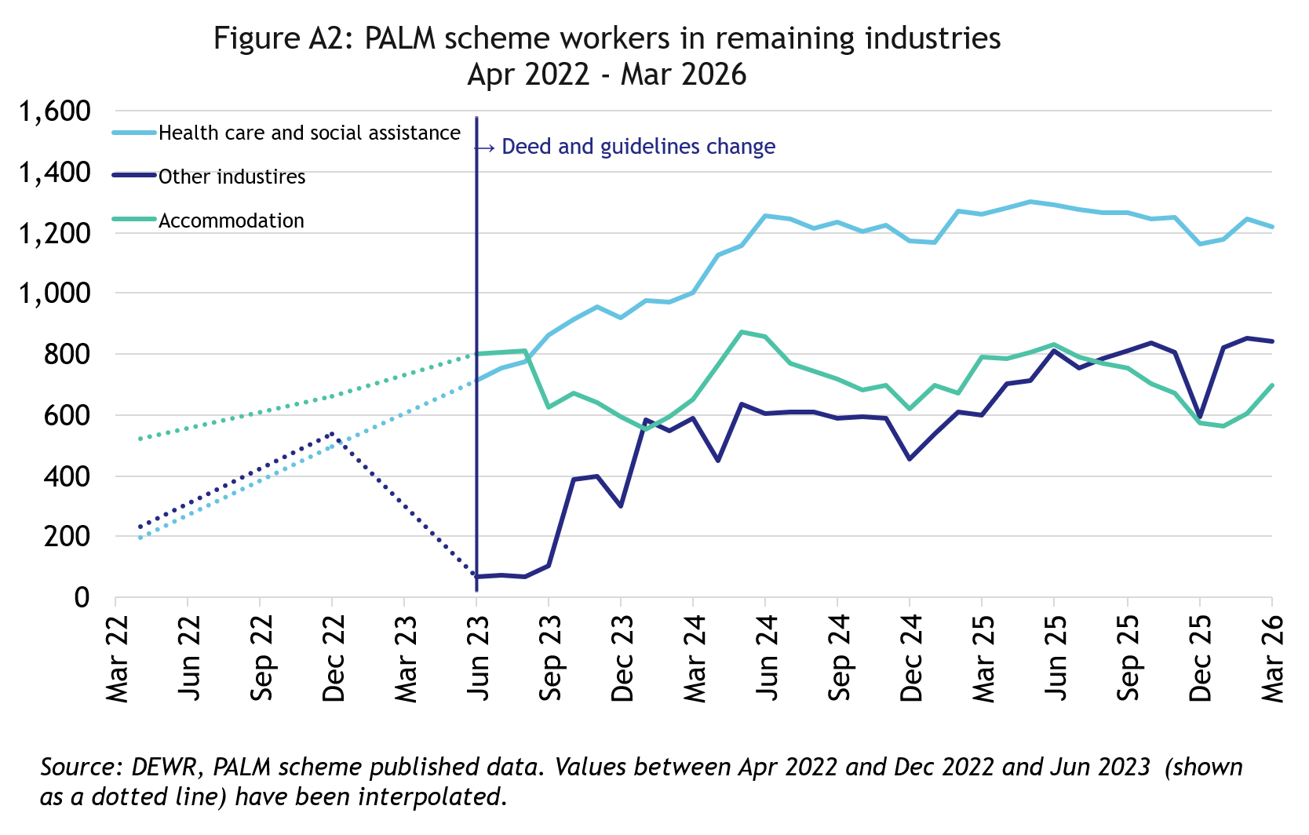

In March 2026, there were:
- 1,220 workers in Health care and Social Assistance
- up significantly since April 2022
- down by 3% in the 12 months to March 2026
- all were long-term

- 840 workers in Other industries
- more than tripled since April 2022
- up by 40% in the 12 months to March 2026
- 19% were short-term
- 81% were long-term
- 700 workers in Accommodation
- up by 35% since April 2022
- down by 11% in the 12 months to March 2026
- 22% were short-term
- 78% were long-term

PALM scheme worker trends by country of origin

Fiji

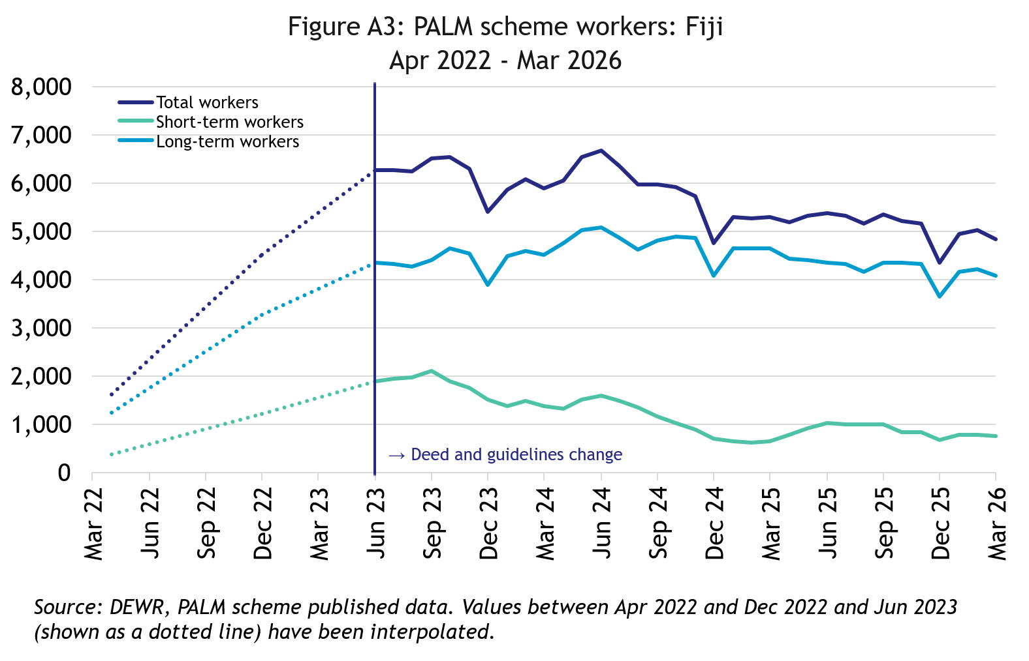
In March 2026, there were 4,855 workers from Fiji:
- more than doubled since April 2022
- down by 8% in the 12 months to March 2026
- 84% of Fijian PALM scheme workers were in the long-term stream

Kiribati

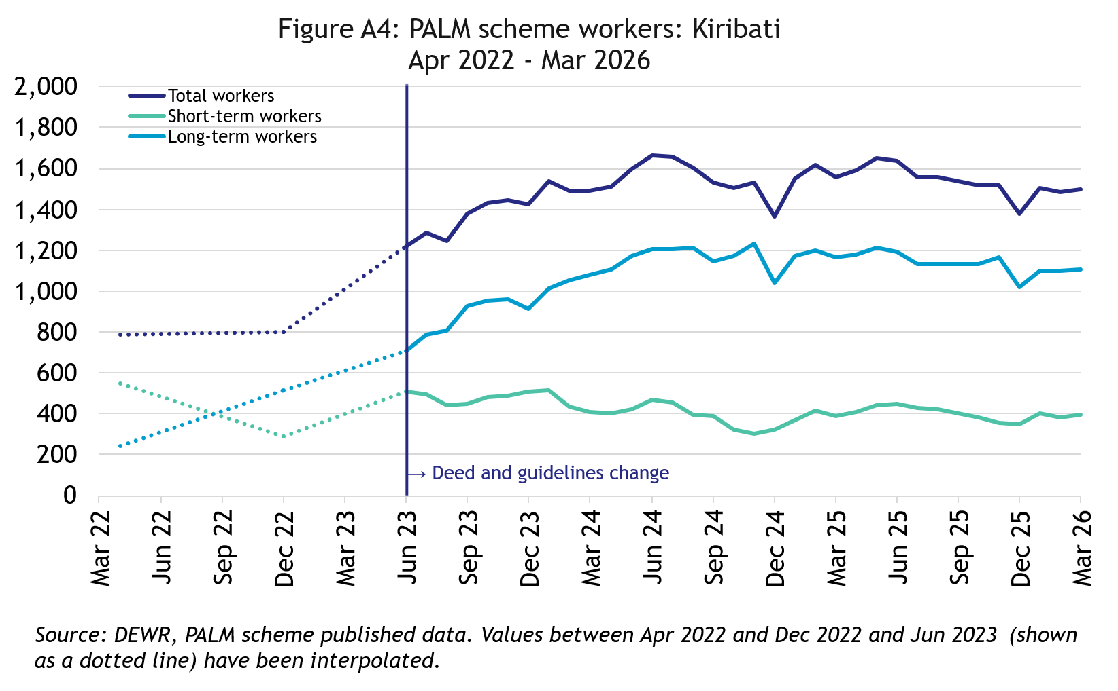
In March 2026, there were 1,500 workers from Kiribati:
- nearly doubled since April 2022
- down by 4% over the 12 months to March 2026
- 74% of I-Kiribati PALM scheme workers were in the long-term stream

Nauru

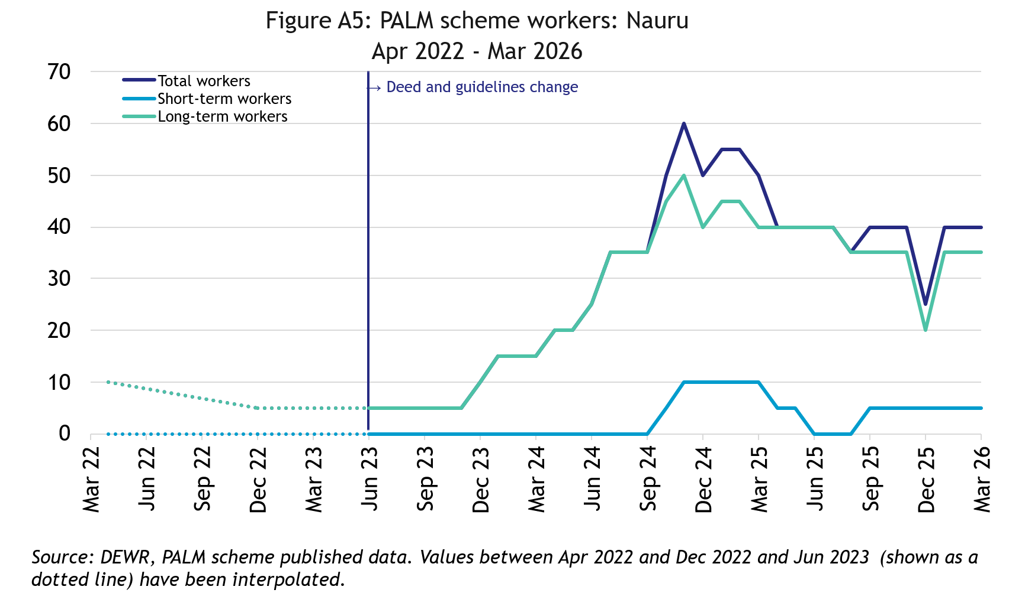
In March 2026, there were 40 workers from Nauru:
- up significantly since April 2022
- down by 10 workers in the 12 months to March 2026
- 88% of the Nauruan PALM scheme workers were in the long-term stream

Papua New Guinea

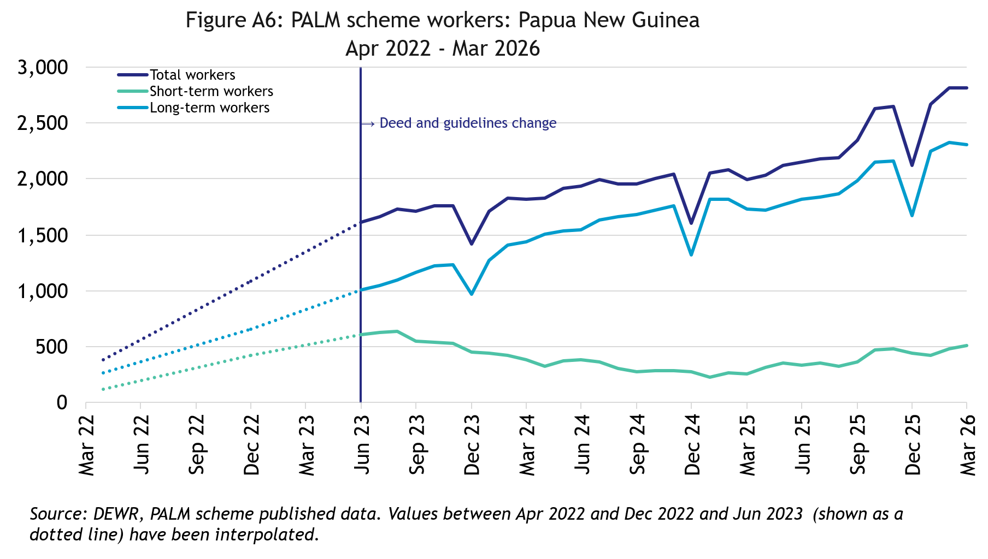
In March 2026, there were 2,815 workers from Papua New Guinea:
- up significantly since April 2022
- up by 41% in the 12 months to March 2026
- 82% of Papua New Guinean PALM scheme workers were in the long-term stream

Samoa

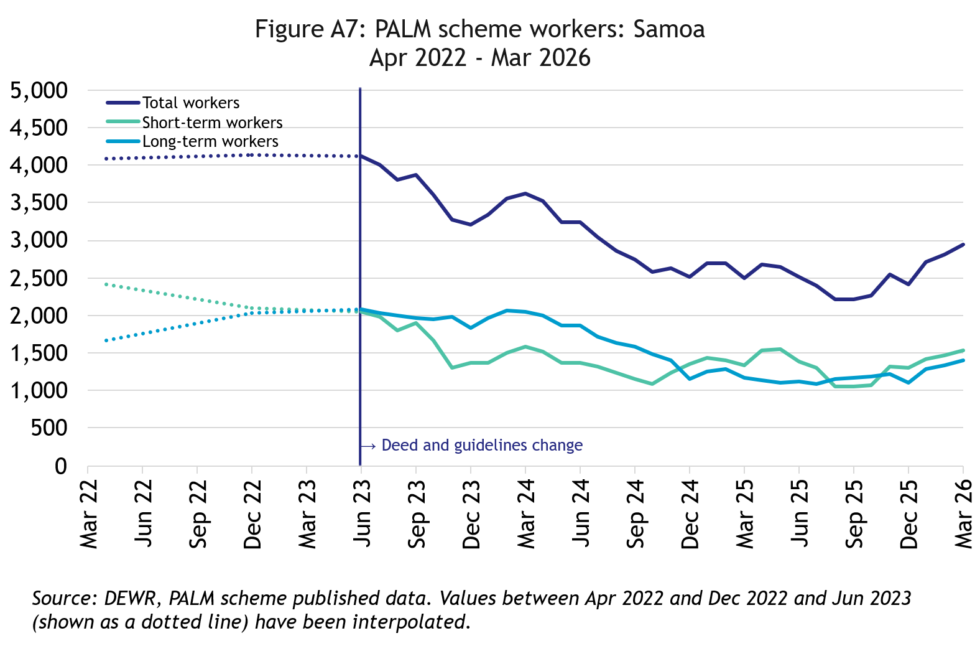
In March 2026, there were 2,950 workers from Samoa:
- down by 28% since April 2022
- up by 18% in the 12 months to March 2026
- 48% of Samoan PALM scheme workers were in the long-term stream

Solomon Islands

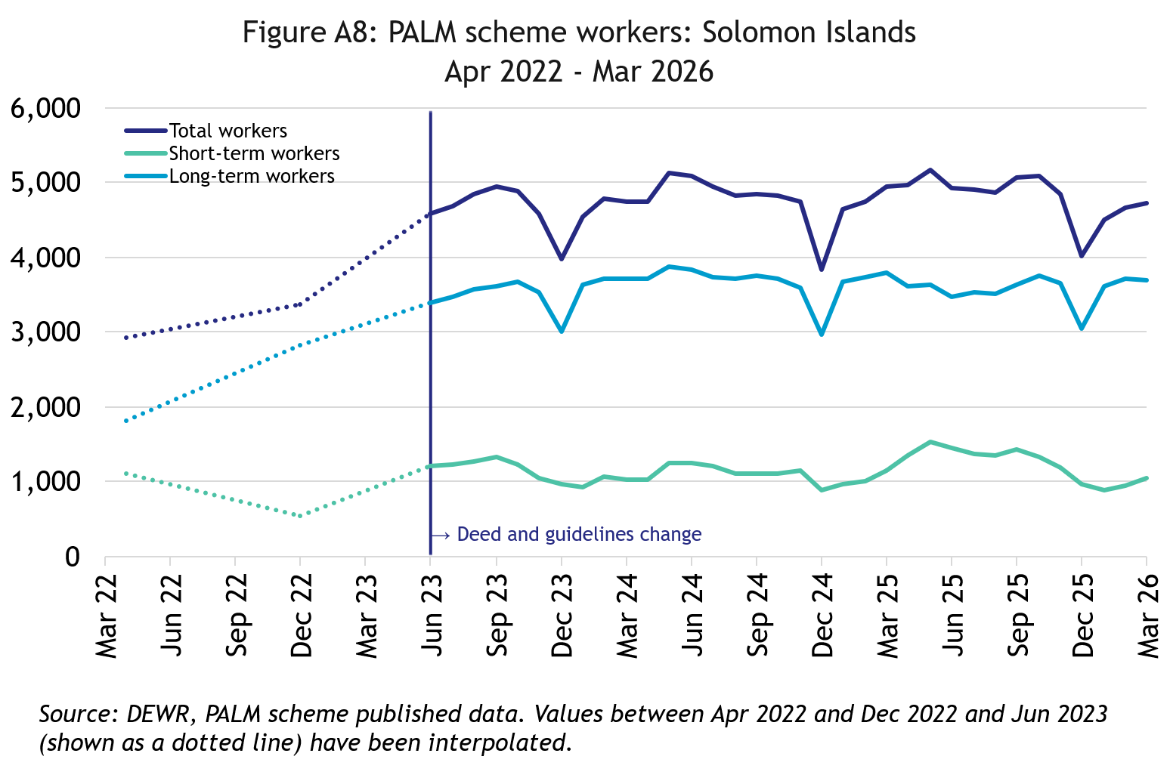
In March 2026, there were 4,730 workers from the Solomon Islands:
- up by 62% since April 2022
- down by 4% in the 12 months to March 2026
- 78% of Solomon Islander PALM scheme workers were in the long-term stream

Timor-Leste

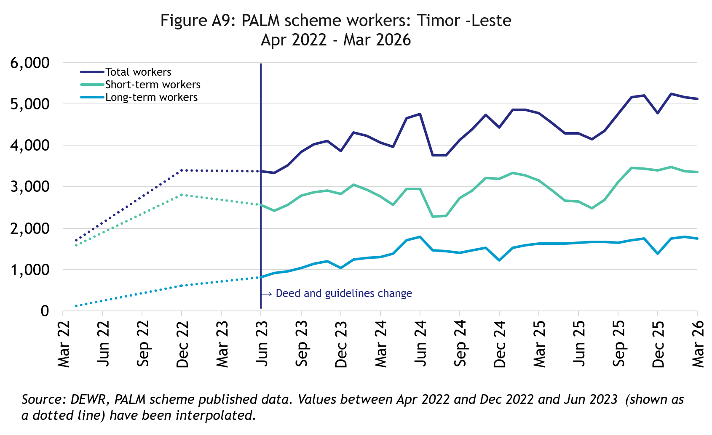
In March 2026, there were 5,115 workers from Timor-Leste:
- more than doubled since April 2022
- up by 7% in the 12 months to March 2026
- 66% of Timorese PALM scheme workers were in the short-term stream

Tonga

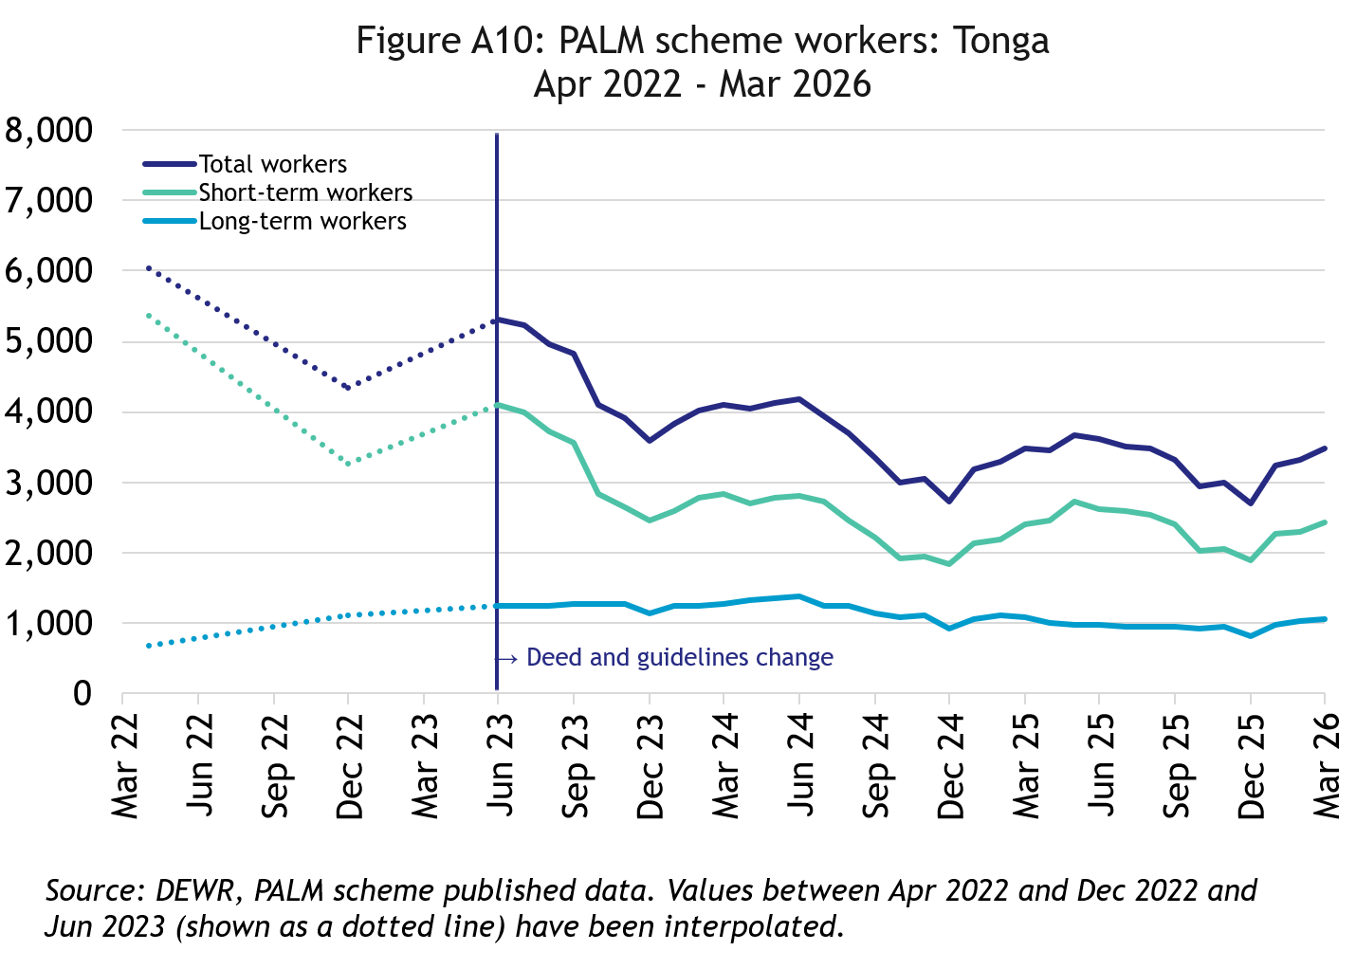
In March 2026, there were 3,475 workers from Tonga:
- down by 42% since April 2022
- has remained at around the same level over the 12 months to March 2026
- 69% of Tongan PALM scheme workers were in the short-term stream

Tuvalu

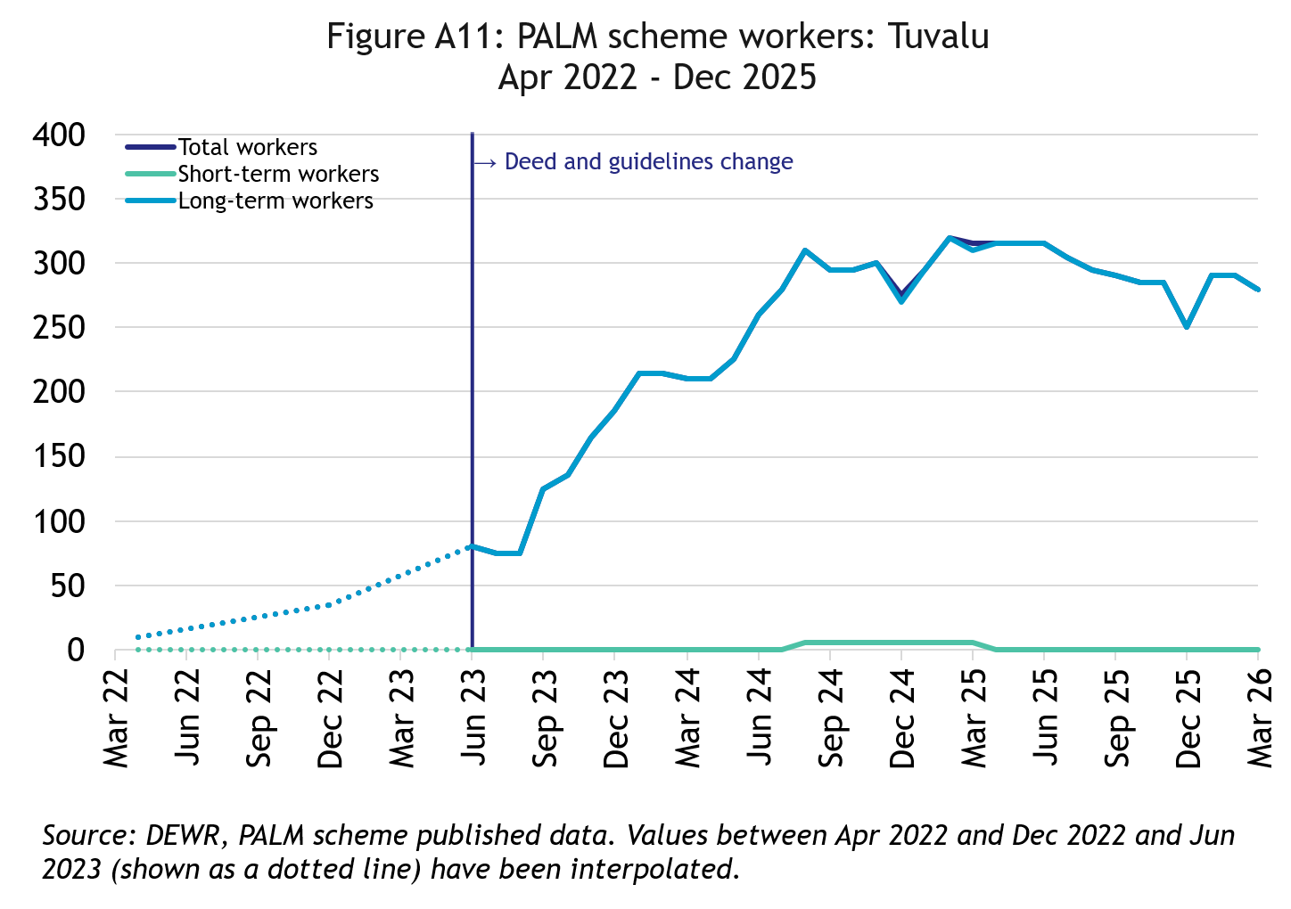
In March 2026, there were 280 workers from Tuvalu:
- a significant increase since April 2022, noting the historically very low number of workers
- down by 11% in the 12 months to March 2026
- All Tuvaluan PALM scheme workers were in the long-term stream

Vanuatu

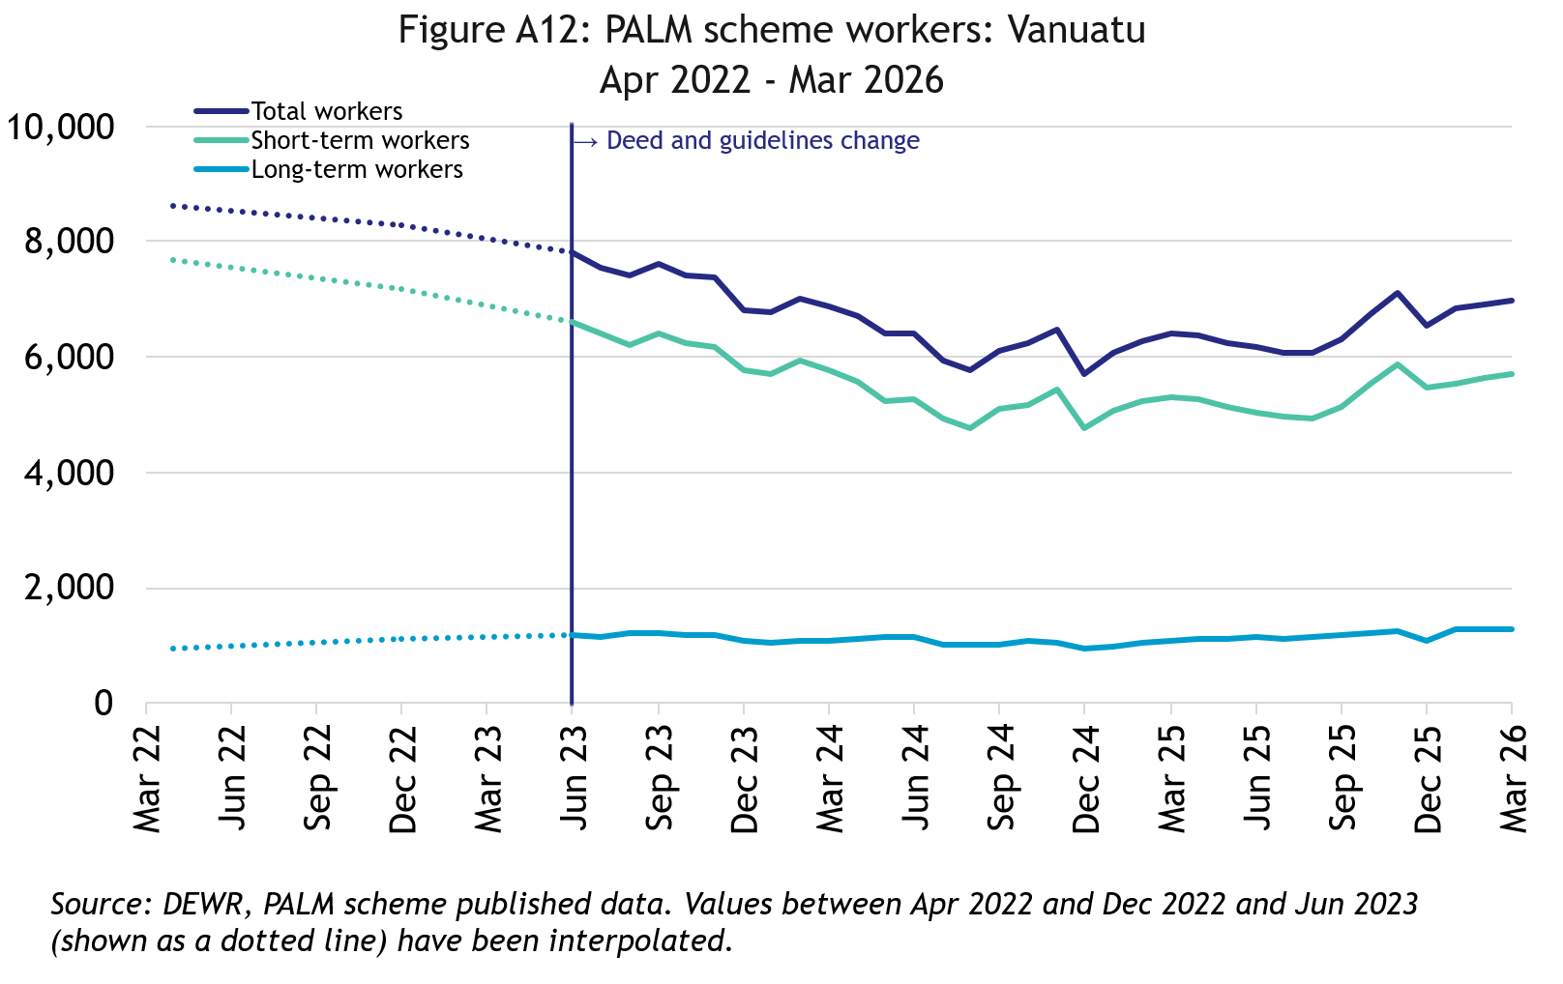
In March 2026, there were 6,970 workers from Vanuatu:
- down by 19% since April 2022
- up by 9% in the 12 months to March 2026
- 82% of ni-Vanuatu PALM scheme workers were in the short-term stream

PALM scheme worker trends by state/territory

New South Wales

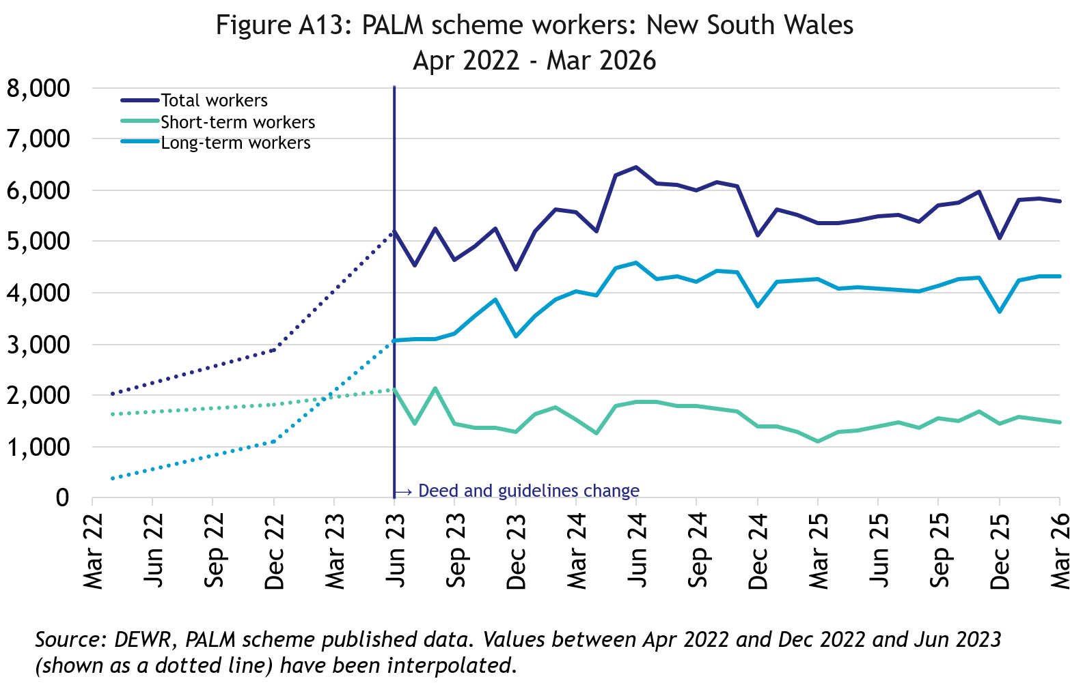
In March 2026, there were 5,785 workers in New South Wales:
- nearly tripled since April 2022
- up by 8% in the 12 months to March 2026
- 75% of New South Wales PALM scheme workers were in the long-term stream

Victoria

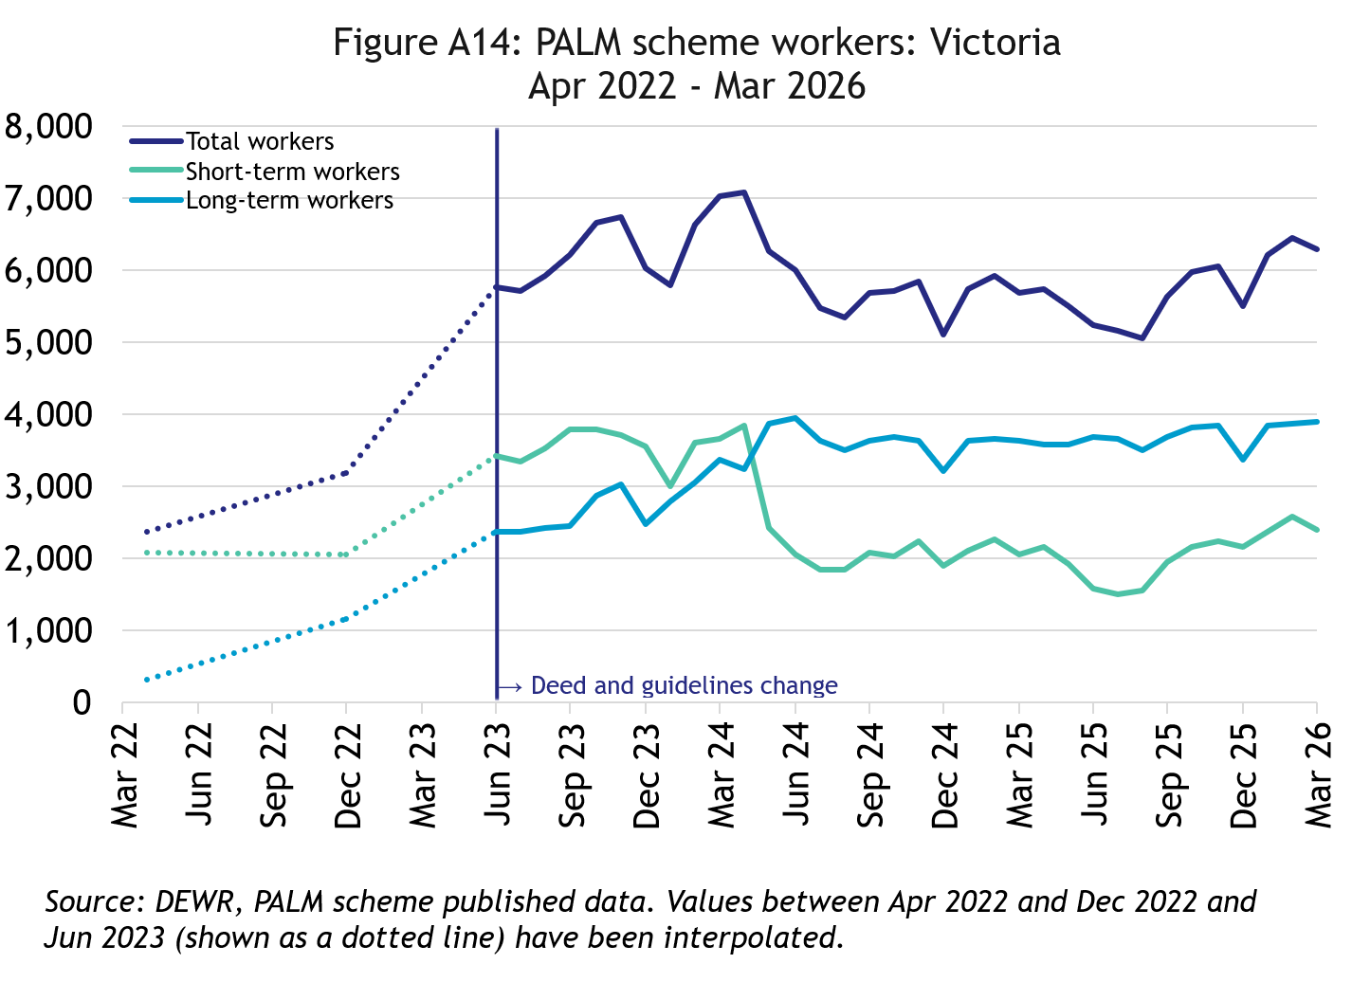
In March 2026, there were 6,275 workers in Victoria:
- More than doubled since April 2022
- up by 10% in the 12 months to March 2026
- 62% of Victorian PALM scheme workers were in the long-term stream

Queensland

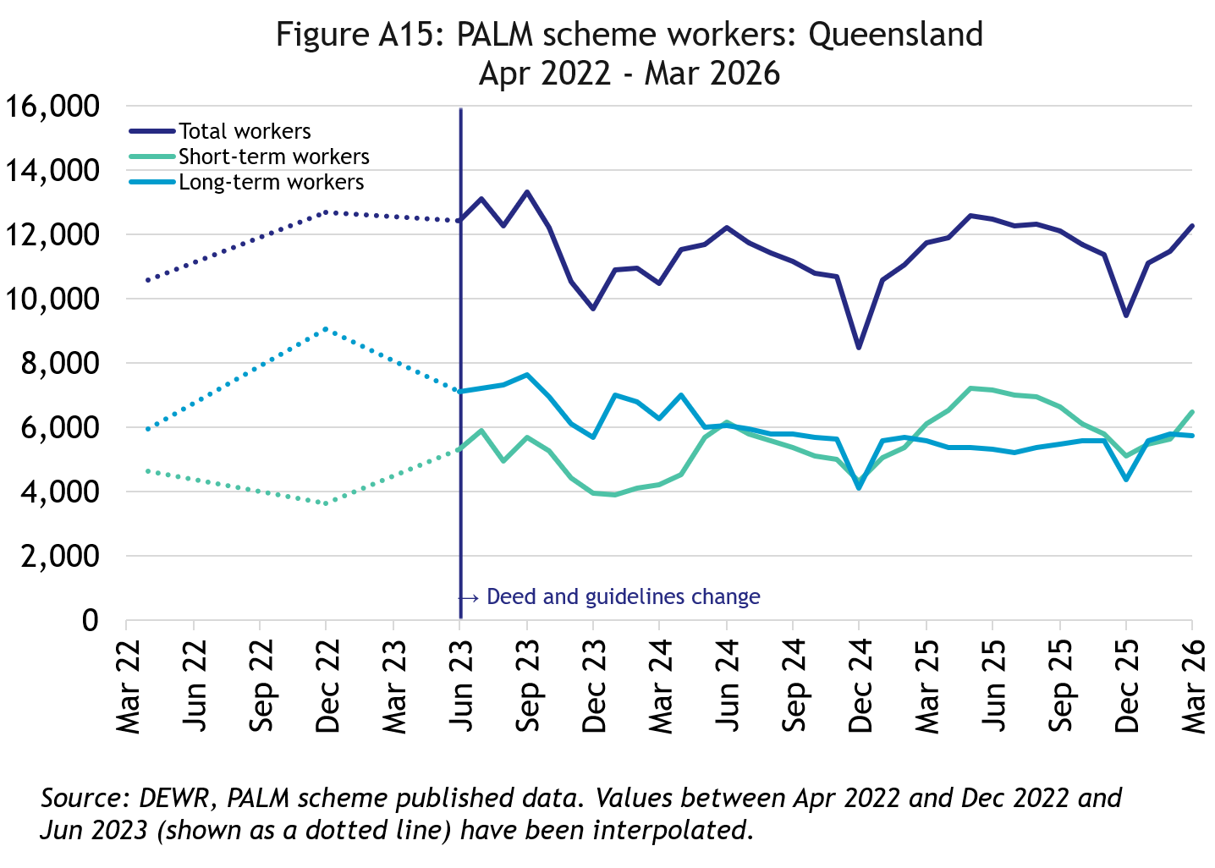
In March 2026, there were 12,260 workers in Queensland:
- up by 16% since April 2022
- up by 4% in the 12 months to March 2026
- 53% of Queensland PALM scheme workers were in the short-term

South Australia

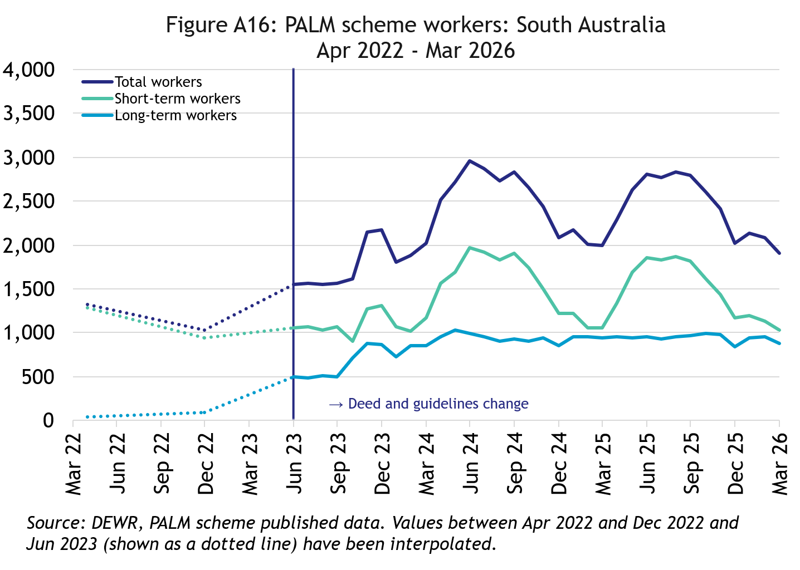
In March 2026, there were 1,905 workers in South Australia:
- up by 44% since April 2022
- down by 5% in the 12 months to March 2026
- 54% of South Australian PALM scheme workers were in the short-term stream

Western Australia

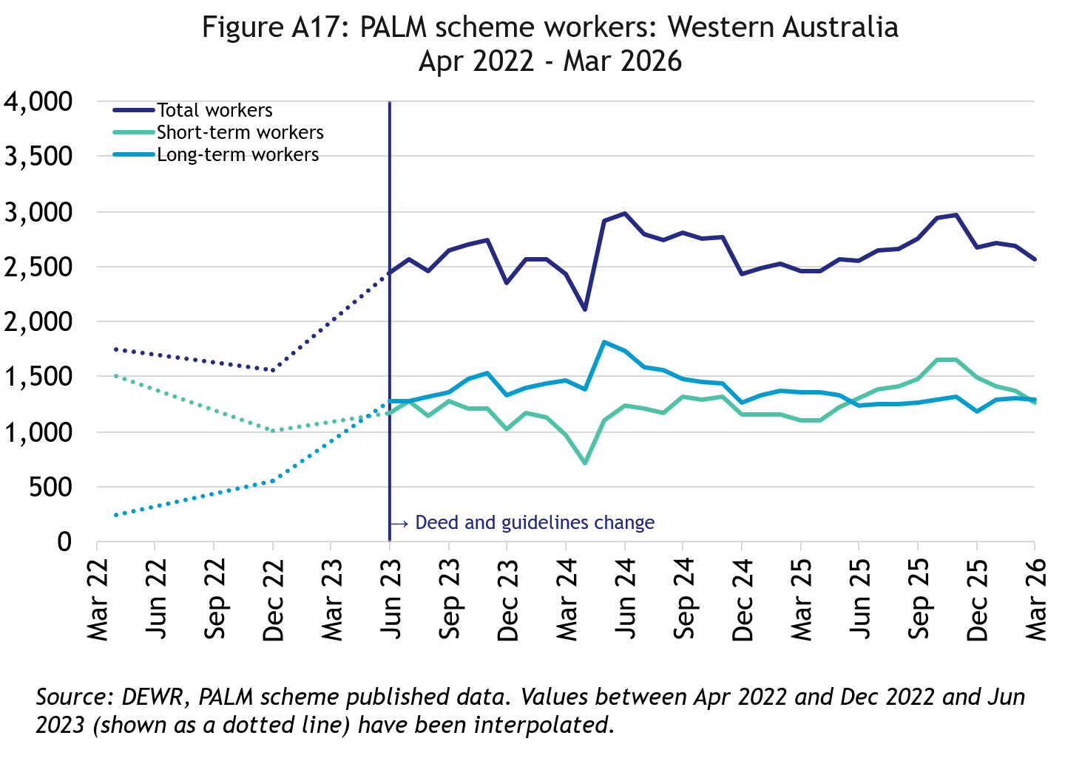
In March 2026, there were 2,560 workers in Western Australia:
- up by 46% since April 2022
- up by 4% in the 12 months to March 2026
- 51% of Western Australian PALM scheme workers were in the long-term stream

Tasmania

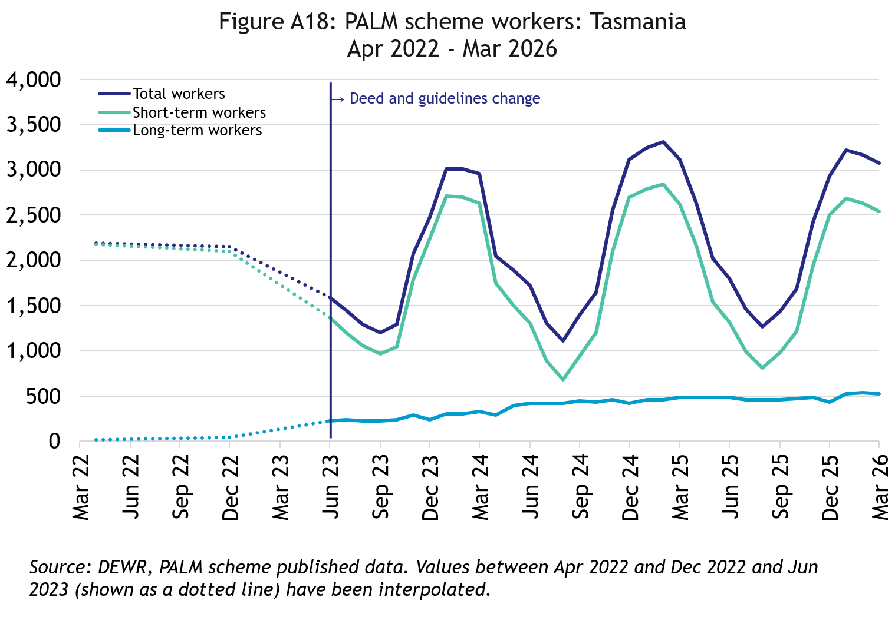
In March 2026, there were 3,070 workers in Tasmania:
- up by 40% since April 2022
- down by 1% in the 12 months to March 2026
- 83% of Tasmanian PALM scheme workers were in the short-term stream

Northern Territory

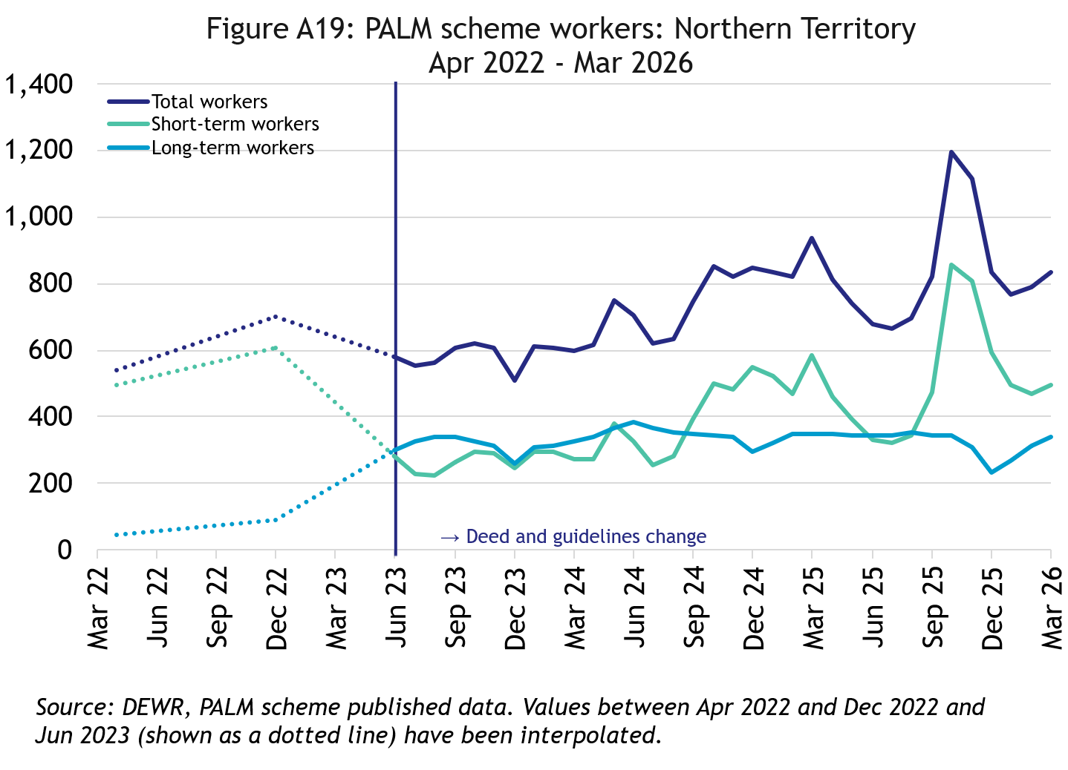
In March 2026, there were 835 workers in the Northern Territory:
- up by 55% since April 2022
- down by 11% in the 12 months to March 2026
- 59% of Northern Territory PALM scheme workers were in the short-term stream

Australian Capital Territory

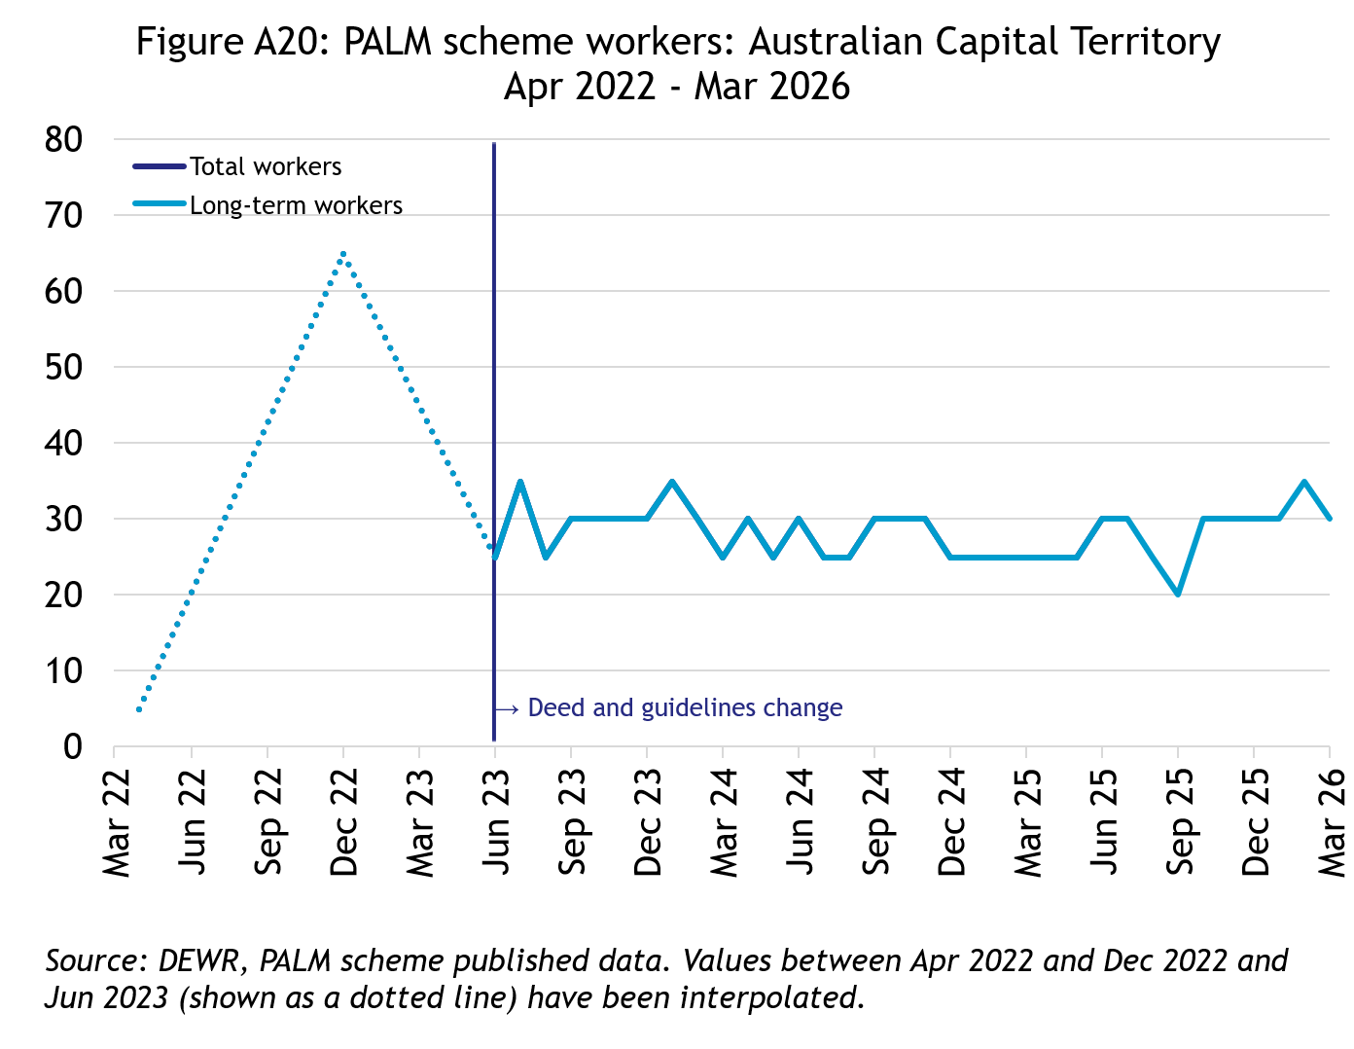
In March 2026, there were 30 workers in the Australian Capital Territory:
- broadly steady since mid-2023
- all PALM scheme workers in the Australian Capital Territory were in the long-term stream

Explanatory notes

Introduction
The PALM scheme allows Australian businesses to hire workers from 9 Pacific Island countries and Timor-Leste when there are not enough local workers available. Businesses who meet the eligibility criteria can access workers in the short-term stream (up to 9 months) and/or in the long-term stream (between one and 4 years).
PALM scheme employers in the agriculture sector and select agriculture-related food product manufacturing sectors can be based anywhere in Australia. All other sectors must be based in a regional or rural location.
For more information, refer to the PALM scheme website: www.palmscheme.gov.au.

Data sources
PALM scheme worker data is a combination of data from the Department of Employment and Workplace Relations (DEWR) IT systems and visa data sourced from the Department of Home Affairs. DEWR administrative data is stored in a live system and reliant on information entered by labour sending units located in each of the partner countries and PALM scheme employers.

Data confidentiality
To protect individuals’ privacy, all cells including any totals and subtotals have been rounded to the nearest 5; values from 1 to 7 are rounded to 5. Zero cells are actual zeros. This may result in non-additivity for some totals. Caution should be taken in recalculating totals from rounded data, as this may compound the effects of rounding.

Glossary
PALM scheme worker:
Citizen of a PALM scheme participating country who is issued an approved offer of employment in accordance with the PALM scheme deed and who is granted a PALM stream - temporary work (international relations) visa (subclass 403); or who held a pandemic event (subclass 408) visa
(up to December 2024).

PALM scheme worker data is derived by combining data from DEWR's IT systems and visa data sourced from the Department of Home Affairs. DEWR data is matched against visa data for comprehensive validation and used to construct valid and accurate counts for PALM scheme workers who are identified in visa data as onshore. Offshore visa holders are excluded from the counts.
Sex of PALM scheme worker:
The sex of PALM scheme workers is categorised into: Female, Male, and ‘not stated or inadequately described’. Note that ‘not stated or inadequately described’ includes: cases where sex is not missing or not captured in the data; where sex could not be accurately matched between data sources; or those who choose not to disclose their sex. Due to data collection limitations, it is not possible to distinguish between these subgroups.
PALM scheme worker data disaggregated by sex has been derived by matching PALM scheme worker data from internal DEWR systems and visa data from Home Affairs. PALM scheme data reports sex based on the data available at the time of data processing.
Reporting of PALM scheme worker data by sex aligns with ABS and DEWR standards for the reporting of sex and gender data.
PALM scheme employer:
An entity contracted by DEWR under the PALM scheme deed. Employers can be direct employers (arranges the placement of PALM scheme workers it employs with its own business) or labour hire organisations arranging the placement of PALM scheme workers it employs with host organisations using a labour hire arrangement.

Country of origin:
PALM scheme participating country that a PALM scheme worker is from. PALM scheme participating countries are Fiji, Kiribati, Nauru, Papua New Guinea, Samoa, Solomon Islands, Timor-Leste, Tonga, Tuvalu and Vanuatu.

‘Unknown’ country of origin is where country of origin cannot be determined for a PALM scheme worker due to incomplete data.

Stream:
Length of placement of employed PALM scheme workers. This is either 'short-term' or 'long-term':
- Short-term: a placement with short-term PALM scheme workers who hold the relevant visa and are employed in a contract of work for up to 9 months.
- Long-term: a placement with long-term PALM scheme workers who hold the relevant visa and are employed in a contract of work for up to 4 years (non-seasonal).
Industry:
Where possible, industries are classified to the Australian Bureau of Statistics Australian and New Zealand Standard Industrial Classification (ANZSIC). An individual business entity is assigned to an industry based on its predominant activity.

Due to gaps in data sources, a best-fit approach has been used to identify industry. ‘Role descriptions’ (which are job or occupation descriptions) may be used to help identify an accurate industry fit. PALM scheme data is reported to 5 key industry groups: Agriculture, Meat Processing, Accommodation, Health Care and Social Assistance, and Other industries.

- Agriculture:
Reflects workers in ANZSIC Division A: Agriculture, Forestry and Fishing.
- Meat Processing:
Includes Meat and Meat Product Manufacturing (a subset of the ANZSIC Division C: Manufacturing)
- Accommodation:
ANZSIC Division H: Accommodation and Food Services.
- Health care and social assistance:
ANZSIC Division Q: Health Care and Social Assistance. Includes aged, disability and other health care services, including residential care.
- Other Industries:
Includes all remaining industries, that are not otherwise classified to the industries above. Note that a small number of workers in manufacturing in non-meat processing (such as grain and cereal manufacturing, or textile or clothing manufacturing) are included in Other industries. Any workers in Retail are included in Other industries.

Citation
Any publications or reports using the data reported by DEWR must cite DEWR as the source. Where this data has been used for further analysis and interpretation, DEWR requests the inclusion of the following statement in the published report:
“The views expressed in this report are those of the authors and do not necessarily represent those of DEWR."

Contact
For any inquiries, please contact:
- for general PALM scheme enquiries: (PALM@dewr.gov.au)
- for PALM scheme data enquiries: (pacificlabourdata@dewr.gov.au).

