PALMLearn Registration Factsheet
PALMLearn is a learning site dedicated to supporting PALM scheme employers, their staff, host employers and other stakeholders to understand the PALM scheme Approved Employer Deed of Agreement (the deed) and the PALM scheme Approved Employer Guidelines (the guidelines). Cultural toolkits are also hosted and available through PALMLearn.

Registration: at a glance

Registration Information
- You will need to register before you can access PALMLearn. Only eligible users will have their registration approved.
- PALMLearn uses a self-registration process for individual users.
- Once you have registered, a PALMLearn Administrator will review your registration, and you will be notified of the outcome. For step-by-step instructions see How to Register on the following pages.

 | Registration Tip  If you are an organisation with multiple staff who need to register, please email palmlearn@dewr.gov.au for a bulk registration form.

Eligibility
Access to PALMLearn is governed by eligibility criteria. Review Table 1 to check your eligibility. If you are unsure if you are an eligible user, please contact palmlearn@dewr.gov.au
Table 1: PALMLearn eligibility criteria
PALMLearn eligibility criteria
Eligible entity types | - Direct employer (approved employer) & staff  - Labour hire (approved employer) & staff  - Host organisation & staff  - SEE (Skills for employment and education) provider staff  - Skills development fund approved training provider staff  - Other*
Eligible user workplace roles and/or responsibilities | - Director/CEO  - Manager  - Human resources (HR) manager or officer  - Staff supervisor  - Team leader  - Employee  - Welfare and wellbeing support person  - PALM scheme worker who supervises PALM workers from another country  - Trainer or Assessor  - Country Liaison Officer (CLO)  - Other*
* Criteria will be assessed case by case.

Support
If you need support during the registration process you can contact:
- Email the PALMLearn Administrator: PALMLearn@dewr.gov.au
- Phone the PALM support line 1800 51 51 31
- Email the PALM support line palm@dewr.gov.au

How to register
Follow these steps to complete the self-registration process.

Registration Tip
Before you register, add no-reply@palmlearn.gov.au to your safe senders or contact list. You need to be able to receive emails from this address to complete the registration process and login to PALMLearn.

 | Initiate registration  - Go to the website www.palmlearn.gov.au  - Select ‘Register’ from the login screen  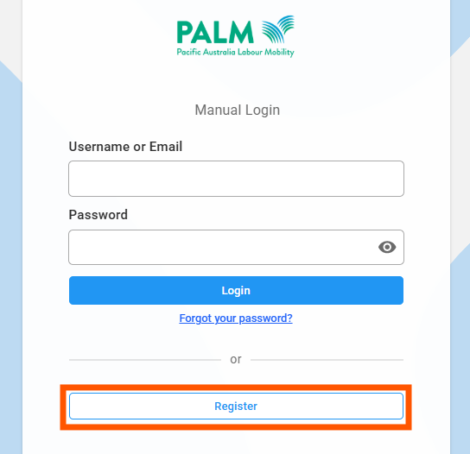
 | Enter registration details  Complete the registration fields. You must make an individual account – use your own email address, not a group inbox.  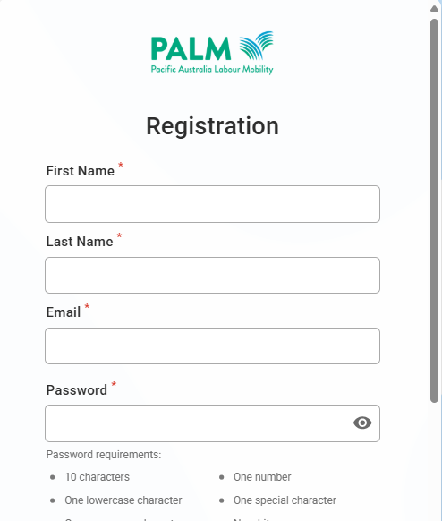
  Registration Tip – Email address
  Use an email address that belongs only to you. Do not use a shared or generic inbox (for example, an admin@ address). You can register with either your work email or a personal email.
 | Verify your email address  This notification will appear:  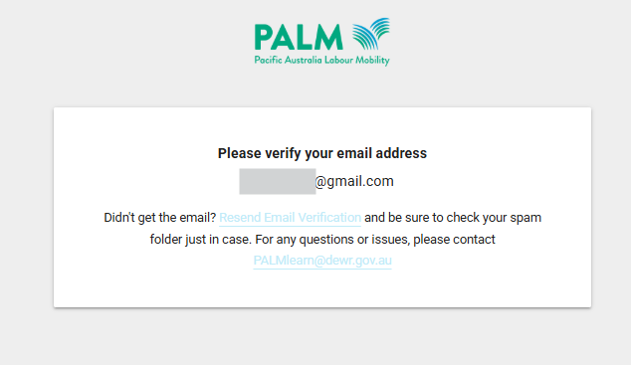  You will receive notification to verify your email – this will by email. The email will be from Acorn PLMS <no-reply@palmlearn.gov.au>  - Go to the email account you used to register  - Select the link to verify your email account.  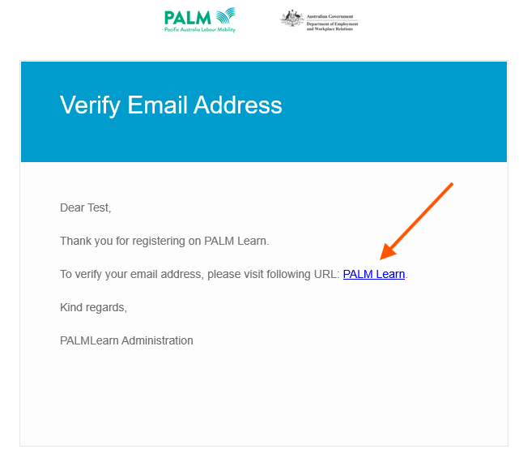
 | Pending approval  You will receive an email confirming your email address verification was successful.  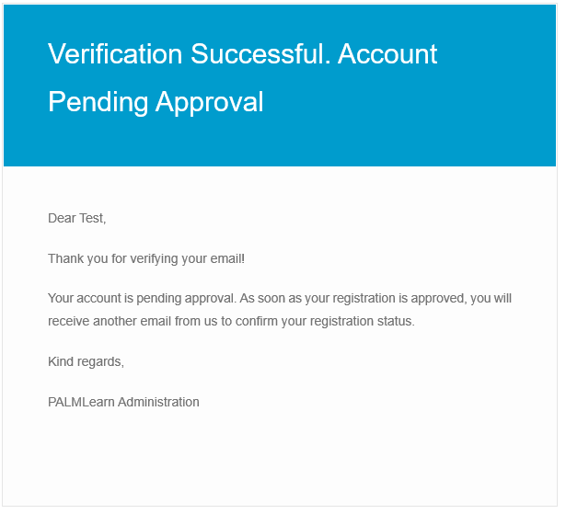
 | Registration outcome  The department will review your registration, and you will be notified of the outcome. This may be:  - Approved  - Denied – this will be if you do not meet the eligibility criteria  - More information required (registration remains pending).  More information required (registration pending)  We will contact you to clarify details provided or ask you to provide information if your registration form was incomplete. We will email the address you used to self-register and ask for the information required – the email will be from PALMLearn@dewr.gov.au  Approved notification example  