PALMLearn Course Finder Factsheet
PALMLearn is a learning site dedicated to supporting PALM scheme employers, their staff, host employers and other stakeholders to understand the PALM scheme Approved Employer Deed of Agreement (the deed) and the PALM scheme Approved Employer Guidelines (the guidelines).

Introduction
This factsheet gives you several ways to find and search for courses and content on PALMLearn.
In this factsheet you will find information on:
- Find a course from the home page
- The course catalogue and how to search for and filter courses.
- How to enrol into a course
- Support

Find a course from the home page
On the PALMLearn home page, there are several ways to access courses.
- Course Catalogue home page menu
- Search bar on the home page
- Recent activity widget

 | Course Home Page  Your PALMLearn Home page may look different to what you see in the image below. Your home page is configured to the role you hold and the courses that you can access.  This factsheet refers to functions that are available for all users, no matter what their homepage or catalogue includes.

Navigating the course home page
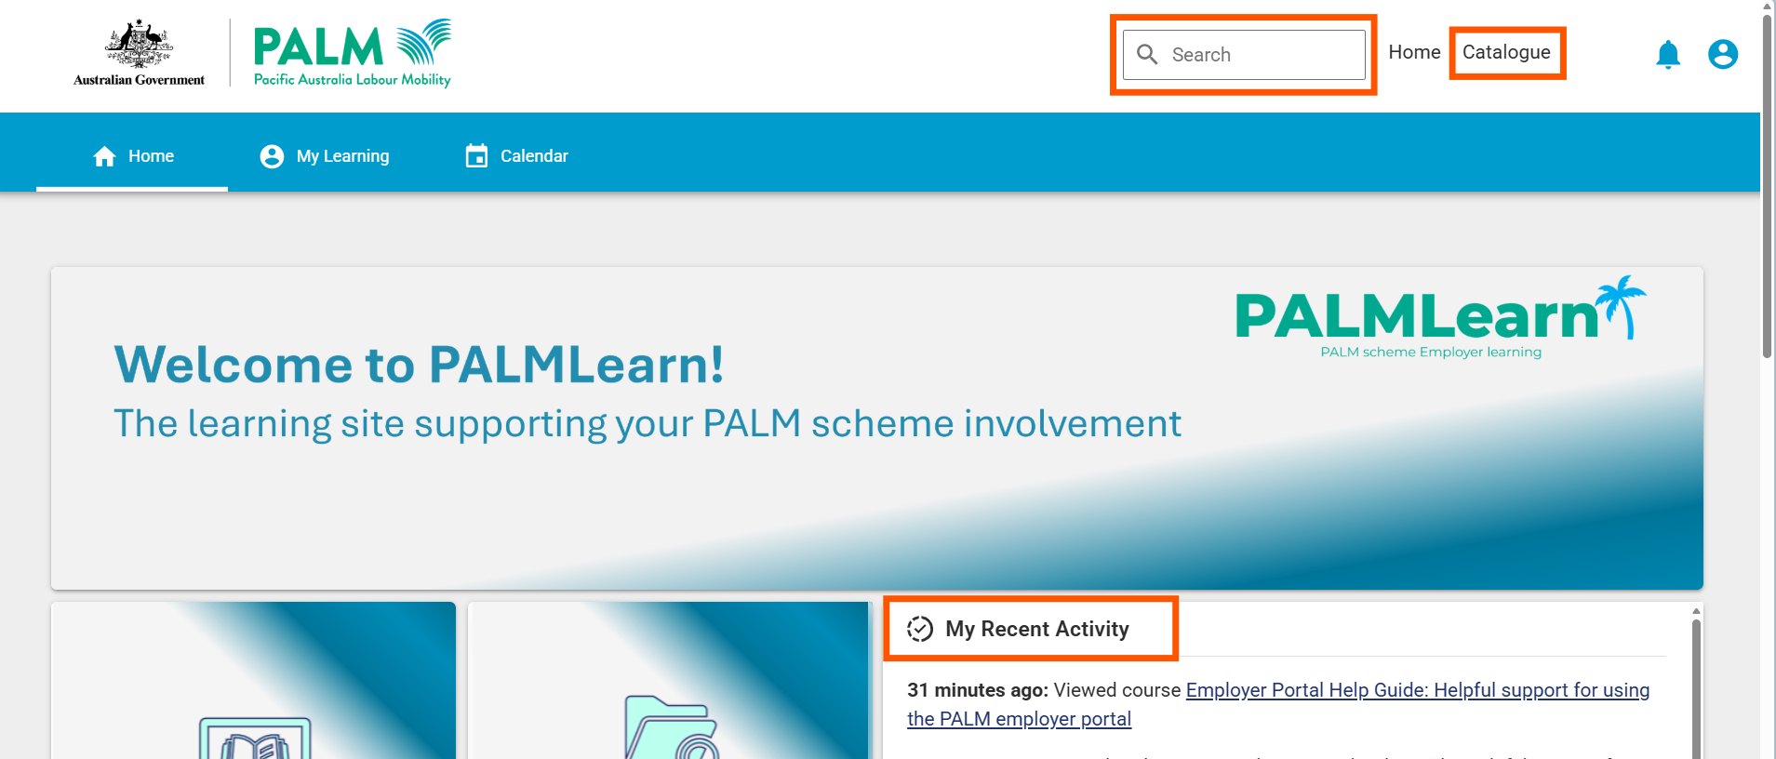

Using the home page
 | Course catalogue    Selecting the course catalogue menu on the home page will take you to the course catalogue page of PALMLearn.  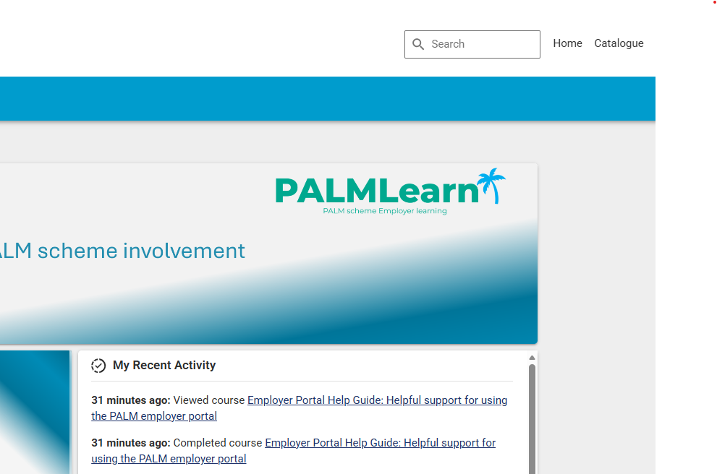
 | Search bar    Selecting the search bar on the home page will allow you to search for the topic, title of a course or a course program.  Type into the search bar the course, information or program you are looking for.
  Home page search bar
  Please note, the search bar function is only available on a desktop or laptop computer. To search on a handheld device, select the course catalogue and search via the course catalogue page.
 | Recent activity widget  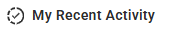  Recently viewed courses will be quickly available to select in the recent activity widget.  Select the course you wish to return to.

Using the catalogue
The course catalogue is where you will explore, enrol into or access any of the courses and content available in PALMLearn.
There are several ways to discover or browse available courses, including:
- Searching for a course
- Filtering using tags and categories
- Filtering using content types
- Browsing the list of available courses

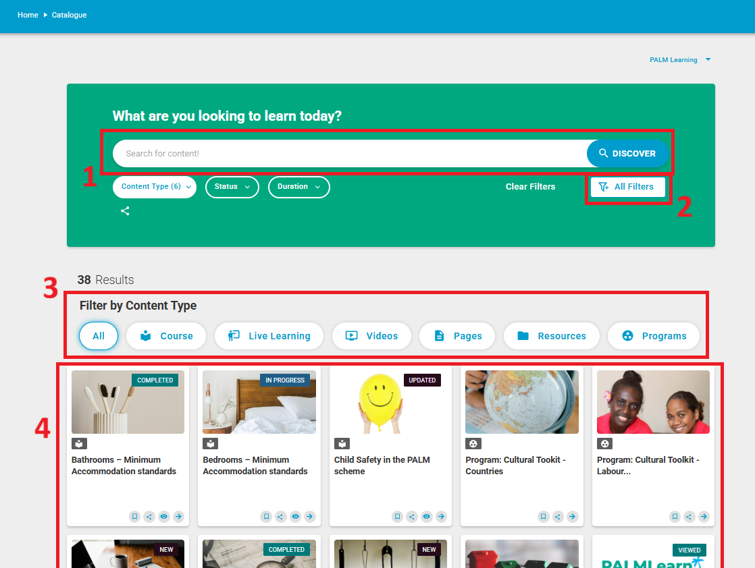

1. Searching for courses and content
Selecting the search bar in the course catalogue page allows you to search for the title of a course, a course program, or resources available. You can also search by topic, for example, searching ‘Fiji’ will produce courses such as ‘Supporting PALM scheme workers – Fiji’ and ‘.’ Working with the labour sending unit – Fiji’.

2. Filtering using tags and categories
- Selecting the ‘All Filters’ button on the course catalogue page will open a list of advanced filters you can use to find a course by its category or tag.

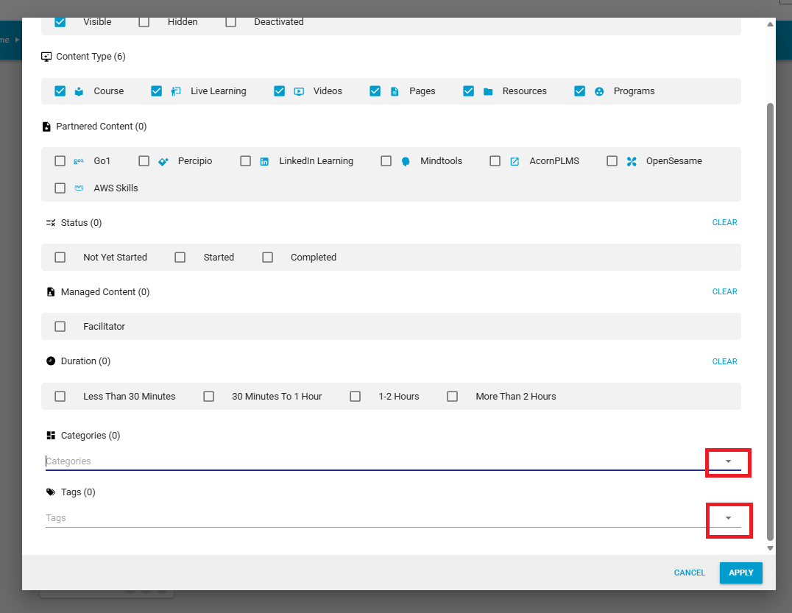

Selecting the drop-down button on the ‘categories’ and ‘tags’ boxes in the advanced filters will filter all courses based on their category, e.g. policy or cultural competency, or their tags, e.g. recruitment or LSU which further refines your search.
- To apply filters, make sure you select the apply button before exiting the advanced filters popup.
- To clear advanced filters, select the ‘all filters’ button and select ‘clear filters’ and apply.
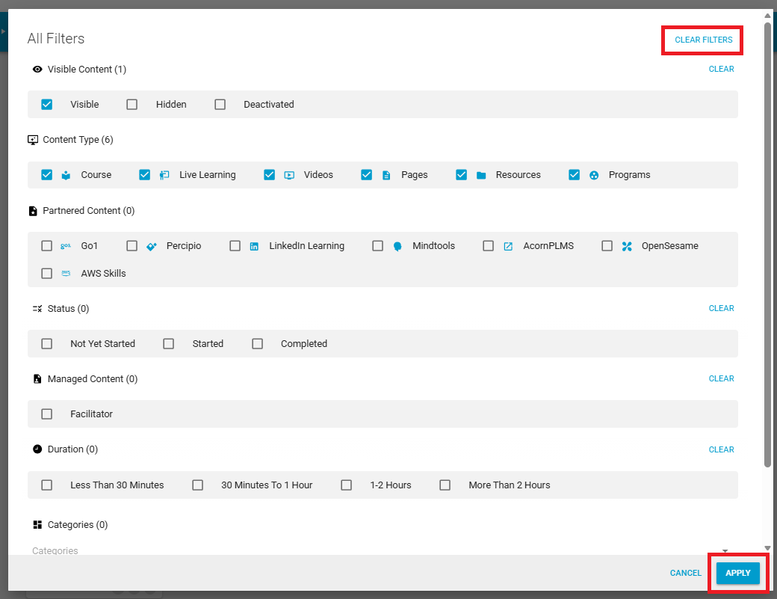

3. Filtering using content types
To filter courses in the course catalogue based on the content type, select the buttons below to view the content. For example, selecting ‘Resources’ will only show the PALMLearn Information and Course Guide as well as other resource documents, this will not show courses or course programs.
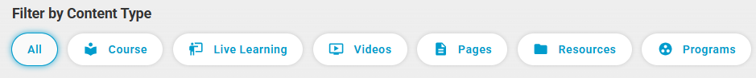

4. Browsing all available courses
If you are not sure what you are looking for, or just want to view all courses, scroll down on your screen to browse all of the course titles, resources, and course programs available on PALMLearn.
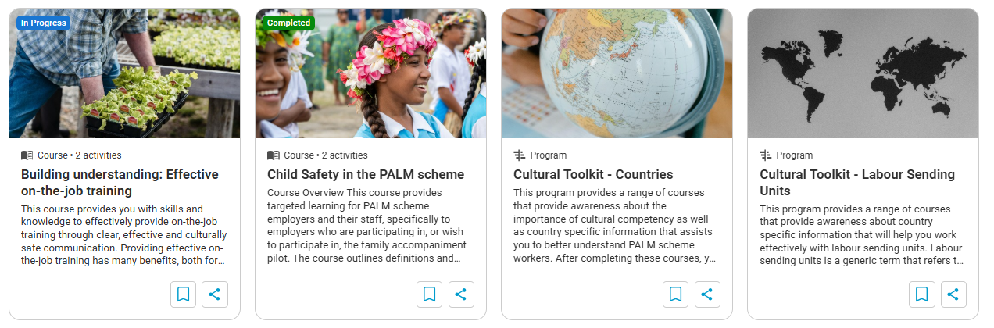

How do I enrol into a course?

1. Select the course tile
From the catalogue or search results, select the course tile.
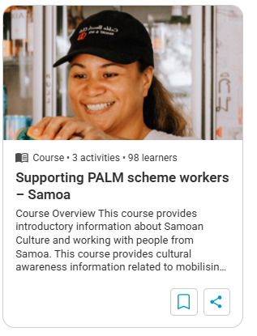

2. Select the ‘enrol’ button
You can find the enrol button on the course page. Select this button to enrol into the course.
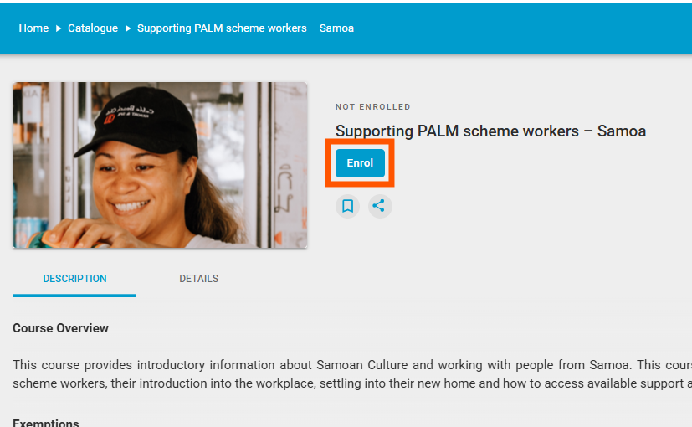

3. Open the course content
Select the course content to start your learning.
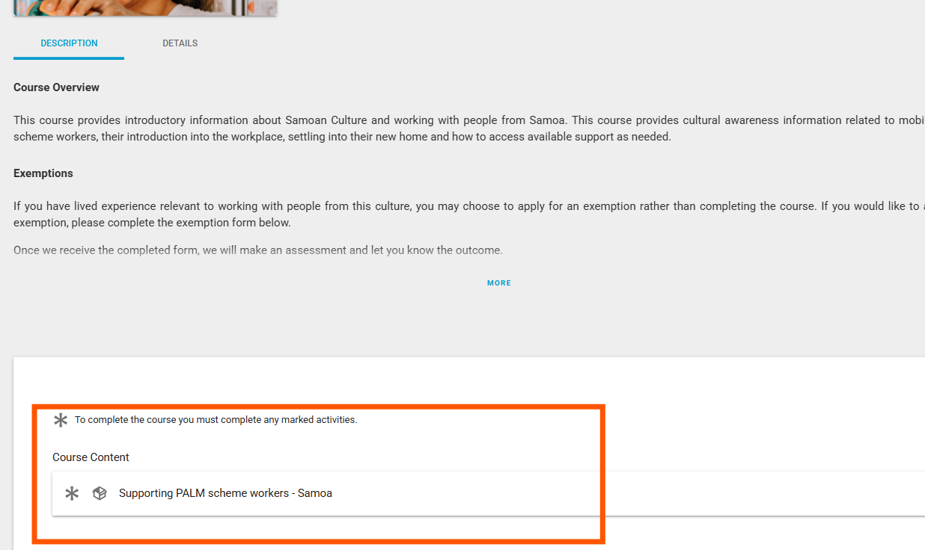

4. Support
If you need support during this process you can contact:
- Email the PALMLearn Administrator: PALMLearn@dewr.gov.au
- Phone the PALM support line 1800 51 51 31
- Email the PALM support line palm@dewr.gov.au

