Pacific Australia Labour Mobility scheme worker grievance factsheet
If you have a problem at work
The Australian Government cares about the welfare and wellbeing of all Pacific Australia Labour Mobility (PALM) scheme workers in Australia. We want you to feel safe, supported and treated fairly.
What is a grievance?
A grievance is a problem you cannot fix with your employer. It may also be a feeling that you have been treated unfairly.
A grievance can be about problems with:
- your health, safety and wellbeing
- the work you do, your tasks, work hours or how you are treated at work
- how much you are paid, missing payments or money taken out of your pay
- your housing, how safe you feel living there or how clean it is.
Try to fix the problem first
Before you lodge a grievance, please try:
- talking to your employer about the problem
- talking to your Country Liaison Officer (CLO) for help.
You can find your CLO’s contact details on the PALM scheme website.
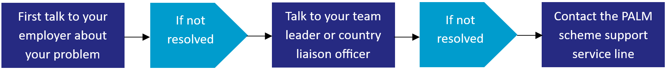
If the problem is still not fixed, you can lodge a grievance case.
How to lodge a grievance
You can lodge a grievance yourself or ask a trusted support person to lodge it for you.
- To lodge a grievance, complete the grievance referral form. You can also refer to the PALM scheme grievance management policy.
- Send your grievance referral form to the PALM scheme support service line by email (palm@dewr.gov.au).
- If you need more information, you can call the PALM scheme support line on (1800 51 31 31).
We are here to help you.

What happens after you lodge a grievance?
The government will:
- contact you to talk more about your problem
- ask you for evidence (for example: payslips, photos, messages)
- help you and your employer talk to each other to fix the issue
- refer your issue to another government authority if needed
- tell you the outcome of the grievance once it has been assessed.
If you think you were unfairly dismissed from your work
If your employer ends your employment and you have worked for at least 6 months, you may be able to make an unfair dismissal claim.
- Before you apply for unfair dismissal, it's important to check whether you are eligible to make an application. You can check on the Fair Work Commission website.
- You must lodge this claim within 21 days of the date your employment ended.
- You will need to pay a fee when you apply.
For more information, you can contact the Fair Work Commission on (1300 799 675).
Getting help and advice
If you feel unsafe or you have been treated unfairly at work, you can contact the PALM scheme support service line to talk about your options.

- Phone: (1800 51 51 31)
- Email: (palm@dewr.gov.au).

Community organisations and employers can also use these contact details to help support you.

