Pacific Australia Labour Mobility scheme quarterly update

Data current up to 31 December 2025

Published: 6 March 2026
Data about workers and employers participating in the Pacific Australia Labour Mobility (PALM) scheme is published monthly on the PALM website www.palmscheme.gov.au/palm-scheme-data. This quarterly report presents longer-term trends and analysis for key metrics.
PALM scheme worker counts are a measure of the number of workers from participating PALM scheme countries holding a valid visa who are currently onshore in Australia. Worker participation will vary from month to month reflecting a range of factors, including:
- the cyclical nature of the program and worker visa conditions (9 months for the short-term stream and up to 4 years for the long-term stream)
- changing workforce demand e.g. stemming from growing cycles for different crops in different regions, and
- workers returning home for holidays or other personal commitments.

PALM scheme employer counts record the number of employers holding a current PALM scheme deed.

PALM scheme worker data by sex
As part of ongoing efforts to improve PALM scheme reporting, the department published worker data disaggregated by sex for the first time on 13 January 2026. Publishing this data enhances transparency in PALM scheme reporting and provides an evidence base to help inform future gender-based policy and program design.
Key findings:
Between April 2022 and December 2025, the composition of PALM scheme workers by sex was:
- 21% on average were female (6,080 onshore as at 31 December 2025)
- 79% on average were male (22,455 onshore as at 31 December 2025).
Industry
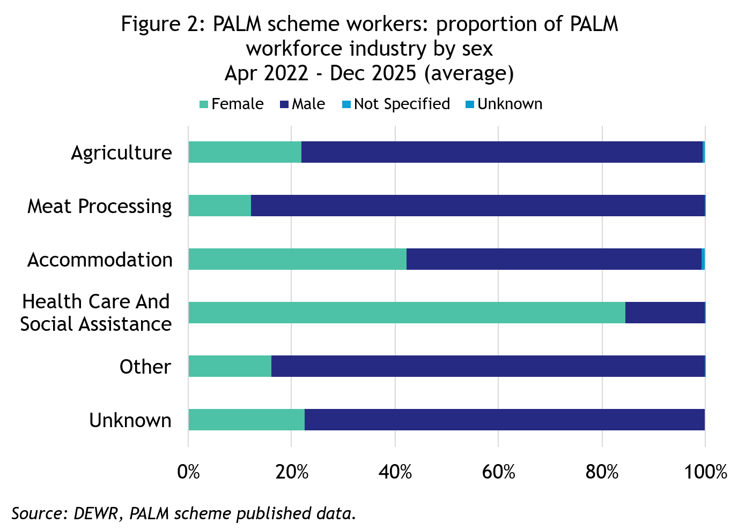
- Most PALM industries, especially Agriculture (77% male) and Meat processing (88% male), are male dominated.
- Accommodation (42% female) and Health care and social assistance (84% female) show comparatively higher female participation.

Worker country
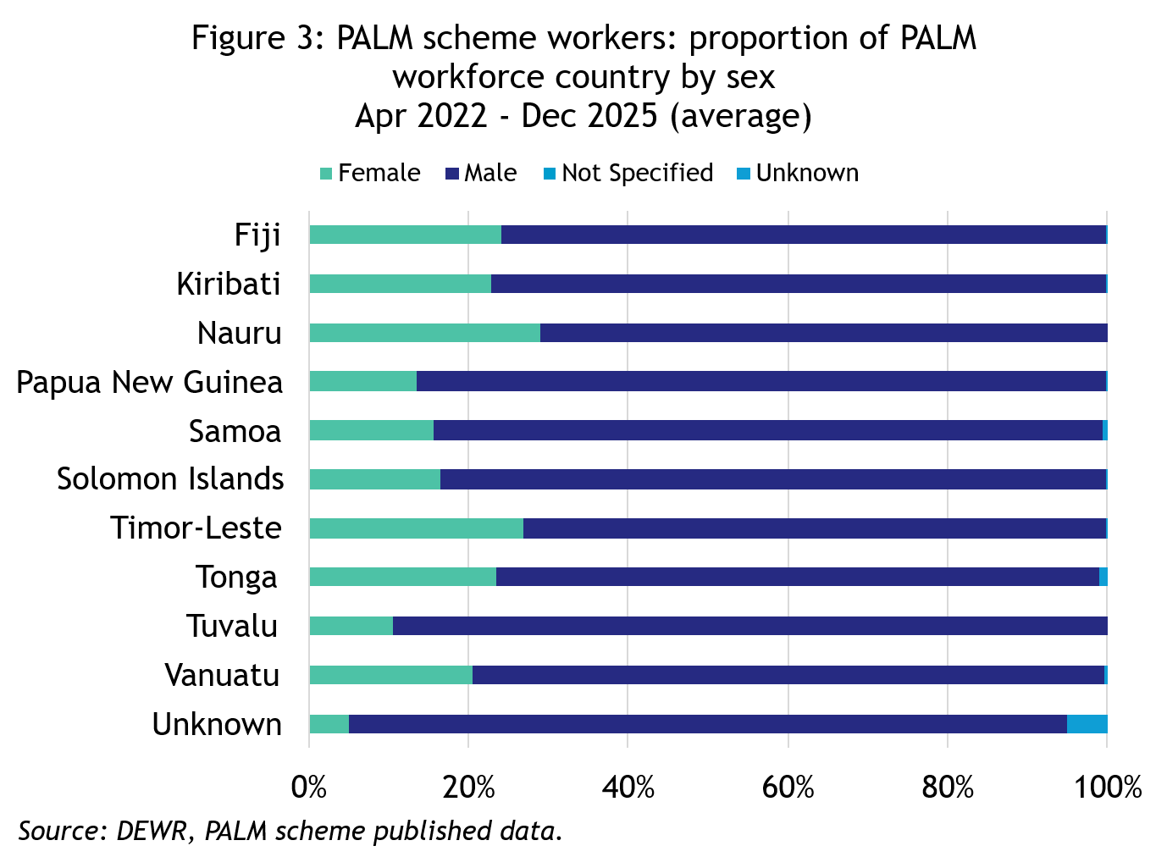
- For the 3 largest employing countries, in December 2025:
  - Vanuatu had 79% males and 21% females
  - Fiji had 76% males and 24% females
  - Solomon Islands had 83% males and 17% females.
- Nauru has the highest proportion of female workers at 29%, noting that Nauru is a very small overall contributor to worker counts with 25 onshore workers as at 31 December 2025.
- Tuvalu has the highest proportion of male workers at 89%, noting that Tuvalu is also a small contributor to overall worker counts, with 250 onshore workers as at 31 December 2025.

PALM scheme worker trends – December quarter 2026
In December each year, the number of PALM scheme workers onshore drops markedly, as a large number of workers return home for the holidays. This is particularly evident for the long-term steam worker count as many of their employers close down temporarily for the holiday period. In the short-term stream, there is also a temporary drop related to the seasonal hiring patterns for a number of large employing PALM scheme employers.

The decline in December 2025 is in line with the drop in worker counts observed in 2023 and 2024, which were followed by a rebound in the subsequent months as workers returned to Australia.

PALM scheme worker counts are not adjusted to account for seasonal events so caution needs to be applied to the findings in this report.

Over the 12 months to December 2025:
- The worker count has remained stable. Short-term worker counts increased by 9% over the year while long-term worker counts increased by 1% over the year.
- Worker counts by industry:
  - Agriculture increased by 10% (1,575 workers) since December 2024.
  - Meat processing declined by 4% (380 workers) over the year to December 2025. Most workers (97%) in this industry are in the long-term stream.
  - Other PALM industries, (which account for about 8% of the total PALM workforce, recorded mixed movements over the year: Accommodation declined by 7%; Health care and social assistance declined by 1%; and Other industries increased by 31%.
- By country, between December 2024 and December 2025, worker counts:
  - increased for: Kiribati, Papua New Guinea, Solomon Islands, Timor-Leste and Vanuatu
  - decreased for: Fiji, Nauru, Samoa, Tonga and Tuvalu.

PALM scheme employer trends
The number of PALM scheme employers has continued to grow since the new PALM scheme deed and guidelines were introduced in June 2023.
- 159 new employers have joined the scheme since June 2023, bringing the total number of employers to 532 in December 2025.

Worker trends
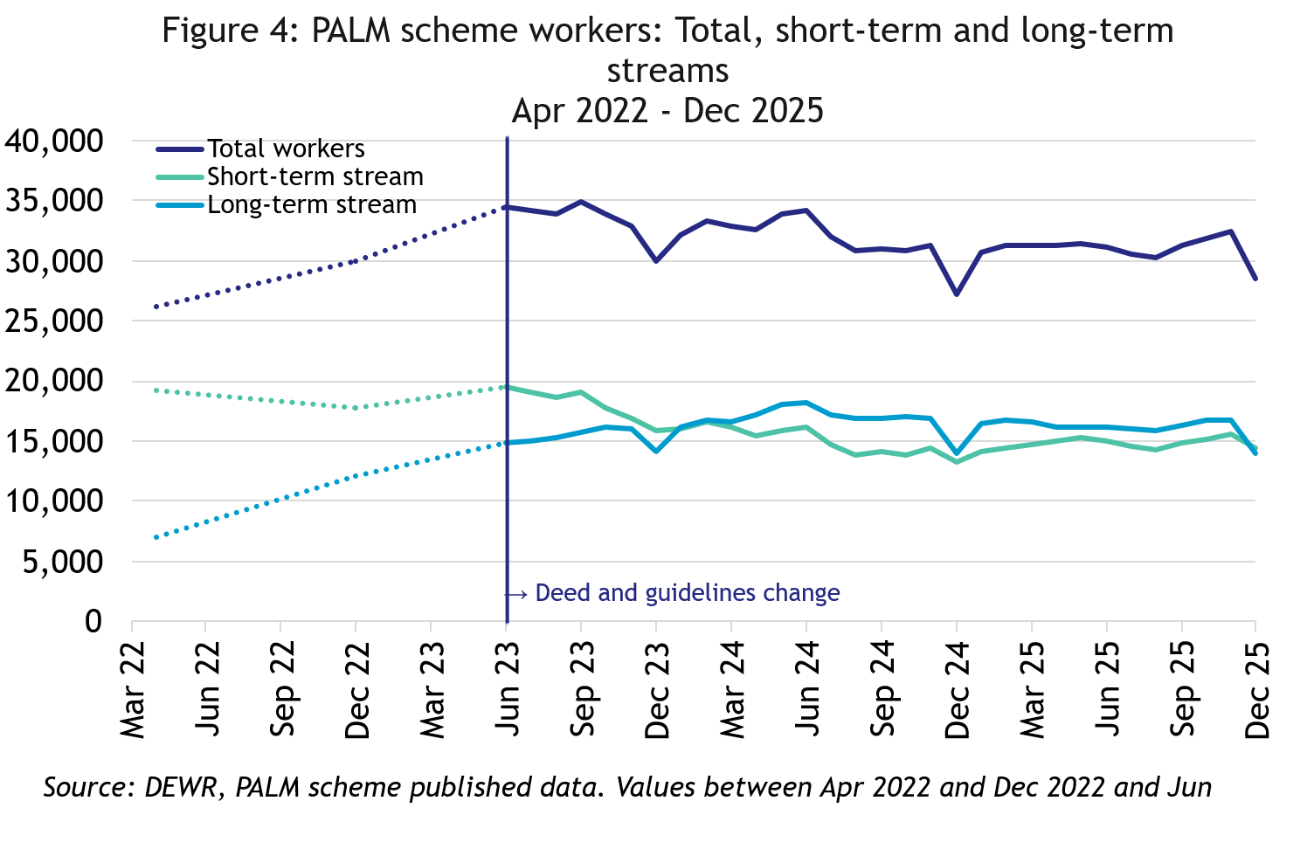
In December 2025, there were:
- 28,535 workers
- 14,485 in the short-term stream
- 14,050 in the long-term stream
In the 12 months to December 2025, the total number of workers was relatively similar.
- Total long-term stream was up by 1%
- Total short-term stream was up by 9%.

PALM scheme employers
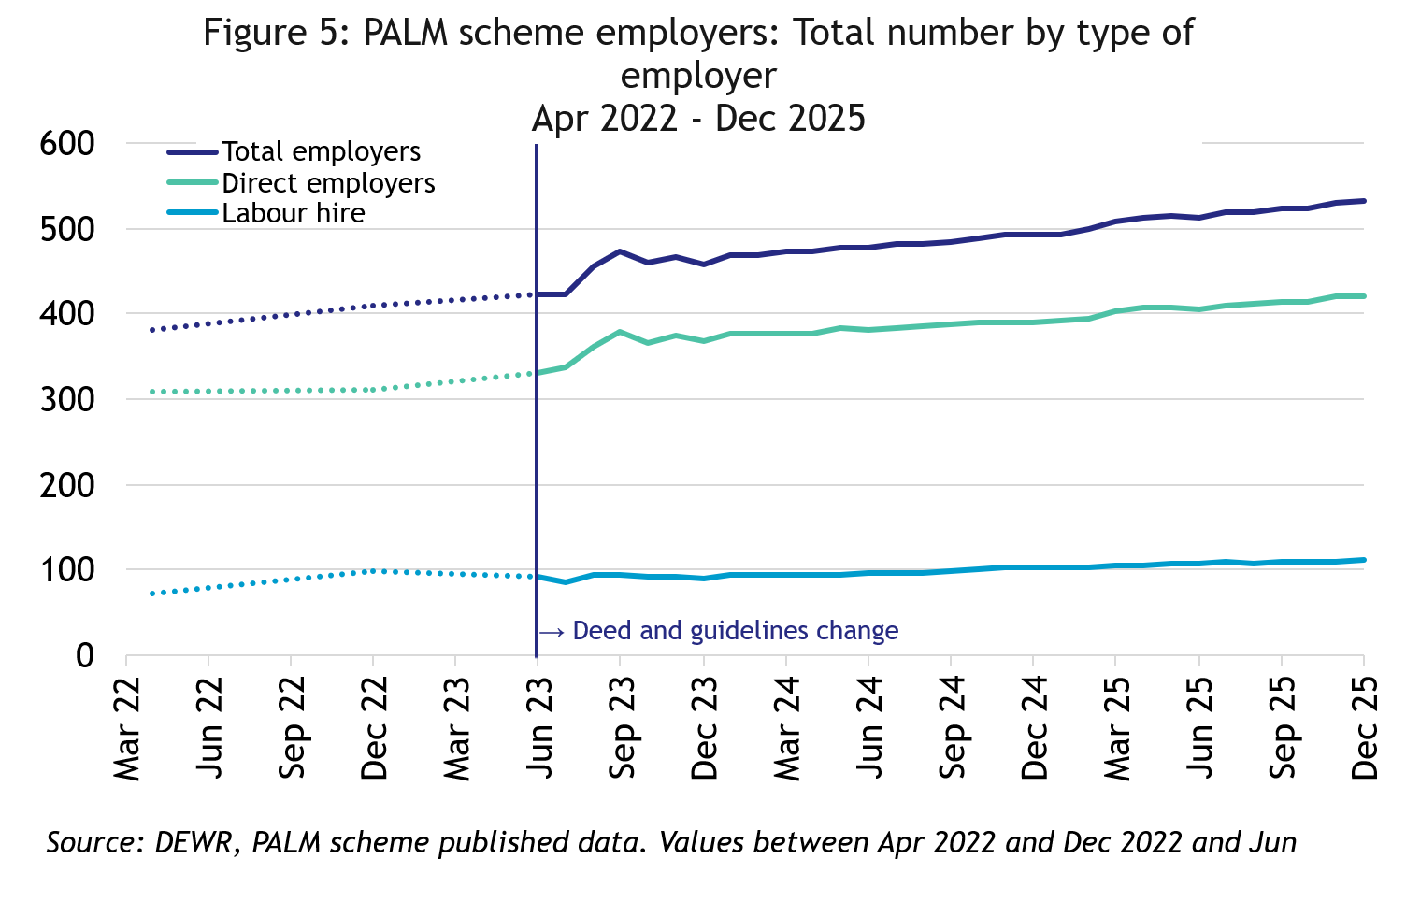
In December 2025, there were:
- 532 employers up by 8% in the 12 months to December 2025.
- 421 were direct employers, up by 8% in the 12 months to December 2025
- 111 were labour hire employers,
up by 9% in the 12 months to December 2025.

Data and chart notes:
All published PALM scheme worker data including any totals and subtotals are rounded to the nearest 5. For more information see the Glossary.
Worker counts are only available for April 2022, December 2022 and from June 2023 onwards. In the charts in this report, the unknown values between April 2022 and December 2022, and December 2022 and June 2023 have been inferred and are represented by the dotted lines. This produces artificially smooth lines that are not representative of the usual fluctuations expected in the monthly data.

Appendix A: Detailed PALM scheme worker trends

PALM scheme worker trends by industry
The PALM scheme has become increasingly diversified, with employers from a broad range of industries entering the scheme, offering Pacific Island and Timor-Leste workers more choice.

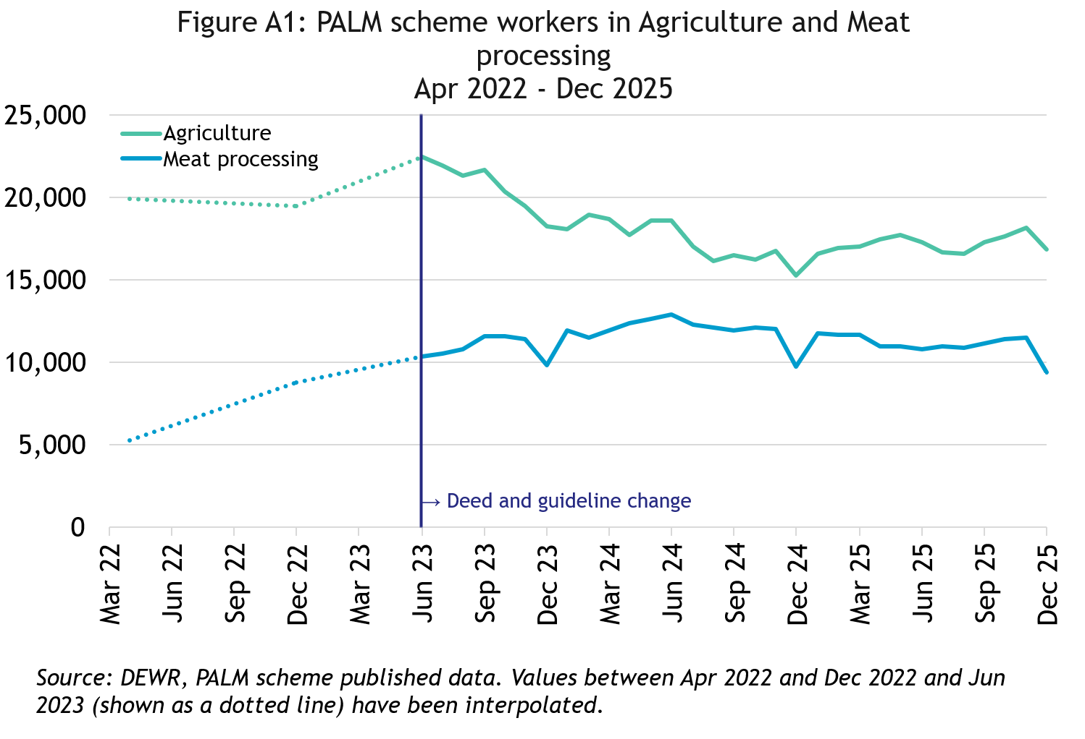
In December 2025, there were:
- 16,840 workers in Agriculture
- down by 15% since April 2022
- up by 10% in the 12 months to December 2025
- 83% were short-term
- 17% were long-term

- 9,365 workers in Meat processing
- almost doubled since April 2022
- down by 4% in the 12 months to December 2025
- 3% were short-term
- 97% were long-term

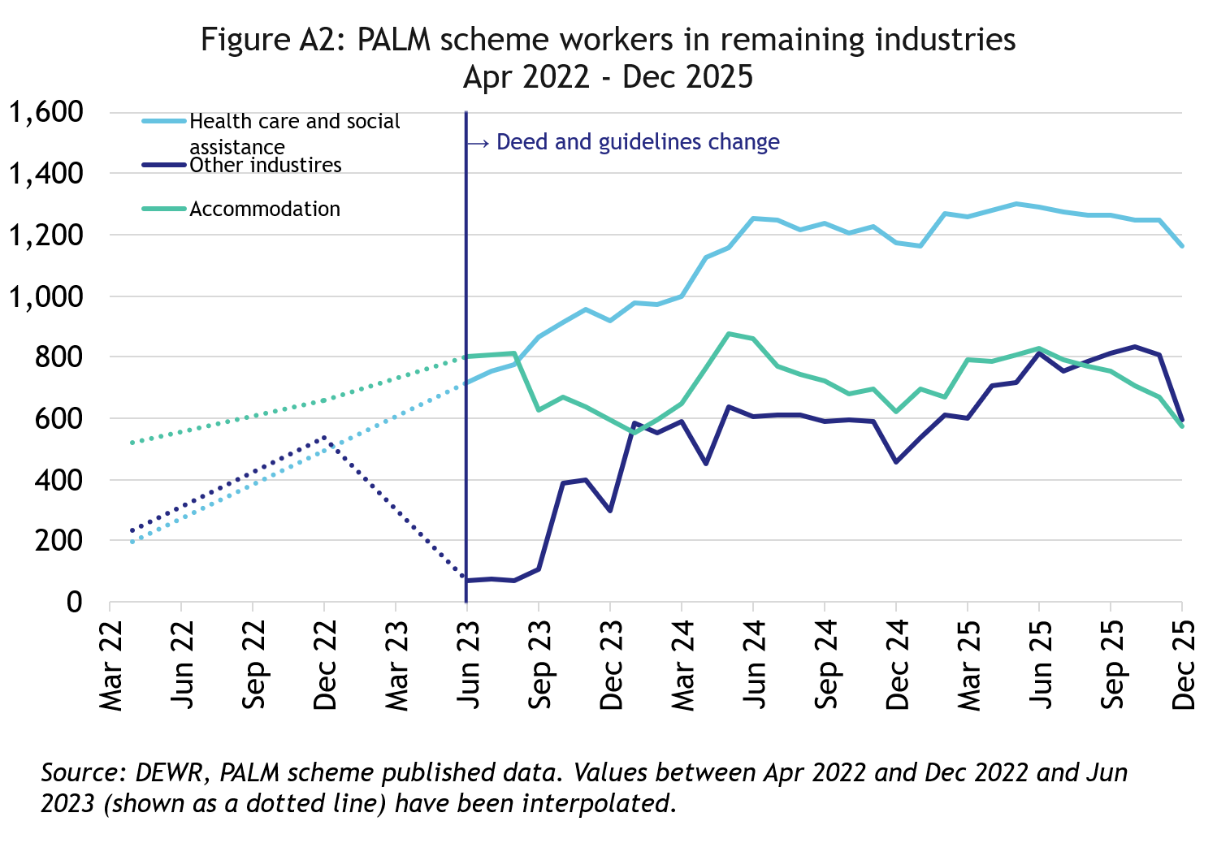

In December 2025, there were:
- 575 workers in Accommodation
- up by 11% since April 2022
- down by 7% in the 12 months to December 2025
- 21% were short-term
- 79% were long-term
- 1,160 workers in Health care and Social Assistance
- up significantly since April 2022
- down by 1% in the 12 months to December 2025
- all were long-term

- 595 workers in Other industries
- more than doubled since April 2022
- up by 31% in the 12 months to December 2025
- 20% were short-term
- 80% were long-term

PALM scheme worker trends by country of origin

Fiji

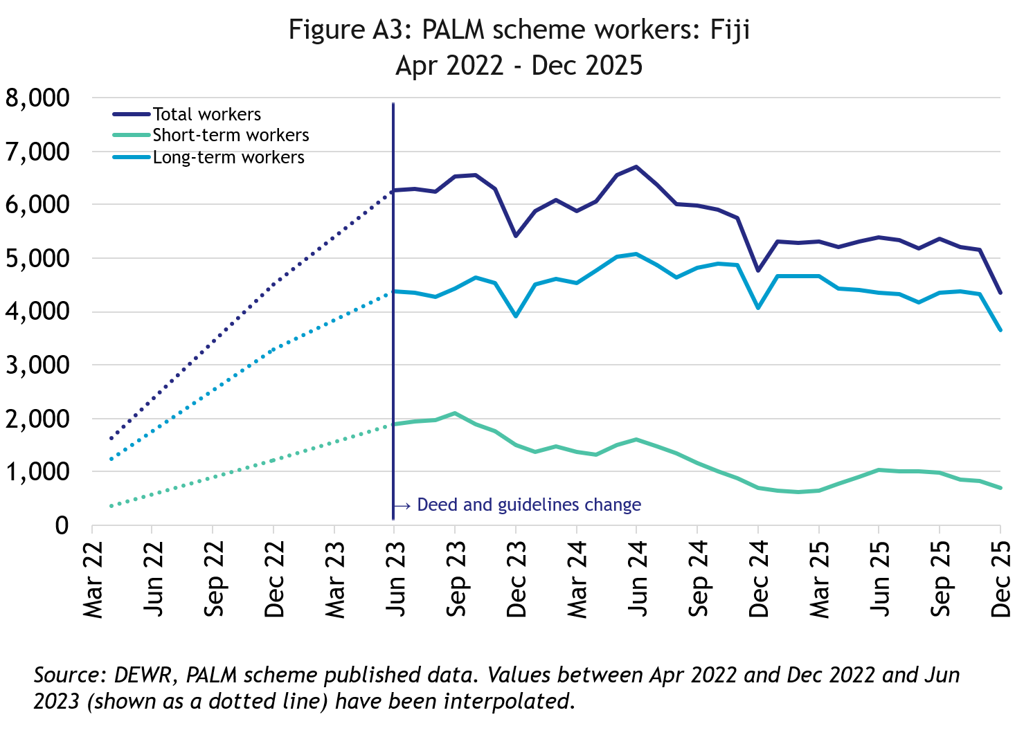
In December 2025, there were 4,355 workers from Fiji:
- More than doubled since April 2022
- down by 9% in the 12 months to December 2025
- 84% of Fijian PALM scheme workers were in the long-term stream

Kiribati

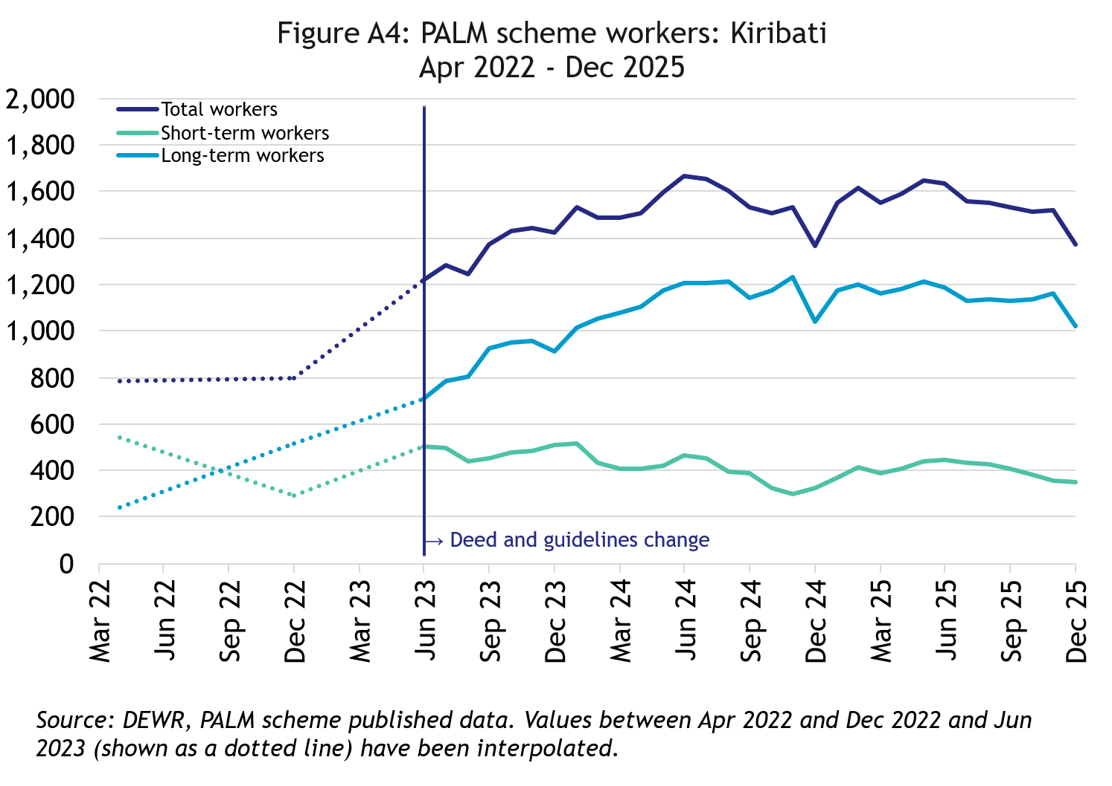
In December 2025, there were 1,375 workers from Kiribati:
- up by 75% since April 2022
- up by 1% over the 12 months to December 2025
- 74% of I-Kiribati PALM scheme workers were in the long-term stream

Nauru

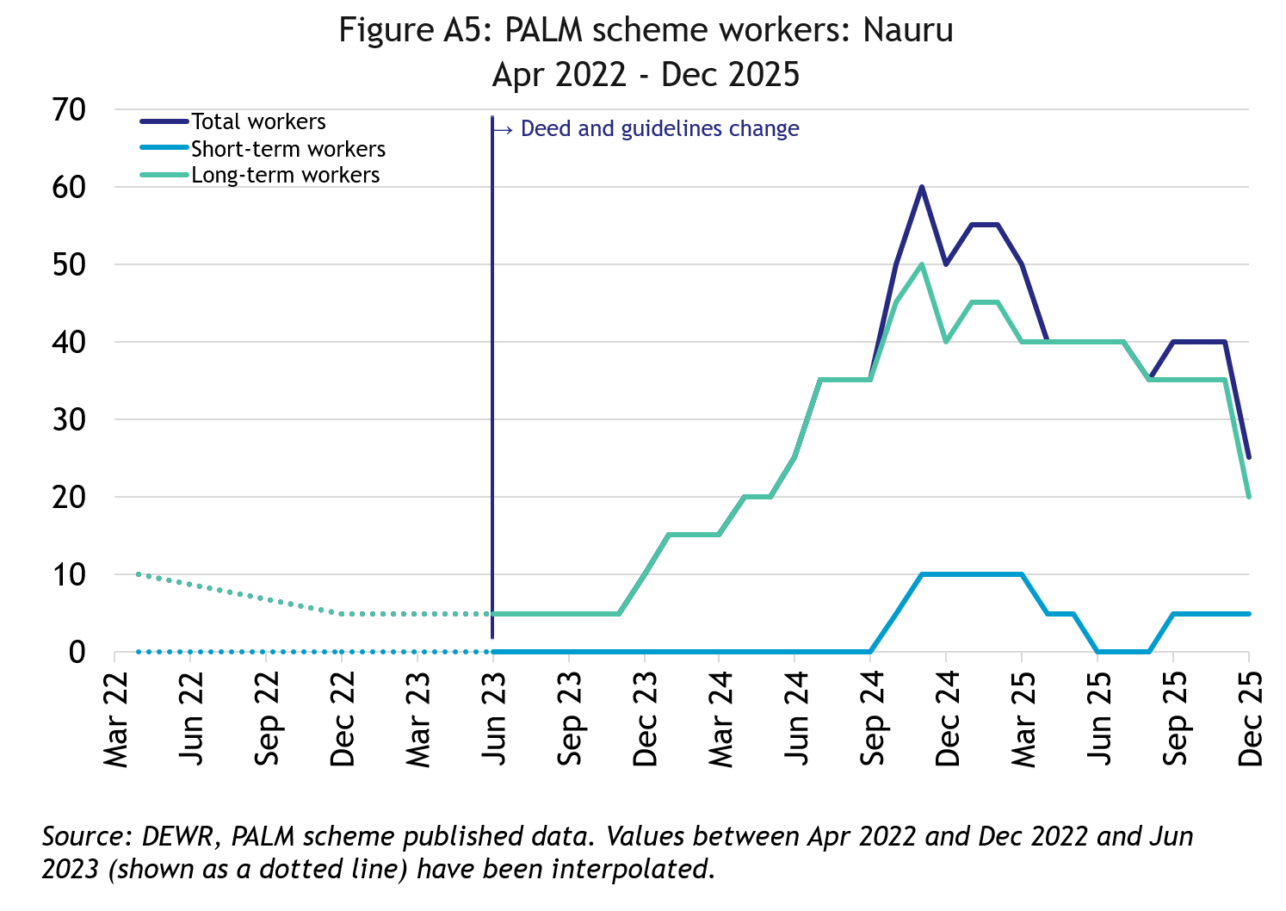
In December 2025, there were 25 workers from Nauru:
- up by significantly since April 2022
- down by 25 workers in the 12 months to December 2025
- 80% of the Nauruan PALM scheme workers were in the long-term stream

Papua New Guinea

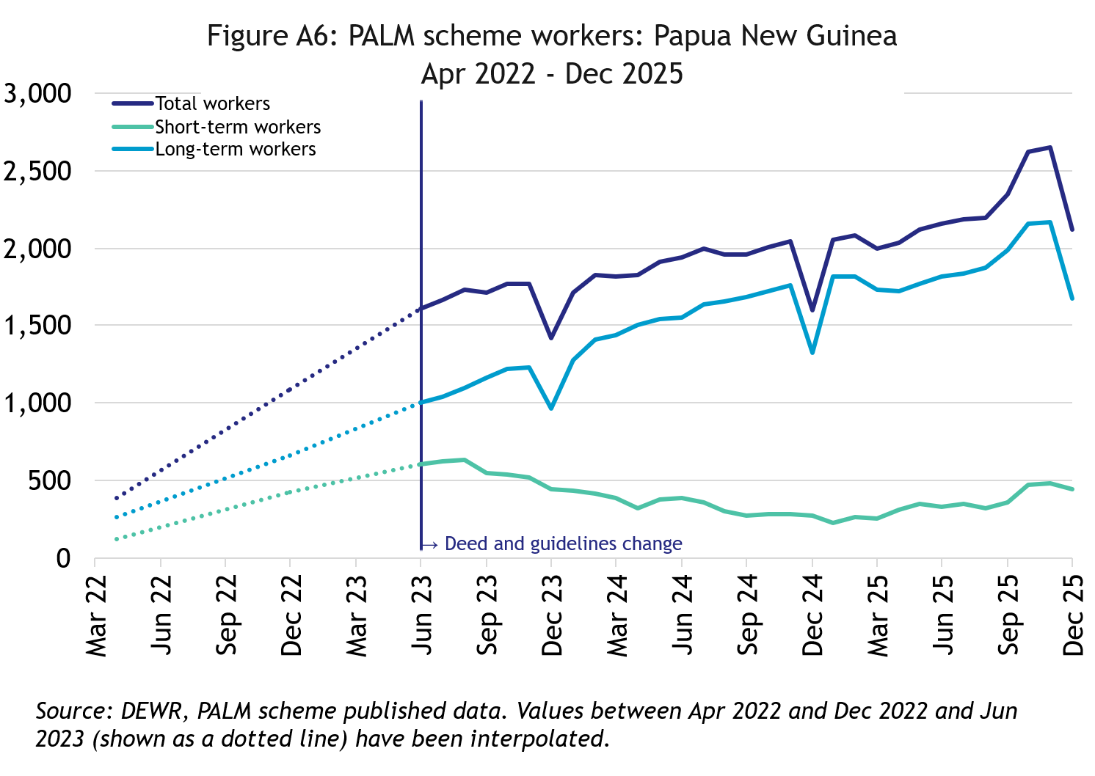
In December 2025, there were 2,120 workers from Papua New Guinea:
- up significantly since April 2022
- up by 33% in the 12 months to December 2025
- 79% of Papua New Guinean PALM scheme workers were in the long-term stream

Samoa

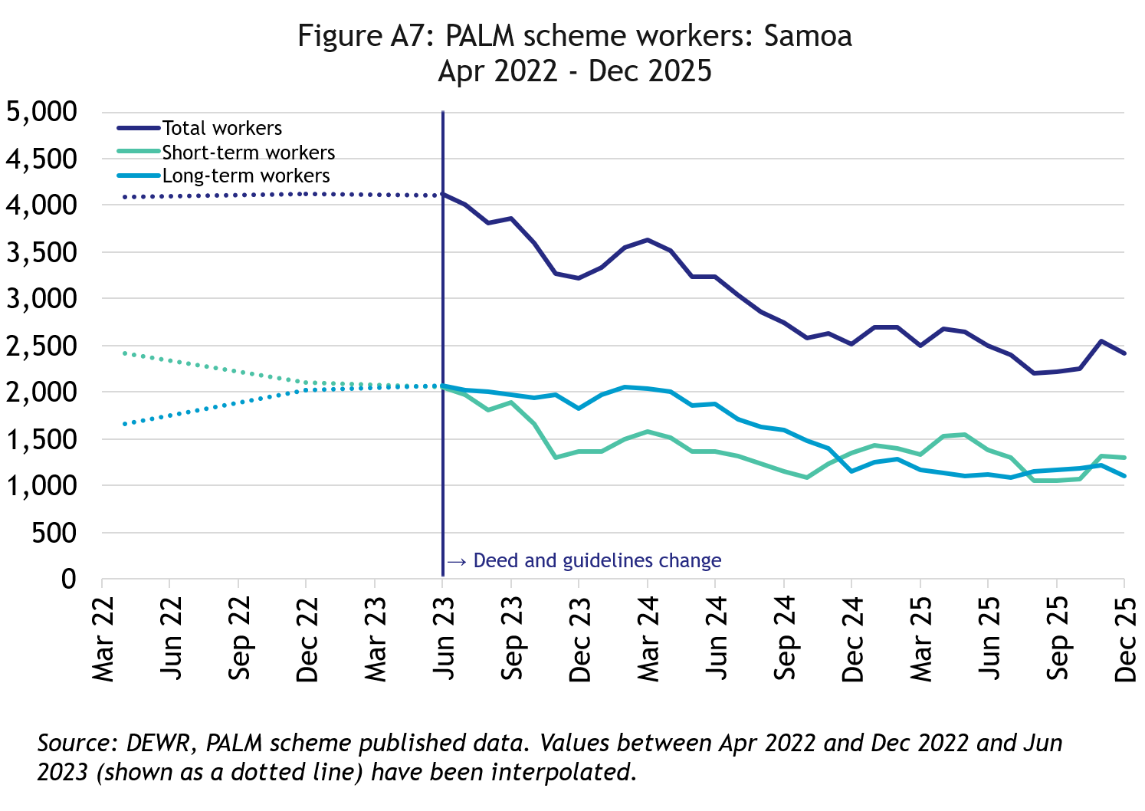
In December 2025, there were 2,410 workers from Samoa:
- down by 41% since April 2022
- down by 4% in the 12 months to December 2025
- 46% of Samoan PALM scheme workers were in the long-term stream

Solomon Islands

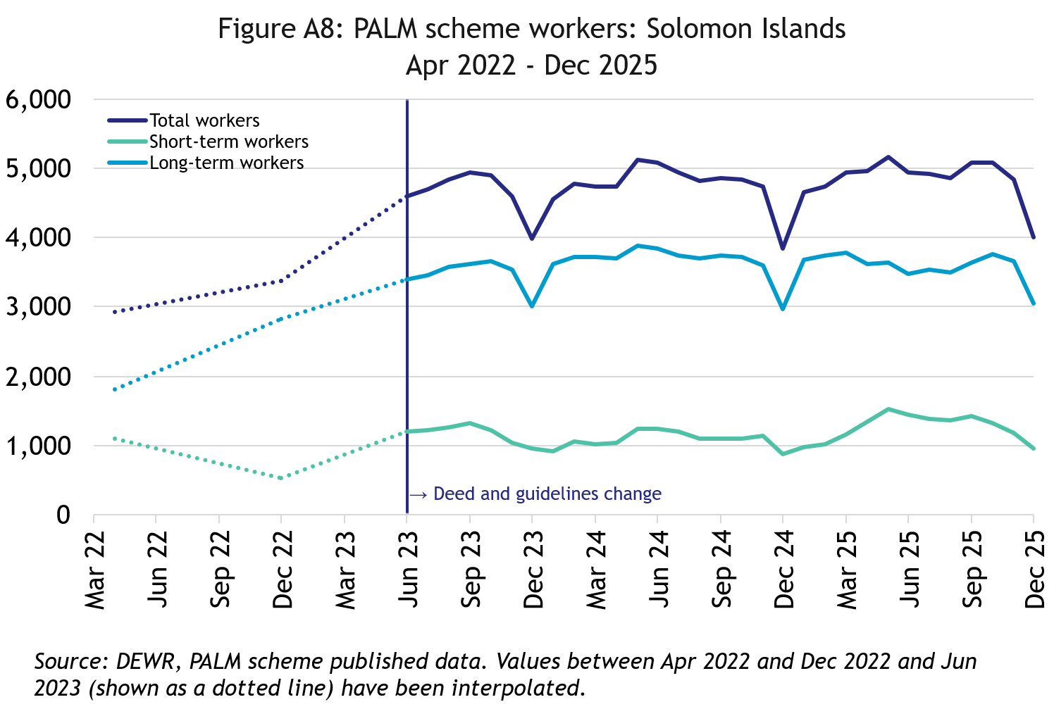
In December 2025, there were 4,010 workers from the Solomon Islands:
- up by 37% since April 2022
- up by 4% in the 12 months to December 2025
- 76% of Solomon Islander PALM scheme workers were in the long-term stream

Timor-Leste

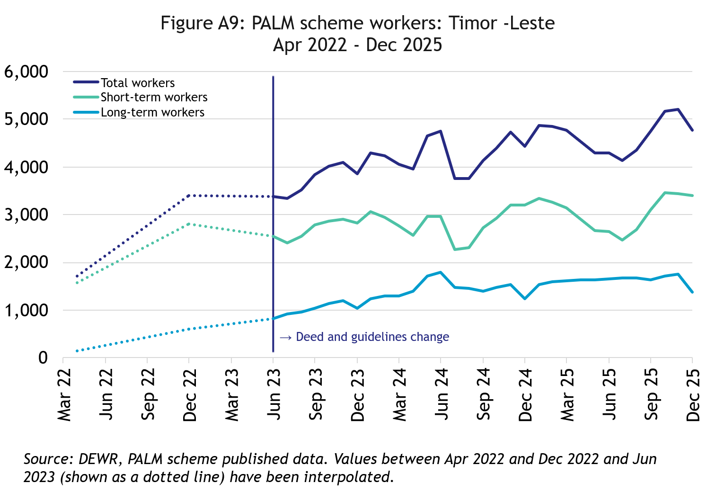
In December 2025, there were 4,770 workers from Timor-Leste:
- more than doubled since April 2022
- up by 8% in the 12 months to December 2025
- 71% of Timorese PALM scheme workers were in the short-term stream

Tonga

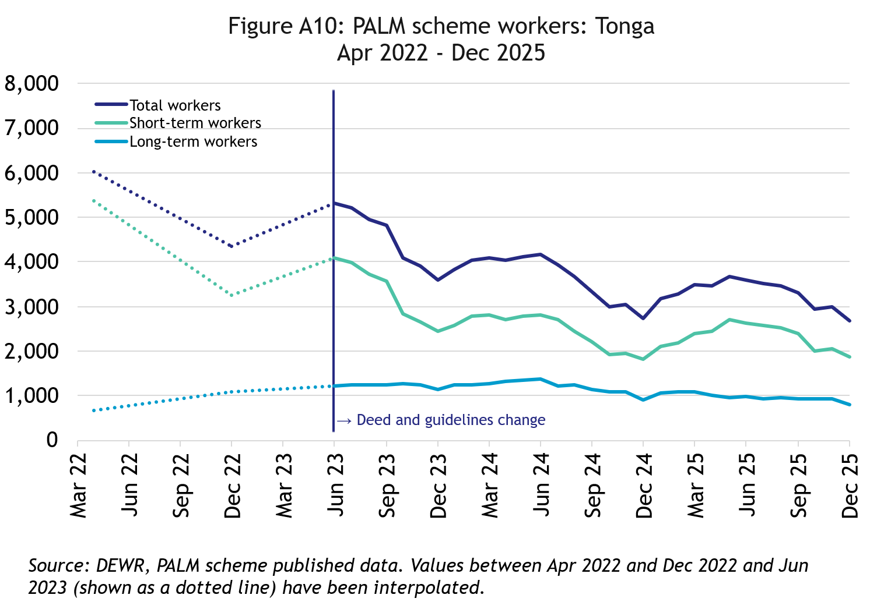
In December 2025, there were 2,680 workers from Tonga:
- down by 56% since April 2022
- down by 2% in the 12 months to December 2025
- 70% of Tongan PALM scheme workers were in the short-term stream

Tuvalu

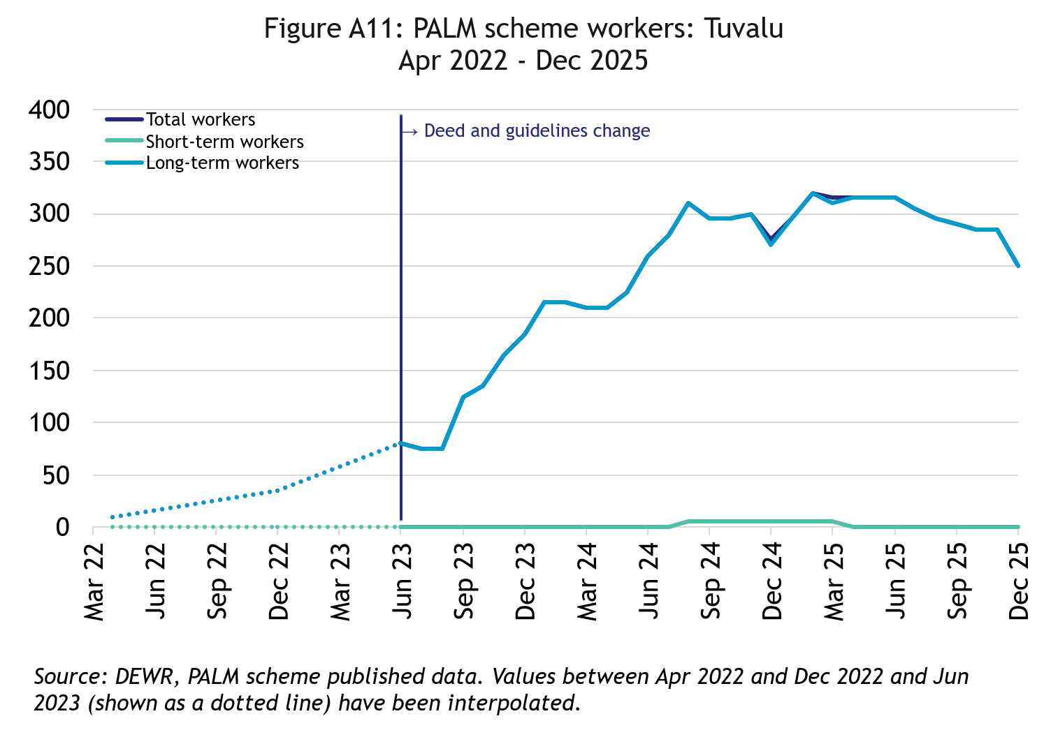
In December 2025, there were 250 workers from Tuvalu:
- a significant increase since April 2022, noting the historically very low number of workers
- down by 9% in the 12 months to December 2025
- All Tuvaluan PALM scheme workers were in the long-term stream

Vanuatu

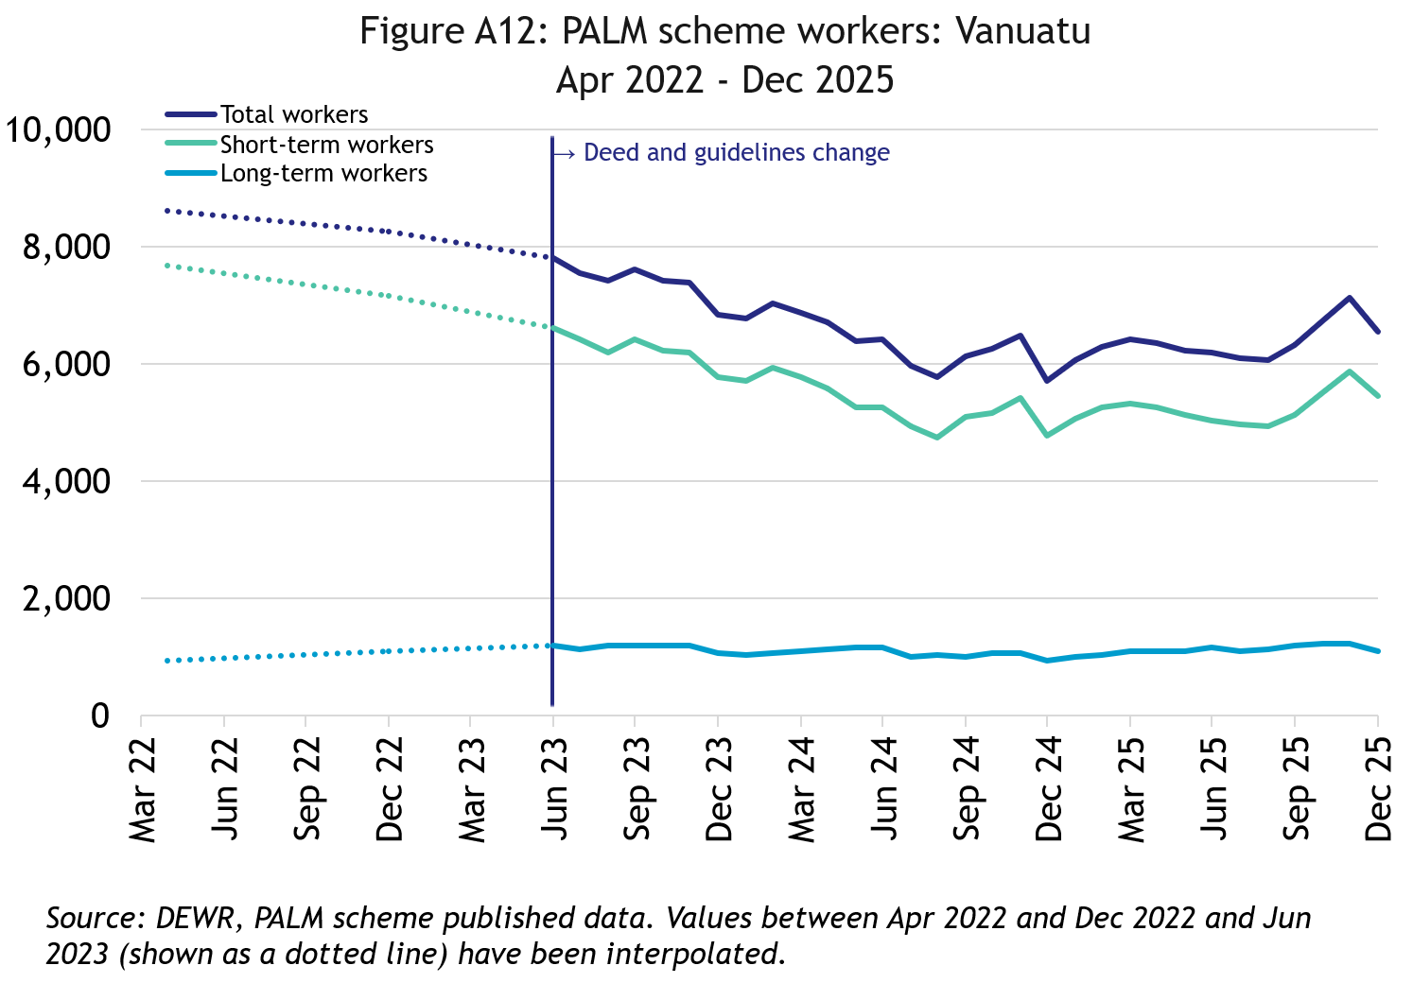
In December 2025, there were 6,540 workers from Vanuatu:
- down by 24% since April 2022
- up by 15% in the 12 months to December 2025
- 83% of ni-Vanuatu PALM scheme workers were in the short-term stream

PALM scheme worker trends by state/territory

New South Wales

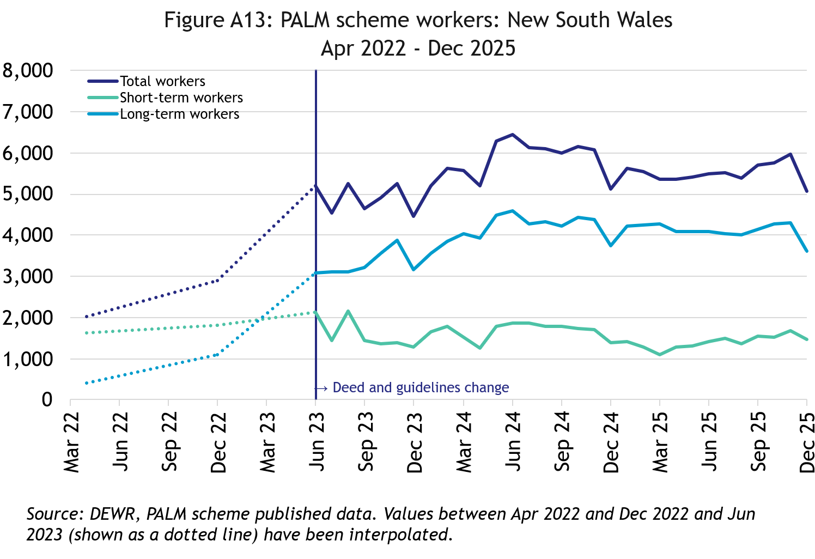
In December 2025, there were 5,075 workers in New South Wales:
- up by 151% since April 2022
- has remained at around the same level over the 12 months to December 2025
- 71% of New South Wales PALM scheme workers were in the long-term stream

Victoria

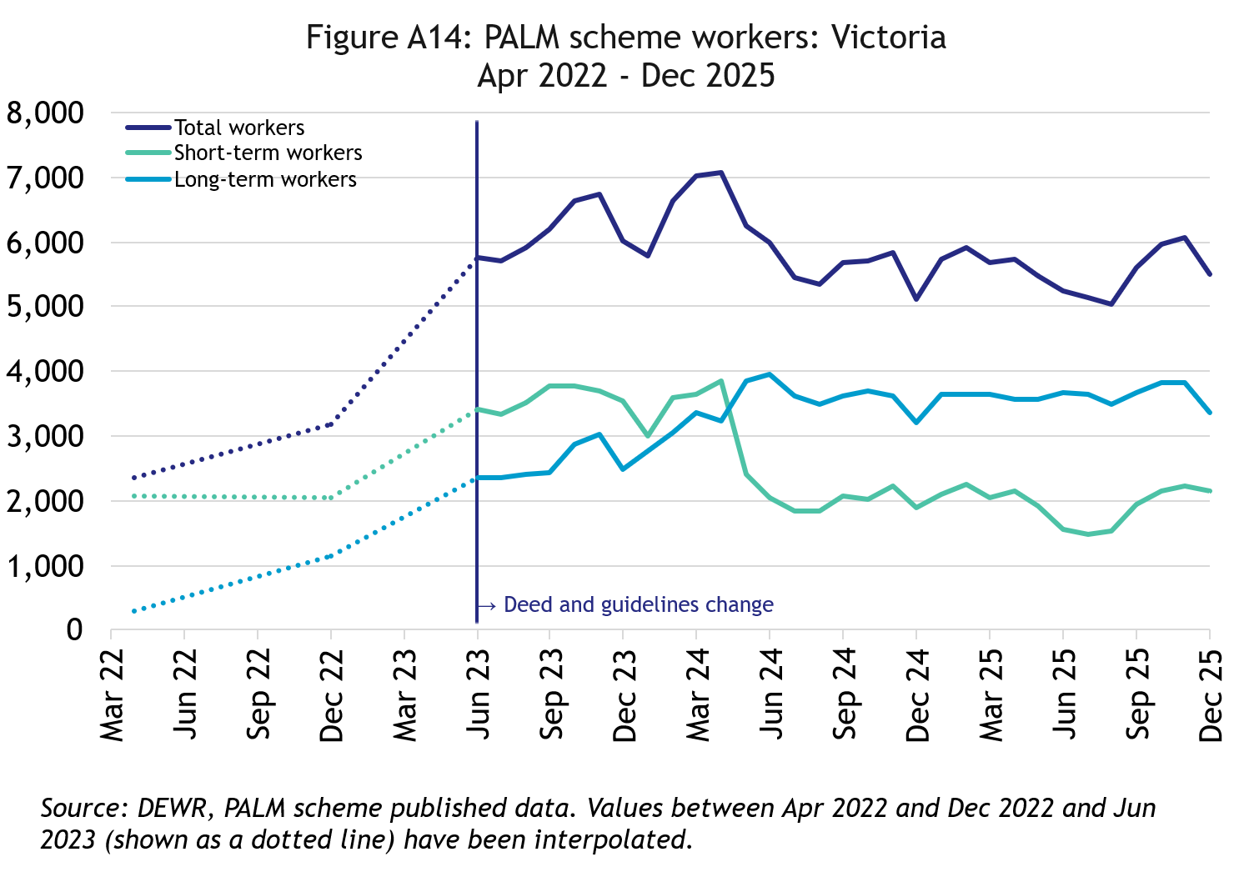
In December 2025, there were 5,495 workers in Victoria:
- up by 132% since April 2022
- up by 8% in the 12 months to December 2025
- 61% of Victorian PALM scheme workers were in the long-term stream

Queensland

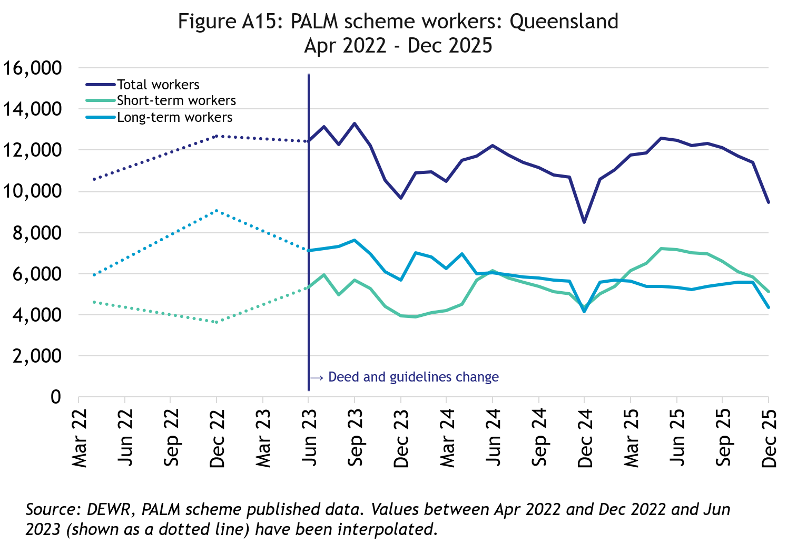
In December 2025, there were 9,485 workers in Queensland:
- down by 10% since April 2022
- up by 12% in the 12 months to December 2025
- 54% of Queensland PALM scheme workers were in the short-term

South Australia

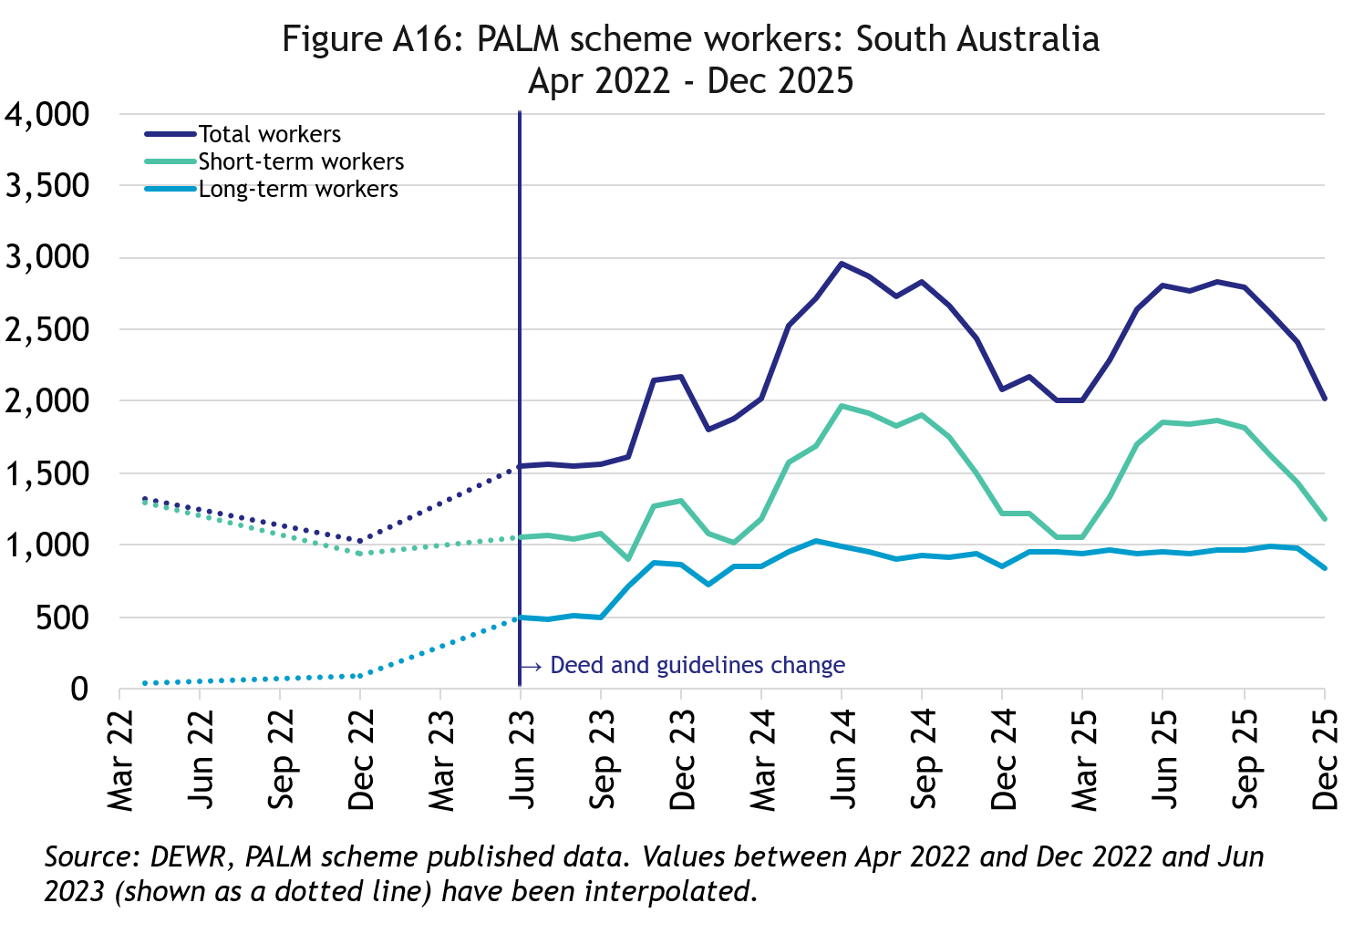
In December 2025, there were 2,015 workers in South Australia:
- up by 52% since April 2022
- down by 3% in the 12 months to December 2025
- 58% of South Australian PALM scheme workers were in the short-term stream

Western Australia

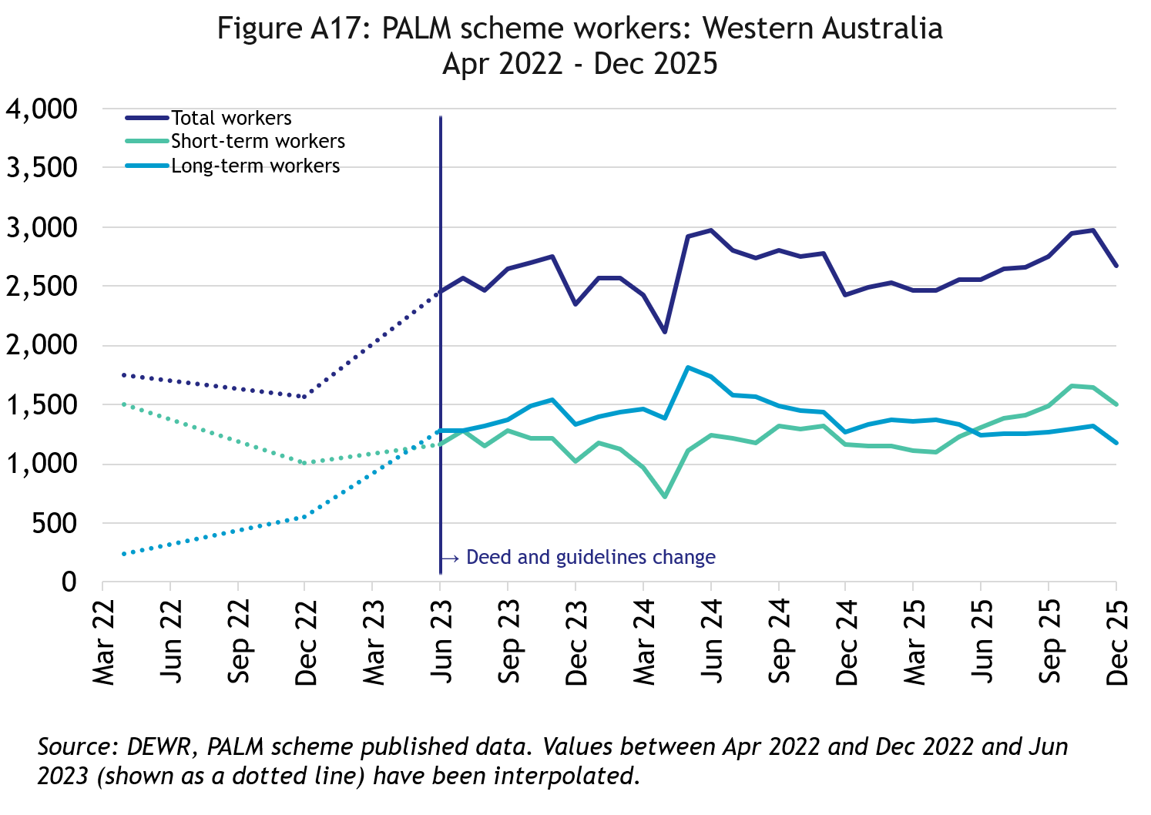
In December 2025, there were 2,675 workers in Western Australia:
- up by 53% since April 2022
- up by 10% in the 12 months to December 2025
- 56% of Western Australian PALM scheme workers were in the short-term stream

Tasmania

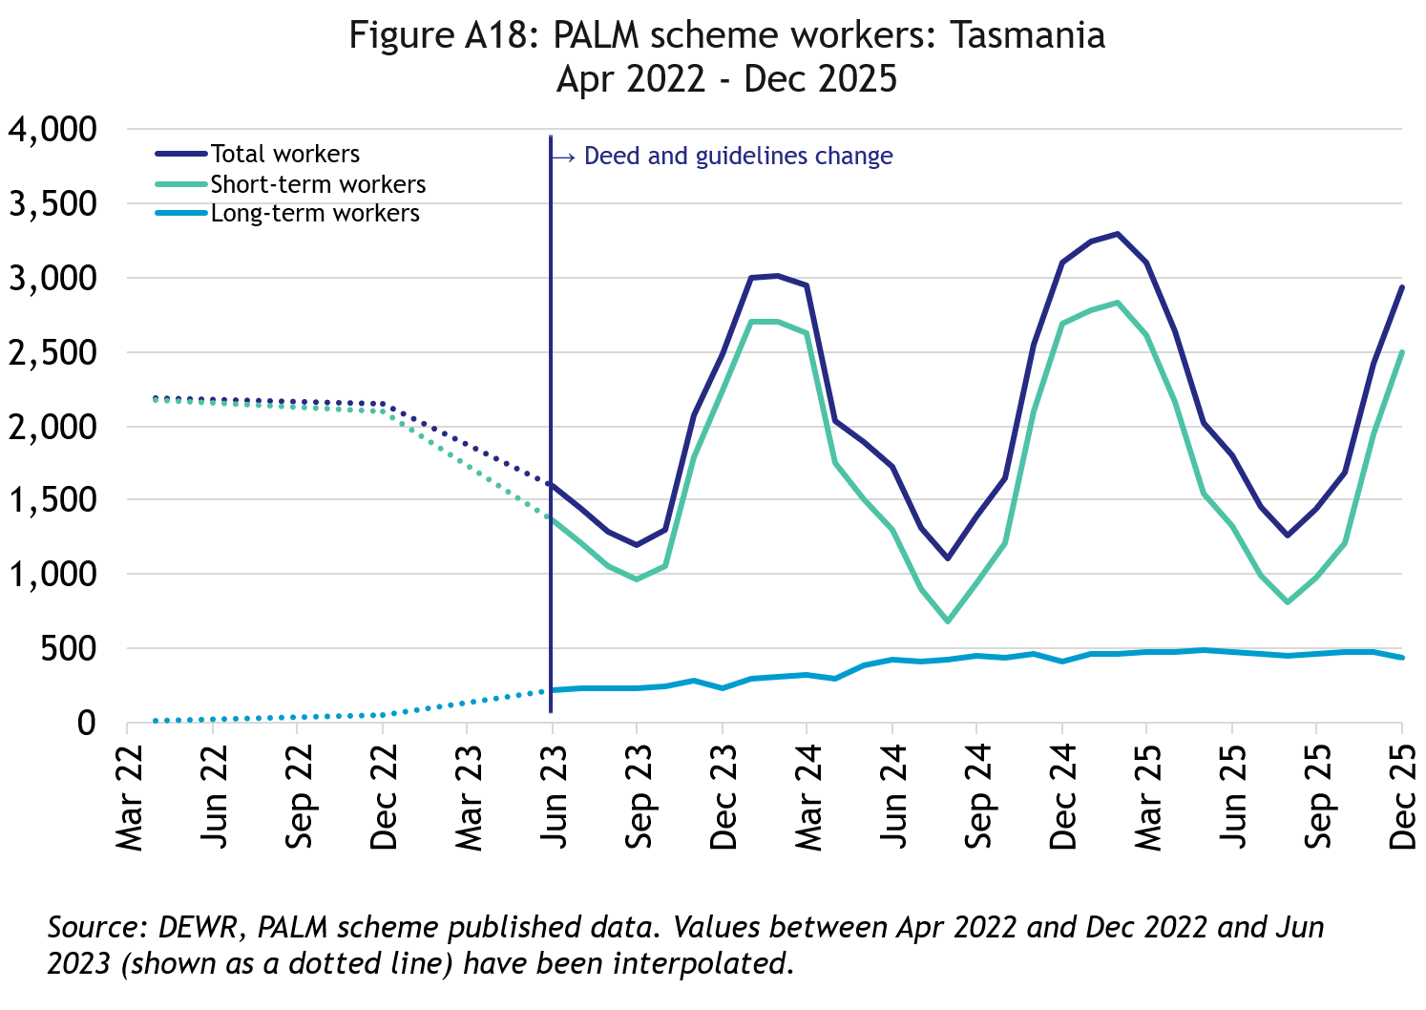
In December 2025, there were 2,935 workers in Tasmania:
- up by 34% since April 2022
- down by 5% in the 12 months to September 2025
- 85% of Tasmanian PALM scheme workers were in the short-term stream

Northern Territory

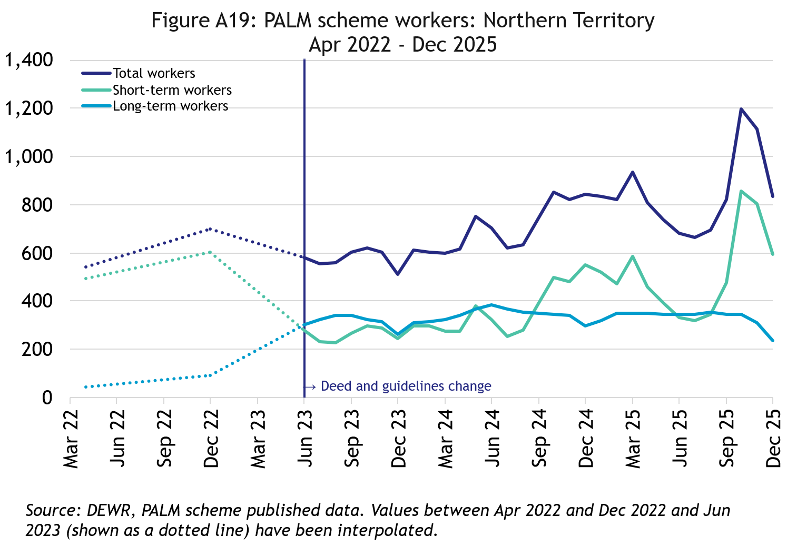
In December 2025, there were 835 workers in the Northern Territory:
- up by 55% since April 2022
- has remained at around the same level in the 12 months to December 2025
- 72% of Northern Territory PALM scheme workers were in the short-term stream

Australian Capital Territory

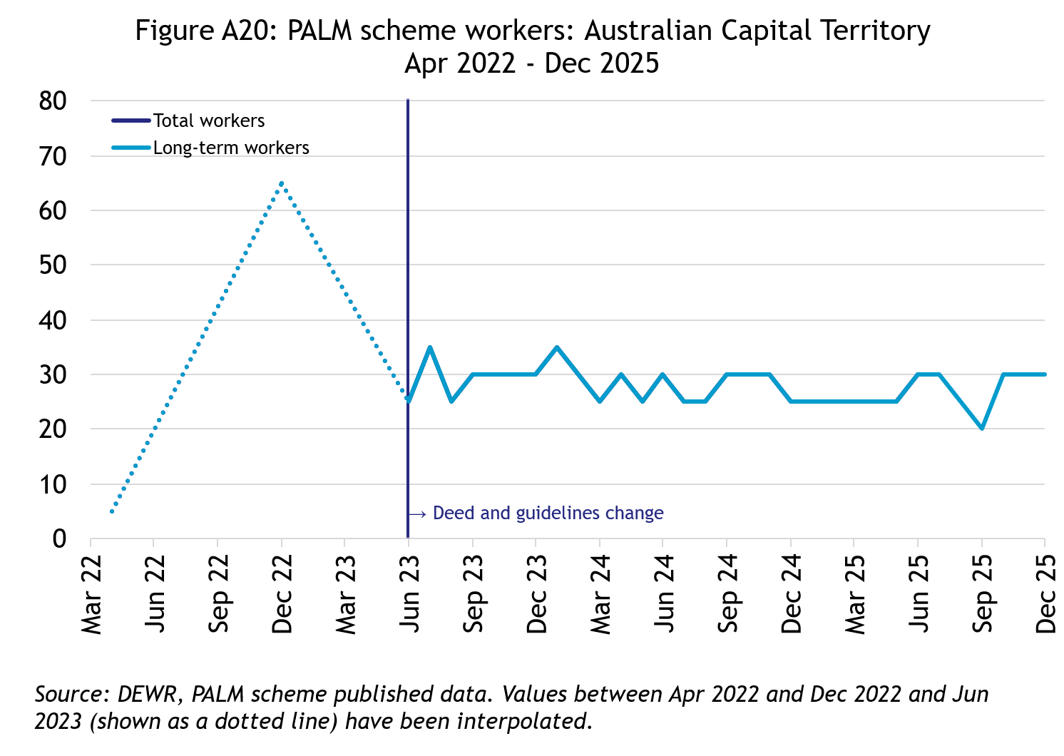
In December 2025, there were 30 workers in the Australian Capital Territory:
- broadly steady since mid-2023
- all PALM scheme workers in the Australian Capital Territory were in the long-term stream

Explanatory notes

Introduction
The PALM scheme allows Australian businesses to hire workers from 9 Pacific Island countries and Timor-Leste when there are not enough local workers available. Businesses who meet the eligibility criteria can access workers in the short-term stream (up to 9 months) and/or in the long-term stream (between one and 4 years).
PALM scheme employers in the agriculture sector and select agriculture-related food product manufacturing sectors can be based anywhere in Australia. All other sectors must be based in a regional or rural location.
For more information, refer to the PALM scheme website: www.palmscheme.gov.au.

Data sources
PALM scheme worker data is a combination of data from the Department of Employment and Workplace Relations (DEWR) IT systems and visa data sourced from the Department of Home Affairs. DEWR administrative data is stored in a live system and reliant on information entered by labour sending units located in each of the partner countries and PALM scheme employers.

Data confidentiality
To protect individuals’ privacy, all cells including any totals and subtotals have been rounded to the nearest 5; values from 1 to 7 are rounded to 5. Zero cells are actual zeros. This may result in non-additivity for some totals. Caution should be taken in recalculating totals from rounded data, as this may compound the effects of rounding.

Glossary
PALM scheme worker:
Citizen of a PALM scheme participating country who is issued an approved offer of employment in accordance with the PALM scheme deed and who is granted a PALM stream - temporary work (international relations) visa (subclass 403); or who held a pandemic event (subclass 408) visa
(up to December 2024).

PALM scheme worker data is derived by combining data from DEWR's IT systems and visa data sourced from the Department of Home Affairs. DEWR data is matched against visa data for comprehensive validation and used to construct valid and accurate counts for PALM scheme workers who are identified in visa data as onshore. Offshore visa holders are excluded from the counts.
Sex of PALM scheme worker:
The sex of PALM scheme workers is categorised into: Female, Male, and ‘not stated or inadequately described’. Note that ‘not stated or inadequately described’ includes: cases where sex is not missing or not captured in the data; where sex could not be accurately matched between data sources; or those who choose not to disclose their sex. Due to data collection limitations, it is not possible to distinguish between these subgroups.
PALM scheme worker data disaggregated by sex has been derived by matching PALM scheme worker data from internal DEWR systems and visa data from Home Affairs. PALM scheme data reports sex based on the data available at the time of data processing.
Reporting of PALM scheme worker data by sex aligns with ABS and DEWR standards for the reporting of sex and gender data.
PALM scheme employer:
An entity contracted by DEWR under the PALM scheme deed. Employers can be direct employers (arranges the placement of PALM scheme workers it employs with its own business) or labour hire organisations arranging the placement of PALM scheme workers it employs with host organisations using a labour hire arrangement.

Country of origin:
PALM scheme participating country that a PALM scheme worker is from. PALM scheme participating countries are Fiji, Kiribati, Nauru, Papua New Guinea, Samoa, Solomon Islands, Timor-Leste, Tonga, Tuvalu and Vanuatu.

‘Unknown’ country of origin is where country of origin cannot be determined for a PALM scheme worker due to incomplete data.

Stream:
Length of placement of employed PALM scheme workers. This is either 'short-term' or 'long-term':
- Short-term: a placement with short-term PALM scheme workers who hold the relevant visa and are employed in a contract of work for up to 9 months.
- Long-term: a placement with long-term PALM scheme workers who hold the relevant visa and are employed in a contract of work for up to 4 years (non-seasonal).
Industry:
Where possible, industries are classified to the Australian Bureau of Statistics Australian and New Zealand Standard Industrial Classification (ANZSIC). An individual business entity is assigned to an industry based on its predominant activity.

Due to gaps in data sources, a best-fit approach has been used to identify industry. ‘Role descriptions’ (which are job or occupation descriptions) may be used to help identify an accurate industry fit. PALM scheme data is reported to 5 key industry groups: Agriculture, Meat Processing, Accommodation, Health Care and Social Assistance, and Other industries.

- Agriculture:
Reflects workers in ANZSIC Division A: Agriculture, Forestry and Fishing.
- Meat Processing:
Includes Meat and Meat Product Manufacturing (a subset of the ANZSIC Division C: Manufacturing)
- Accommodation:
ANZSIC Division H: Accommodation and Food Services.
- Health care and social assistance:
ANZSIC Division Q: Health Care and Social Assistance. Includes aged, disability and other health care services, including residential care.
- Other Industries:
Includes all remaining industries, that are not otherwise classified to the industries above. Note that a small number of workers in manufacturing in non-meat processing (such as grain and cereal manufacturing, or textile or clothing manufacturing) are included in Other industries. Any workers in Retail are included in Other industries.

Citation
Any publications or reports using the data reported by DEWR must cite DEWR as the source. Where this data has been used for further analysis and interpretation, DEWR requests the inclusion of the following statement in the published report:
“The views expressed in this report are those of the authors and do not necessarily represent those of DEWR."

Contact
For any inquiries, please contact:
- for general PALM scheme enquiries: (PALM@dewr.gov.au)
- for PALM scheme data enquiries: (pacificlabourdata@dewr.gov.au).

