Grievance management policy
  - January 2024
Version 1.0

Table of contents
1. Purpose 3
2. Application 3
3. Scope 3
4. Principles 4
5. Things to consider before lodging a grievance 5
5.1 Grievance submitted by a worker, or a representative on behalf of the worker: 5
5.2 Matters for other organisations 6
5.3 Anonymous tip offs 6
5.4 Anonymity and confidentiality 6
5.5 Referral to police or support services 7
6. How to lodge a grievance 7
7. Grievance handling process 7
7.1 Lodgement 8
7.2 Acknowledge 8
7.3 Assess 8
7.4 Action – early resolution 8
7.5 Action - investigation where required 9
7.6 Communicate the outcome 10
7.7 Review 10
7.8 Unreasonable conduct 11
7.9 Learn from feedback received 11
8. Contact information 12
Annex A: first response escalation process 13
Annex B: grievance lodgement form 14
Annex C: grievance process map 18

Purpose

The Australian Government is committed to protecting and supporting workers under the Pacific Australia Labour Mobility (PALM) scheme.

The domestic operations of the PALM scheme are managed by the Department of Employment and Workplace Relations (DEWR). DEWR works closely with other responsible government agencies including the Department of Foreign Affairs and Trade, Department of Home Affairs, Australian Border Force, and the Fair Work Ombudsman to maintain integrity of the scheme.

The purpose of the grievance management policy is to provide clear information and guidance outlining how the department will manage grievances of PALM scheme workers to ensure that grievances are managed in a way that is fair, accessible, responsive, efficient, and integrated within the PALM scheme’s core business.

The PALM scheme Deed of Agreement (Section 36) and Approved Employer Guidelines (Section 9.12) outline the requirements a PALM scheme employer must adhere to in relation to establishing and publicising the existence and details of their feedback system, and how they will manage PALM scheme worker grievances.

For the purpose of this policy, the ‘department’ will be used to reference DEWR.

Application

For the purposes of this policy, a grievance can be defined as:

‘a complaint or a strong feeling that you have been treated unfairly’

A grievance can be reported to the department by:
- A PALM scheme worker (including current or past workers), or a representative on behalf of the worker.
- Any other person e.g., a PALM scheme stakeholder.

Scope

A grievance process is a best practice approach to deal with conflicts between employees and employers. The grievance management policy sets out the approach for dealing with grievances in the PALM scheme to ensure conflicts are dealt with in a timely and unbiased way, while also ensuring employees feel comfortable to raise issues of concern so that they can be resolved.

The approach outlined in the grievance management policy seeks to achieve solution-based outcomes and advice where an issue has not been resolved between a worker and an employer.

This policy outlines the principles and processes that will guide the management of grievances including:

- things to consider before reporting a grievance
- processes of early intervention to resolve grievances before they escalate
- how to report a grievance
- how the department will manage the grievance, including documented timeframes and communication methods
- referrals to other agencies, where appropriate
- review options available if the person lodging the grievance is not satisfied with the outcome.

Grievances lodged with the department will be acknowledged, assessed, actioned and outcomes communicated in accordance with the principles documented in this policy.

Principles

The principles in this policy are based on those set out in the Better Practice Complaint Handling Guide published by the Commonwealth Ombudsman. The department is focused on managing grievances in a confidential and supportive manner, in line with the following principles.

Fair | Grievances will be dealt with impartially, proportionately (seriousness) and with appropriate empathy. There will be no adverse repercussions for lodging grievances with the department.
Accessible | Information about how to report a grievance is easily available and can be made using a variety of channels, including online, verbally and in writing.
Responsive | Grievances will be responded to appropriately including extending special assistance to vulnerable people where appropriate.
Efficient | Grievances are resolved as quickly as possible. The grievance process commits to a respectful, solutions-focused approach.
Transparent | The grievance process aims to ensure involved parties are kept informed of the progress of the matter. Steps, timelines, and outcomes related to grievance management are clearly set out from the commencement of the process.
Integrated | Grievance management is integrated with the department’s core business activities so that any lessons or systemic issues can be appropriately reflected in future practice.

Things to consider before lodging a grievance

PALM scheme workers, employers and stakeholders are encouraged to discuss issues early to seek resolution of grievances informally, prior to submitting a formal grievance to the department. The requirements for action and recording grievances are outlined in the PALM scheme deed and guidelines. Workers or a representative acting on behalf of the worker may be referred to the PALM scheme first response escalation process (refer annex A) for information on assistance available to seek a remedy based on the issue.

5.1 Grievance submitted by a worker, or a representative on behalf of the worker:

The following should be considered prior to lodging a grievance:

- Has there been an attempt to resolve the issue/s or concern/s informally or directly with the person/s involved?
- Has the employer or their appointed welfare and wellbeing support person been given an opportunity to resolve the issue prior to a grievance being lodged with the department, in accordance with the PALM first response escalation process?
- Would the assistance of a foreign government representative such as a labour attaché or country liaison officer assist in seeking a resolution or with the submission process?
- Where a grievance is being reported on behalf of a worker, has appropriate consent been obtained to act on the worker’s behalf?

If you are submitting a grievance on behalf of a worker, you should also consider:

- Is it appropriate or safe for the worker involved to discuss directly with the employer involved?
- Is there an avenue for you to support the worker in question to be directly involved in the grievance process, including direct lodgement?
- Is the individual/s in question available to be contacted directly?
- Can the claims be verified?
- Can documented evidence be provided to support the claims, including photos and other media?
- Do you have relevant consent to disclose personal information of others?

Before lodging a grievance, it is important to provide as much information as possible. Where the department is not provided adequate detail and evidence to support the concerns raised, a finalised outcome may not be possible.

5.2 Matters for other organisations

If a grievance relates to a matter that another organisation or government agency is better placed to investigate or support, the department will direct the grievance to the relevant organisation such as a service provider, state or territory agency or regulator, or federal government agency. The referral of these grievances to external agencies or organisations will be managed in accordance with the Privacy Act 1988, including seeking appropriate permissions to share personal information.

Where a grievance involves matters that relate to suspicious or illegal immigration or visa issues the issue should be submitted to Border Watch online. Grievances that involve matters that may relate to criminal activity should be submitted to local law enforcement. Notifications that include potential breaches of work health and safety (WHS) law or involve requests for worker compensation may be referred to relevant WHS regulators through Safe Work Australia. The Fair Work Ombudsman may also be a referral point for advice and investigations into workplace rights, or where there is evidence of award breaches.

The department will continue to liaise directly with the referral agency to remain informed of the investigation and any potential next steps required.

5.3 Anonymous tip offs

The wellbeing of workers is at the heart of the department’s approach to the PALM scheme and the department strongly encourages all issues to be reported.

Anonymous submissions will be accepted however action and investigation of concerns will require the lodging person to provide adequate details of the issue, including any names of workers or employers, and relevant supporting evidence.

The department strongly encourages that individuals providing an anonymous tip off address the issues in a constructive manner and have attempted to raise the issue with the employer or involved individuals directly, if appropriate, to allow for the greatest opportunity to seek resolution.

5.4 Anonymity and confidentiality

If a person does not feel comfortable raising their concerns for fear of reprisal, they may choose not to disclose their identity.

The department takes very seriously any adverse actions or impacts for workers who lodge a grievance in accordance with relevant protections under Australian whistleblower legislation, Treasury Laws Amendment (Enhancing Whistleblower Protections) Act 2019.

5.5 Referral to police or support services

If the grievance raised poses significant harm to one or more individuals or an allegation of criminal conduct, the matter will be referred to the police or other appropriate authority, having regard to privacy considerations and confidentiality requirements. The person lodging the grievance may also be encouraged to report to these agencies.

If the worker is feeling distressed, it may be appropriate to advise of support services available (section 8).

How to lodge a grievance

The preferred approach is for grievances to be lodged using the grievance lodgment form at Annex B, as this form helps to capture relevant information to assist with the initial assessment of concerns. Grievances can also be otherwise lodged in writing or verbally through the following means:

Email: (palm@dewr.gov.au)
Call: 1800 51 51 31

Where a grievance has been lodged verbally and there is uncertainty about the situation, or if the grievance raises complex or serious matters, the department may encourage the grievance to be submitted in writing. This will assist the department to thoroughly investigate the grievance.

Grievance handling process

The department recognises that grievances will vary widely in nature and content. Grievances will be managed on a case-by-case basis in line with the principles and processes detailed in this document. Workers will be provided with a process map (annex C). Grievances received will be triaged prior to formal acknowledgement with any that pose a threat of mental or physical harm given priority and escalated outside of standard processing times.

Both the PALM scheme deed (section C1.4 36) as well as the guidelines (9.12) stipulate the obligations of employers regarding handling grievances.

7.1 Lodgement

Grievance notification received from worker or representative acting on behalf of a worker (union representative, foreign official, community representative etc).

7.2 Acknowledge

The department will:

- Acknowledge the grievance within 3 working days.
- Explain the standard grievance process.
- Provide the grievance timeline.
- Provide contact details for queries.

The department will attempt to acknowledge the grievance in writing. Acknowledgement of grievances may occur by phone where the person specifically requests not to receive written correspondence.

The department will expedite grievances received where there appears to be a high risk to safety of workers or where the situation involves potential criminal conduct, including referrals to other agencies as per sections 5.2 and 5.5.

7.3 Assess

Grievances will be triaged for assessment and where relevant, referral to another agency better placed to address the grievance.

Where a grievance is low risk/sensitivity and has not yet been raised through an informal resolution process, the department may advise the person lodging the grievance to contact the employer first to attempt to resolve, giving them the opportunity to resolve the issue informally. Where this results in a successful outcome, the department may conclude the grievance process, however the worker or representative acting on behalf of the worker will be able to resubmit the grievance where a successful resolution is not maintained.

If a real or apparent conflict of interest exists in relation to a particular PALM scheme staff member being involved in the assessment of the grievance, it will be referred to another staff member or team.

7.4 Action – early resolution

Early resolution meeting

The department may seek to convene and facilitate an early resolution meeting to address a grievance.
The department will endeavor to arrange an early resolution meeting within 10 working days of the grievance being acknowledged by the department.

The grievance early resolution meeting may include the following participants:

- departmental representative
- PALM scheme employer representative
- PALM scheme worker and/or a nominated representative
- PALM scheme sending country government representative (if requested by
the worker).

While the department encourages PALM scheme workers to participate directly in an early resolution meeting with their employer, it is recognised that a worker may not feel comfortable in some circumstances to do so. A worker is able to nominate another person to represent them at a meeting. If there are multiple workers who have lodged the grievance, the workers may identify a single representative to act on their behalf or take part in the meeting as a group.

The department will endeavour to create a safe and secure environment for all parties involved in the early resolution process.

The department may recommend actions to be taken by participants to resolve the grievance.

The department will aim for a resolution to a grievance that is not referred to other bodies within 20 working days of the grievance being acknowledged by the department.

7.5 Action - investigation where required

If the grievance cannot be resolved through the early resolution approach, the matter will be passed on for assessment and investigation. A certain level of evidence may be required to escalate to formal investigation however the department will assess grievances based on the balance of probabilities.

The purpose of an investigation is to try to resolve the grievance by reaching a fair and independent decision on the established facts and the actions to be taken by involved parties to rectify the issues. Factual evidence will be sought as part of the investigation process and options considered for grievance resolution.

An investigation plan may be required with the following considerations:

- what needs to be investigated
- the steps required in the investigation
- what information or evidence will be required and how it may be obtained
- the remedy sought and whether the expectation is realistic or needs to be managed
- any special considerations that apply to the grievance
- estimated timeframe for completion.

If the investigation will be lengthy, the department will provide an update to the person lodging the grievance on the revised timeline for an outcome and response.

7.6 Communicate the outcome

Potential outcomes (or actions resulting) of an early resolution meeting

- An employer may be required to take actions, for example rectifying an issue or providing the worker with additional information.
- The worker may be required to take actions.
- If certain criteria are met, the department may recommend that the worker be redeployed to another employer.
- If the submitted grievance results in an investigation (section 7.5), the department can take actions in accordance with the guidelines, chapter 14 - scheme assurance.

The department will contact the parties to confirm actions from an early resolution meeting are/have been enacted. The grievance will be finalised and all parties informed in line with privacy and confidentiality laws.

Wherever possible the grievance outcome will be provided to the worker directly. For third-party submissions, permission will be sought to share information from the worker.

Communication of the outcome will be clear and informative and in line with privacy and confidentiality requirements. There may be limitations on the extent of the information that can be provided in a response, for example, to protect personal privacy.

Where appropriate the communication of the outcome will be made in writing. The department will ensure it responds to grievances in a manner that is accessible and easy to understand taking into consideration any communication requirements including, translation requirements, cultural preferences, and any reasonable requests that the worker may have.

7.7 Review

If the worker who lodged the grievance is not happy with the resolution, outcome, remedy, or advice, they may request a review by:

- getting in touch with the grievance contact officer
- emailing (palm@dewr.gov.au).
If the worker who lodged the grievance is still not satisfied, they may pursue an independent review by the Commonwealth Ombudsman. Further information is at https://www.ombudsman.gov.au/how-to-make-a-complaint.

7.8 Unreasonable conduct

Where the department considers that a PALM scheme worker or a representative acting on behalf of a worker is engaging in unreasonable conduct, the matter will be managed in accordance with the PALM unreasonable conduct policy.

Unreasonable conduct may include:

- persistently asking for solutions which are unreasonable, disproportionate, or not possible
- insisting on speaking to the head of the department
- seeking to direct the department on how to handle feedback and grievances
- aggressive language or behaviour.

7.9 Learn from feedback received

Insights identified through the grievance resolution process may be used to continuously improve PALM scheme systems and processes to optimise high-quality program delivery. This may include sharing de-identified issues and resolutions with stakeholders to support capacity building.

The department will review this policy on an annual basis in consultation with relevant stakeholders.

Contact information

PALM scheme
PALM scheme support service line | 1800 51 51 31 - 8:30 am to 6:30 pm (AEST), Mon-Fri
PALM scheme support service email | (palm@dewr.gov.au)

Wellbeing support services
Lifeline | 13 11 14
Beyond Blue | 1300 224 636
Health Direct | 1800 022 222

Useful agency contacts
Country liaison officers | https://www.palmscheme.gov.au/contact
Fair Work Ombudsman | Contact us - Fair Work Ombudsman  FWO anonymous report  Workplace relations in Australia presentation package  13 13 94 – Information line 8:00 am to 5:30 pm Monday to Friday (excluding public holidays)  13 14 50 – If you need an interpreter
Fair Work Commission | https://www.fwc.gov.au/
Australian Human Rights Commission | https://humanrights.gov.au/our-work/employers/quick-guide-australian-discrimination-laws
Department of Home Affairs | Border Watch Online Report
Safe Work Australia | WHS regulators and workers' compensation authorities contact information | Safe Work Australia

Useful links
PALM scheme website | PALM scheme Approved Employer Guidelines
PALM scheme Deed of Agreement | Worker Support for PALM scheme

Annex A: first response escalation process
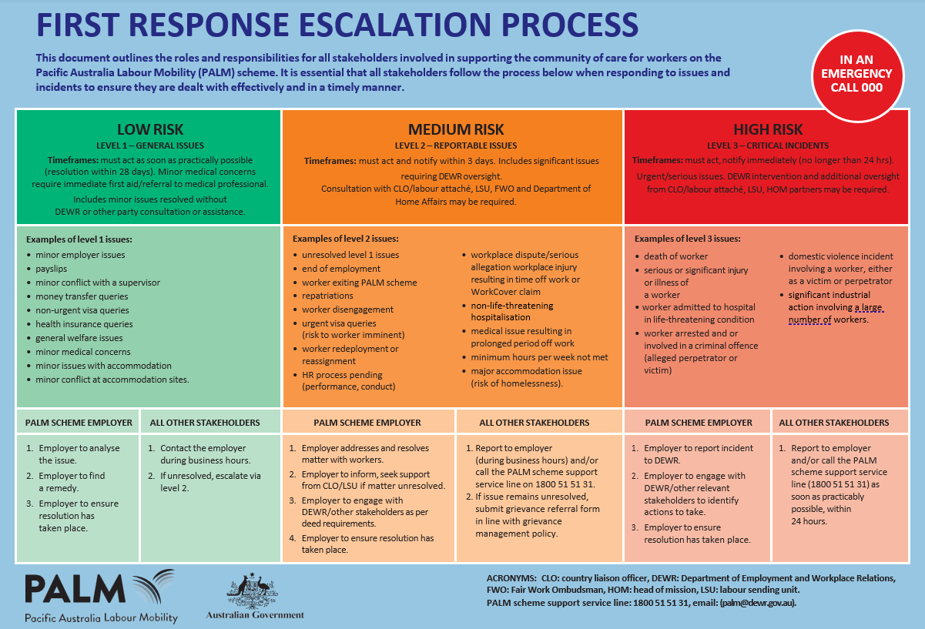

Annex B: grievance lodgement form
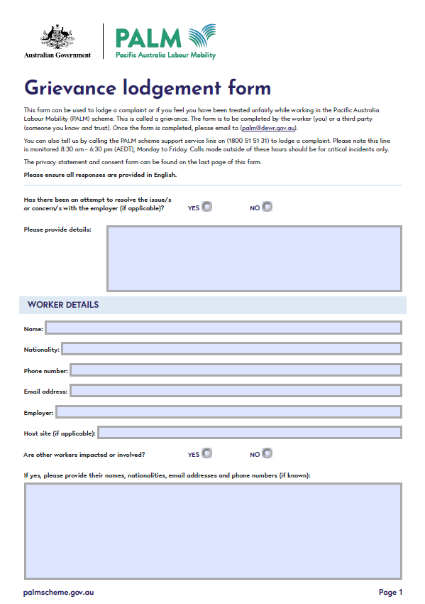
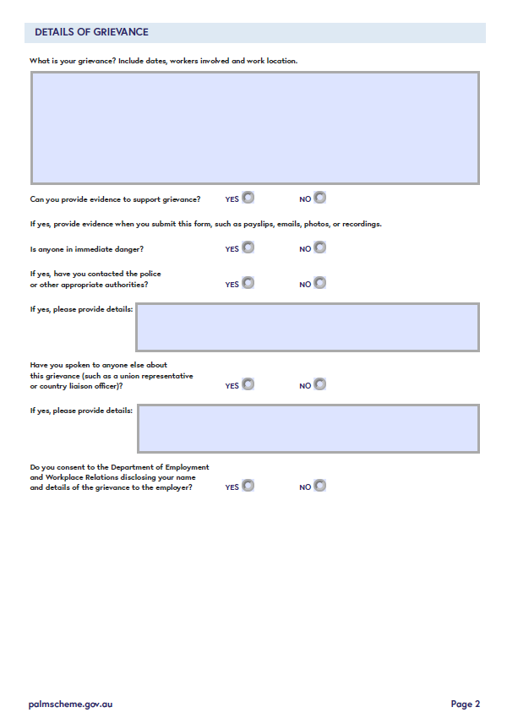
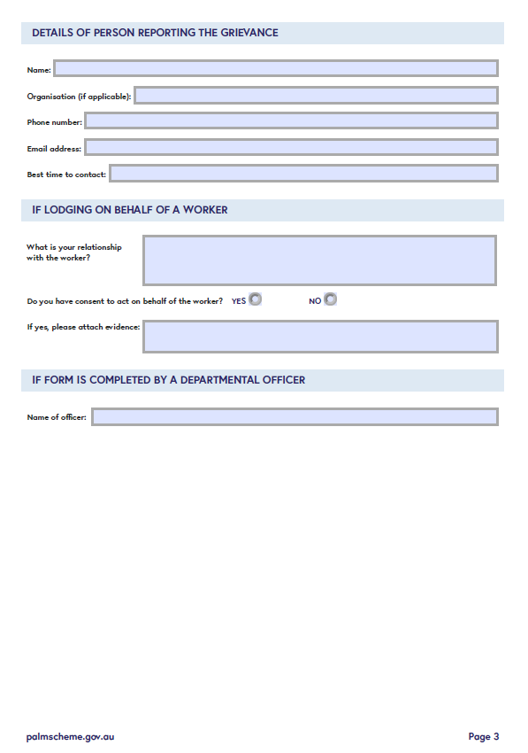

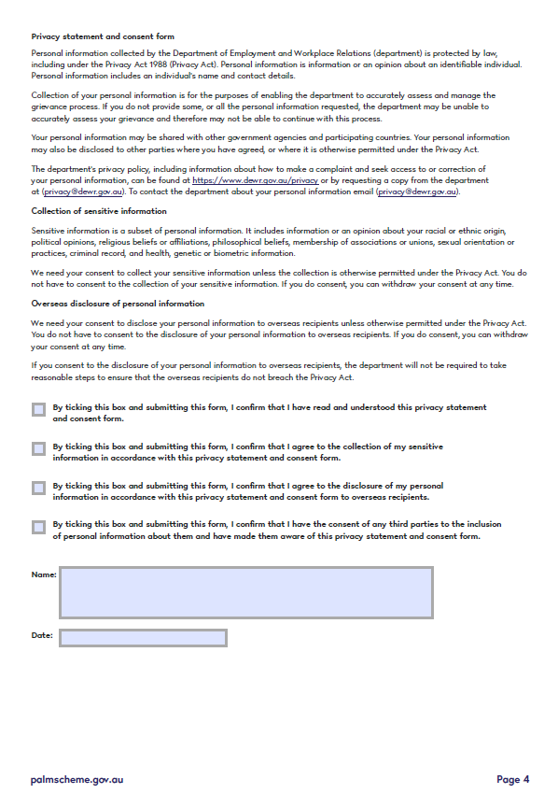

Annex C: grievance process map
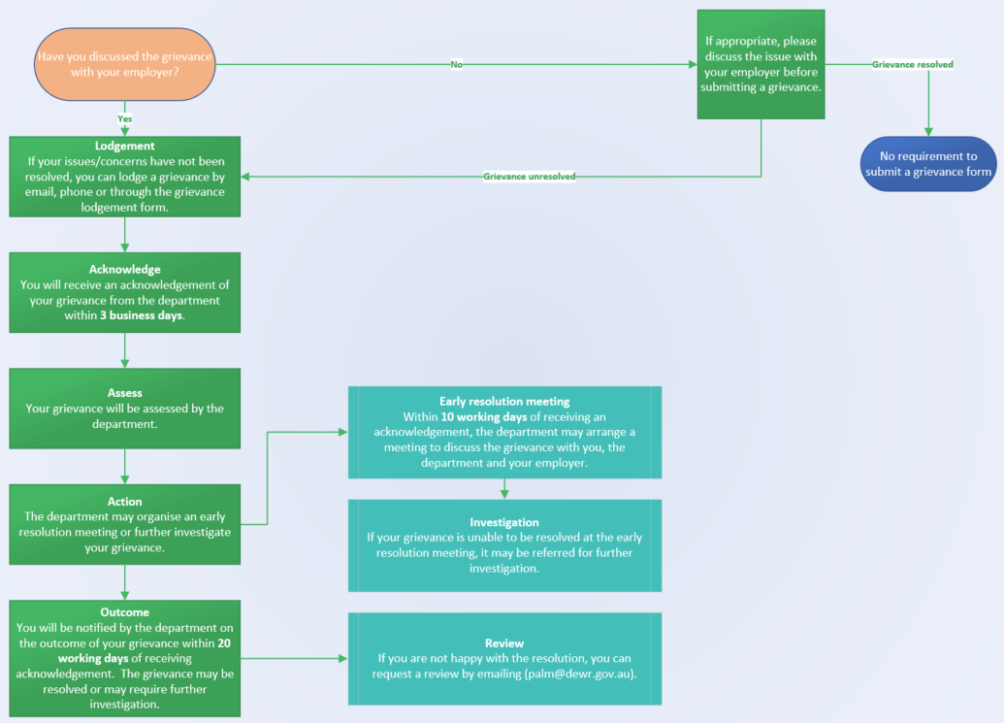

Cambridge Dictionary

