PALMLearn registration factsheet

1 December 2025

PALMLearn is a learning site dedicated to supporting PALM scheme employers, their staff, host employers and other stakeholders meet their obligations under the PALM scheme Approved Employer Deed of Agreement and the PALM scheme Approved Employer Guidelines.

Registration information
You will need to register before you can access PALMLearn. Only eligible users will have their registration approved. PALMLearn uses a self-registration process.
Once you have registered, a PALMLearn Administrator will review your registration, and you will be notified of the outcome.

Eligibility
Learning Management System user eligibility guidelines
Eligible business types | - Direct employer (approved employer) & staff  - Labour hire (approved employer) & staff  - Host organisation & staff  - SEE (Skills for employment and education) provider staff  - Skills development fund approved training provider staff  - Other*
Eligible user workplace roles and/or responsibilities | - Human resources (HR) manager or officer  - Manager  - Staff supervisor  - Team leader  - Welfare and wellbeing support person  - Trainer  - Other*
* Criteria will be assessed case by case.

How to register
 | Initiate registration  - Go to the website www.palmlearn.gov.au  - Select ‘Register’ from the login screen  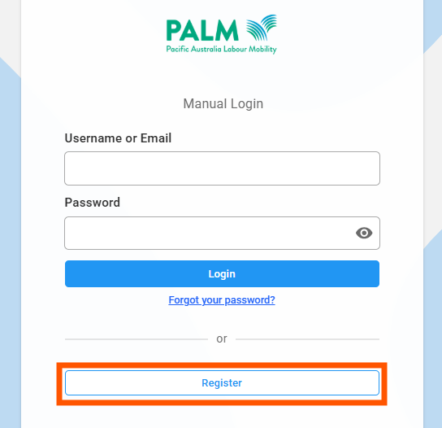
 | Enter registration details  Complete the registration fields. You must make an individual account – use your own email address, not a group inbox.  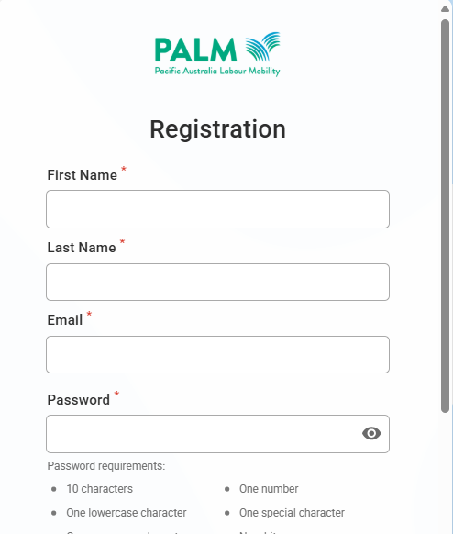
 | Verify your email address  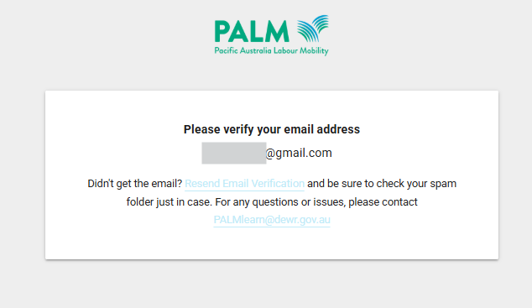  You will receive notification to verify your email – this will by email. The email will be from Acorn PLMS (no-reply@palmlearn.gov.au)  - Go to the email account you used to register  - Select the link to verify your email account.  Tip: Add no-reply@palmlearn.gov.au to your address book or safe-sender’s list  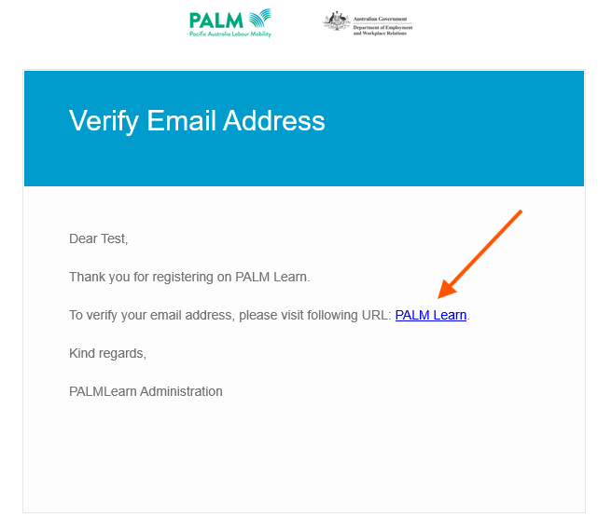
 | Pending approval  You will receive an email confirming your email address verification was successful.  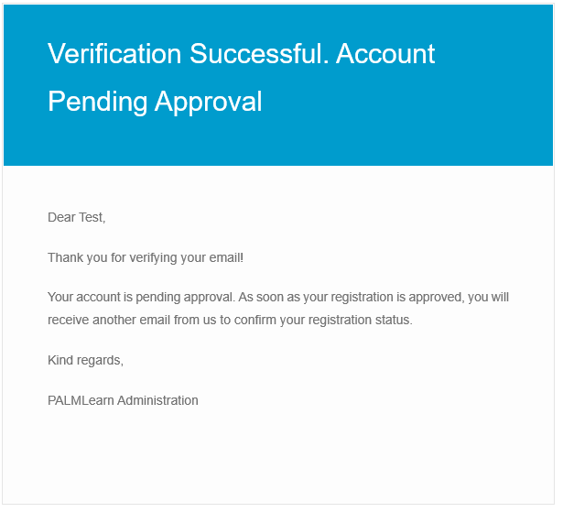
 | Registration outcome  The department will review your registration, and you will be notified of the outcome. This may be:  - Approved  - Denied – more information required (you will receive a request for the information required)  - Denied – this will be if you do not meet the eligibility criteria.  Approved notification example  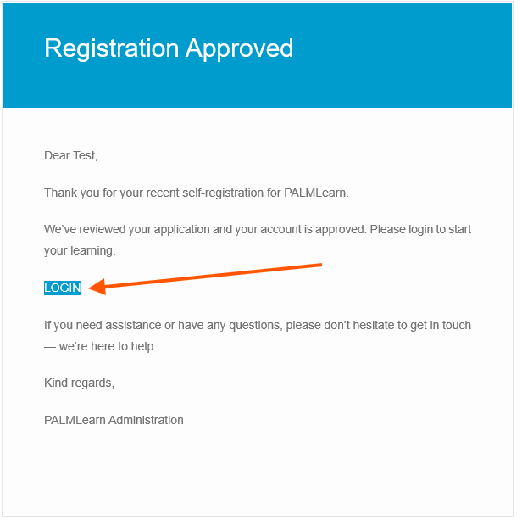

Support
If you need support during the registration process, you can:
- Phone the PALM scheme support service: 1800 51 51 31
- Email the PALM scheme support service: palm@dewr.gov.au
- Email the PALMLearn administrator: palmlearn@dewr.gov.au

