PALMLearn login factsheet

1 December 2025
PALMLearn is a learning site dedicated to supporting PALM scheme employers, their staff, host employers and other stakeholders to meet their obligations under the PALM scheme Approved Employer Deed of Agreement and the PALM scheme Approved Employer Guidelines.

Login information
- You will need to login each time you access PALMLearn. Logging in includes a two-factor authentication process.
- The first time you login (or when updates occur) you will need to read and agree to the terms and conditions of use.
In this factsheet you will find information on:
- How to login
- Logging in for the first time
- Resetting your password.

How to login
 | Initiate login  - Go to the website www.palmlearn.gov.au  - Enter the email address you used to register  - Enter your password – if you don’t remember your password, you can reset your password.  - Select/click on the ‘Login’ button  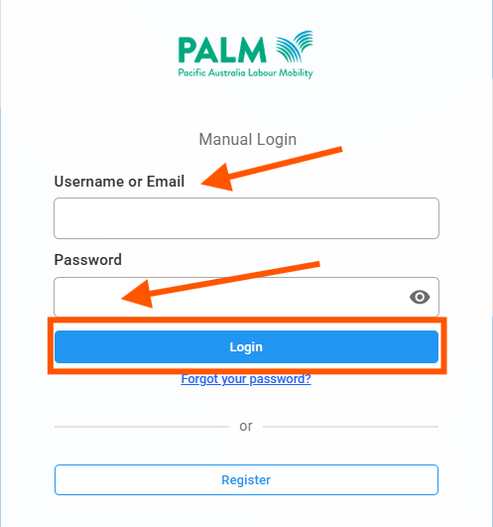
 | Two-factor authentication  After entering your user details and selecting ‘login’, you will receive a message telling you an access code has been sent to your email account. Select ‘continue’.  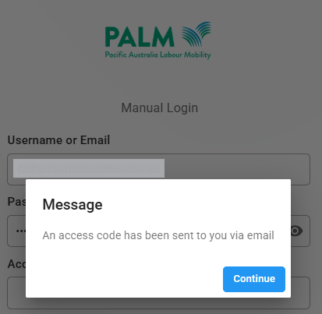
 | Access your two-factor authentication code  - Access your email account. You will have received an email from Acorn PLMS no-reply@palmlearn.gov.au  - Copy the code in the email – this will be a unique code each time you login.  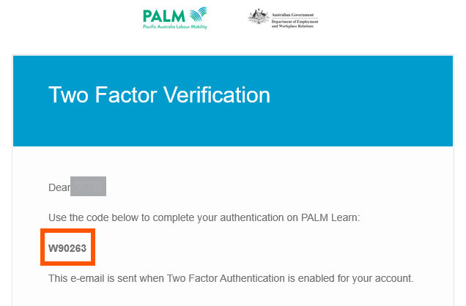
 | Verify your two-factor authentication code  - Return to the login screen.  - Enter the access code from the two-factor authentication email.  - Select ‘login’.  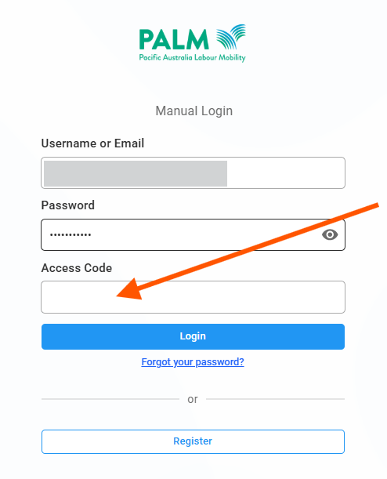  If this is the first time that you log in, see First Time Login for an additional step.
 | Logged in  You have now logged in and can access the resources.  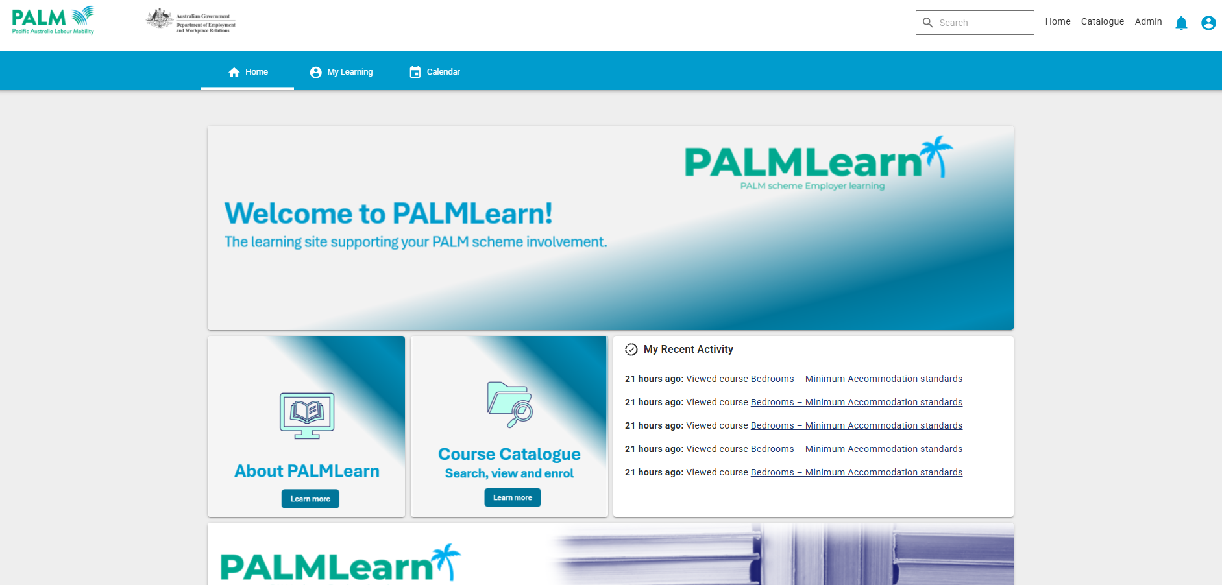

First time login
The first time you login (and then if updates have occurred) you will have a pop-up appear. In the pop-up you will be asked to read the:
- Site User Agreement
- Privacy Notice
- Privacy Consent.
If you agree to the terms and conditions, mark the checkbox at the end of the pop-up window.
You will then be able to access the content in PALMLearn.

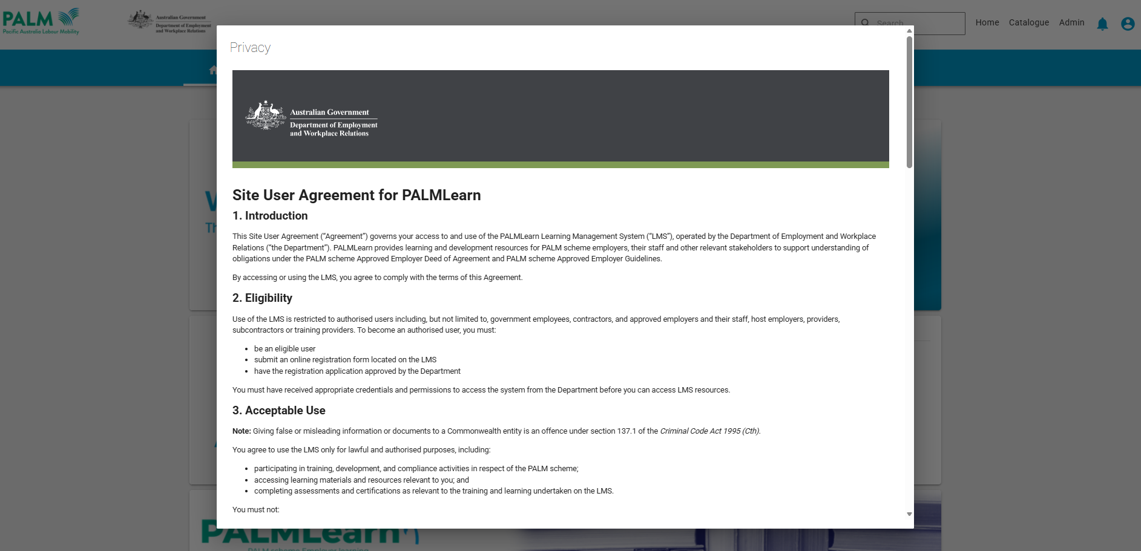

Reset your password
You can reset your password at any time.

Initiate password reset
If you have forgotten your password, you can use the password reset function.
- On the login screen (www.palmlearn.gov.au), select ‘Forgot your password’
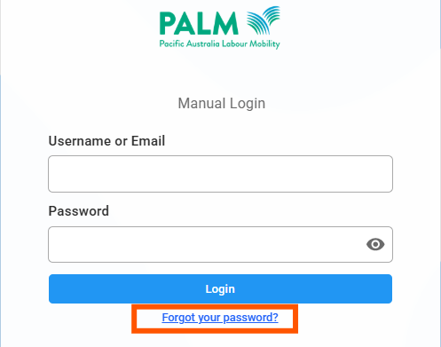

Enter email address
You will then need to enter your email address in the password reset screen. A link will be sent to your nominated email account for you to reset your password.
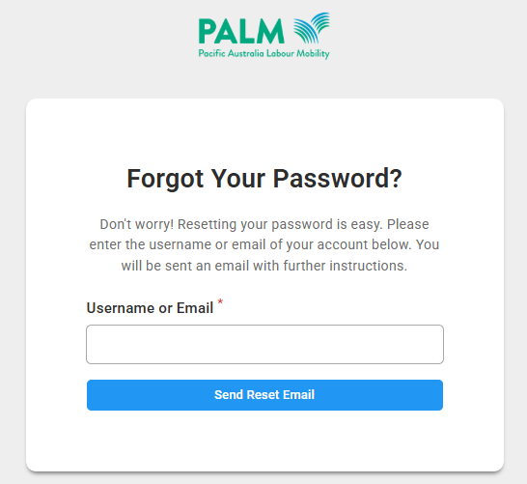

Reset password
Go to your email account and follow the instructions to change your password.

Support
If you need support during the login process you can contact:
- Phone the PALM scheme support service: 1800 51 51 31
- Email the PALM scheme support service: palm@dewr.gov.au
- Email the PALMLearn administrator: palmlearn@dewr.gov.au

