PALMLearn course finder factsheet

1 December 2025
PALMLearn is a learning site dedicated to supporting PALM scheme employers, their staff, host employers and other stakeholders to meet their obligations under the PALM scheme Approved Employer Deed of Agreement (the deed) and the PALM scheme Approved Employer Guidelines (the guidelines).

Course information
PALMLearn hosts courses that cover a range of themes, including:
- Understanding deed and guidelines obligations
- Working effectively with PALM scheme workers
- Worker welfare and wellbeing support
- Cultural competency.
In this factsheet you will find information on:
- How to find a course via the:
  - Course catalogue widget
  - Course guide widget
  - Catalogue button
  - Search bar
  - Recent activity widget
- The course catalogue and how to search for and filter courses.
- How to register for a course
- Support

1. How to find a course from the PALMLearn home page
On the PALMLearn home page, there are 5 ways to access courses.
- Course Catalogue widget on the home page
- Course guide widget on the home page
- Catalogue button on the navigation bar
- Search bar on the navigation bar
- Recent activity widget
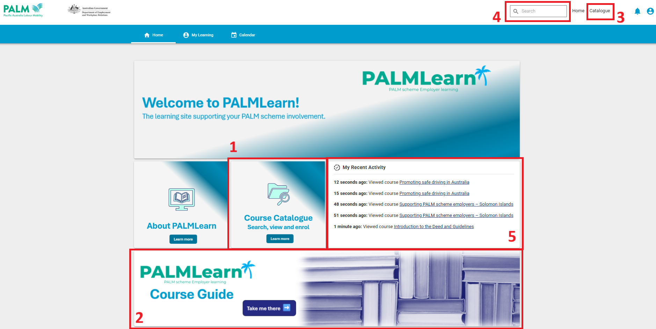
Please note, the search bar function is only available on a desktop. To search on a handheld device, select the course catalogue (option 1 or 3 above) and search via the course catalogue page.
 | Course catalogue widget  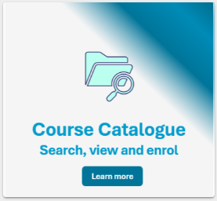  Selecting the course catalogue widget on the home page, by selecting any section of the widget, will take you to the course catalogue page of PALMLearn.
 | Course guide widget    Selecting the course guide widget on the home page, by selecting any section of the widget, will take you to the course guide resource page of PALMLearn.  The PALMLearn Information and Course Guide provides information on each course available on PALMLearn and outlines the courses by their themes and target audiences.  This guide can be viewed or downloaded via its page on PALMLearn.  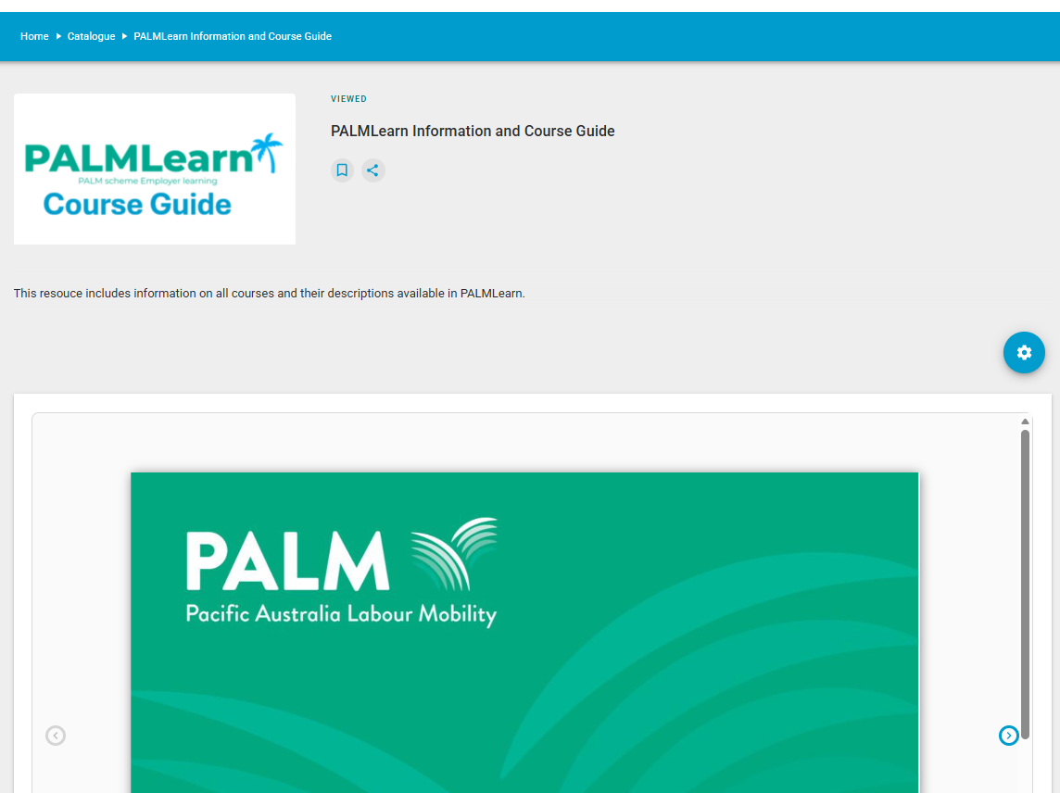  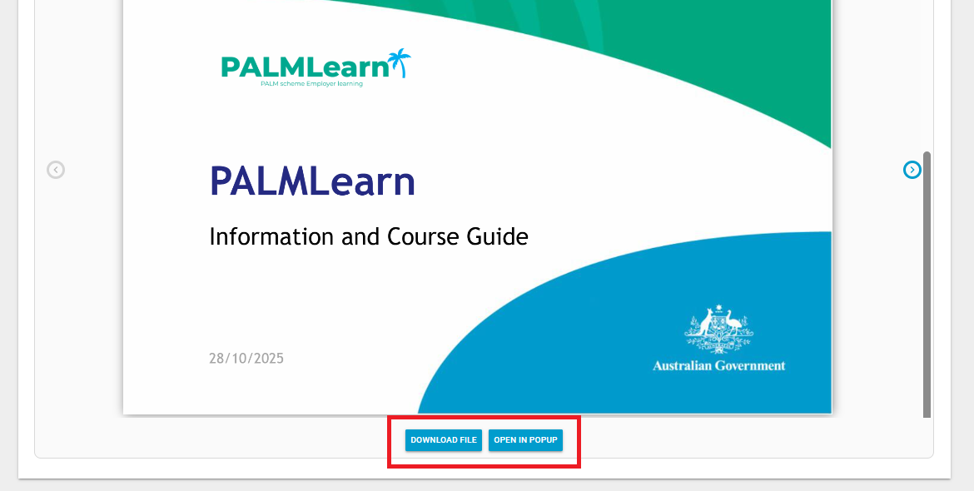
 | Catalogue button    Selecting the course catalogue button on the home page will take you to the page of PALMLearn.
 | Search bar    Selecting the search bar on the home page will allow you to search for the title of a course or a course program.
 | Recent activity widget  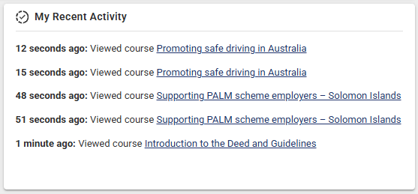  Recently viewed courses will be quickly available to select via the recent activity widget.

2. The course catalogue
The course catalogue is where you will explore, sign up for, and complete any of the courses offered through PALMLearn.
There are several ways to discover or browse available courses, including:
- Searching for a course
- Filtering using tags and categories
- Filtering using content types
- Browsing the list of available courses

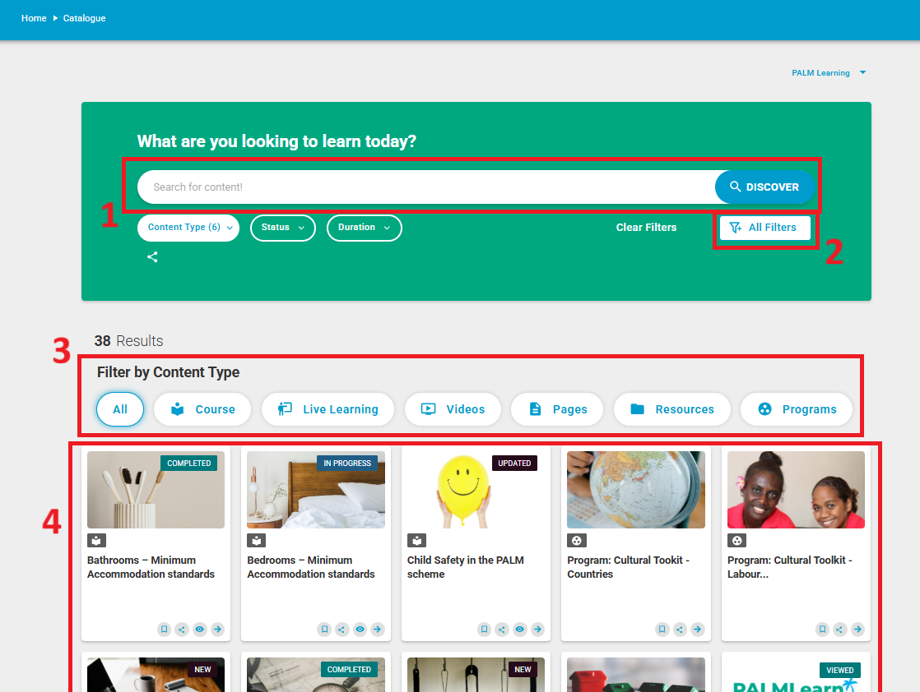

Searching for courses and content
Selecting the search bar in the course catalogue page allows you to search for the title of a course, a course program, or resources available. You can also search by topic, for example, Fiji.

Filtering using tags and categories
Selecting the ‘All Filters’ button on the course catalogue page will open a list of advanced filters you can use to find a course by its category or tag.
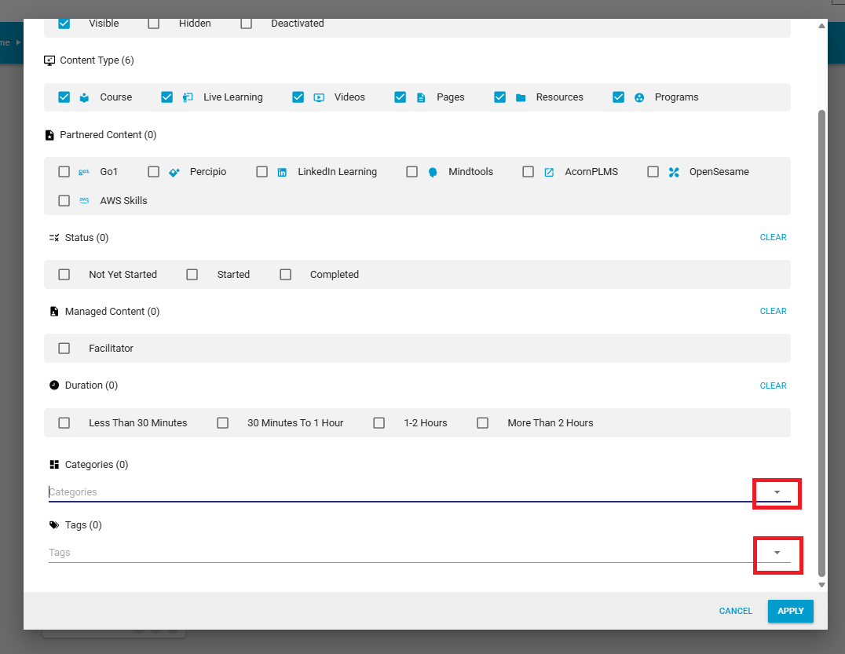
Selecting the drop-down button on the ‘categories’ and ‘tags’ boxes in the advanced filters will filter all courses based on their category, e.g. policy or cultural competency, or their tags, e.g. recruitment or LSU which further refines your search.
To apply filters, make sure you select the apply button before exiting the advanced filters popup.
To clear advanced filters, select the ‘all filters’ button and select ‘clear filters’ and apply.
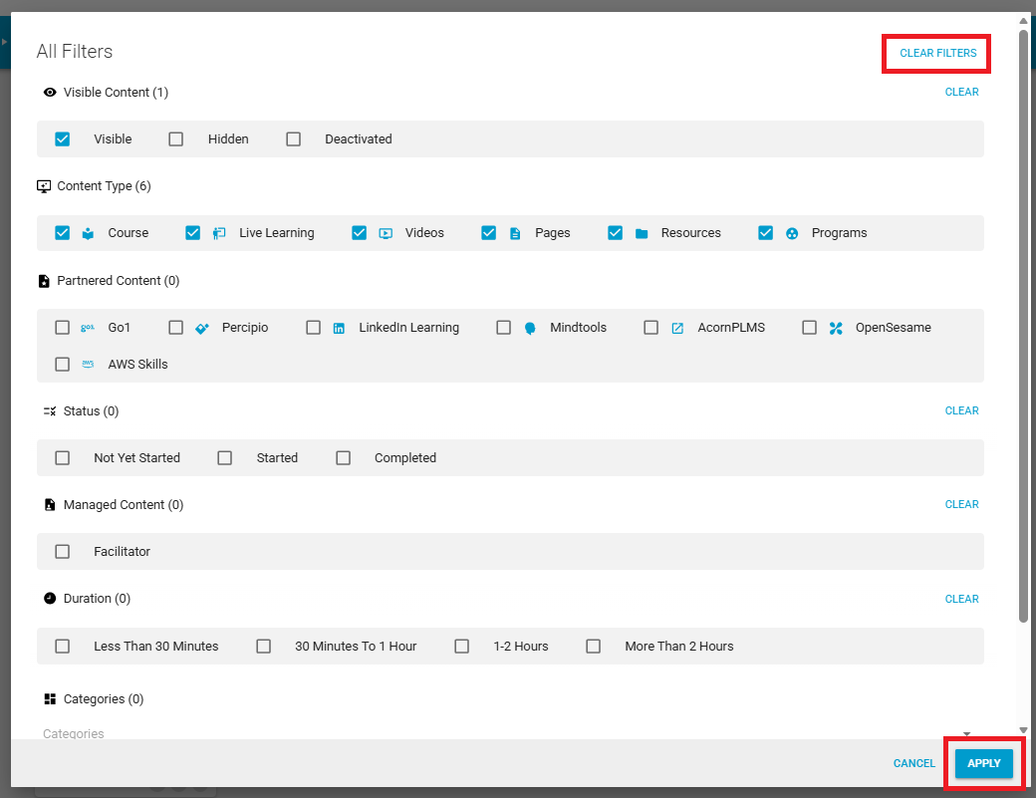

Filtering using content types
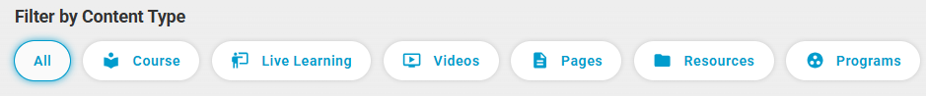To filter courses in the course catalogue based on the content type, select the buttons above to view the content. For example, selecting ‘Resources’ will only show the PALMLearn Information and Course Guide as well as other resource documents, this will not show courses or course programs.

Browsing all available courses
If you are not sure what you are looking for, or just want to view all courses, scroll down on your screen to browse all of the course titles, resources, and course programs available on PALMLearn.

3. How do I enrol into a course?
To enrol in a course:
- Select the course tile – this will open with more information
- Select the ‘enrol’ button – this will enrol you into the course.
- Select the ‘go to course’ to start your learning.

4. Support
If you need support during this process you can contact:
- Phone the PALM scheme support service: 1800 51 51 31
- Email the PALM scheme support service: palm@dewr.gov.au
- Email the PALMLearn administrator: palmlearn@dewr.gov.au

