Pacific Australia Labour Mobility scheme quarterly update

Data current up to 30 September 2025

Published: 27 November 2025
Data about workers and employers participating in the Pacific Australia Labour Mobility (PALM) scheme, is published monthly on the PALM website www.palmscheme.gov.au/palm-scheme-data. This quarterly report presents longer-term trends and analysis for key metrics.
PALM scheme worker counts are a measure of the number of workers from participating PALM scheme countries holding a valid visa who are currently onshore in Australia. Worker participation will vary from month to month reflecting a range of factors, including:
- the cyclical nature of the program and worker visa conditions (9 months for the short-term stream and up to 4 years for the long-term stream)
- changing workforce demand e.g. stemming from growing cycles for different crops in different regions, and
- workers returning home for holidays or other personal commitments.

PALM scheme employer counts record the number of employers holding a current PALM scheme deed.

PALM scheme worker trends
Over the 12 months to September 2025:
- The worker count has remained stable. Short-term worker counts increased by 3% over the year while long-term worker counts declined by 3% over the year.
- Worker counts by industry:
  - Agriculture increased by 3% (535 workers) since September 2024. This represents a moderate increase in workers in Agriculture over the last 12 months.
  - Meat processing declined by 7% (820 workers) over the year to September 2025. Most workers (97%) in this industry are in the long-term stream.
  - Other PALM industries, (which account for about 9% of the total PALM workforce). recorded an increase over the year: Accommodation increased by 5%; Health care and Social Assistance increased by 2%; and Other industries increased by 38%.
- By country, between September 2024 and September 2025, worker counts:
  - increased for: Nauru, Papua New Guinea, Solomon Islands, Timor-Leste and Vanuatu
  - decreased for: Fiji, Kiribati, Samoa, Tonga and Tuvalu.

PALM scheme employer trends
The number of PALM scheme employers has continued to grow since the new PALM scheme deed and guidelines were introduced in June 2023.
- 148 new employers have joined the scheme since June 2023, bringing the total number of employers to 523 in September 2025.
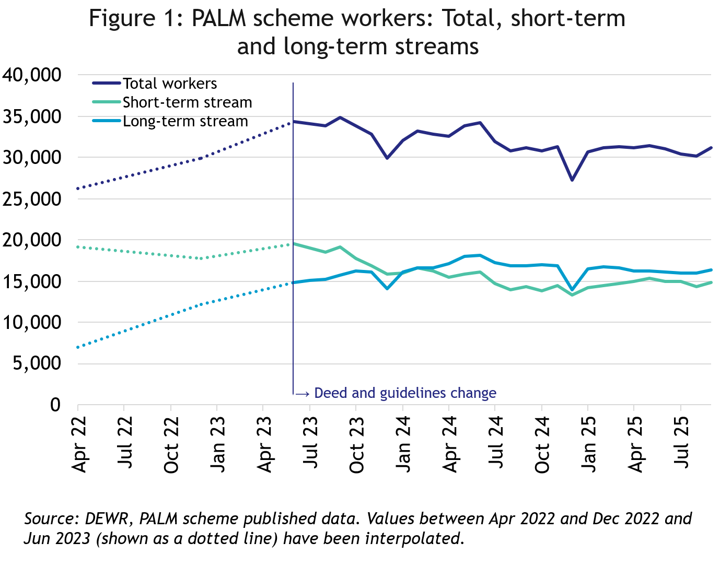
Worker trends — year to September 2025
In September 2025, there were:
- 31,225 workers
- 14,860 in the short-term stream
- 16,365 in the long-term stream
In the 12 months to September 2025, the number of workers was stable.
- Total long-term stream was down by 3%
- Total short-term stream was up by 3%.

PALM scheme employers
In September 2025, there were:
- 523 employers
- 414 were direct employers, up by 7% in the 12 months to September 2025
- 109 were labour hire employers,
up by 11% in the 12 months to September 2025.
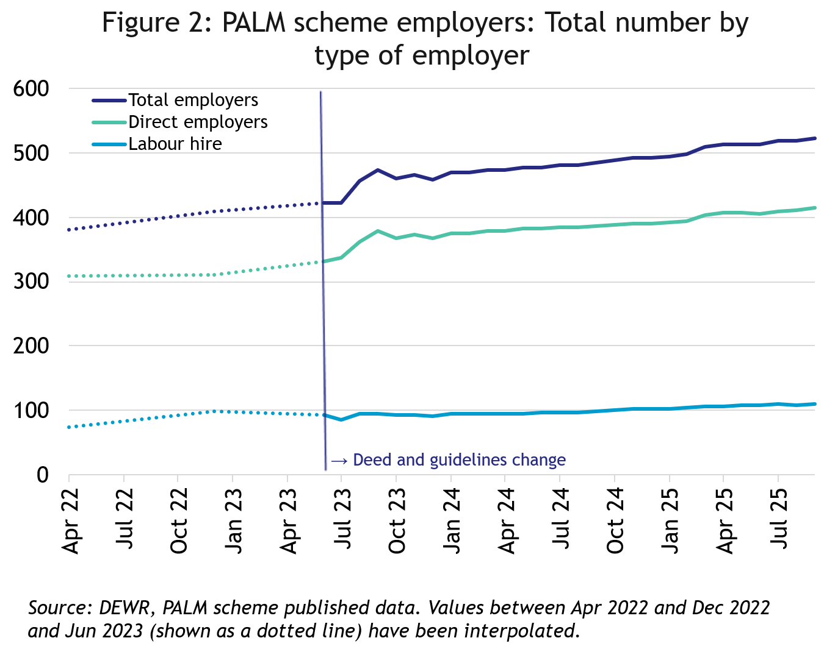

Data and chart notes:
All published PALM scheme worker data including any totals and subtotals are rounded to the nearest 5. For more information see the Glossary.
Worker counts are only available for April 2022, December 2022 and from June 2023 onwards. In the charts in this report, the unknown values between April 2022 and December 2022, and December 2022 and June 2023 have been inferred and are represented by the dotted lines. This produces artificially smooth lines that are not representative of the usual fluctuations expected in the monthly data.

Appendix A: Detailed PALM scheme worker trends

PALM scheme worker trends by industry
The PALM scheme has become increasingly diversified, with employers from a broad range of industries entering the scheme, offering Pacific Island and Timor-Leste workers more choice.

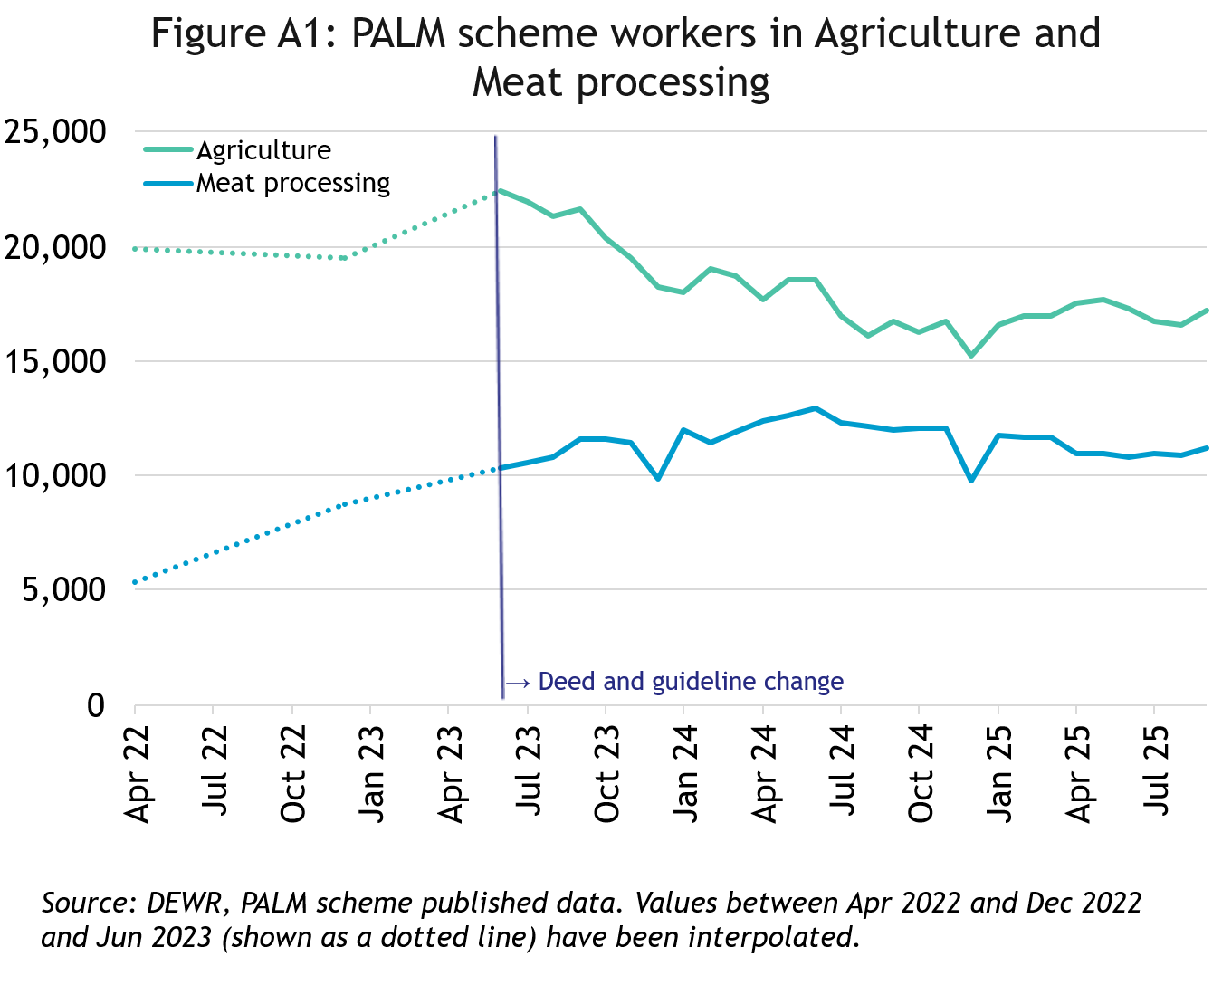
In September 2025, there were:
- 17,240 workers in Agriculture
- down by 13% since April 2022
- up by 3% in the 12 months to September 2025
- 83% were short-term
- 17% were long-term
- 11,160 workers in Meat processing
- More than double April 2022
- down by 7% in the 12 months to September 2025
- 3% were short-term
- 97% were long-term

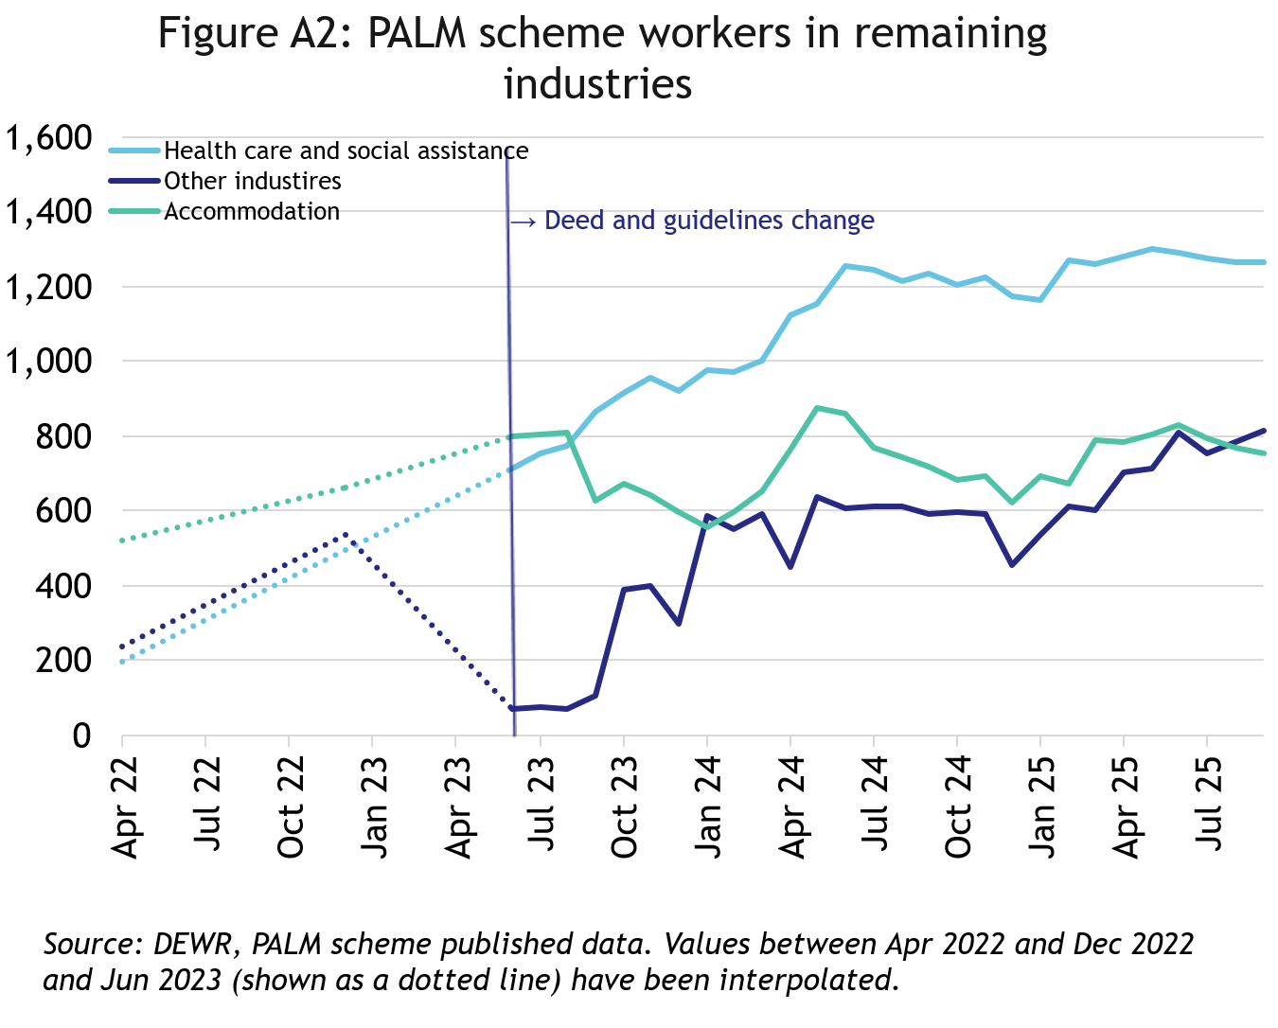
In September 2025, there were:
- 755 workers in Accommodation
- up by 45% since April 2022
- up by 5% in the 12 months to September 2025
- 26% were short-term
- 74% were long-term
- 1,265 workers in Health care and Social Assistance
- up significantly since April 2022
- up by 2% in the 12 months to September 2025
- 100% were long-term

- 810 workers in Other industries
- more than tripled since April 2022
- up by 37% in the 12 months to September 2025
- 17% were short-term
- 83% were long-term

PALM scheme worker trends by country of origin

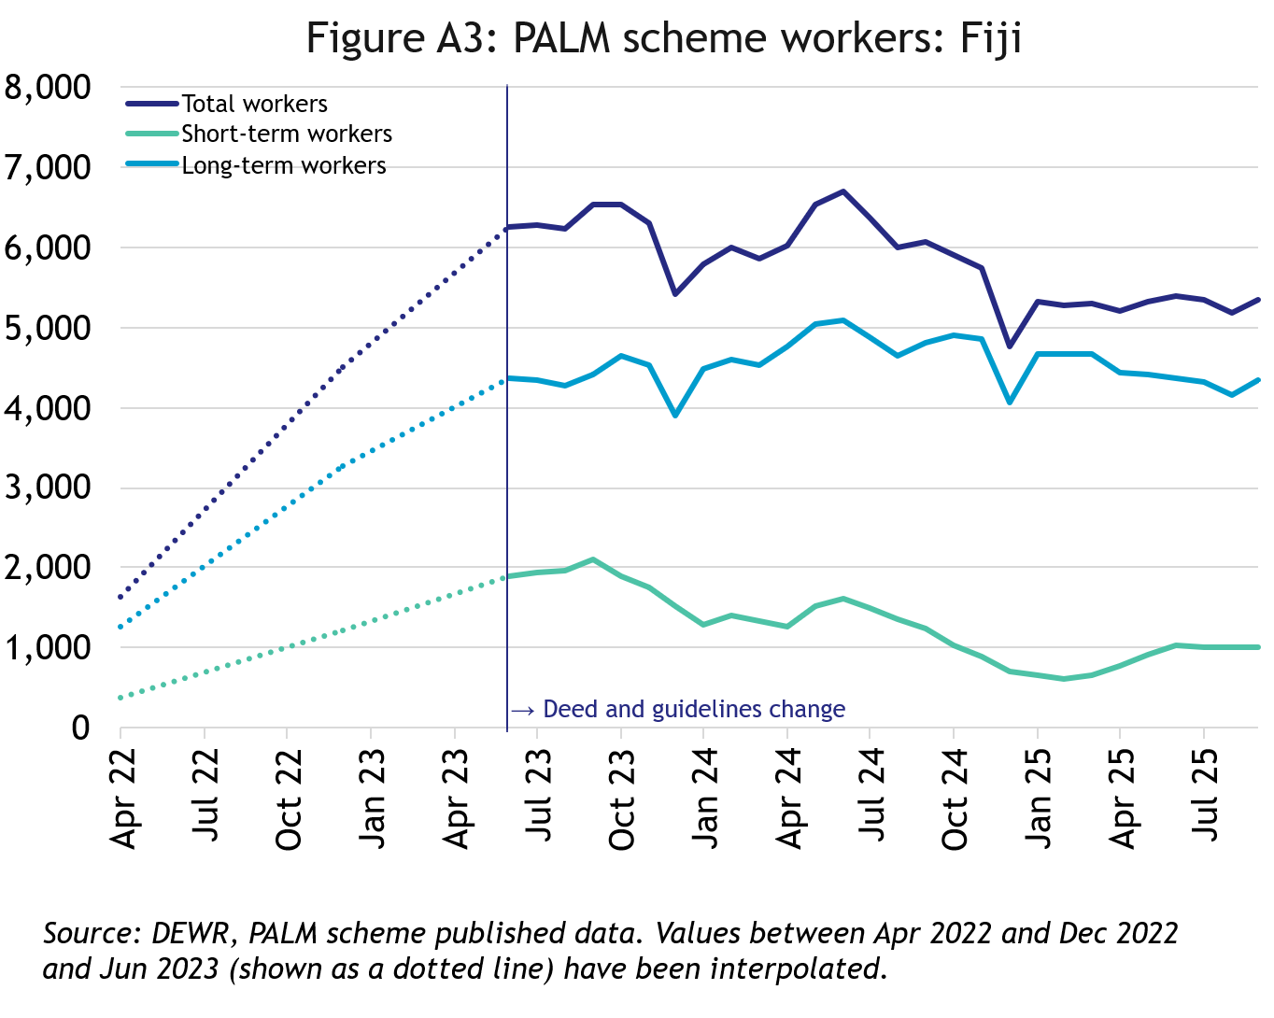
Fiji
In September 2025, there were 5,350 workers from Fiji:
- more than tripled since April 2022
- down by 12% in the 12 months to September 2025
- 81% of Fijian PALM scheme workers were in the long-term stream

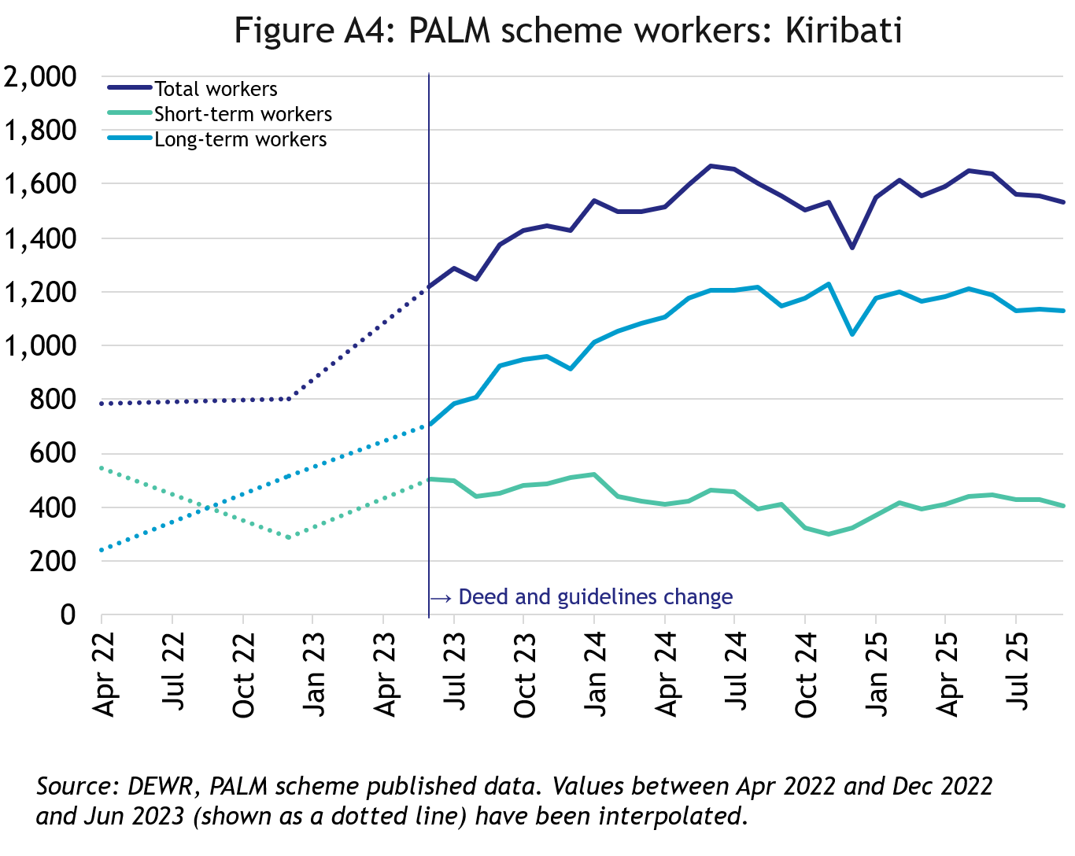
Kiribati
In September 2025, there were 1,535 workers from Kiribati:
- Nearly doubling since April 2022
- down by 1% in the 12 months to September 2025
- 74% of I-Kiribati PALM scheme workers were in the long-term stream

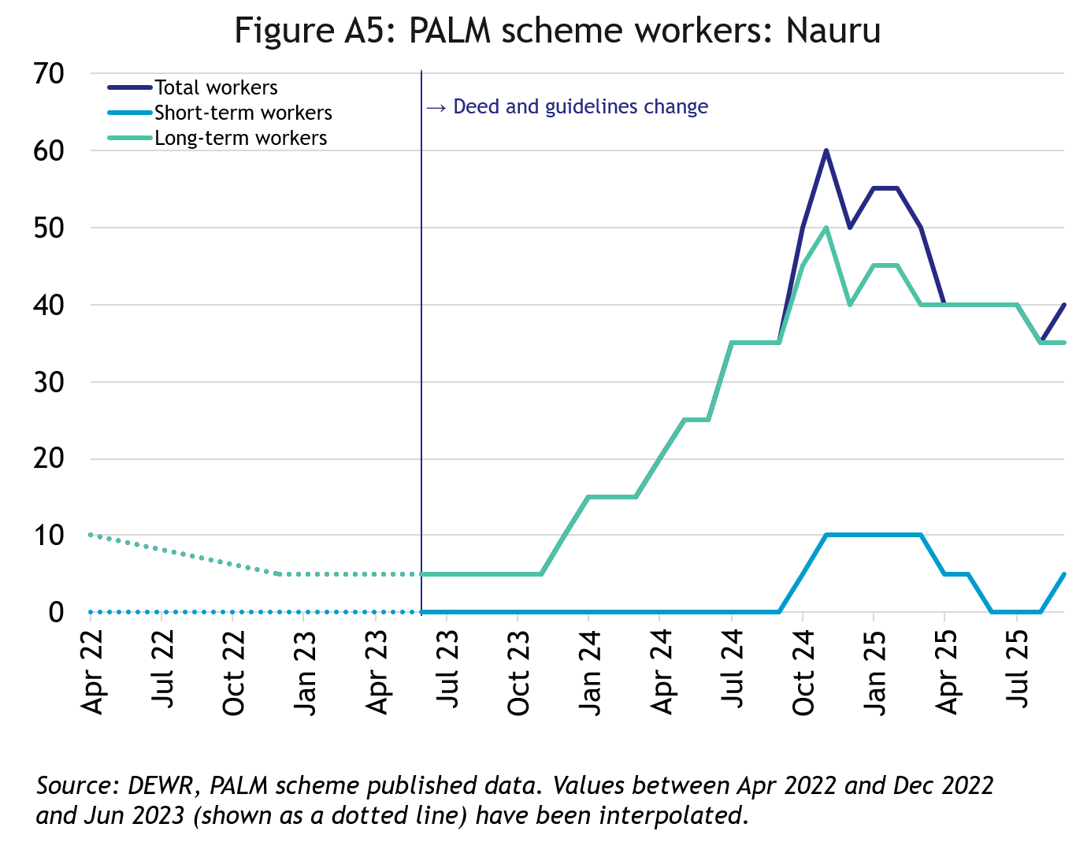
Nauru
In September 2025, there were 40 workers from Nauru:
- up by 30 workers since April 2022
- up by 5 workers in the 12 months to September 2025
- 88% of the Nauruan PALM scheme workers were in the long-term stream

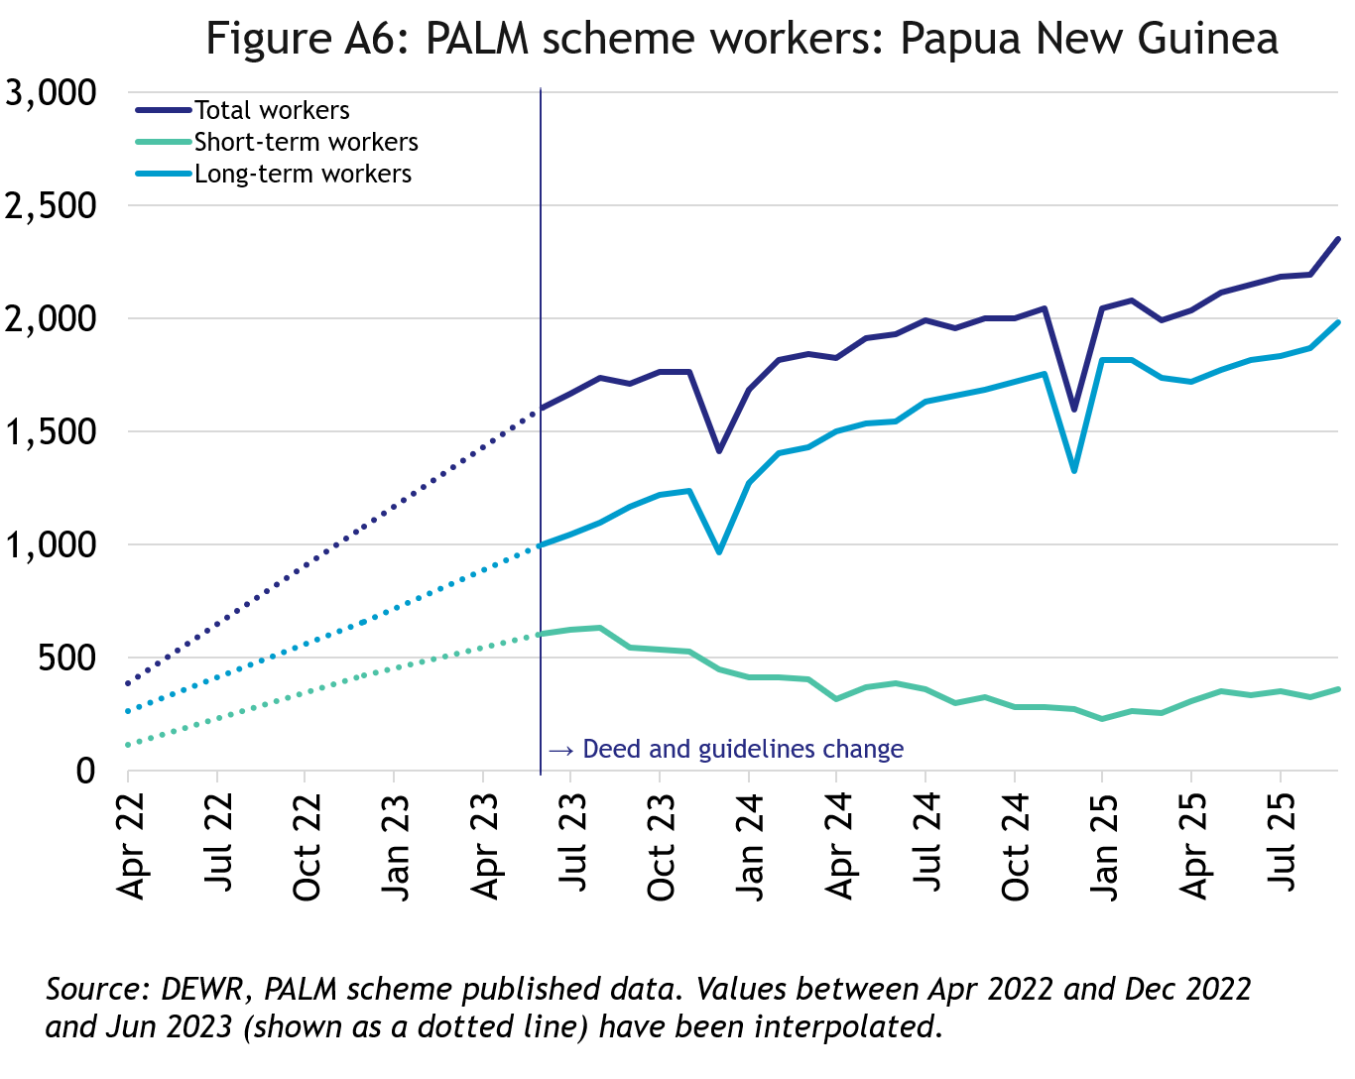
Papua New Guinea
In September 2025, there were 2,350 workers from Papua New Guinea:
- up significantly since April 2022
- up by 17% in the 12 months to September 2025
- 84% of Papua New Guinean PALM scheme workers were in the long-term stream

Samoa
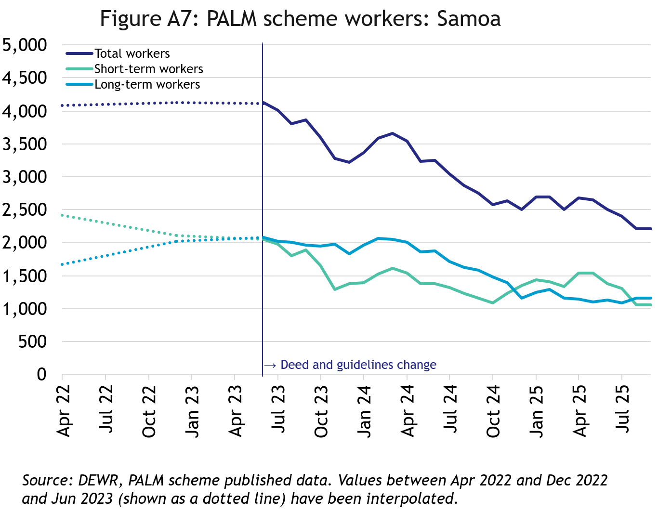
In September 2025, there were 2,215 workers from Samoa:
- down by 46% since April 2022
- down by 19% in the 12 months to September 2025
- 53% of Samoan PALM scheme workers were in the long-term stream

Solomon Islands
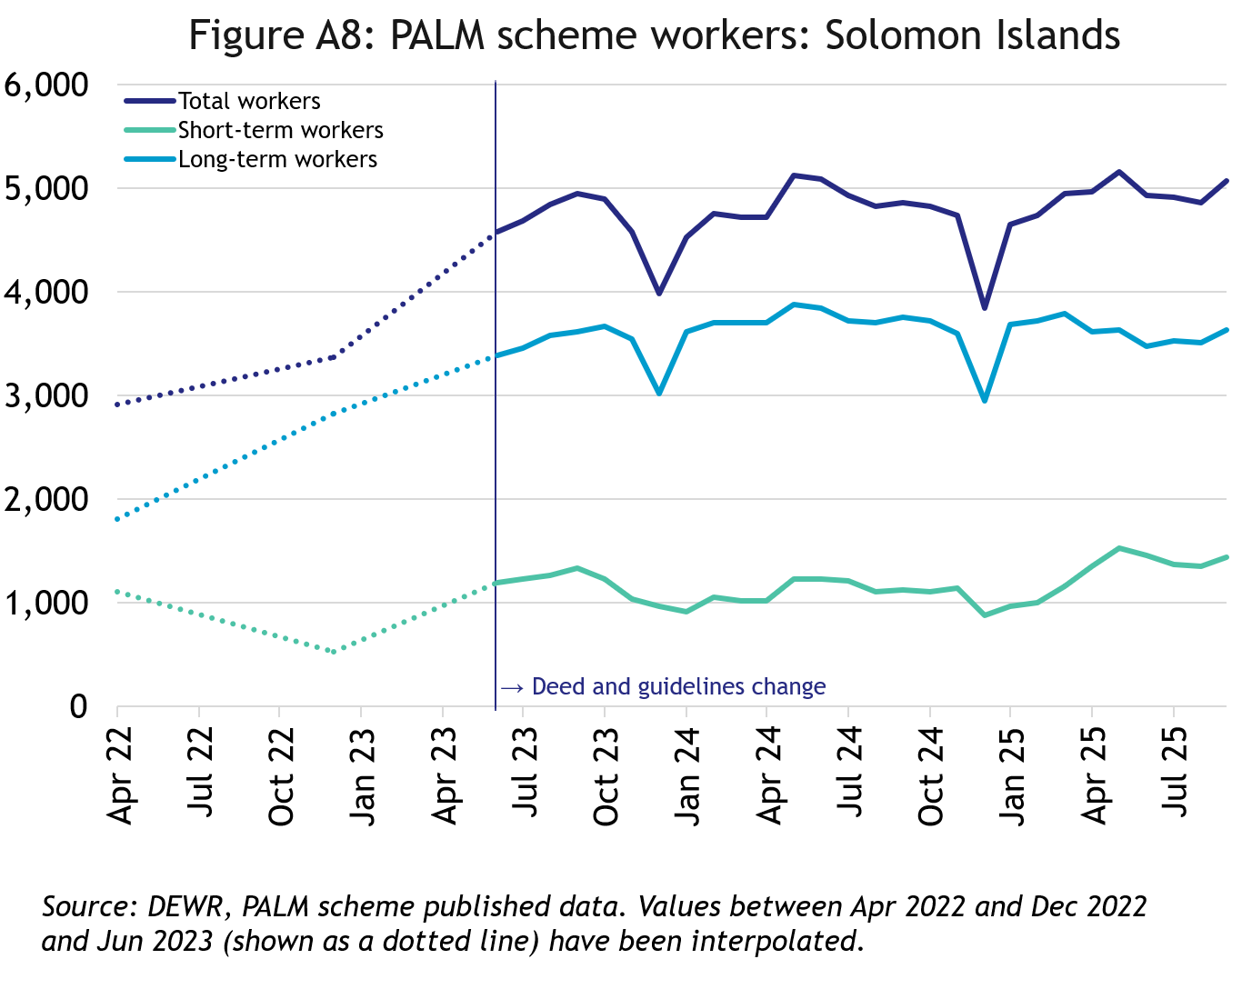
In September 2025, there were 5,075 workers from the Solomon Islands:
- up by 74% since April 2022
- up by 4% in the 12 months to September 2025
- 72% of Solomon Islander PALM scheme workers were in the long-term stream

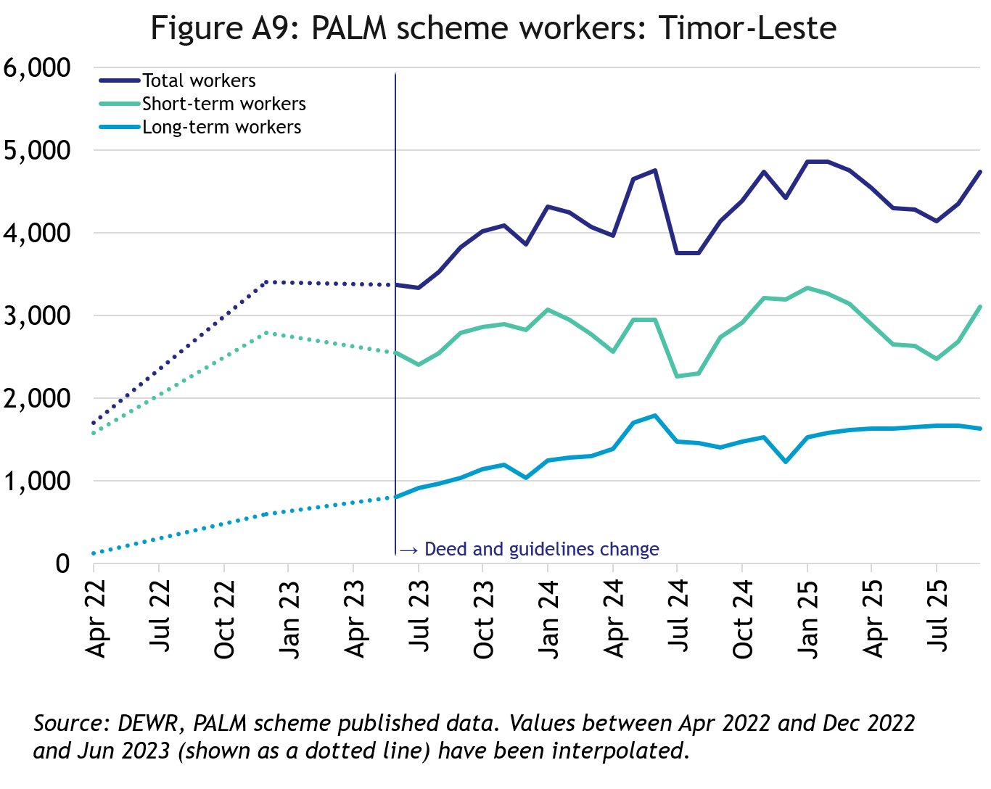
Timor-Leste
In September 2025, there were 4,745 workers from Timor-Leste:
- up by 177% since April 2022
- up by 15% in the 12 months to September 2025
- 65% of Timorese PALM scheme workers were in the short-term stream

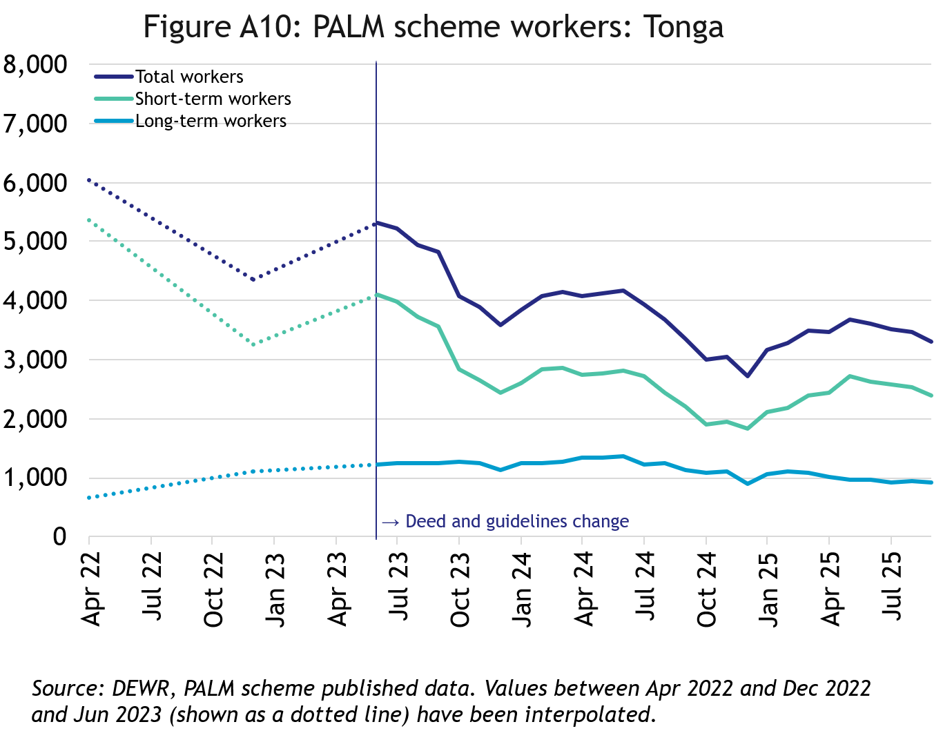
Tonga
In September 2025, there were 3,315 workers from Tonga:
- down by 45% since April 2022
- down by 1% in the 12 months to September 2025
- 72% of Tongan PALM scheme workers were in the short-term stream

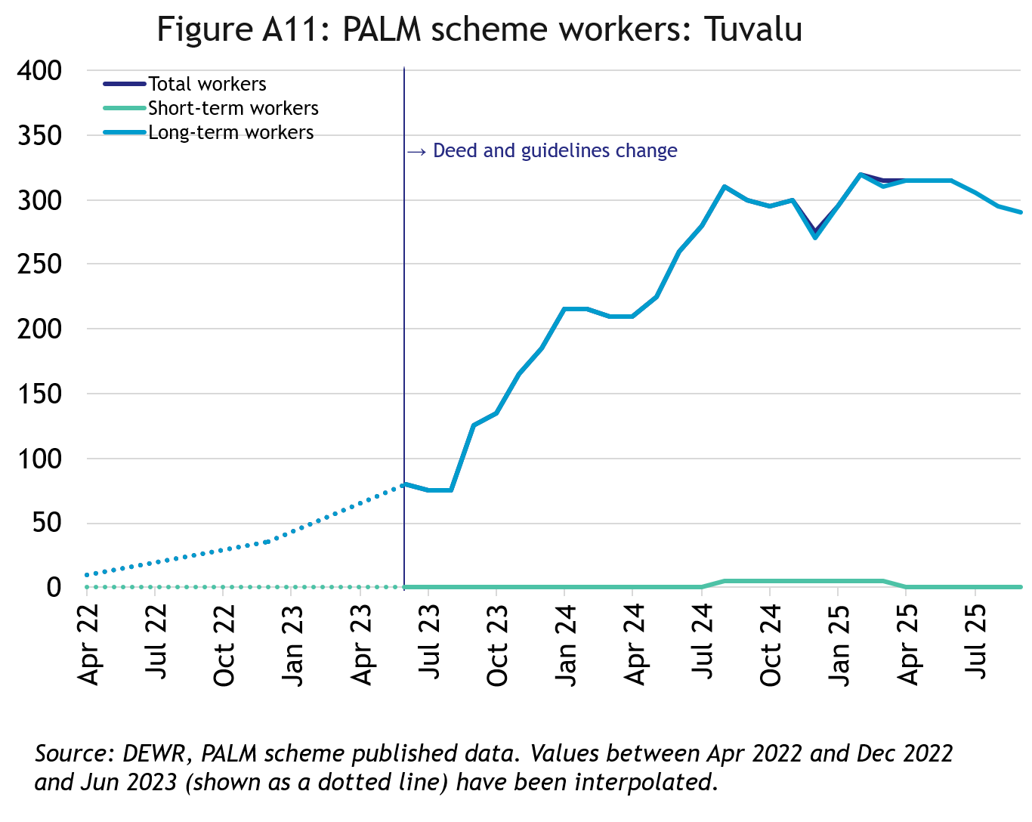
Tuvalu
In September 2025, there were 290 workers from Tuvalu:
- a significant increase since April 2022, noting the historically low small number of workers
- down by 3% in the 12 months to September 2025
- All Tuvaluan PALM scheme workers were in the long-term stream

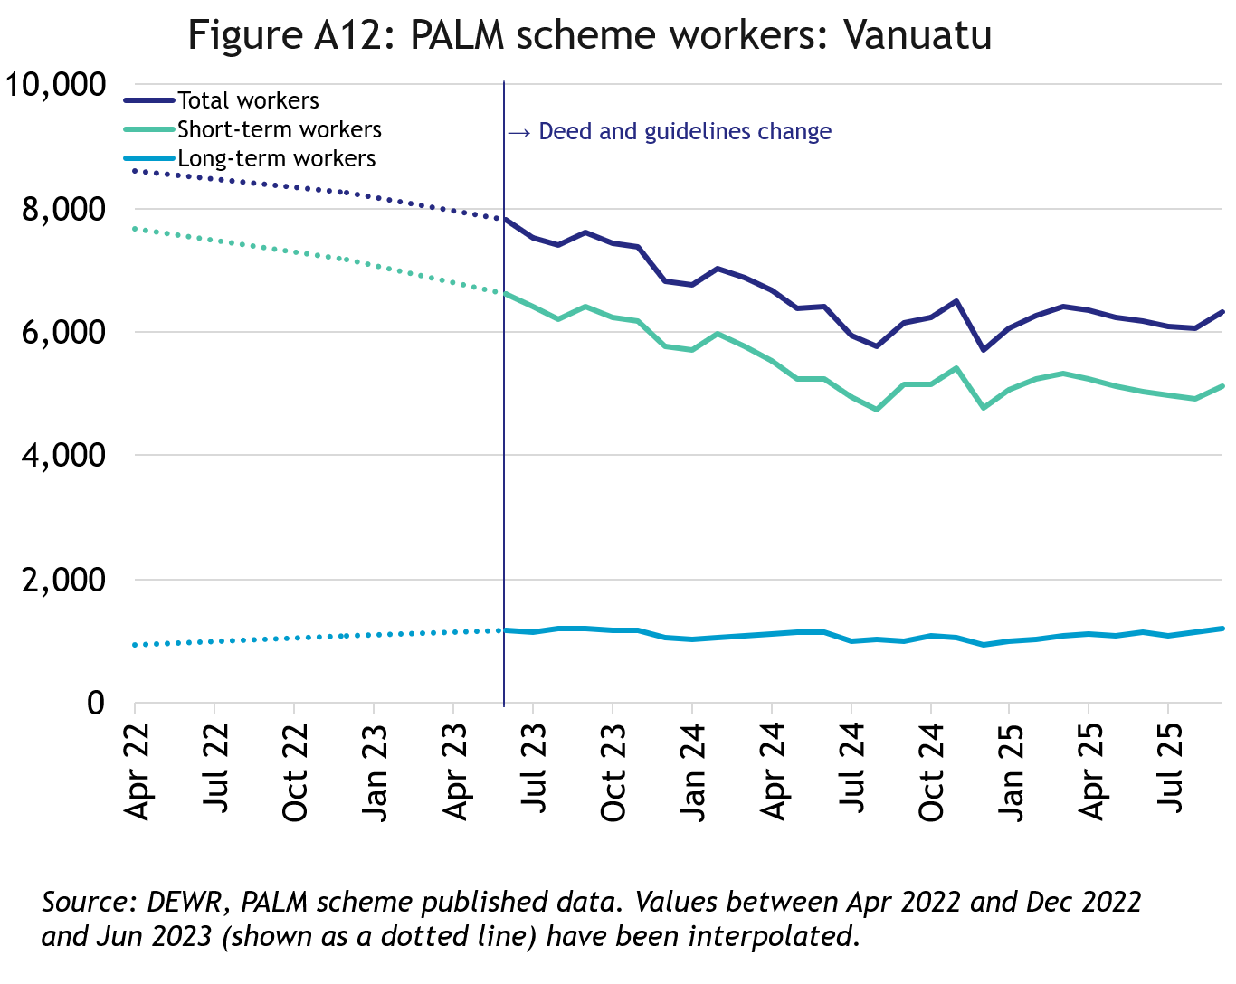
Vanuatu
In September 2025, there were 6,320 workers from Vanuatu:
- down by 27% since April 2022
- up by 3% in the 12 months to September 2025
- 81% of ni-Vanuatu PALM scheme workers were in the short-term stream

PALM scheme worker trends by state/territory

New South Wales
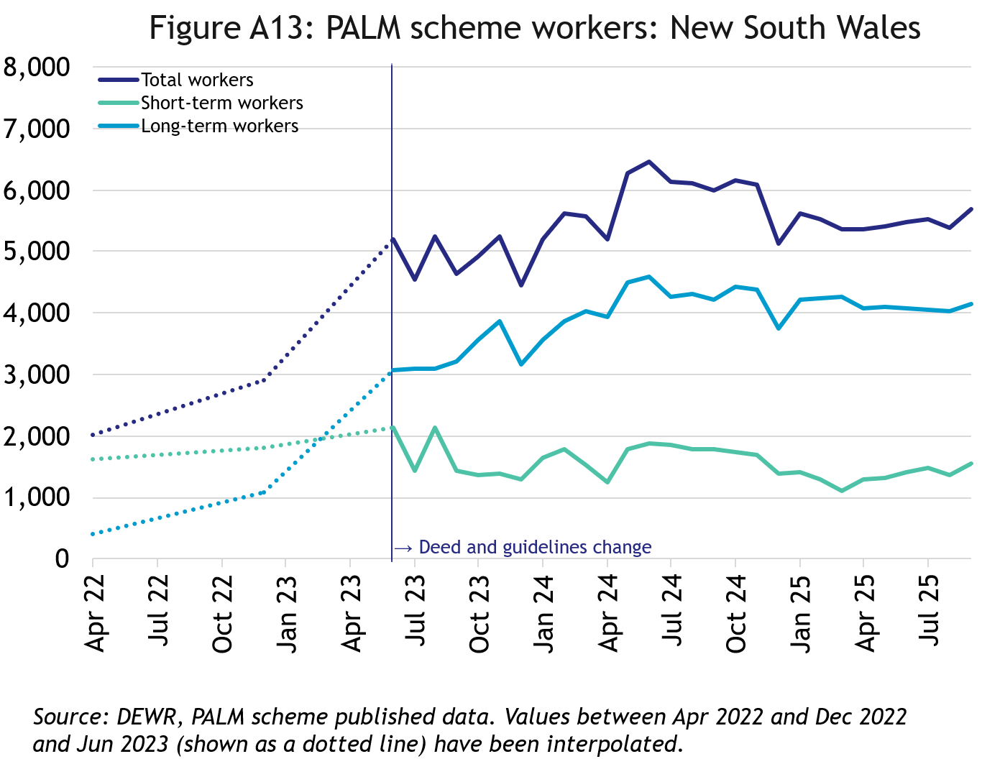
In September 2025, there were 5,695 workers in New South Wales:
- up by 182% since April 2022
- down by 5% in the 12 months to September 2025
- 73% of New South Wales PALM scheme workers were in the long-term stream

Victoria
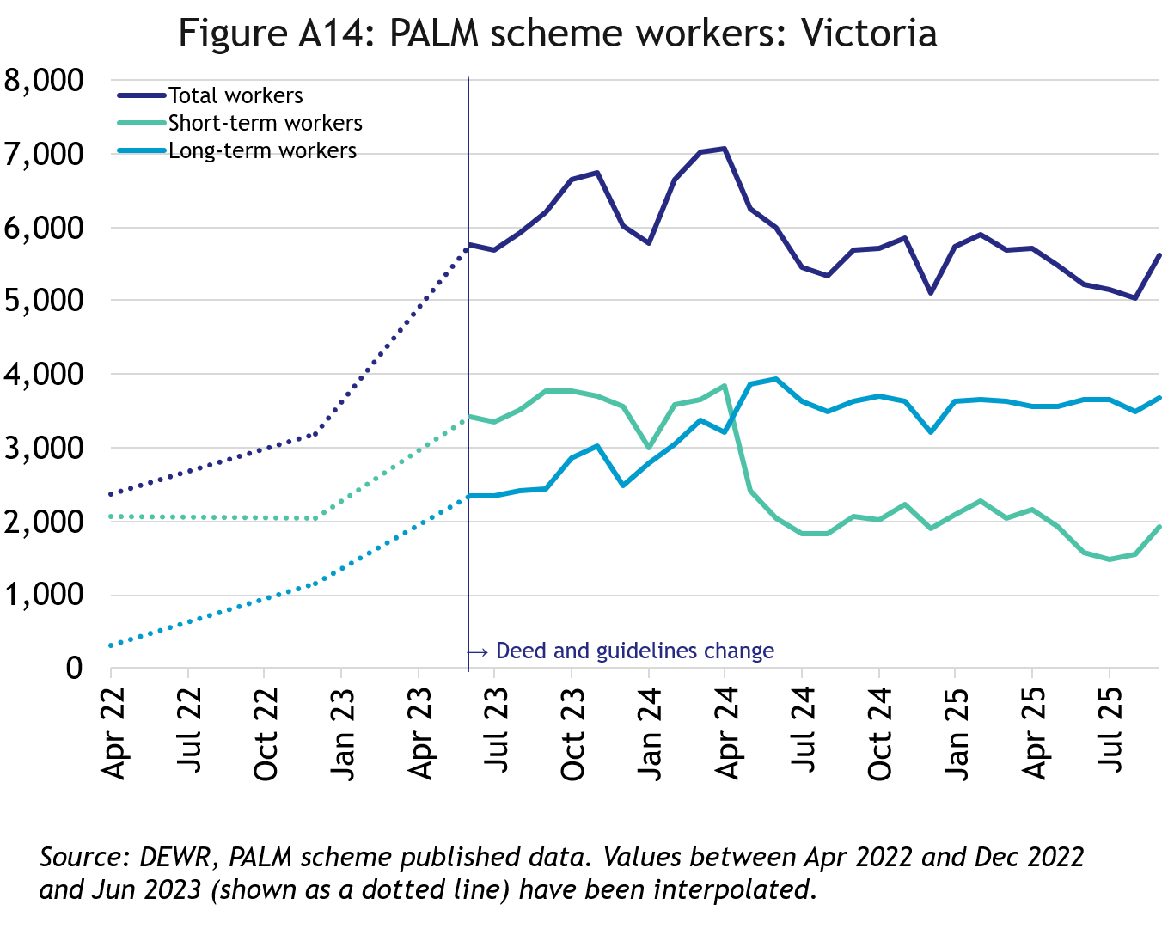
In September 2025, there were 5,615 workers in Victoria:
- up by 137% since April 2022
- down by 1% in the 12 months to September 2025
- 66% of Victorian PALM scheme workers were in the long-term stream

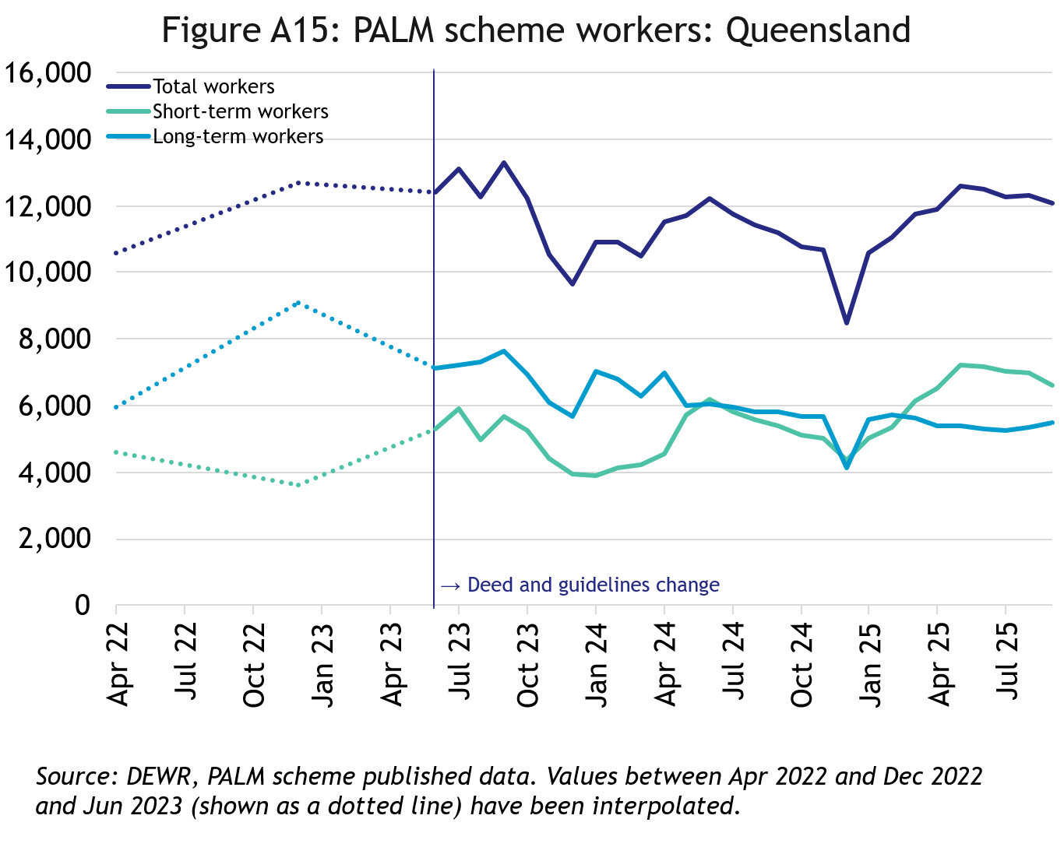
Queensland
In September 2025, there were 12,100 workers in Queensland:
- up by 14% since April 2022
- up by 8% in the 12 months to September 2025
- 55% of Queensland PALM scheme workers were in the short-term stream

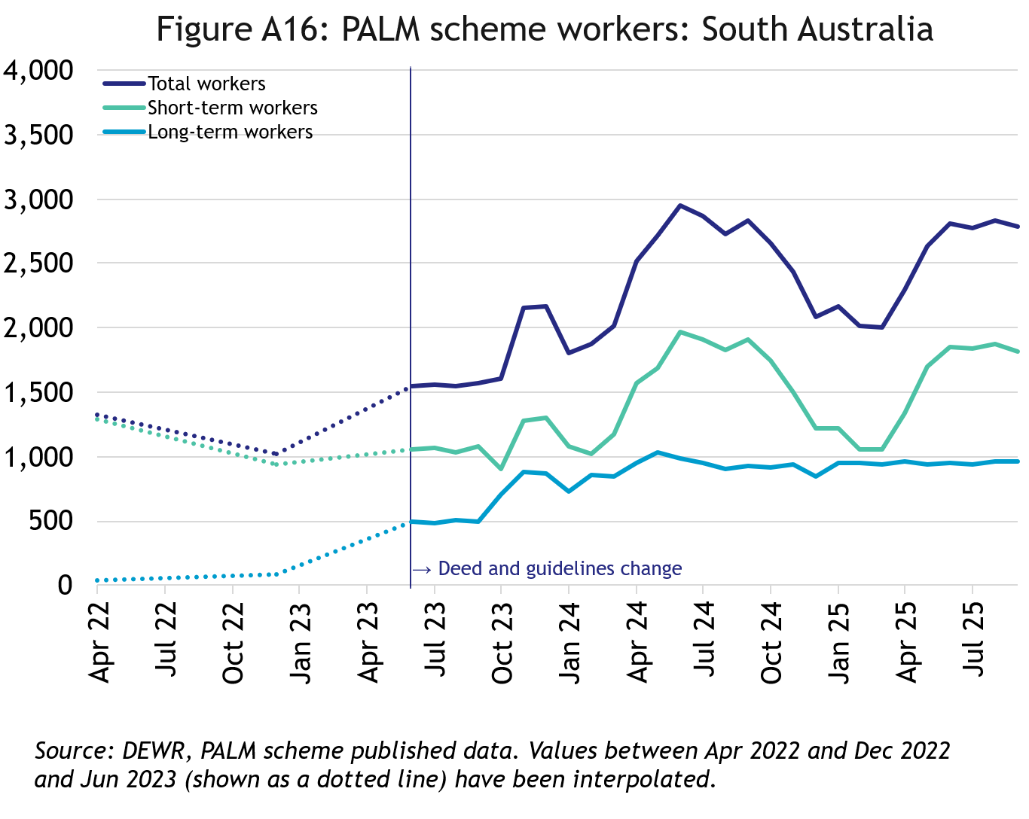
South Australia
In September 2025, there were 2,790 workers in South Australia:
- up by 111% since April 2022
- down by 1% in the 12 months to September 2025
- 65% of South Australian PALM scheme workers were in the short-term stream

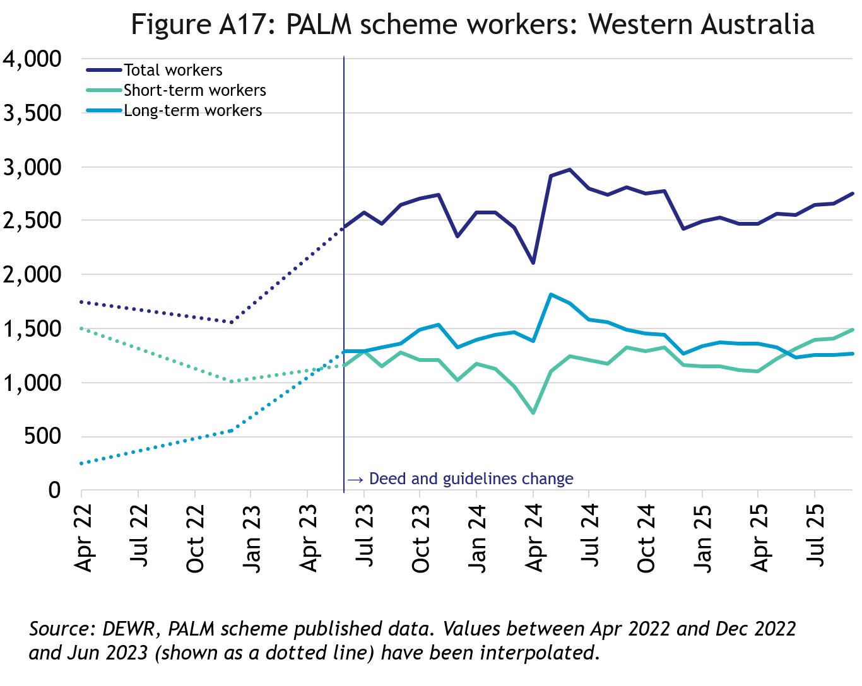
Western Australia
In September 2025, there were 2,750 workers in Western Australia:
- up by 57% since April 2022
- down by 2% in the 12 months to September 2025
- 54% of Western Australian PALM scheme workers were in the short-term stream

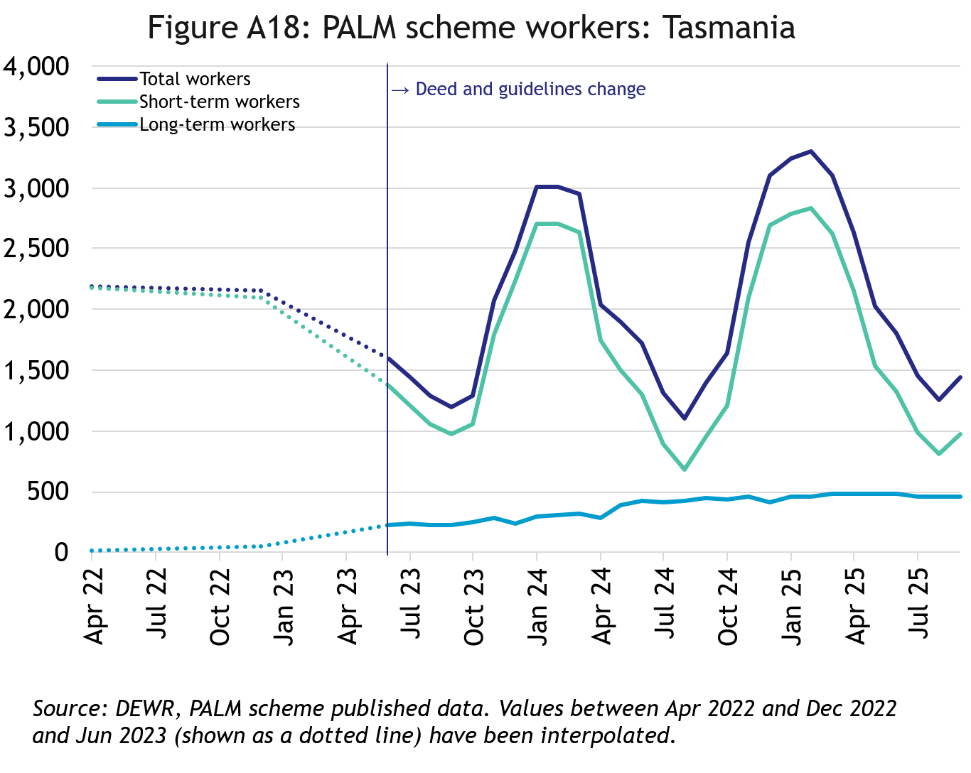
Tasmania
In September 2025, there were 1,440 workers in Tasmania:
- down by 34% since April 2022
- up by 4% in the 12 months to September 2025
- 68% of Tasmanian PALM scheme workers were in the short-term stream

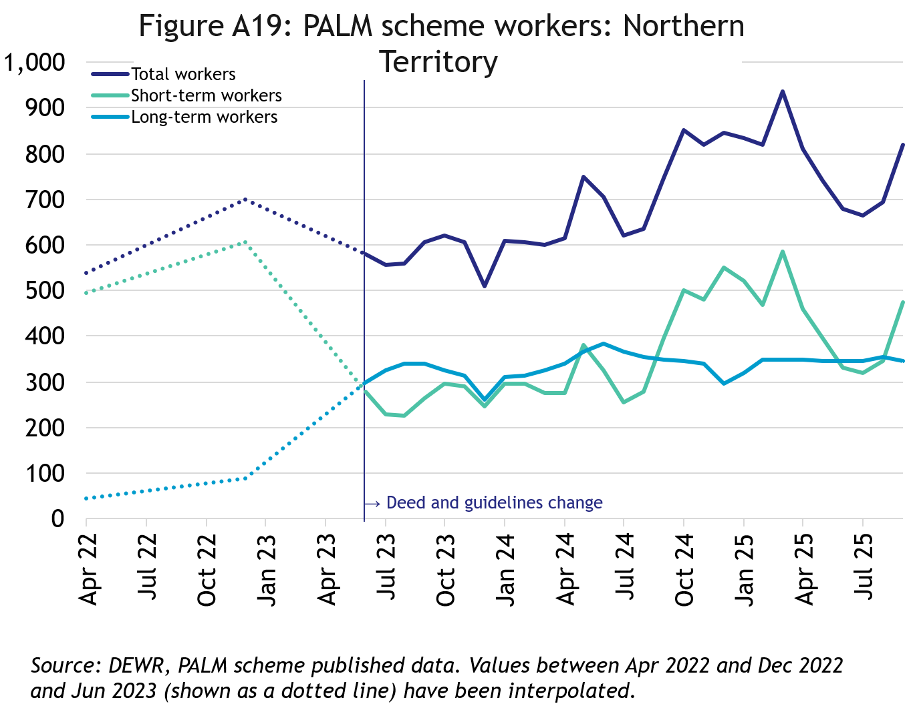
Northern Territory
In September 2025, there were 820 workers in the Northern Territory:
- up by 52% since April 2022
- up by 10% in the 12 months to September 2025
- 58% of Northern Territory PALM scheme workers were in the long-term stream

Australian Capital Territory
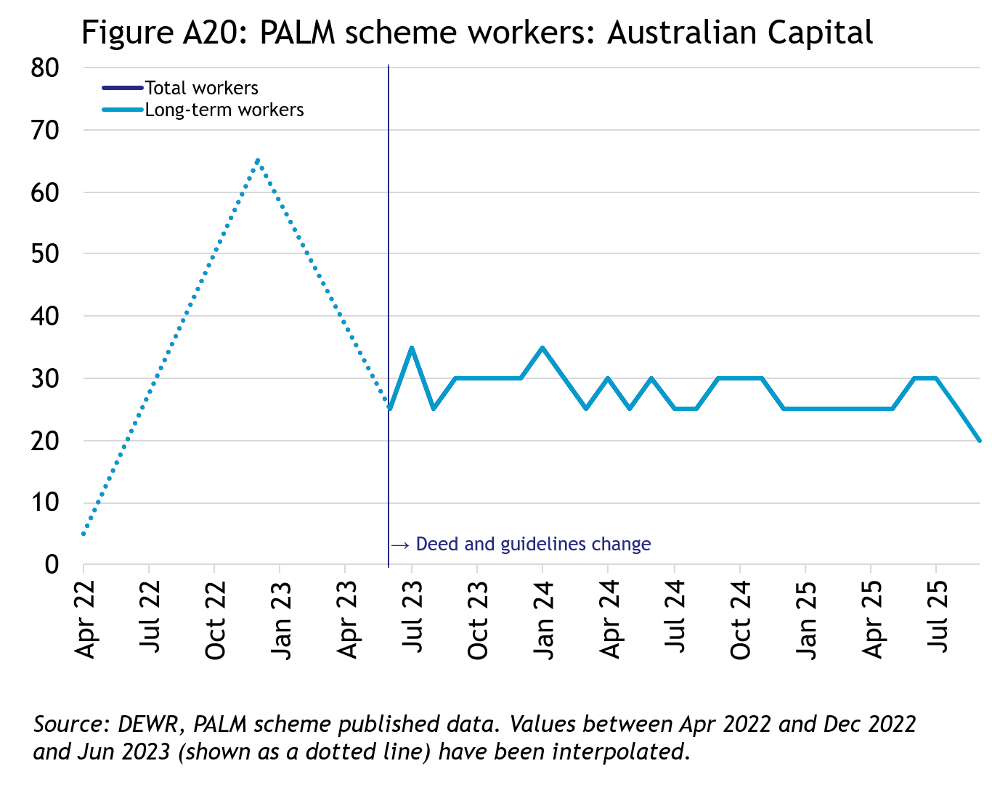
In September 2025, there were 20 workers in the Australian Capital Territory:
- broadly steady since mid-2023
- all PALM scheme workers in the Australian Capital Territory were in the long-term stream

Explanatory notes

Introduction
The PALM scheme allows Australian businesses to hire workers from 9 Pacific Island countries and Timor-Leste when there are not enough local workers available. Businesses who meet the eligibility criteria can access workers in the short-term stream (up to 9 months) and/or in the long-term stream (between one and 4 years).
PALM scheme employers in the agriculture sector and select agriculture-related food product manufacturing sectors can be based anywhere in Australia. All other sectors must be based in a regional or rural location.
For more information, refer to the PALM scheme website: www.palmscheme.gov.au.

Data sources
PALM scheme worker data is a combination of data from the Department of Employment and Workplace Relations (DEWR) IT systems and visa data sourced from the Department of Home Affairs. DEWR administrative data is stored in a live system and reliant on information entered by labour sending units located in each of the partner countries and PALM scheme employers.

Data confidentiality
To protect individuals’ privacy, all cells including any totals and subtotals have been rounded to the nearest 5; values from 1 to 7 are rounded to 5. Zero cells are actual zeros. This may result in non-additivity for some totals. Caution should be taken in recalculating totals from rounded data, as this may compound the effects of rounding.

Glossary
PALM scheme worker:
Citizen of a PALM scheme participating country who is issued an approved offer of employment in accordance with the PALM scheme deed and who is granted a PALM stream - temporary work (international relations) visa (subclass 403); or who held a pandemic event (subclass 408) visa
(up to December 2024).
PALM scheme worker data is derived by combining data from DEWR's IT systems and visa data sourced from the Department of Home Affairs. DEWR data is matched against visa data for comprehensive validation and used to construct valid and accurate counts for PALM scheme workers who are identified in visa data as onshore. Offshore visa holders are excluded from the counts.

PALM scheme employer:
An entity contracted by DEWR under the PALM scheme deed. Employers can be direct employers (arranges the placement of PALM scheme workers it employs with its own business) or labour hire organisations arranging the placement of PALM scheme workers it employs with host organisations using a labour hire arrangement.

Country of origin:
PALM scheme participating country that a PALM scheme worker is from. PALM scheme participating countries are Fiji, Kiribati, Nauru, Papua New Guinea, Samoa, Solomon Islands, Timor-Leste, Tonga, Tuvalu and Vanuatu.

‘Unknown’ country of origin is where country of origin cannot be determined for a PALM scheme worker due to incomplete data.

Stream:
Length of placement of employed PALM scheme workers. This is either 'short-term' or 'long-term':
- Short-term: a placement with short-term PALM scheme workers who hold the relevant visa and are employed in a contract of work for up to 9 months.
- Long-term: a placement with long-term PALM scheme workers who hold the relevant visa and are employed in a contract of work for up to 4 years (non-seasonal).
Industry:
Where possible, industries are classified to the Australian Bureau of Statistics Australian and New Zealand Standard Industrial Classification (ANZSIC). An individual business entity is assigned to an industry based on its predominant activity.

Due to gaps in data sources, a best-fit approach has been used to identify industry. ‘Role descriptions’ (which are job or occupation descriptions) may be used to help identify an accurate industry fit. PALM scheme data is reported to 5 key industry groups: Agriculture, Meat Processing, Accommodation, Health Care and Social Assistance, and Other industries.

- Agriculture:
Reflects workers in ANZSIC Division A: Agriculture, Forestry and Fishing.
- Meat Processing:
Includes Meat and Meat Product Manufacturing (a subset of the ANZSIC Division C: Manufacturing)
- Accommodation:
ANZSIC Division H: Accommodation and Food Services.
- Health care and social assistance:
ANZSIC Division Q: Health Care and Social Assistance. Includes aged, disability and other health care services, including residential care.
- Other Industries:
Includes all remaining industries, that are not otherwise classified to the industries above. Note that a small number of workers in manufacturing in non-meat processing (such as grain and cereal manufacturing, or textile or clothing manufacturing) are included in Other industries. Any workers in Retail are included in Other industries.

Citation
Any publications or reports using the data reported by DEWR must cite DEWR as the source. Where this data has been used for further analysis and interpretation, DEWR requests the inclusion of the following statement in the published report:
“The views expressed in this report are those of the authors and do not necessarily represent those of DEWR."

Contact
For any inquiries, please contact:
- for general PALM scheme enquiries: (PALM@dewr.gov.au)
- for PALM scheme data enquiries: (pacificlabourdata@dewr.gov.au).

