Praivesi bilong yu em bikpela samting
Gude
I no longtaim i go pinis, Department of Employment and Workplace Relations i apdetim pinis PALM skim praivesi notis na konsent fom (pepa bilong pasim tok), em bai helpim mipela long yusim na serim pesonel infomesen long gutpela wei moa (palmscheme.gov.au/resources/worker-privacy-notice-and-consent-form).
Sapos yu wanpela PALM skim wokman inap longpela haptaim, husat i bin kirap wok long Australia bipo long Julai 1, ol toktok i stap daunbilo em bilong yu.

Wanem samting mi mas mekim?
- Namel long Ogas na Septemba 2025, PALM skim emploiya bilong yu bai i givim pepa bilong 'PALM skim wokman praivesi notis' na 'konsent fom', em ol i bin apdetim, i go long olgeta longpela-haptaim wokman (em ol i wok long Australia namel long 1 inap 4-pela yia).
- Plis ritim praivesi notis na, sapos yu wanbel:
  - prinim nem bilong yu, sainim na putim det long laspela peji bilong konsent fom.
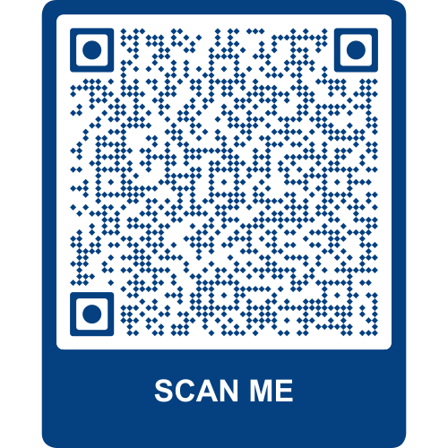
- Taim yu mekim olsem pinis, plis givim bek konsent fom em yu bin sainim i go long PALM skim emploiya bilong yu.

Painimaut moa infomesen?
Sapos yu laik save moa long wanem ol senis i bin kamap long dispela fom, plis yusim fom bilong yu na skenim QR kod.

Wanem samting mi ken mekim sapos mi gat sampela askim moa?
- Toktok long PALM skim emploiya o supavaisa bilong yu.
- Kontektim PALM skim sapot sevis lain - ringim (1800 51 51 31), Manda inap Fraide, 8:30am i go 6:30pm AEST o salim email (palm@dewr.gov.au).
- Kontektim CLO o leba atase bilong yu. Visitim (palmscheme.gov.au/contact) bilong painim moa kontekt infomesen.

