Private Infomeison Blo Iu Important
Hello
Department of Employment and Workplace Relations mekem samfa change lo PALM scheme privacy notis and konsent form fo kontrolem hao oketa iusim and sharem private infomeison blo wakaman lo scheme (palmscheme.gov.au/resources/worker-privacy-notice-and-consent-form). If iu wanfala long-term PALM scheme wakaman, wea start waka lo Australia bifo 1 July 2025, infomeison lo daon fitim iu.

What na mi nid fo duim?
- Midolwan August and September 2025, evri long-term wakaman (wea bae waka lo Australia wan kasem 4 year) bae kasem wanfala PALM scheme worker privacy notis and konsent form from kampani hem waka fo hem.
- Plis readim privacy notis and, if iu agree:
  - Raetem nem, saenem and putum date lo last page blo konsent form.
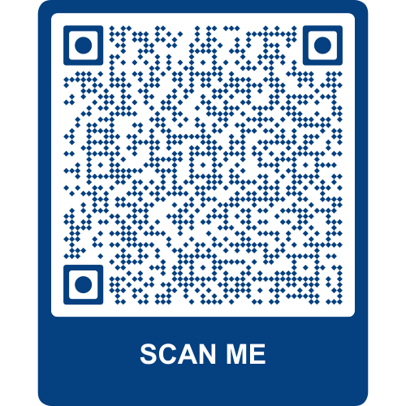
- Taem iu raetem finis, plis saenem and givim baek konsent form lo PALM scheme kampani iu waka fo hem.

Iu nidim moa infomeison?
Fo save moa abaotem oketa change wea mifala duim lo form, plis scanim QR code lo fone blo Iu.

Wanem nao fo duim if mi garem kwestin?
- Stori witim PALM scheme kampani or supervisor blo iu.
- Kontaktim PALM scheme sapot service laen – kolem (1800 51 51 31), Monday go kasem Friday, 8:30am go kasem 6:30pm AEST or email (palm@dewr.gov.au).
- Kontaktim CLO or labour attaché blo iu. Go lo (palmscheme.gov.au/contact) fo moa kontakt.

