Your privacy matters
Ekamawir omo,
Bita Department bwait Employment mwe Workplace Relations ung ogiten updateiy bita wora PALM scheme privacy notice mwe consent form bwe ura num adaborida riringen ata gonan owunan mwe toto wota personal information in bita scheme (palmscheme.gov.au/resources/worker-privacy-notice-and-consent-form).

Iya awe engame ion rakwen am makur ian bitune PALM scheme work, mwe wo aweida makur ian Otereria ian obwon 1st July 2025, mwarane information nan towew mwe tsimine woun eaw.

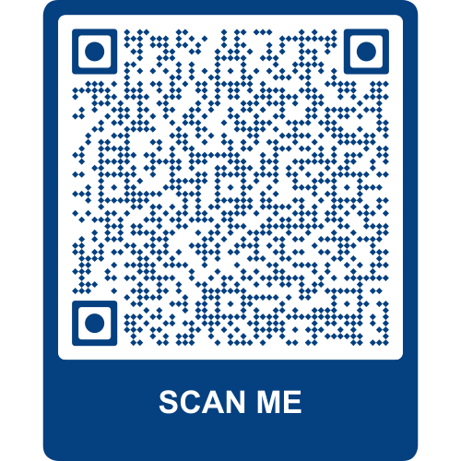
Iken wo’ needeiy wanum riring?
- Inimagen August mwe September 2025, ura memak ambina dabwein makur (ngabuna makur ian Otereria inimagen aiquon mwe aeoq eobweni aura makur ian Otereria) inan oija ura copy’n mwara updated PALM scheme worker privacy notice mwe consent form atsin turin ngabemi ian bitune PALM scheme work.
- Kangaw wanum retsineiy mwarana privacy notice mwe iya epo tabum:
- Wo ere egom, mwe wo’ signeiy, mwe totu bet bita date or ibum,
Ngane enum riring ean bita dogit page ean mwarana form.

- Ngaga wo ogun riring ngea, wo’ num aredowan mwarana document wo’ ogiten signeiy. Aredowana ngabem na iat PALM scheme.

Iya wo’ teng tsid bet angoget information?
Iya wo’ teng bet tsid angogen mwana imin ngana eiwud ean mwara form, wo’ gona owunan wan terpon mwe scanneiy bita QR code.

Iya tsimine am kouda?
- Wo’ gona dorera ngabem ian bita PALM scheme work or gona dorera wam supervisor.
- Wo gona bet contacteiy ambina amin puog ian bitune PALM scheme work. Wora numpa ngea (1800 51 51 31) gona contacteiy ura inimagen Monday ea Friday 8:30am ea 6;30pm or wo gona emaileiy ura (palm@dewr.gov.au).
- Gona bet contacteiy wam CLO or dabwein makur ean wora site ngea (palmscheme.gov.au/contact).

