E kakawaaki manon rongorongom
Mauri
E a tia aobitin te Department of Employment and Workplace Relations ni manga kaboua ana kamataata iaon te kaetieti ibukin manon rongorongom iaan te PALM tikiim n ikotaki ma te booma ibukin am kariaia iaon katamaroan waaki iaon tibwakin rongorongom n te tikiim
(palmscheme.gov.au/resources/worker-privacy-notice-and-consent-form).
Ngkana te tia mwakuri ngke n te boraraoi are e abwabwaki iaan te PALM tikiim, ao ko teirake ni mwakuri i Aotiteria imwain 1 n Turai 2025, a kaineti rongorongo aikai nakoim.

Tera te bwai ae nna riai n karaoia?
- Imarenan Aokati ao Tebetembwa 2025, taan mwakuri iaan te boraraoi are e abwabwaki (aika a mwakuri i Aotiteria man 1 nakon 4 te ririki), a na bon anganaki, iroun aia emburoea, kaobiin te kamataata ae e boou ibukin manon rongorongoia n ikotaki ma te booma ibukin aia kariaia iaan te PALM tikiim.
- Taiaoka wareka te kamataata ibukin manon rongorongom ao ngkana ko kukurei iai:
  - korea aram, tiaaina ao kaota bongin namwakaina n te booma ibukin am kariaia ane te kabanea n iteranibaa.
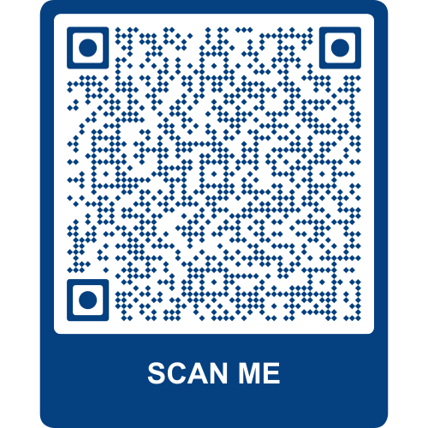
- Ngkana e tia, taiaoka kaoka te booma ibukin am kariaia are ko a tia n tiaainaia nakon am emburoea ae e kaaina te PALM tikiim.

Kakaean riki rongorongona?
Ibukin kakaean riki rongorongon kamataata aika a tia ni karaoaki nakon
te booma, taiaoka kabongana am tareboon n tikaenia te QR code aio.

Tera ae nna karaoia ngkana iai riki au titiraki?
- Maroro ma am emburoea ke am tia kairiiri aika a kaaina te PALM tikiim.
- Reitaki ma ana tieweti n ibuobuoki te PALM tikiim iaon - (1800 51 51 31), Moanibong nakon te Kanimabong, man 8:30am nakon 6:30pm AEST ke imeeri nakon (palm@dewr.gov.au).
- Reitaki ma am CLO ke te tia tei man te reibwa. Noora (palmscheme.gov.au/contact) ibukin rongorongon aron rekeia iroum.

