Āp ke nijhi jīwan maneye rakhe he
Namaste
Dipāṭmenṭ of Emploemenṭ aur Wōkplais Rilaīshans abhi jaldi PALM skim praevasi nōṭis aur konsen fōm ke badlis he tāki skim me kaise āp ke nijhi jānkari ke istamal aur shea kara jāe he uske sudhār kara jae sake (palmscheme.gov.au/resources/worker-privacy-notice-and-consent-form).
Agar āp ek PALM skim karamchāri lamba taem se he, jon Asṭrelia me ek julae 2025 se pahile kām suru karis he, to i age dewal jānkari āp ke khatin he.

Hamme konchi kare ke chahi?
- 2025 Augasṭ aur Sepṭemba ke bich me, sab lamba kām kare wala karamchārilong ke (jon Asṭrelia me ek se char sāl tak se kām kare he) ke PALM skim bōs long ek nawa badlān PALM skim wōka praevasi nōtis aur ek consen fōm dai.
- Plīs praevasi nōtis paḍh lena aur, agar āp sahmaṭi deta he to:
  - Konsen fōm ke akhri paij pe apan nām prin kar ke, sāin kar ke aur tarik likh dena.
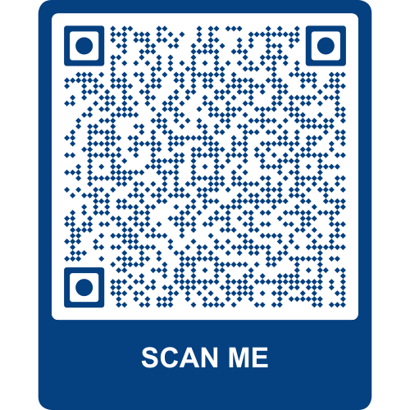
- pura hoe pe, plīs apan PALM skim bōs ke sain karan la konsen fōm lauṭār dena.

Aur jānkari mangta?
Fōm me konchi badlān he uske bare me aur jānkari jane ke khatin, plīs i QR kauḍ ke apan faῡn se sken karo.

Ham konchi kari agar hamār pās aur sawal he?
- Apan PALM skim bōs ya supāvaiza se bāt karo.
- PALM skim sapōṭ sebis lain ke kontekṭ karo – kol karo (1800 51 51 31), Sammār se Suk tak, 8:30am se 6:30pm AEST ya imail karo (palm@dewr.gov.au).
- Apan CLO ya laiba atechi ke kontekṭ karo. Jāo (palmscheme.gov.au/contact) pe kontekṭ ke jānkari ke khatin.

