Your privacy matters
Hello
The Department of Employment and Workplace Relations has recently updated the PALM scheme privacy notice and consent form to improve the way we use and share your personal information in the scheme (palmscheme.gov.au/resources/worker-privacy-notice-and-consent-form).
If you are a long-term PALM scheme worker, who started working in Australia before 1 July 2025, the following information applies to you.

What do I need to do?
- Between August and September 2025, all long-term workers (working in Australia from one to 4 years) will be provided a copy of the updated PALM scheme worker privacy notice and consent form by your PALM scheme employer.
- Please read the privacy notice and, if you agree:
  - print your name, sign and date the consent form on the last page.
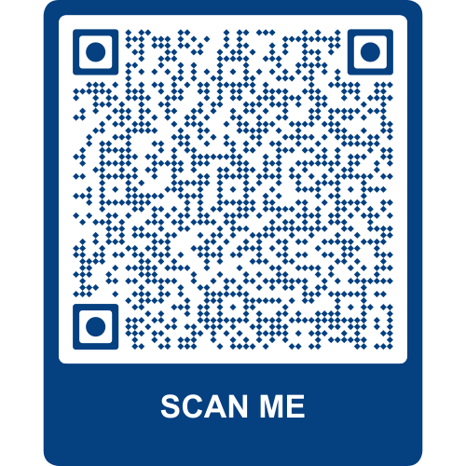
- Once completed, please return the signed consent form to your PALM scheme employer.

Find out more information?
To find out more about what changes have been made to the form, please scan the QR code using your phone.

What should I do if I have more questions?
- Talk to your PALM scheme employer or supervisor.
- Contact the PALM scheme support service line – call (1800 51 51 31), Monday to Friday, 8:30am to 6:30pm AEST or email (palm@dewr.gov.au).
- Contact your CLO or labour attaché. Visit (palmscheme.gov.au/contact) for contact details.

