Praevisi blong yu hem i impoten
Halo
Dipatmen blong Emploimen mo Wokples Rilesens i bin apdetem wan praevisi notis mo konsent fom blong PALM skim blong impruvum fasin blong mifala i yusum mo serem ol pesonel infomesen blong yu anda long skim ia (palmscheme.gov.au/resources/worker-privacy-notice-and-consent-form).
Sapos yu wan long-tem PALM skim woka mo yu bin stat blong wok long Ostrelia bifo long 1 Julae 2025, ol infomesen ia hem i blong yu.

Wanem nao mi nid blong mekem?
- Bitwin long manis Okis mo Septemba 2025, PALM skim emploia blong yu bae oli givim wan kopi blong apdet praevisi notis mo konsent fom i kam long ol long-tem woka (olgeta we oli wok long 1 kasem 4 yia long Ostrelia).
- Plis ridim praevisi notis ia mo sapos yu agri long hem, bae yu:
  - raetemaot nem blong yu, saenem mo putum deit long konsent fom, long las pej blong hem.
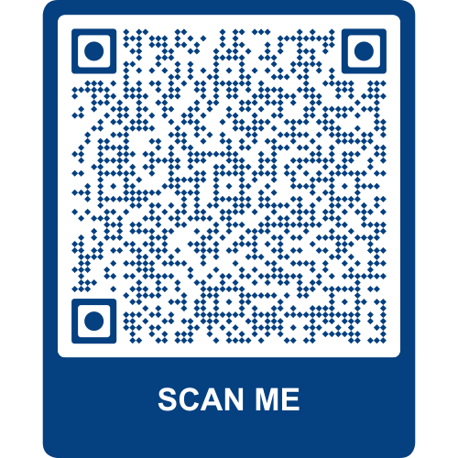
- Taem yu fulumap finis, pasem fom we yu saenem long PALM skim emploia blong yu.

Blong kasem moa infomesen
Blong kasem moa infomesen long saed blong ol jenis we oli mekem insaed long fom ia, plis skanem QR kod ia wetem fon blong yu.

Sapos mi gat sam kwestin, bae mi askem long hu?
- Toktok long PALM skim emploia o supavaesa blong yu.
- Kontaktem PALM skim sapot sevis laen – kolem namba ia (1800 51 51 31) long Mandei kasem Fraedei long 8:30am kasem 6:30pm AEST o sanem imel i kam long (palm@dewr.gov.au).
- Kontaktem CLO o leba attaché blong yu. Go long websaet ia (palmscheme.gov.au/contact) blong kasem ol kontak blong olgeta.

