# Pacific Australia Labour Mobility scheme quarterly update

# Data current up to 31 March 2025

# Published: 11 June 2025

## Key findings

Pacific Australia Labour Mobility (PALM) scheme worker counts are a measure of the number of workers from participating PALM scheme countries holding a valid visa who are currently onshore in Australia. Worker participation will vary from month to month reflecting a range of factors, including:

* the cyclical nature of the program and worker visa conditions (9 months for the short-term stream and up to 4 years for the long-term stream)
* changing workforce demand stemming from growing cycles for different crops in different regions, and
* workers returning home for holidays or other personal commitments.

**Worker counts — year to March 2025**

Over the 12 months to March 2025:

* the worker count decreased by 5%
  + short-term worker counts declined by 10% over the year
  + long-term worker counts held steady.
* by industry, worker counts in:
  + Agriculture declined by 9% (1,715 workers) since March 2024. This is largely attributed to the departure of 408 Pandemic event visa holders, who predominantly worked in agriculture.
  + Meat processing declined by 2% over the year to March 2025. Over 97% of workers in this industry are in the long-term stream. A slightly higher proportion of these workers temporarily departed Australia in December 2024 compared with December 2023.
  + Other PALM industries (which account for about 9% of the total PALM workforce) recorded an increase over the year: Accommodation increased by 22%; Health care and Social Assistance increased by 26%; and Other industries increased by 2%.
* by country, between March 2024 and March 2025:
  + worker counts increased for: Papua New Guinea, Kiribati, Solomon Islands, Tuvalu, Timor-Leste, and a significant increase for Nauru.
  + worker counts decreased for: Fiji, Samoa, Tonga and Vanuatu.

**PALM scheme visa analysis**

Until recently, PALM scheme workers could access two types of visa:

* PALM stream temporary work (international relations) visa (subclass 403); or
* the temporary COVID-19 Pandemic event (subclass 408 visa) visa (now closed).

During the COVID-19 pandemic, the PALM scheme was heavily relied upon as there were limited alternate sources of temporary labour. Short-term PALM workers could apply for the Pandemic even subclass 408 visa to stay in Australia longer, providing a reliable workforce during the pandemic, overwhelmingly employed in agriculture.

In June 2023, 14% of PALM workers (or 4,830 people) held a 408 visa. By December 2024, this had reduced to 0.2% (65 workers). Due to the small and diminishing number of PALM 408 visa holders, from January 2025 the Department of Employment and Workplace Relations ceased reporting on 408 visa holders.

By contrast, the number of onshore 403 visa holders rose rapidly between April 2022 and early 2024. Setting aside the expected December dip in 2024 (as workers temporarily returned home for holidays), the number of 403 visa holders has been generally steady over 2024 and into the first quarter of 2025.

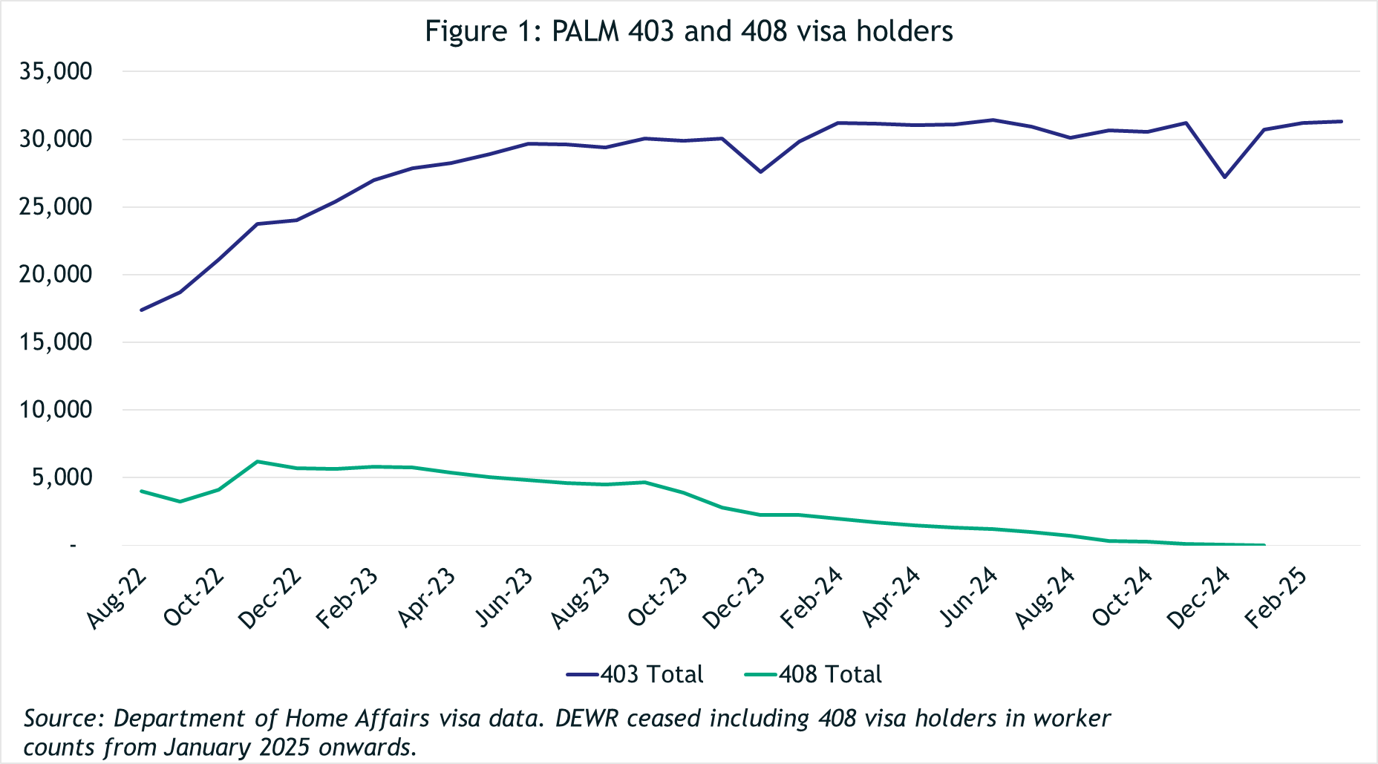

**PALM scheme employers**

The number of PALM scheme employers has continued to grow since the new PALM scheme deed and guidelines were introduced in June 2023.

* 127 new employers have joined the scheme since June 2023, bringing the total number of employers to 509 in March 2025, a record high since the commencement of the PALM scheme (and predecessor schemes).

# *Data and chart notes:*

All published PALM scheme worker data including any totals and subtotals are rounded to the nearest 5. For more information see the Glossary.

Worker counts are only available for April 2022, December 2022 and from June 2023 onwards. In the charts below, the unknown values between April 2022 and December 2022, and December 2022 and June 2023 have been inferred and are represented by the dotted lines. This produces unnaturally smooth lines that are not representative of the usual fluctuations expected in the monthly data.

## PALM scheme worker trends

In March 2025, there were:

* 31,310 workers
* 14,655 in the short-term stream
* 16,655 in the long-term stream

In the 12 months to March 2025, the number of workers fell by 5%:

* Total long-term stream remained steady
* Total short-term stream was down by 10%.

## PALM scheme employer trends

In March 2025, there were:

* 509 employers
* 403 were direct employers  
  (Up 7% in the 12 months to March 2025)
* 106 were labour hire employers  
  (Up 12% in the 12 months to March 2025).

## Appendix A: detailed PALM scheme worker trends

### PALM scheme worker trends by industry

The PALM scheme has become increasingly diversified, with employers from a broader range of industries entering the scheme, offering Pacific Island and Timor-Leste workers more choice.

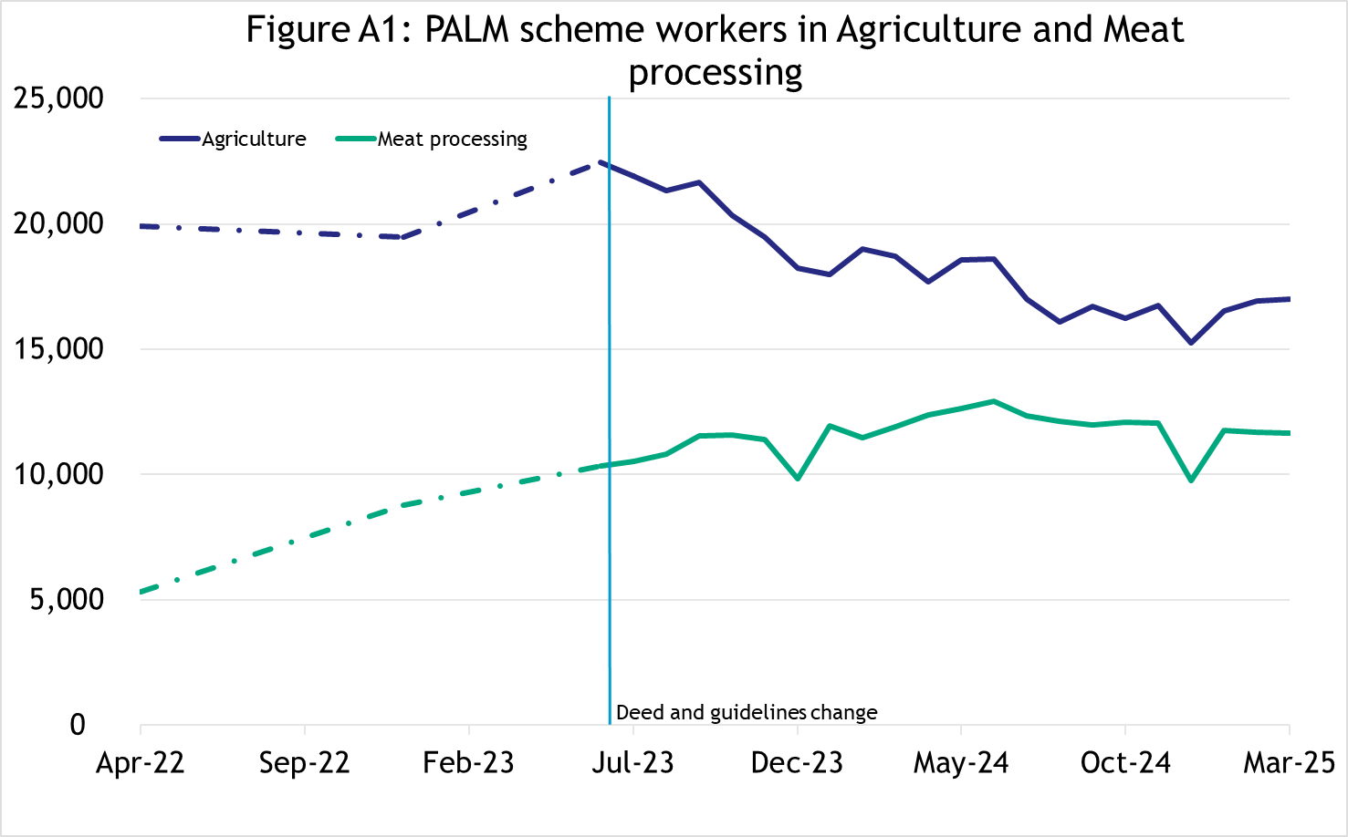

In March 2025, there were:

* 17,010 workers in Agriculture
* down 15% since April 2022
* down 9% in the 12 months to March 2025
* 83% were short-term
* 17% were long-term.
* 11,650 workers in Meat processing
* up 119% since April 2022
* down 2% in the 12 months to March 2025
* 3% were short-term
* 97% were long-term.

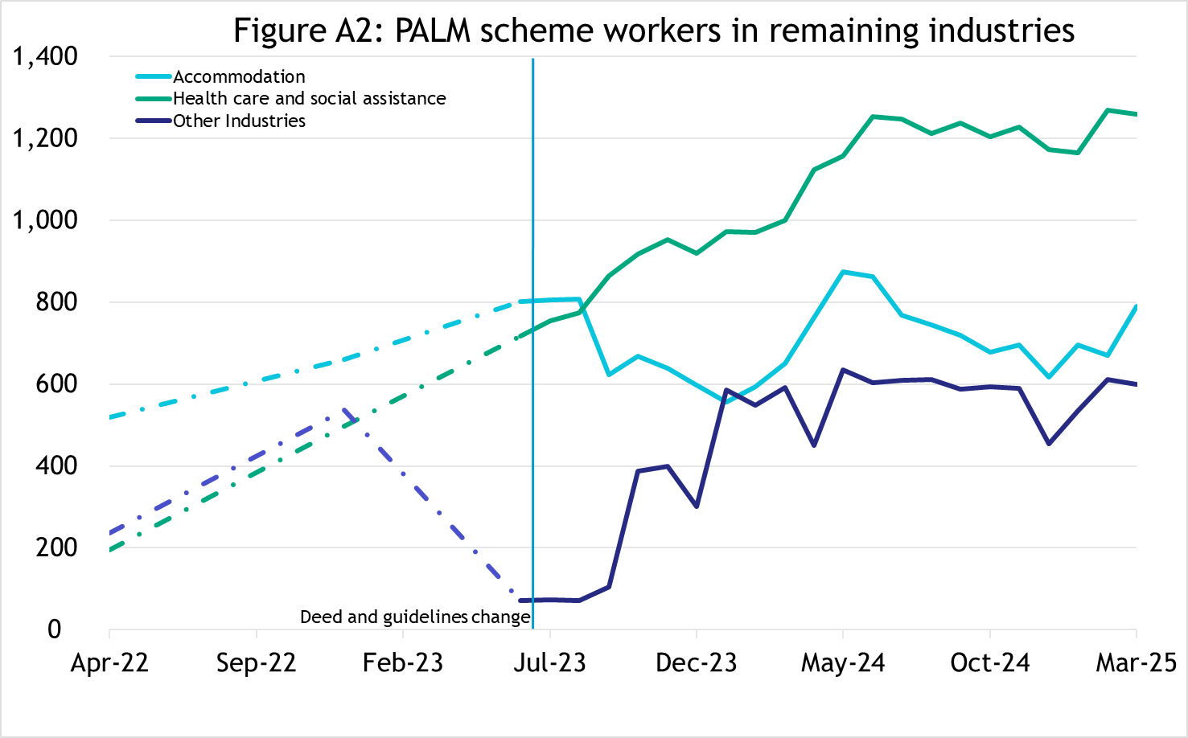

In March 2025, there were:

* 790 workers in Accommodation
* up 52% since April 2022
* up 21% in the 12 months to March 2025
* 25% were short-term
* 75% were long-term.
* 1,260 workers in Health care and Social Assistance
* up 543% since April 2022
* up 26% in the 12 months to March 2025
* 100% were long-term.
* 600 workers in other industries
* up 153% since April 2022
* up 1% in the 12 months to March 2025
* 14% were short-term
* 86% were long-term.

**PALM scheme worker trends by country of origin**

##### **Fiji**

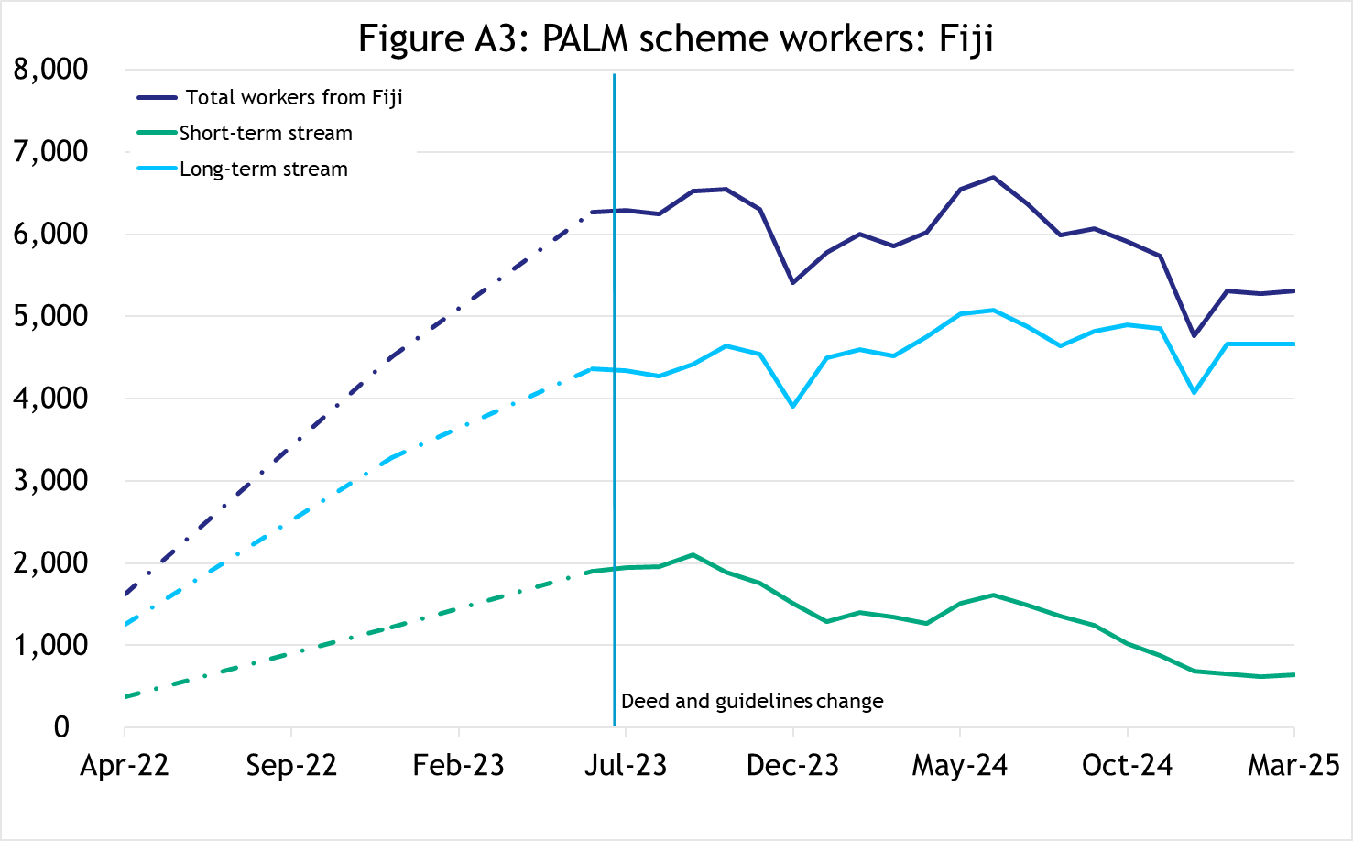

In March 2025, there were 5,305 workers from Fiji,

* up 226% since April 2022
* down 9% in the 12 months to March 2025
* 88% of Fijian PALM scheme workers were in the long-term stream.

##### 



**Kiribati**

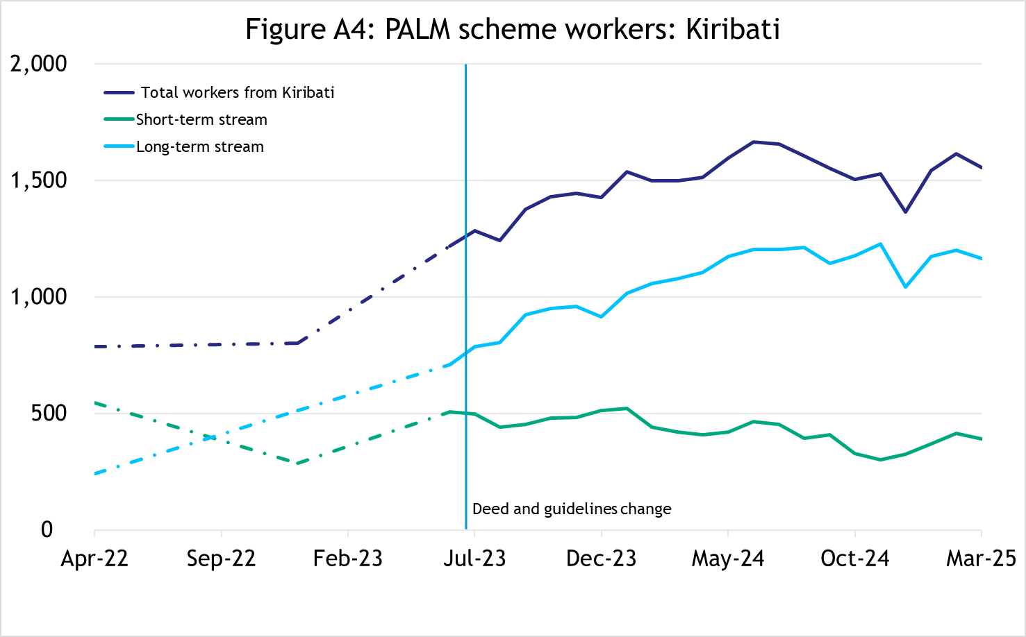

In March 2025, there were 1,555 workers from Kiribati,

* up 98% since April 2022
* down 4% in the 12 months to March 2025
* 75% of Kiribati PALM scheme workers were in the long-term stream.

**Nauru**

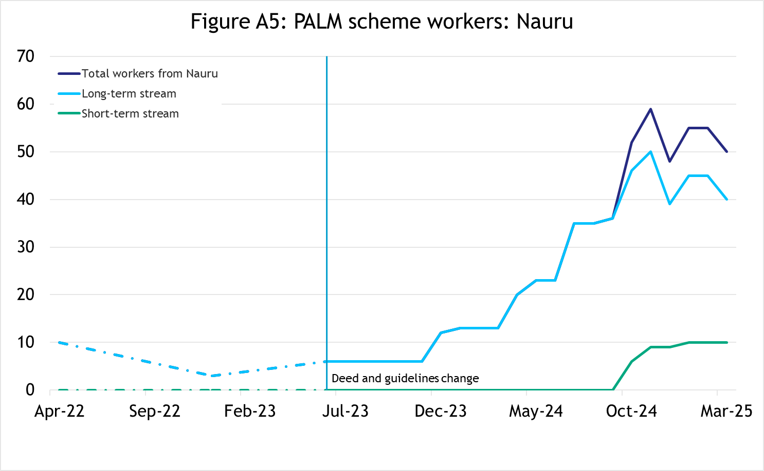

In March 2025, there were 50 workers from Nauru,

* up 410% since April 2022
* up 233% in the 12 months to March 2025
* 80% of Nauru PALM scheme workers were in the long-term stream.

**Papua New Guinea**

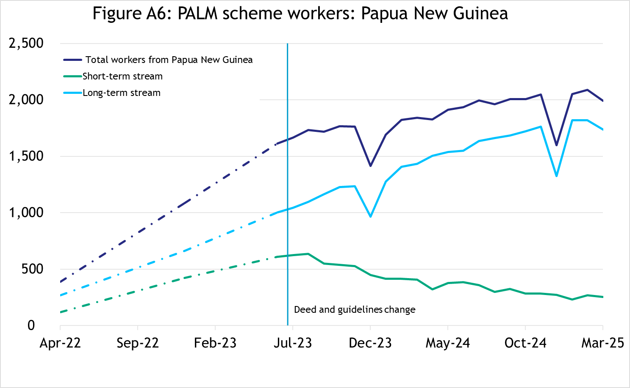

In March 2025, there were 1,995 workers from Papua New Guinea,

* up 416% since April 2022
* up 8% in the 12 months to March 2025
* 87% of Papua New Guinea PALM scheme workers were in the long-term stream.

**Samoa**

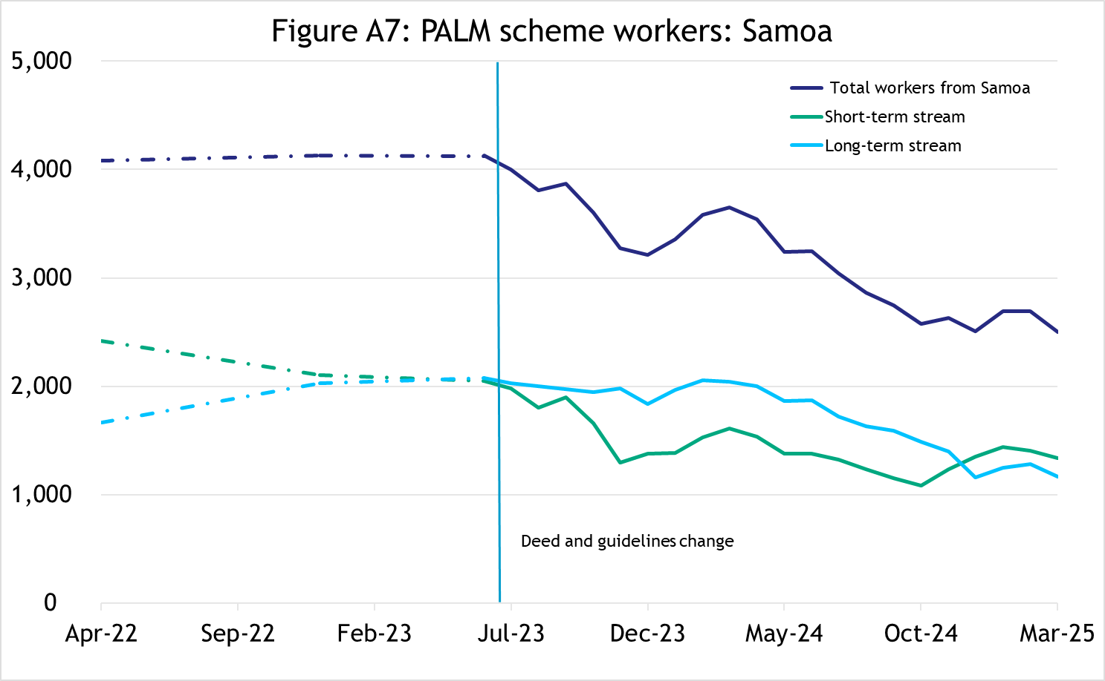

In March 2025, there were 2,500 workers from Samoa,

* down 39% since April 2022
* down 32% in the 12 months to March 2025
* 53% of Samoan PALM scheme workers were in the short-term stream.

**Solomon Islands**

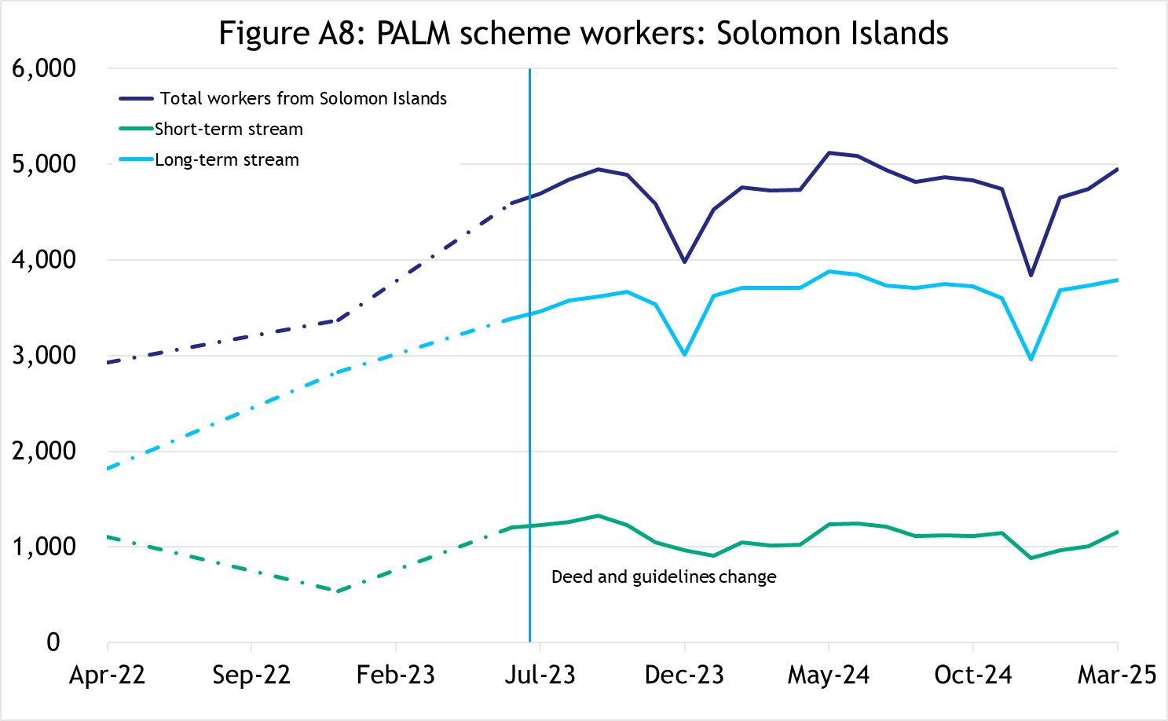

In March 2025, there were 4,945 workers from the Solomon Islands,

* up 69% since April 2022
* up 5% in the 12 months to March 2025
* 77% of Solomon Islands PALM scheme workers were in the long-term stream.

**Timor-Leste**

##### 

In March 2025, there were 4,765 workers from Timor-Leste,

* up 178% since April 2022
* up 17% in the 12 months to March 2025
* 66% of Timor-Leste PALM scheme workers were in the short-term stream.

##### **Tonga**

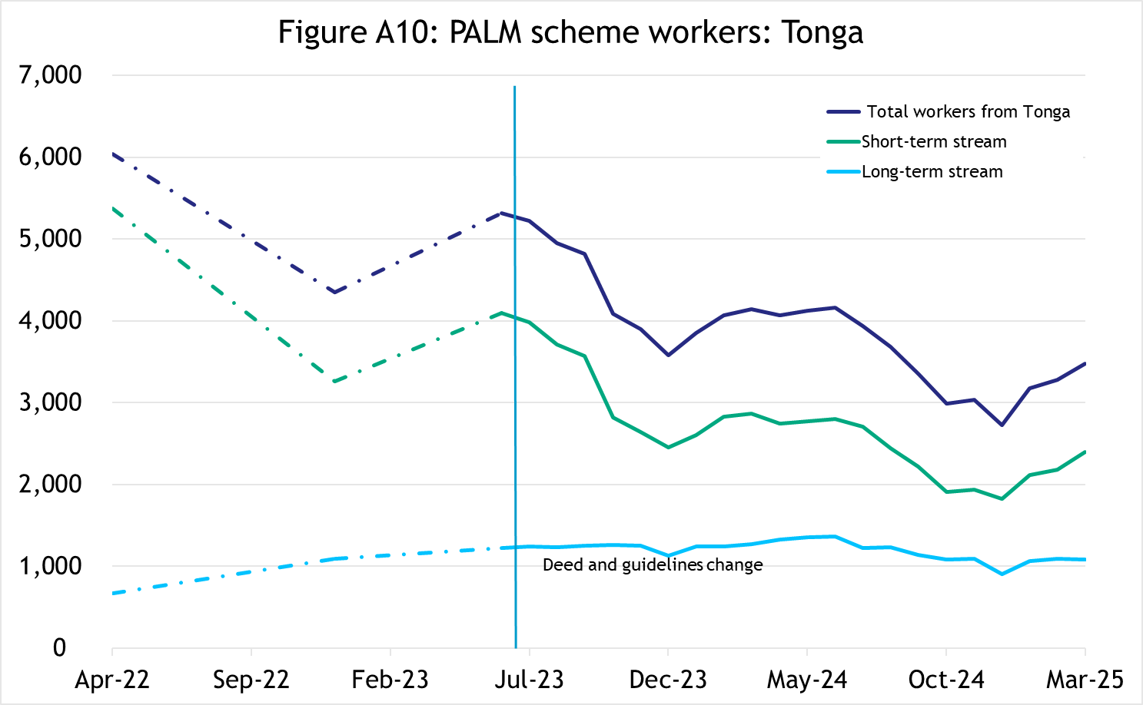

In March 2025, there were 3,480 workers from Tonga,

* down 42% since April 2022
* down 16% in the 12 months to March 2025
* 69% of Tongan PALM scheme workers were in the short-term stream.

##### **Tuvalu**

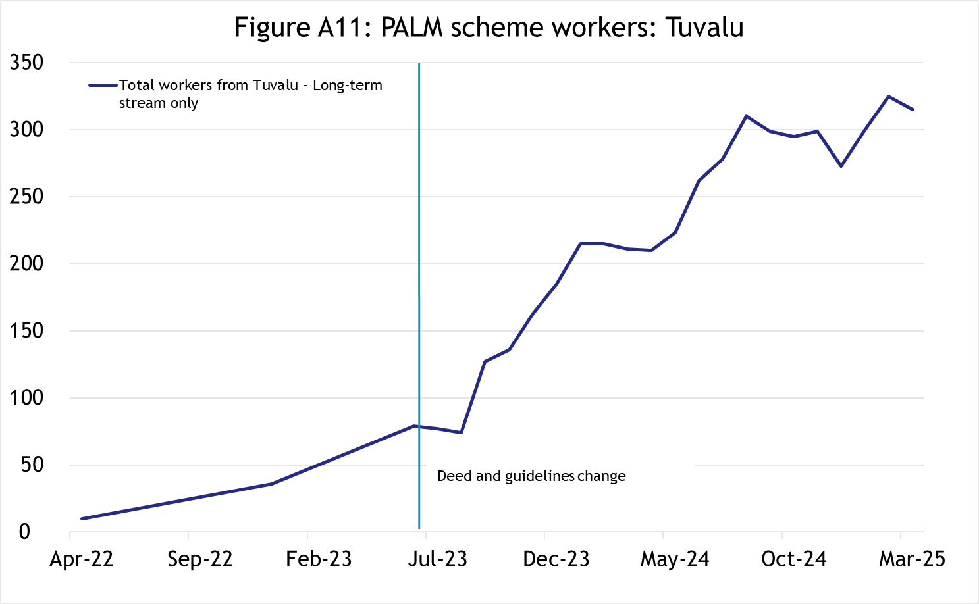

In March 2025, there were 315 workers from Tuvalu,

* up 3,030% since April 2022
* up 48% in the 12 months to March 2025
* 100% of Tuvalu PALM scheme workers were in the long-term stream.

##### **Vanuatu**

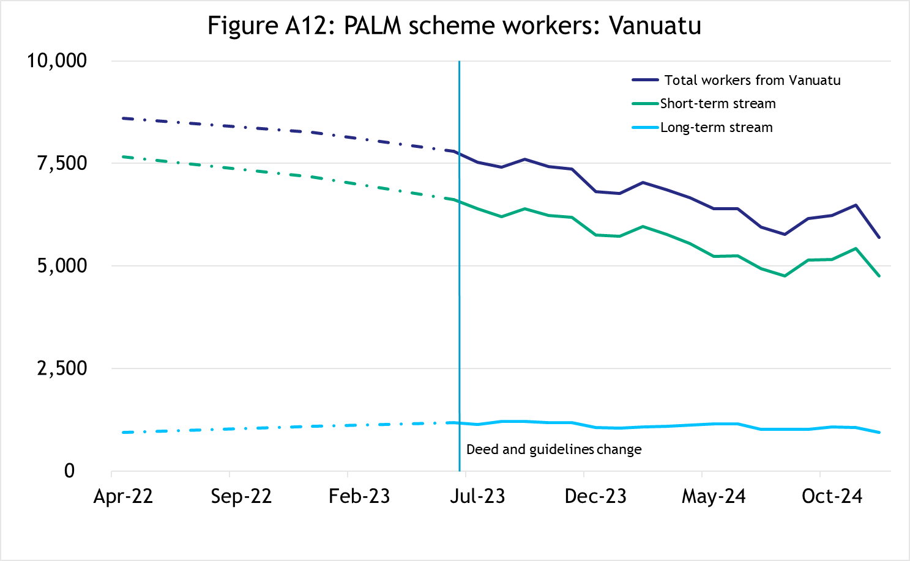

In March 2025, there were 6,400 workers from Vanuatu,

* down 26% since April 2022
* down 7% in the 12 months to March 2025
* 83% of Vanuatu PALM scheme workers were in the short-term stream.

### PALM scheme worker trends by state/territory New South Wales

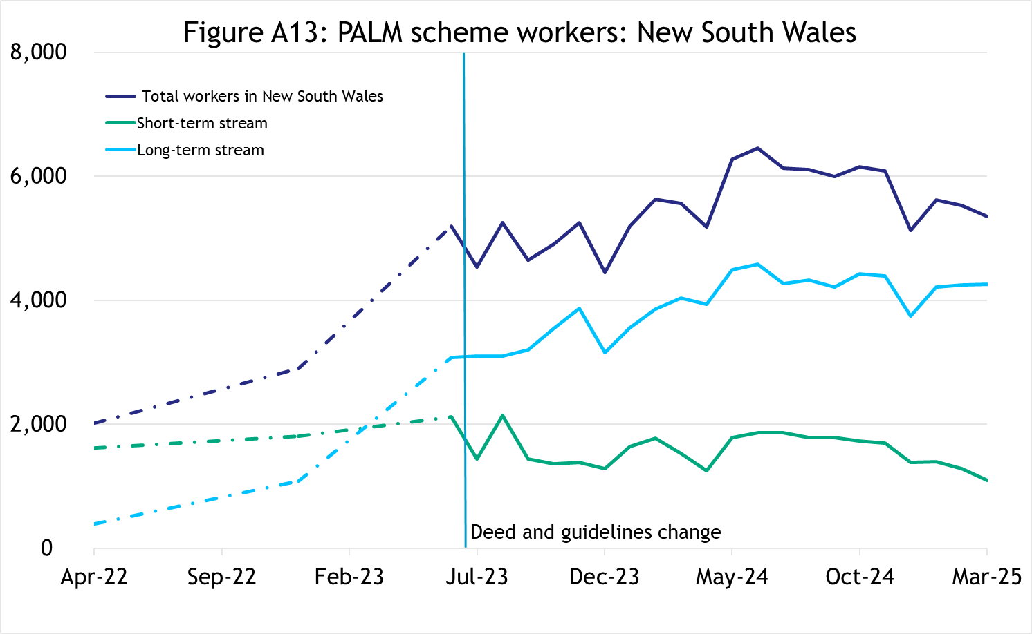

In March 2025, there were 5,355 workers in New South Wales,

* up 165% since April 2022
* down 4% in the 12 months to March 2025
* 80% of New South Wales PALM scheme workers were in the long-term stream.

**Victoria**

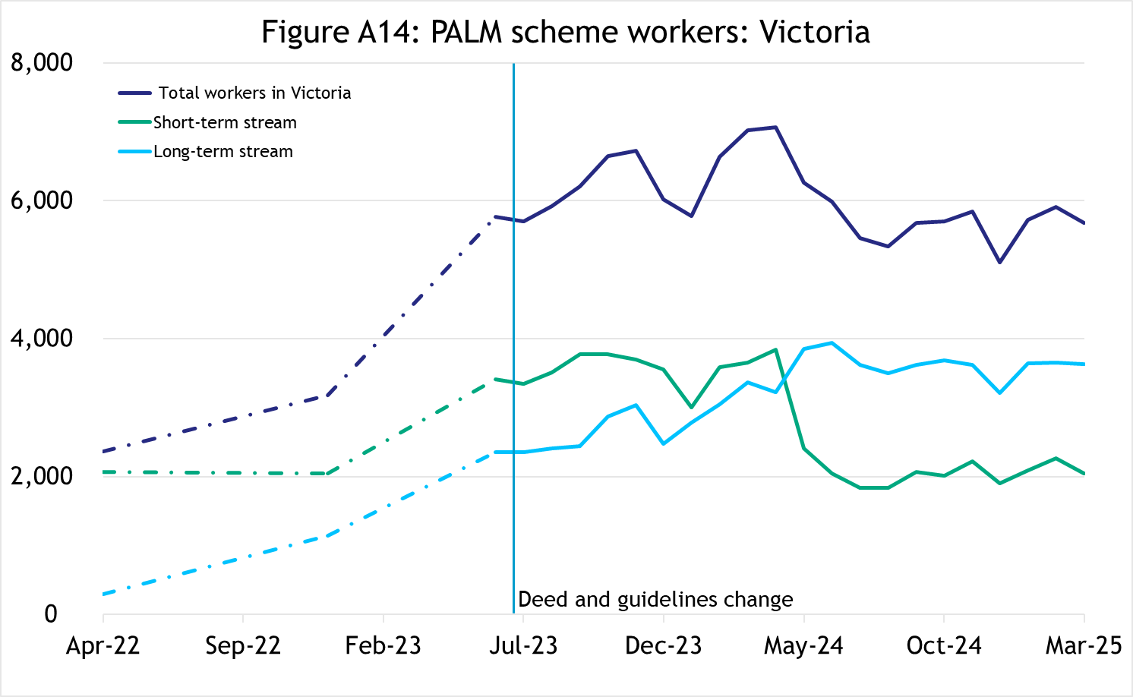

In March 2025, there were 5,680 workers in Victoria,

* up 140% since April 2022
* down 19% in the 12 months to March 2025
* 64% of Victorian PALM scheme workers were in the long-term stream.

##### **Queensland**

In March 2025, there were 11,745 workers in Queensland,

* up 11% since April 2022
* up 12% in the 12 months to March 2025
* 52% of Queensland PALM scheme workers were in the short-term stream.

##### **South** **Australia**

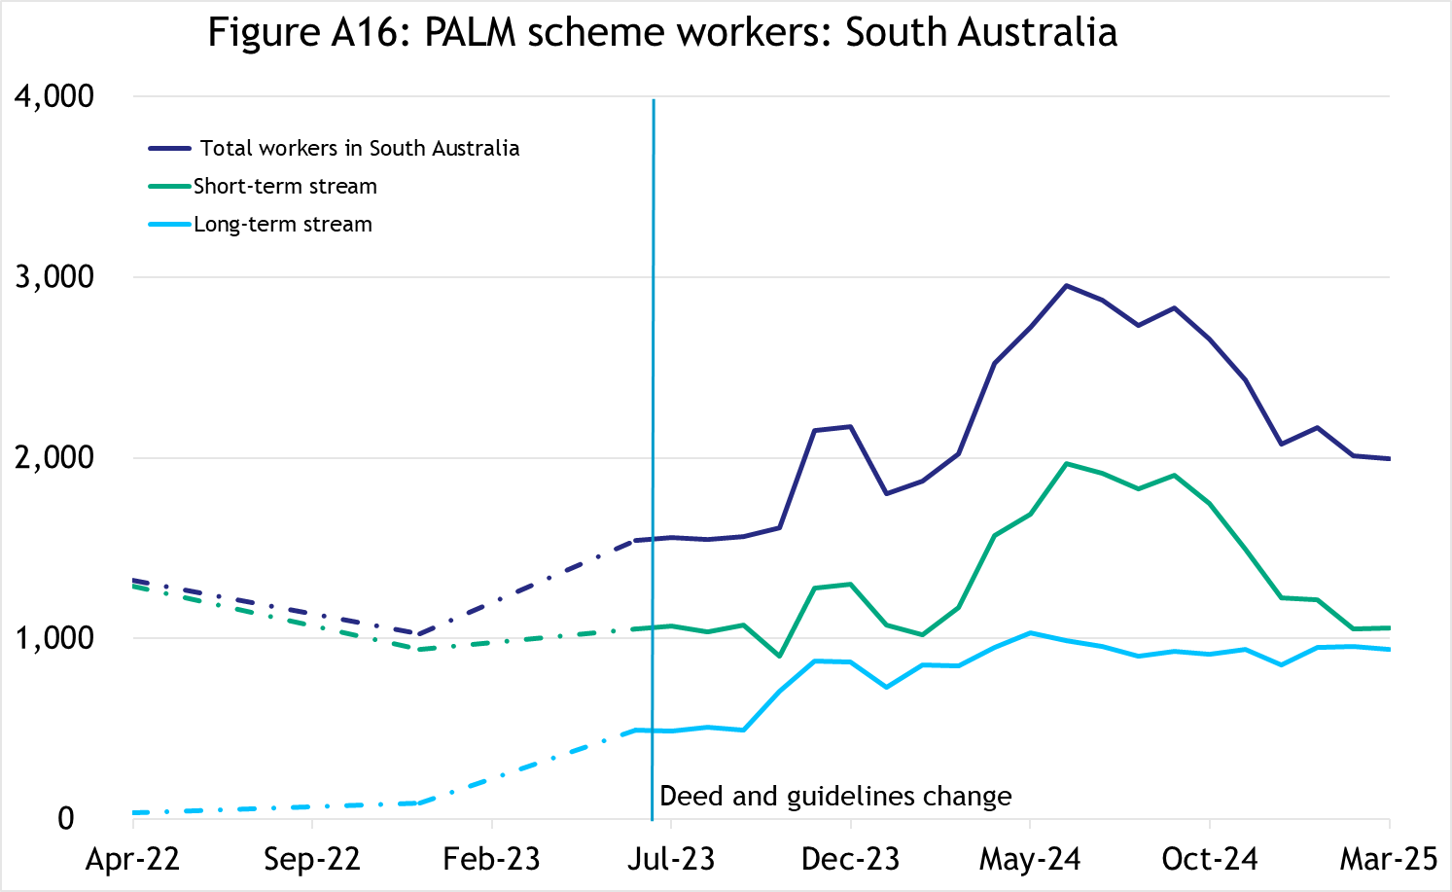

In March 2025, there were 2,000 workers in South Australia,

* up 51% since April 2022
* down 1% in the 12 months to March 2025
* 53% of South Australian PALM scheme workers were in the short-term stream.

##### 

##### 

##### **Western** **Australia**

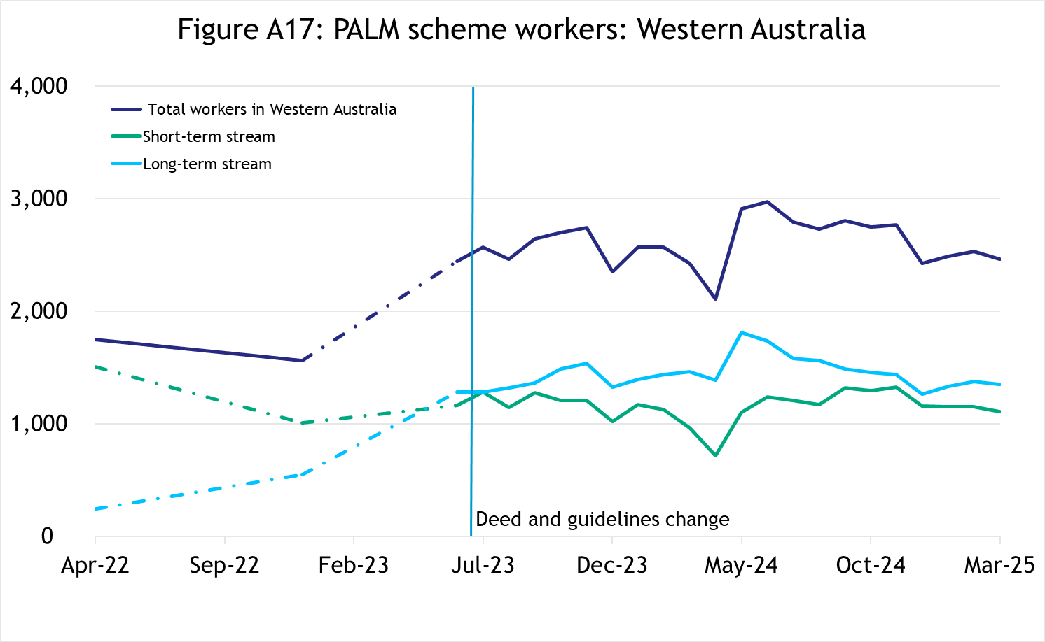

In March 2025, there were 2,465 workers in Western Australia,

* up 41% since April 2022
* up 1% in the 12 months to March 2025
* 55% of Western Australian PALM scheme workers were in the long-term stream.

##### **Tasmania**

In March 2025, there were 3,105 workers in Tasmania,

* up 42% since April 2022
* up 5% in the 12 months to March 2025
* 84% of Tasmanian PALM scheme workers were in the short-term stream.

**Northern** **Territory**

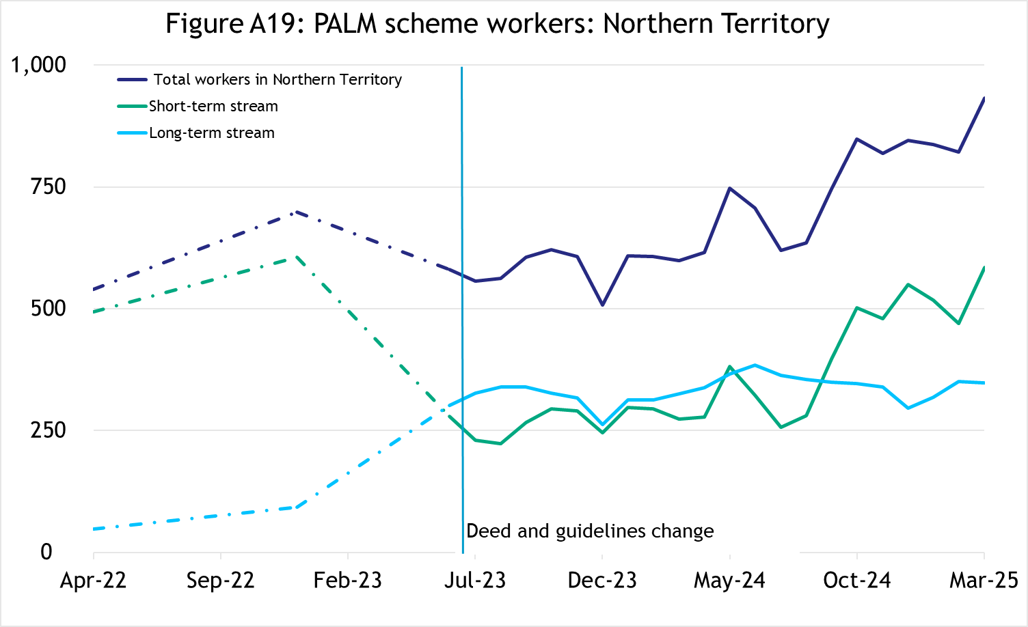

In March 2025, there were 935 workers in the Northern Territory,

* up 73% since April 2022
* up 56% in the 12 months to March 2025
* 63% of Northern Territory PALM scheme workers were in the short-term stream.

**Australian** **Capital** **Territory**

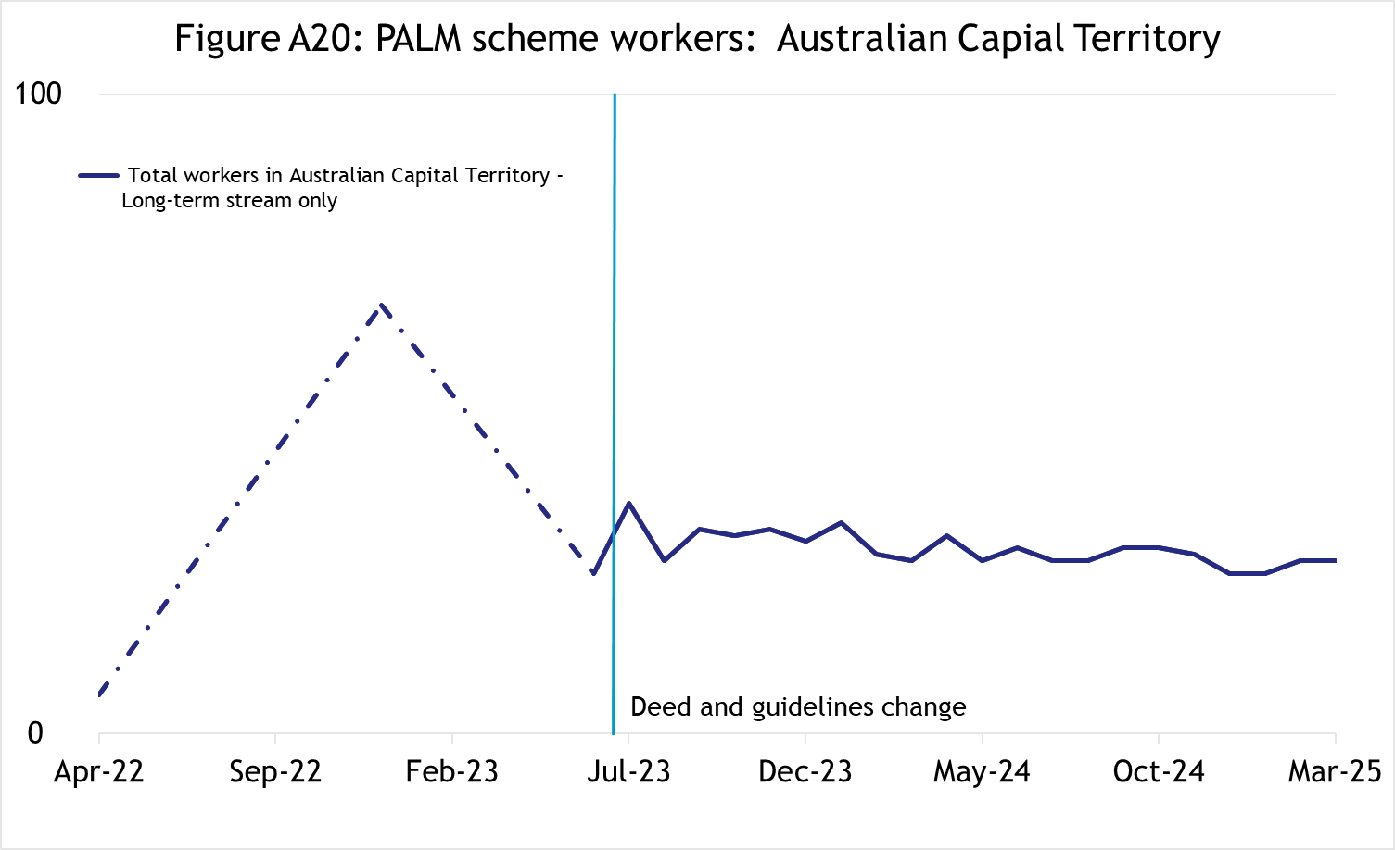

In March 2025, there were 25 workers in the Australian Capital Territory,

* broadly steady since mid 2023
* all PALM scheme workers in the Australian Capital Territory were in the long-term stream.

## Explanatory notes

### Introduction

The PALM scheme allows Australian businesses to hire workers from 9 Pacific Island countries and Timor-Leste when there are not enough local workers available. Businesses who meet the eligibility criteria can access workers in the short-term stream (up to 9 months) and/or in the long-term stream (between one and 4 years).

PALM scheme employers in the agriculture sector and select agriculture-related food product manufacturing sectors can be based anywhere in Australia. All other sectors must be based in a regional or rural location.

For more information, refer to the PALM scheme website: [www.palmscheme.gov.au](http://www.palmscheme.gov.au).

### Data sources

PALM scheme worker data is a combination of data from the Department of Employment and Workplace Relations (DEWR) IT systems and visa data sourced from the Department of Home Affairs. DEWR administrative data is stored in a live system and reliant on information entered by labour sending units located in each of the partner countries and PALM scheme employers.

### Data confidentiality

To protect individuals’ privacy, all cells including any totals and subtotals have been rounded to the nearest 5; values from 1 to 7 are rounded to 5. Zero cells are actual zeros. This may result in non-additivity for some totals. Caution should be taken in recalculating totals from rounded data, as this may compound the effects of rounding.

### Glossary

*PALM scheme worker:*

Citizen of a PALM scheme participating country who is issued an approved offer of employment in accordance with the PALM scheme deed and who is granted a PALM stream - temporary work (international relations) visa (subclass 403); or who held a pandemic event (subclass 408) visa (up to December 2024).

PALM scheme worker data is derived by combining data from DEWR's IT systems and visa data sourced from the Department of Home Affairs. DEWR data is matched against visa data for comprehensive validation and used to construct valid and accurate counts for PALM scheme workers who are identified in visa data as onshore. Offshore visa holders are excluded from the counts.

*PALM scheme employer:*

An entity contracted by DEWR under the PALM scheme deed. Employers can be direct employers (arranges the placement of PALM scheme workers it employs with its own business) or labour hire organisations arranging the placement of PALM scheme workers it employs with host organisations using a labour hire arrangement.

*Country of origin:*

PALM scheme participating country that a PALM scheme worker is from. PALM scheme participating countries are Fiji, Kiribati, Nauru, Papua New Guinea, Samoa, Solomon Islands, Timor-Leste, Tonga, Tuvalu and Vanuatu.

‘Unknown’ country of origin is where country of origin cannot be determined for a PALM scheme worker due to incomplete data.

*Stream:*

Length of placement of employed PALM scheme workers. This is either 'short-term' or 'long-term':

* *Short-term*: a placement with short-term PALM scheme workers who hold the relevant visa and are employed in a contract of work for up to 9 months.
* *Long-term*: a placement with long-term PALM scheme workers who hold the relevant visa and are employed in a contract of work for up to 4 years (non-seasonal).

*Industry:*

Where possible, industries are classified to the Australian Bureau of Statistics Australian and New Zealand Standard Industrial Classification (ANZSIC). An individual business entity is assigned to an industry based on its predominant activity.

Due to gaps in data sources, a best-fit approach has been used to identify industry. ‘Role descriptions’ (which are job or occupation descriptions) may be used to help identify an accurate industry fit.

PALM scheme data is reported to 5 key industry groups: Agriculture, Meat Processing, Accommodation, Health Care and Social Assistance, and Other industries.

* *Agriculture:*

Reflects workers in ANZSIC Division A: Agriculture, Forestry and Fishing.

* *Meat Processing:*

Includes Meat and Meat Product Manufacturing (a subset of the ANZSIC Division C: Manufacturing)

* *Accommodation:*  
  ANZSIC Division H: Accommodation and Food Services.
* *Health care and social assistance*:  
  ANZSIC Division Q: Health Care and Social Assistance. Includes aged, disability and other health care services, including residential care.
* *Other Industries:*

Includes all remaining industries, that are not otherwise classified to the industries above. Note that a small number of workers in manufacturing in non-meat processing (such as grain and cereal manufacturing, or textile or clothing manufacturing) are included in Other industries. Any workers in Retail are included in Other industries.

## Citation

Any publications or reports using the data reported by DEWR must cite DEWR as the source. Where this data has been used for further analysis and interpretation, DEWR requests the inclusion of the following statement in the published report:

*“The views expressed in this report are those of the authors and do not necessarily represent those of DEWR."*

## Contact

For any inquiries, please contact:

* for general PALM scheme enquiries: ([PALM@dewr.gov.au](mailto:PALM@dewr.gov.au))
* for PALM scheme data enquiries: ([pacificlabourdata@dewr.gov.au](mailto:pacificlabourdata@dewr.gov.au)).