Pacific Australia Labour Mobility (PALM) Scheme Data report

**June quarter 2024**

# Introduction

The Australian Government is committed to the responsible and sustainable growth of the Pacific Australia Labour Mobility (PALM) scheme to meet industry demand and the aspirations of partner countries. Labour mobility is central to Australia’s engagement with the Pacific and Timor-Leste, providing jobs for Pacific and Timor-Leste workers and enabling them to develop skills, earn income and support their families and communities back home.

PALM allows Australian businesses to hire workers from 9 Pacific Island countries and Timor- Leste when there are not enough local workers available. Businesses who meet the eligibility criteria can access workers in the short-term stream (up to 9 months) and/or in the long-term stream (between one and 4 years).

PALM scheme employers in the agriculture sector and select agriculture-related food product manufacturing sectors can be based anywhere in Australia. All other sectors must be based in a regional or rural location.

For more information, refer to the PALM scheme website: [www.palmscheme.gov.au](http://www.palmscheme.gov.au/).

## Data quality review

From July 2023, the Australian Government consolidated and insourced the PALM scheme’s domestic operations within the Department of Employment and Workplace Relations. Shortly after the insourcing of the scheme including related data systems, the department undertook a review of data quality. The review identified inaccuracies in the methods used to calculate previously reported worker numbers. The department undertook an extensive process to identify the errors and develop a new methodology for quantifying worker numbers. Counts of employer numbers are not affected.

The review and development of the revised methodology was a joint undertaking with the

department’s Chief Data Officer, providing independent oversight of the review.

The review found errors in both short and long-term raw datasets. A range of factors contributed to the incorrect calculation of PALM worker data, including: the impact of combining disparate data from the short-term stream under the Seasonal Worker Program (SWP) and the long-term stream under the Pacific Labour Scheme (PLS); missing and duplicate records; the incorrect treatment when counting onshore and offshore movements; and a range of inconsistent and incompatible data processing rules over time.

The net result of these data integrity issues was an overcount of PALM workers. The revised calculations do not reflect a fall in the number of actual workers employed under the PALM scheme or a sudden decrease in demand.

## Improved methodology

While the factors that contributed to the miscalculation are inter-related, the largest single contributor to the revisions is improving the handling of offshore workers. The new methodology corrects the issues identified by the review by matching Department of Home

1

PALM Scheme data report – June quarter 2024

Affairs visa data with the department’s administrative data (stored in the PALMIS system) at the unit record level. The count of workers now excludes workers who are shown to be offshore in the visa data and also accurately accounts for workers that are onshore.

The new counts include workers who hold a PALM stream visa: the Temporary Work (International Relations) visa (subclass 403); or the COVID-19 Pandemic event (subclass 408) visa. Detailed information for 408 visa holders is not available to the department so some data tables, such as by state/territory, do not include PALM workers holding a 408 visa.

The department ceased reporting of worker data in March 2024, with February 2024 data being the final month prepared using the former (incorrect) approach. All worker estimates from March 2024 onwards are based only on the new methodology. To allow comparisons over time, the department recalculated selected historical data points for April 2022, December 2022, and June 2023 to February 2024.

The new methodology has also helped quantify gaps in PALMIS data, such as delayed or inaccurate reporting, particularly by employers. The department has commenced an intensive education and enforcement program to improve reporting accuracy and timeliness.

## Publication of data

Data for January to June 2024 were published on 31 July 2024, marking the first regular monthly reporting of PALM scheme data. Data for the historical recalculated periods (April 2022, December 2022 and June to December 2023) were published on 30 September 2024.

PALM data are available on the PALM scheme website: [www.palmscheme.gov.au/palm-scheme-data](http://www.palmscheme.gov.au/palm-scheme-data).

# PALM scheme trends — overview

This section provides an overview of the trends from April 2022 to June 2024. Section 3 provides more detailed views of PALM worker counts by country of origin, by industry, and for PALM scheme employer numbers.

## PALM worker trends, April 2022 to June 2024

Between April 2022 and June 2024, the number of PALM scheme workers increased by 31%. This rate of growth is responsible and sustainable. Growth rates in the PALM scheme have moderated since COVID-19, when PALM was heavily relied upon as there were limited alternate sources of labour.

* + There have been shifts in composition over time, with significant growth in the long- term stream which more than doubled, from 7,010 workers in April 2022 to 18,140 workers in June 2024 (an increase of 159%).
  + By contrast, the short-term stream has been in decline since April 2022, prior to the commencement of the new PALM scheme in mid-2023. Since April 2022, the short-term stream has declined by 16%.

The PALM scheme has become increasingly diversified, with employers from a broader range of industries entering the scheme, offering Pacific Island and Timor-Leste workers with more choice.

* + Data from April 2022 to June 2024 shows a decline in workers in Agriculture of 7%.
    - Short-term Agriculture declined by 14% between April 2022 and June 2024 but continues to employ the largest cohort of workers in any sector, at 15,730 workers in June 2024.

2

PALM Scheme data report – June quarter 2024

* + - The decline in short-term agricultural workers was partly offset by an increase in long-term agriculture, rising from 1,680 in April 2022 to 2,855 in June 2024.
  + All long-term industry components increased, with the most significant increases from April 2022 recorded for Health care and social assistance (increasing by 796%, albeit from a small base) and Meat processing, which rose by 161% to 12,755 workers in June 2024.

The compositional shift to long-term work in the scheme likely reflects a range of factors, including:

* + the expected decline of 408 pandemic event visa holders in the scheme (almost all of whom were in short-term agricultural roles)
  + growth in new sectors that are experiencing domestic labour shortages (such as Meat processing) that are not seasonal and require a consistent longer term workforce, and
  + employer and worker behaviours may be changing, such as the employer preference to avoid the churn of short-term workforces, and worker preferences for longer term placements.

## PALM employer trends (since July 2023)

The number of PALM scheme employers has continued to grow since the new PALM Deed and Guidelines were introduced in July 2023.

* + 86 new employers have joined the scheme since July 2023, bringing the total number of employers to 479 in June 2024, a record high since the commencement of the PALM scheme (and predecessor schemes).

3

PALM Scheme data report – June quarter 2024

# PALM scheme trends

This section provides in-depth views of PALM worker counts by country of origin and by industry.

*Chart notes:*

Most of the charts below compare worker counts based on the previous methodology with the new methodology. The previous methodology ceased in February 2024.

Historical worker counts have been recalculated, only for: April 2022, December 2022 and each month from June 2023 to February 2024. In the charts, the unknown values between April 2022 and December 2022, and December 2022 and June 2023 have been inferred and are represented by the dotted lines. This produces smooth lines that are not representative of the usual fluctuations expected in the monthly data.

All published PALM worker data including any totals and subtotals are rounded to the nearest 5. For more information see the Glossary.

## Australia – PALM worker trends

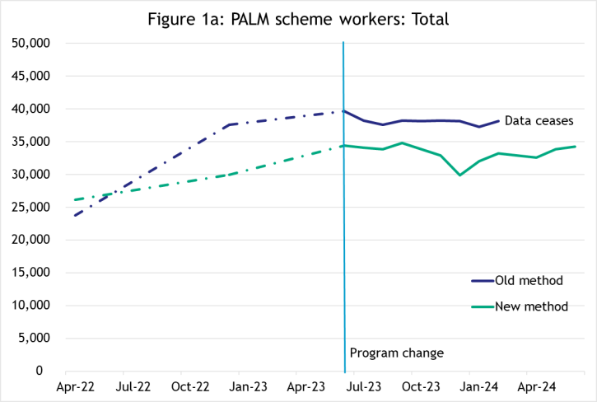Total PALM worker numbers

PALM scheme worker numbers have increased by 31% between April 2022 and June 2024 (see Figure 1a). Apart from a marked drop in December 2023 due to workers returning home for holidays, levels have remained relatively stable over the last year.

Under the new methodology, new worker counts are generally 9% to 14% lower than previously reported, except for December 2022 and 2023; these were over-estimated by around 20%.

PALM worker numbers — by stream

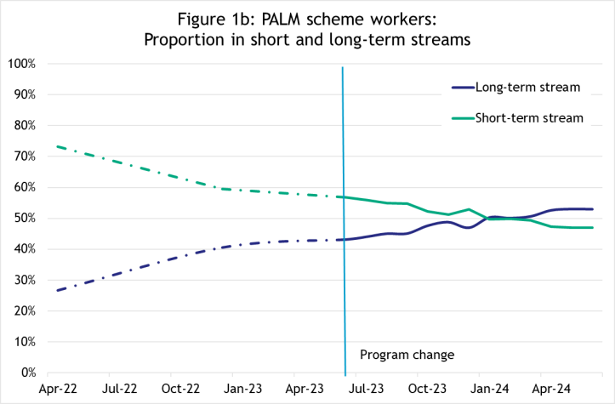Figure 1b shows the proportion of PALM scheme workers engaged in the short-term and long- term streams between April 2022 and June 2024.

Over time, PALM scheme worker participation by stream has shifted significantly. In April 2022, the short-term stream accounted for 73% of the PALM scheme workforce, and by June 2024, this had reduced to just under half (47%). Conversely, the proportion of workers in the long-term stream increased from just 27% in April 2022 to 53% in June 2024.

The most significant changes occurred between April 2022 and December 2022, with the trend towards an increasing share of long-term workers continuing to June 2024, albeit at a slower rate of change.

4

PALM Scheme data report – June quarter 2024

Short-term stream

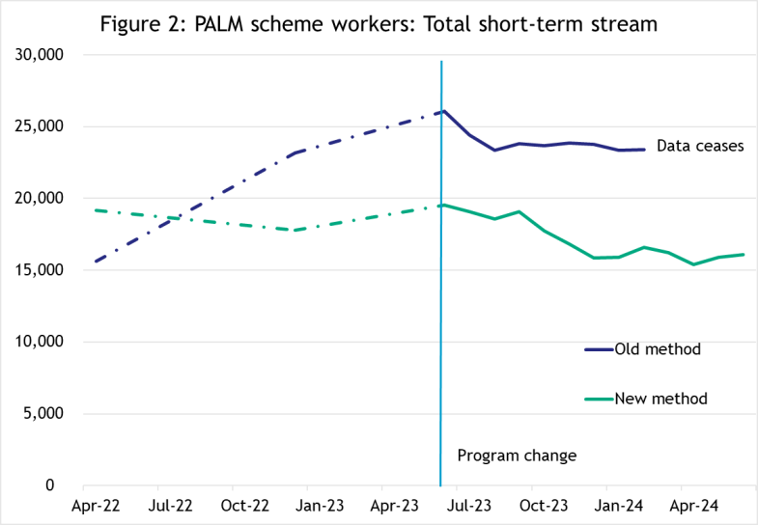The short-term stream has been generally in decline since April 2022 (prior to the commencement of the new PALM scheme in mid-2023). Between April 2022 and June 2024, the short-term stream declined by 16%.

This decline likely reflects a range of factors, including the departure of 408 pandemic event visa holders and the return of working holiday makers as another source of seasonal labour. There may be some changes in employer and worker preferences emerging, including the possible impact of new program settings that encourage employers to better plan their workforce needs.

* Previously reported short-term worker counts were overestimated by 26%, on average, except for April 2022 which was under-counted.

Long-term stream

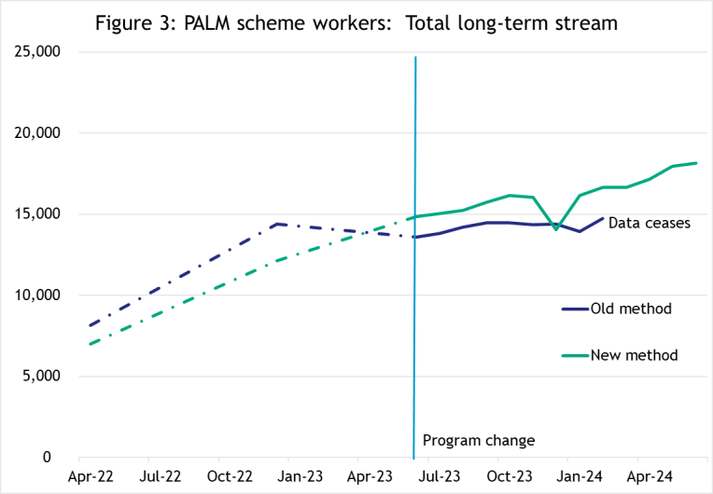There has been significant growth in the long-term stream between April 2022 and June 2024, with the number of long-term workers more than doubling over the period.

The December 2023 drop in worker counts highlighted above is driven by long-term workers temporarily leaving the country. This same pattern can be seen below for those countries and industries that have greater proportions of workers in the long- term stream.

* Previously reported long-term worker counts were over-reported for April 2022 and December 2022. After June 2023, long-term worker counts were typically under-reported instead.

5

PALM Scheme data report – June quarter 2024

## Worker trends by country of origin

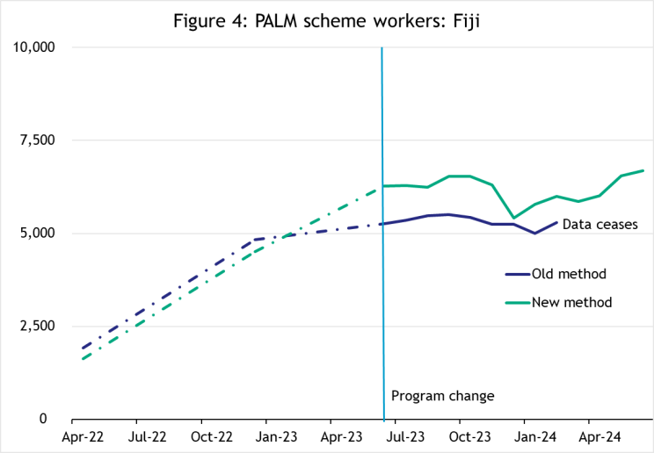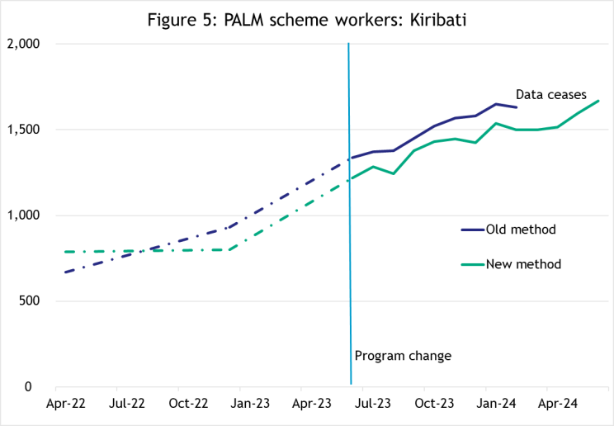

Fiji

The number of PALM scheme workers from Fiji increased significantly over the period, up from 1,630 in April 2022, to 6,695 in

June 2024.

Around three-quarters of Fijian workers are in the long-term stream. After a drop in December 2023, it took a number of months for the series to return to earlier levels.

* PALM worker counts are similar for old and new methodologies up to December 2022. The two series then diverged and the revised count of PALM workers from Fiji is on average higher than previously reported, by 16% for 2023/241.

Kiribati

The total number of workers from Kiribati has been steadily increasing, from 785 in April 2022, to 1,665 in June 2024 (up by 112%). Around 72% of workers from Kiribati were in the long-term stream, the source of all of the growth; worker counts in the short-term stream have been mainly steady over the period.

* The revised counts of PALM worker numbers from Kiribati are on average lower than previously reported, by between 5% and 10% for 2023/24.

1 In this report, 2023/24 refers to the period June 2023 to February 2024.

6

PALM Scheme data report – June quarter 2024

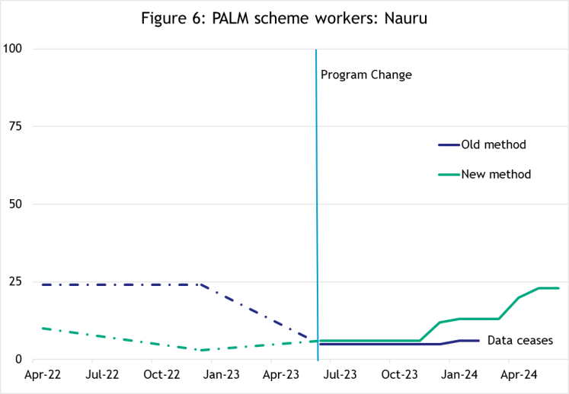Nauru

Nauru has a small number of workers which remained roughly level between April 2022 and December 2023. In 2024, worker numbers from Nauru have risen to their highest levels.

* While the differences between the old and new methodologies may seem large, they are based on very small numbers and do not represent significant changes.

Papua New Guinea

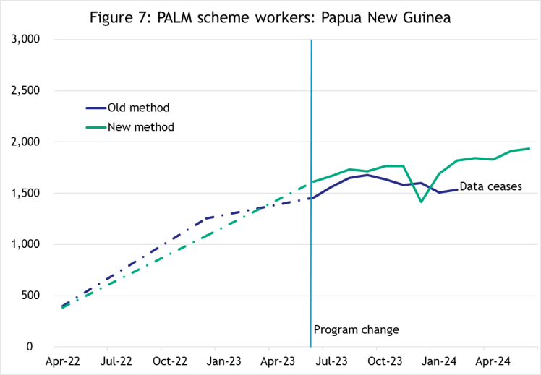Overall, the total number of PALM workers from Papua New Guinea has risen strongly over the period, increasing from 385 in April 2022 to 1,935 in June 2024.

The 20% drop in December 2023 is noteworthy, as is the subsequent rebound in the following two months. Around 80% of Papua New Guinean workers were in the long-term stream in June 2024.

* The revised count of PALM worker numbers from Papua New Guinea are on average higher than previously reported, by 7% for 2023/24.

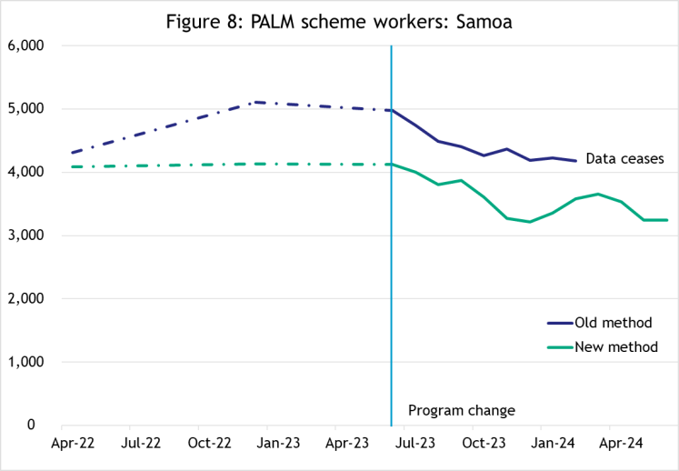Samoa

The total number of workers from Samoa has been generally declining between April 2022 and June 2024, despite some volatility in the series during 2024. The decline over the period occurs mostly in the short-term stream, with around 42% of Samoan PALM scheme workers participating in the short-term stream.

* The revised count of PALM worker numbers from Samoa are on average lower than previously reported, by 18% for 2023/24.

7

PALM Scheme data report – June quarter 2024

Solomon Islands

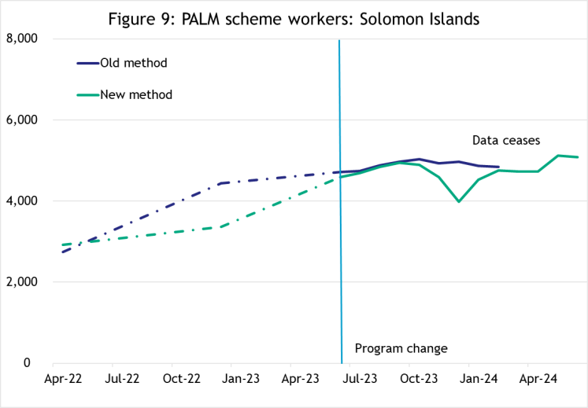The total number of workers from the Solomon Islands has been increasing over the last two years or so, rising by 74% between April 2022 and June 2024. Around three-quarters of PALM scheme workers from the Solomon Islands are in the long-term stream.

* The revised counts of PALM worker numbers from the Solomon Islands are lower than previously reported, by around 3% on average for 2023/24, excluding the large difference recorded for December 2023.

Timor-Leste

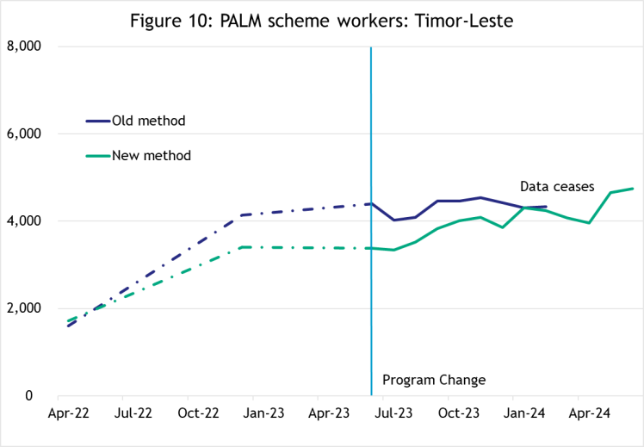Between April 2022 and June 2024, the number of workers from Timor-Leste has more than doubled, rising to 4,750 in June 2024. Growth remains positive, despite some fluctuations in December 2023 and again in April 2024.

* Revised counts for Timor-Leste are generally lower than previously reported, with varied differences of

-23% in June 2023, to -2% in February

2024.

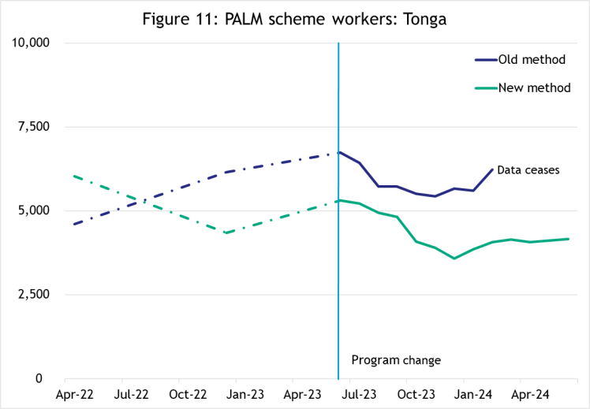Tonga

Between April 2022 and December 2023, the number of workers from Tonga was generally decreasing (apart from a rise in the first half of 2023). Again, the decrease is primarily observed in the short-term stream, which accounted for about two-thirds of Tongan workers in June 2024. In 2024 however, the number of Tongan PALM scheme workers has been generally steady.

* The revised counts of PALM worker numbers from Tonga are on average lower than previously reported, by 25% for 2023/24.

8

PALM Scheme data report – June quarter 2024

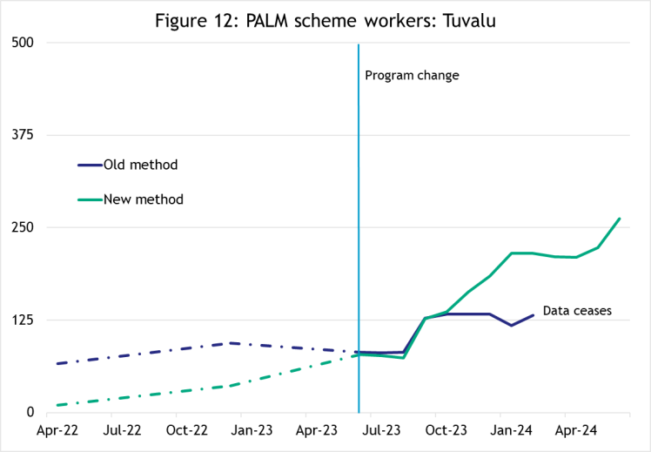Tuvalu

Tuvalu is a small contributor to the PALM scheme workforce, with around 260 workers participating in the scheme in June 2024. The number of Tuvaluan workers has been steadily growing since April 2024, with particularly strong growth since mid-2023.

* There is some variation between the counts under the previous and new methodologies, with the gap between the two series widening in late 2023.

Vanuatu

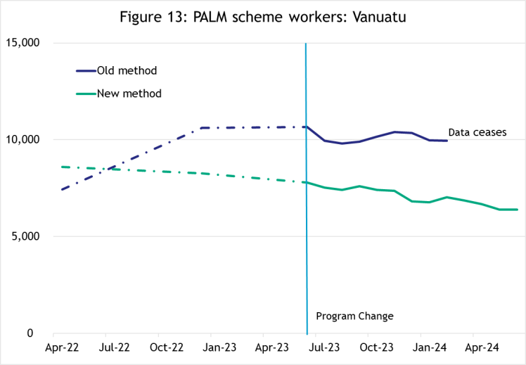Worker counts from Vanuatu have been consistently declining over the period, falling by 26% between April 2022 and June 2024.

All of this decline has been in the short-term stream, which makes up almost 80% of the Ni-Vanuatu PALM workforce. Conversely, worker counts in the long-term stream have been generally steady over the same period.

* There is a considerable difference in worker counts between the old and new methods, with the counts for Vanuatu previously over-reported, by 29% in February 2024.

9

PALM Scheme data report – June quarter 2024

## Worker trends by Industry

PALM scheme data is reported for five key industry groups: Agriculture, Meat processing, Accommodation, Health care and social assistance, and Other industries. Due to gaps in data sources, a best-fit approach has been used to identify industry. See the Glossary for more information.

Agriculture

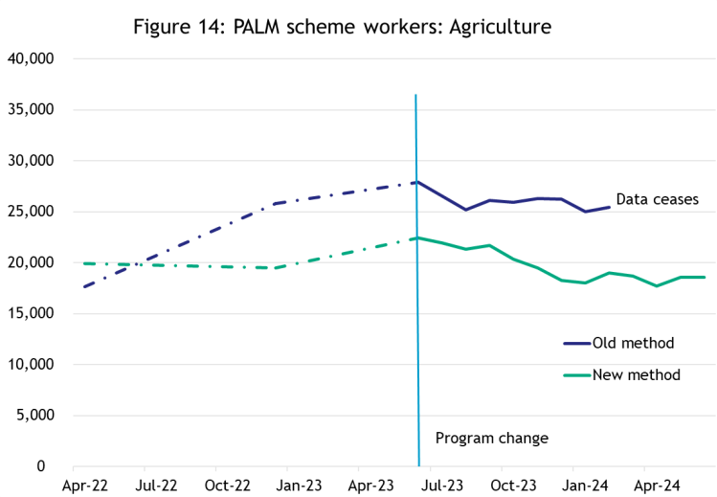Between April 2022 and June 2024, the total number of PALM workers in Agriculture has decreased by 7%, with numbers generally steady between January and June 2024.

* The revised count of PALM worker numbers in Agriculture businesses is generally lower than previously reported, by 22% on average, for 2023/24.

Agriculture short-term stream

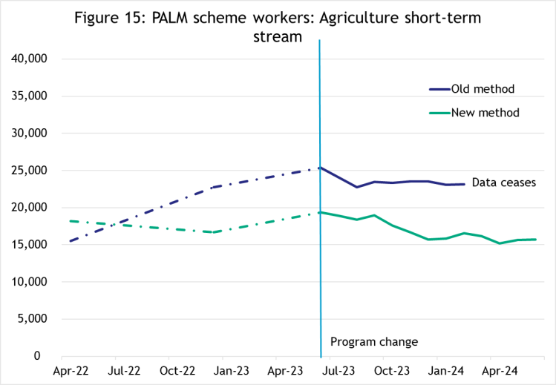The trends for the short-term stream mirror those for total Agriculture, which is not surprising as most of Agriculture (around 85%) consists of short-term stream workers.

While the number of workers for this cohort was generally declining between April 2022 and December 2023, numbers appear to have stabilised somewhat in 2024.

It should be noted there was a large influx of workers during the COVID-19 pandemic, under the temporary pandemic event 408 visa subclass. The vast majority of these workers were in short-term Agriculture.

The number of 408 pandemic event visa holders held steady for much of 2023 but began declining noticeably from October 2023. Some caution needs to be applied interpreting trends in short-term Agriculture, until all 408 PALM visa holders have exited the program, expected by the end of 2024.

10

PALM Scheme data report – June quarter 2024

Agriculture long-term stream

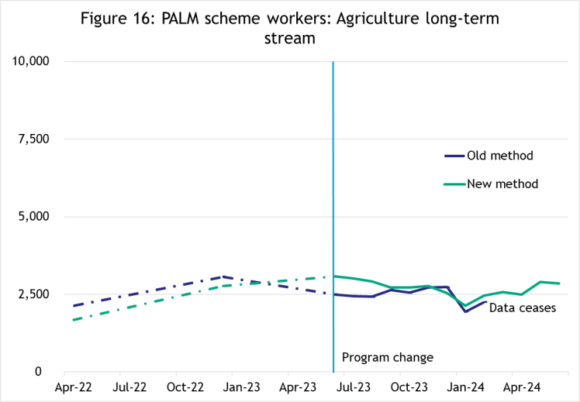Between April 2022 and June 2024, the number of long-term stream workers in Agriculture rose by 70%.

Over the last year, numbers generally declined to December 2023, but have since recovered.

* The revised count of PALM long-term stream worker numbers in Agriculture businesses were on average higher than previously reported, by 10% for 2023/24.

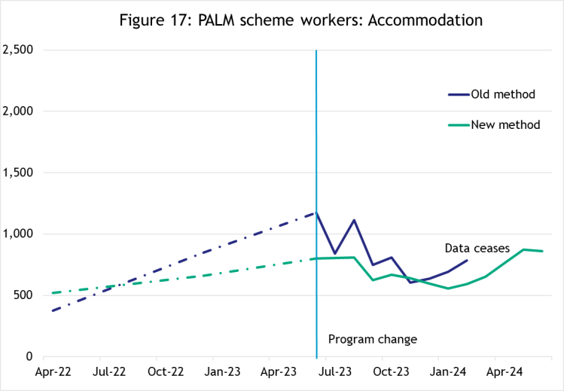Accommodation

The total number of workers in the Accommodation sector increased by 54% from April 2022 to June 2023. From June 2023, numbers declined to the end of that year but have since picked up in 2024.

* The revised count of PALM worker numbers in Accommodation businesses are on average lower than previously reported, by 16% for 2023/24.

Accommodation by stream

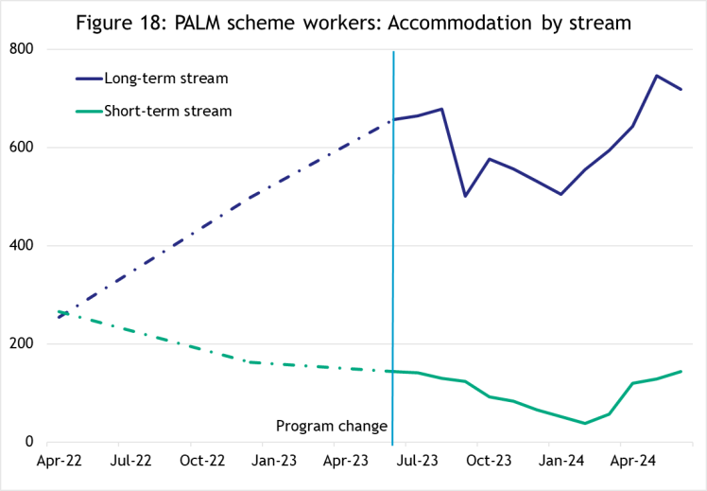While the short and long-term streams for Accommodation were roughly the same size in April 2022:

* The number of short-term stream workers in Accommodation declined consistently over the period between April 2022 to February 2024, with a slight uptick since then.
* By contrast, the number of long-term stream workers in Accommodation has generally shown strong growth, apart from a reduced level between September 2023 and January 2024.

11

PALM Scheme data report – June quarter 2024

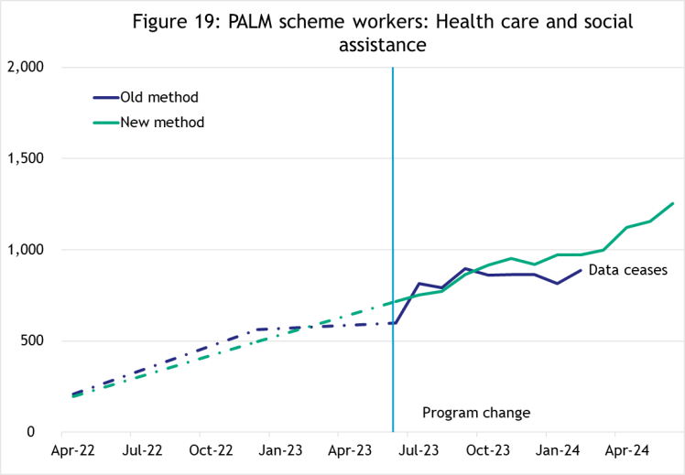Health care and social assistance

All workers in the Health care and social assistance industry are participating in the long-term stream. Worker counts in this sector have increased strongly over the period, rising from 195 workers in April 2022 to 1,255 in June 2024.

* The revised count of PALM worker numbers in Health care and social assistance businesses are on average higher than previously reported, by 7% for 2023/24.

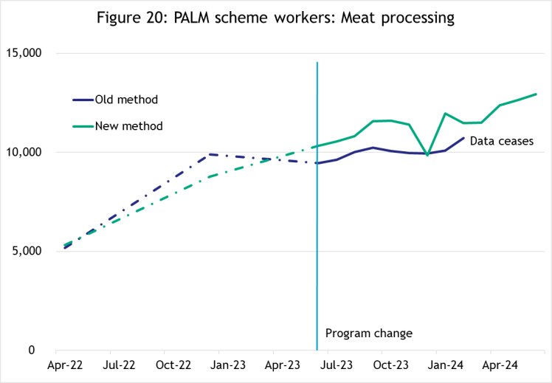Meat processing

The number of workers in Meat processing has shown consistent growth over the period April 2022 to June 2024, up by 143%.

Most PALM scheme meat processing workers (around 98%) are in the long-term stream.

Similar to other long-term stream cohorts, there was a significant drop in the number of workers in December 2023, down by 14% from November 2023.

* The revised counts of PALM worker numbers in Meat processing businesses are on average higher than previously reported, by 10% for 2023/24.

Other industries

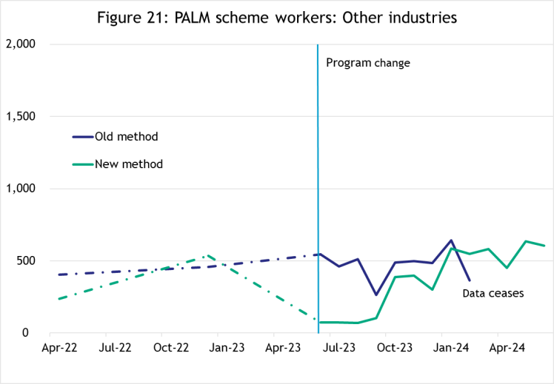This group of industries captures those not otherwise classified to the industries above (i.e. Agriculture, Meat processing, Accommodation, and Health care and social assistance).

Changes in the way industry information has been classified over time under different program models has likely impacted the consistency of this data series. Caution needs to be applied when analysing historical data for Other industries.

From July 2023, the number of workers in Other industries has been generally increasing, and now stands at 605 workers in June 2024.

12

PALM Scheme data report – June quarter 2024

# PALM scheme employer trends

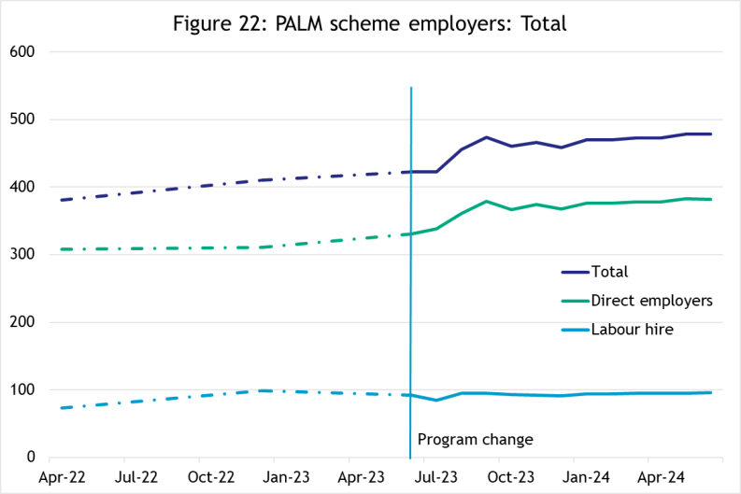The number of PALM Scheme employers has been slowly increasing since April 2022.

From June 2023 to September 2023, there was a surge of direct employers joining the scheme, up by 16%. The number of direct employers flattened from September 2023 to June 2024,

up by 1%.

The number of labour hire companies has remained relatively consistent, increasing by 2% in the period June 2023 to September 2023, and up by 1% in the following period to June 2024.

13

PALM Scheme data report – June quarter 2024

# Explanatory notes

## Data sources

PALM scheme worker data is a combination of data from the Department of Employment and Workplace Relations (DEWR) IT systems and visa data sourced from the Department of Home Affairs. This data is reliant on information entered by labour sending units located in each of the partner countries and PALM scheme employers.

## Data confidentiality

To protect individuals’ privacy, all cells including any totals and subtotals have been rounded to the nearest 5; values from 1 to 7 are rounded to 5. Zero cells are actual zeros. This may result in non- additivity for some totals. Caution should be taken in recalculating totals from rounded data, as this may compound the effects of rounding.

## Glossary

*PALM scheme worker:*

Citizen of a PALM scheme participating country who is issued an approved offer of employment in accordance with the PALM scheme deed and who is granted a PALM stream - temporary work (international relations) visa (subclass 403) or who holds a pandemic event (subclass 408) visa.

* Some PALM scheme workers continue to hold a Pandemic event (subclass 408) visa. This visa type is no longer being granted for the purposes of participating in the PALM scheme. Existing Pandemic event (subclass 408) visas will phase out until the end of 2024.

PALM scheme worker data is derived by combining data from DEWR's IT systems and visa data sourced from the Department of Home Affairs. DEWR data is matched against visa data for comprehensive validation and used to construct valid and accurate counts for PALM scheme workers who are identified in visa data as onshore. Offshore visa holders are excluded from the counts.

*PALM scheme employer:*

An entity contracted by DEWR under the PALM Scheme Deed. Employers can be direct employers (arranges the placement of PALM scheme workers it employs with its own business) or Labour Hire organisations arranges the placement of PALM scheme workers it employs with host organisations using a labour hire arrangement.

*Country of origin:*

PALM scheme participating country that a PALM scheme worker is from. PALM scheme participating countries are:

* + Fiji
  + Kiribati
  + Nauru
  + Papua New Guinea
  + Samoa
  + Solomon Islands
  + Timor-Leste
  + Tonga
  + Tuvalu
  + Vanuatu.

‘Unknown’ country of origin is where country of origin cannot be determined for a PALM scheme worker

due to incomplete data.

14

PALM Scheme data report – June quarter 2024

*Stream*:

Length of placement of employed PALM scheme workers. This is either 'short-term' or 'long-term':

* *Short-term*: a placement with short-term PALM scheme workers who hold the relevant visa and are employed in a contract of work for up to 9 months.
* *Long-term*: a placement with long-term PALM scheme workers who hold the relevant visa and are employed in a contract of work for up to 4 years (non-seasonal).

*Industry:*

Where possible, industries are classified to the Australian Bureau of Statistics Australian and New Zealand Standard Industrial Classification (ANZSIC). An individual business entity is assigned to an industry based on its predominant activity.

Due to gaps in data sources, a best-fit approach has been used to identify industry. ‘Role descriptions’

(which are job or occupation descriptions) may be used to help identify an accurate industry fit.

PALM scheme data is reported to 5 key industry groups: Agriculture, Meat Processing, Accommodation, Health Care and Social Assistance, and Other industries.

* *Agriculture:*

Reflects workers in ANZSIC Division A: Agriculture, Forestry and Fishing.

* *Meat Processing:*

Includes meat and meat product manufacturing (a subset of the ANZSIC Division C: Manufacturing)

* *Accommodation:*

ANZSIC Division H: Accommodation and Food Services.

* *Health care and social assistance*:

ANZSIC Division Q: Health care and social assistance. Includes aged, disability and other health care services, including residential care.

* *Other Industries:*

Includes all remaining industries, that are not otherwise classified to the industries above. Note that a small number of workers in manufacturing in non-meat processing (such as grain and cereal manufacturing, or textile or clothing manufacturing) are included in Other industries. Any workers in Retail are included in Other industries.

## Citation

Any publications or reports using the data reported by DEWR must cite DEWR as the source. Where this data has been used for further analysis and interpretation, DEWR requests the inclusion of the following statement in the published report:

*“The views expressed in this report are those of the authors and do not necessarily represent*

*those of DEWR."*

## Contact

For any inquiries, please contact:

For general PALM scheme enquiries: [PALM@dewr.gov.au](mailto:PALM@dewr.gov.au)

For PALM scheme data enquiries: [pacificlabourdata@dewr.gov.au](mailto:pacificlabourdata@dewr.gov.au)

15

PALM Scheme data report – June quarter 2024