Factsheet: requirements for reimbursement invoices

This factsheet provides information for Pacific Australia Labour Mobility (PALM) scheme employers on the requirements for tax invoices provided to the Department of Employment and Workplace Relations (DEWR) for travel and skill cost claims.

For information on eligibility and how to claim reimbursements please refer to: [travel cost reimbursement for short-term PALM scheme workers](https://www.palmscheme.gov.au/resources/travel-cost-reimbursement-short-term-palm-scheme-workers).

Information on reimbursement of travel costs is included in clause 20 of the PALM scheme Approved Employer Deed and sections 7.2 and 7.5 of the PALM scheme Approved Employer Guidelines.

## A guide to your invoice

The tax invoice below is an example to assist PALM scheme employers with the details DEWR requires to accurately process reimbursement claims.

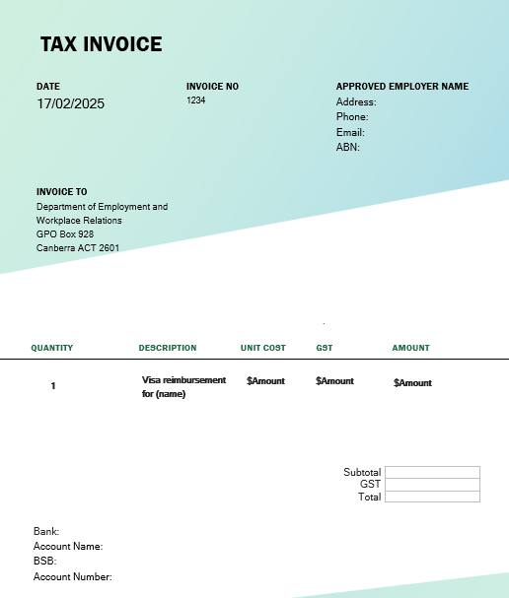

A short and simple invoice number

Accurate company name, ABN, address and contact details

Please ensure the invoice is addressed to the Department of Employment and Workplace Relations

Include GST amount. If no GST is charged, amount is $0

A brief description of the reimbursement

Accurate and up to date banking details

## Have you changed your details recently?

If you have recently changed your details including your company name, ABN, address or banking details, please complete and submit a vendor information request form to ensure your details align with our records and that DEWR pays you promptly.

The vendor information request form can be located here: [Vendor information request form - DEWR.docx](https://view.officeapps.live.com/op/view.aspx?src=https%3A%2F%2Fwww.palmscheme.gov.au%2Fsites%2Fdefault%2Ffiles%2F2023-10%2FVendor%2520information%2520request%2520form%2520-%2520DEWR.docx&wdOrigin=BROWSELINK).

## Resources and other help

* For further information regarding tax invoice requirements, please refer to this information on the Australian Taxation Office website: [tax invoices](https://www.ato.gov.au/businesses-and-organisations/gst-excise-and-indirect-taxes/gst/tax-invoices).
* Refer to clauses 20 of the deed and sections 7.2 and 7.5 of the PALM scheme guidelines.